LAB No 6> Computer Network Design using SWITCH and ROUTERS in GNS3

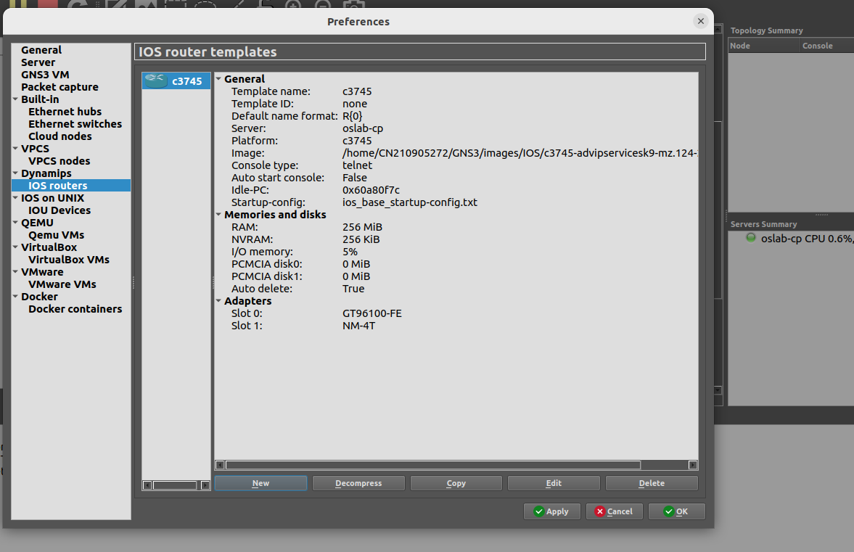
DESIGN:
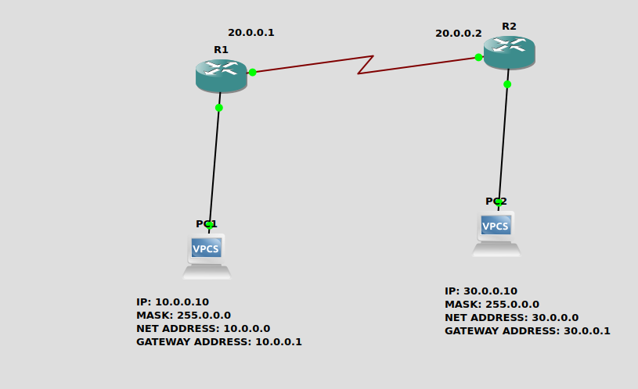
.

CONFIGURE PC1
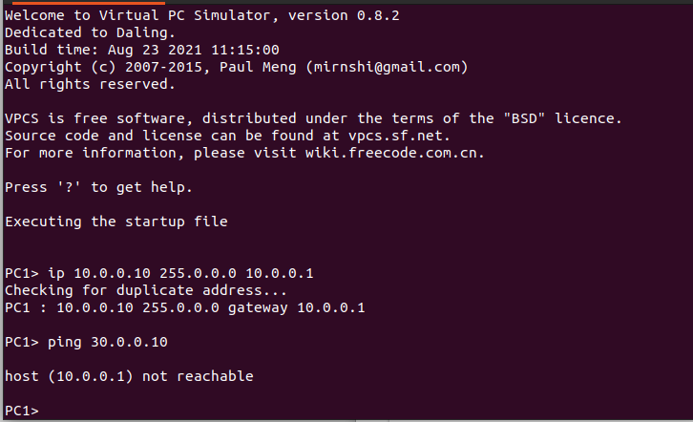

CONFIGURE PC2
