LAB8> STUDY OF DHCP PROTOCOL
Satwik Saurav 210905272

Q1)
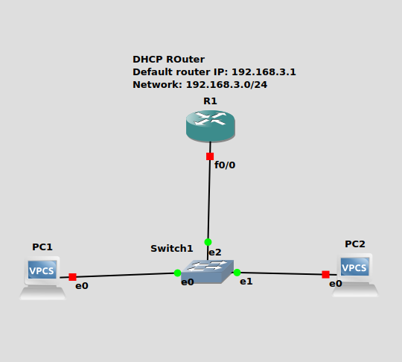
.

R1 is assigned as the dhcp router and it assigns pc1 and pc2 their ip addresses.
D O R A packets observed.
DHCP discover, offer, request, acknowledge

R1)
R1#config t
R1(config)#ip dhcp pool NAME
R1(dhcp-config)#network 192.168.3.0 255.255.255.0
R1(dhcp-config)#default-router 192.168.3.1
R1(dhcp-config)#exit
R1(config)#interface f0/0
R1(config-if)#ip address 192.168.3.1 255.255.255.0
R1(config-if)#no shutdown
R1(config-if)#exit
R1(config)#

PC1)
PC1> dhcp
DDORA IP 192.168.3.2/24 GW 192.168.3.1

PC1> show ip
NAME : PC1[1]
IP/MASK : 192.168.3.2/24
GATEWAY : 192.168.3.1
DNS :
DHCP SERVER : 192.168.3.1
DHCP LEASE : 86368, 86400/43200/75600
MAC : 00:50:79:66:68:00
LPORT : 10008
RHOST:PORT : 127.0.0.1:10009
MTU : 1500

PC2)
PC2> dhcp
DORA IP 192.168.3.3/24 GW 192.168.3.1

PC2> show ip
NAME : PC2[1]
IP/MASK : 192.168.3.3/24
GATEWAY : 192.168.3.1
DNS :
DHCP SERVER : 192.168.3.1
DHCP LEASE : 86398, 86400/43200/75600
MAC : 00:50:79:66:68:01
LPORT : 10010
RHOST:PORT : 127.0.0.1:10011
MTU : 1500

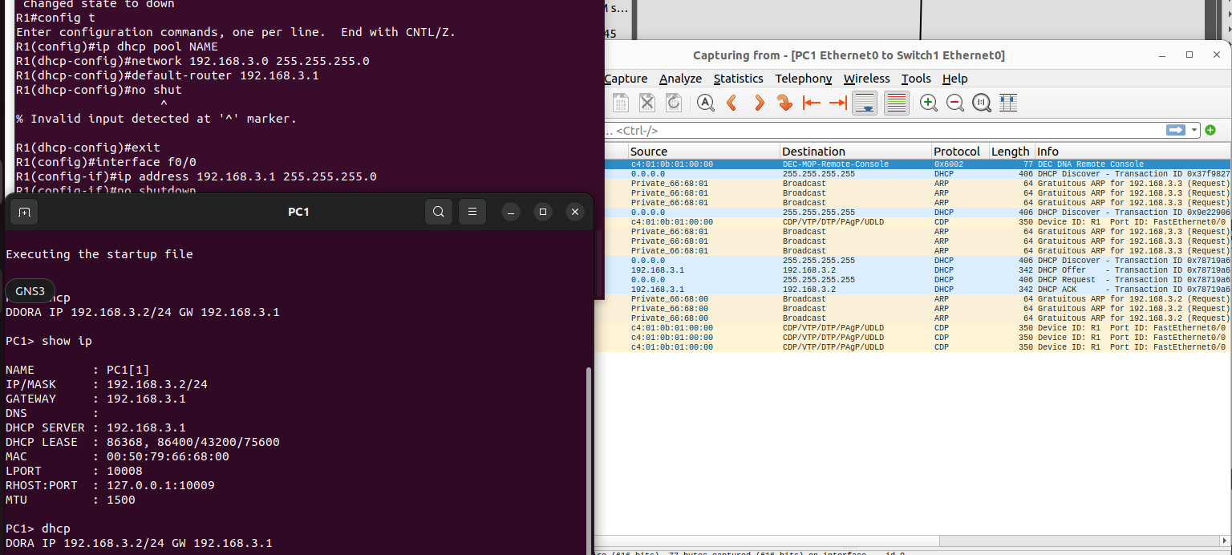

Q2)
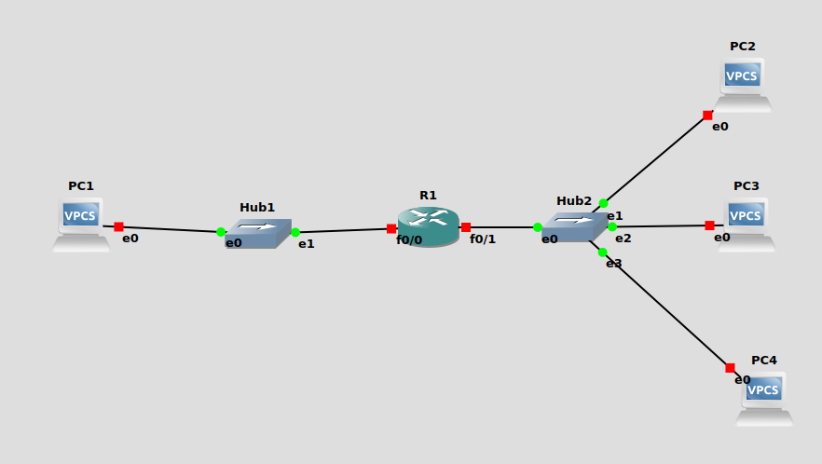

R1)
R1#config t
R1(config)#interface f0/0
R1(config-if)#ip address 10.1.1.1 255.255.255.0
R1(config-if)#no shutdown
R1(config-if)#
*Mar 1 00:13:32.447: %LINK-3-UPDOWN: Interface FastEthernet0/0, changed state to up
*Mar 1 00:13:33.447: %LINEPROTO-5-UPDOWN: Line protocol on Interface FastEthernet0/0, changed state to up
R1(config-if)#exit
R1(config)#interface f0/1
R1(config-if)#ip address 10.0.2.138 255.255.255.0
R1(config-if)#no shut
R1(config-if)#
*Mar 1 00:17:27.483: %LINK-3-UPDOWN: Interface FastEthernet0/1, changed state to up
*Mar 1 00:17:28.483: %LINEPROTO-5-UPDOWN: Line protocol on Interface FastEthernet0/1, changed state to up
R1(config-if)#exit
R1(config)#end

Q3)

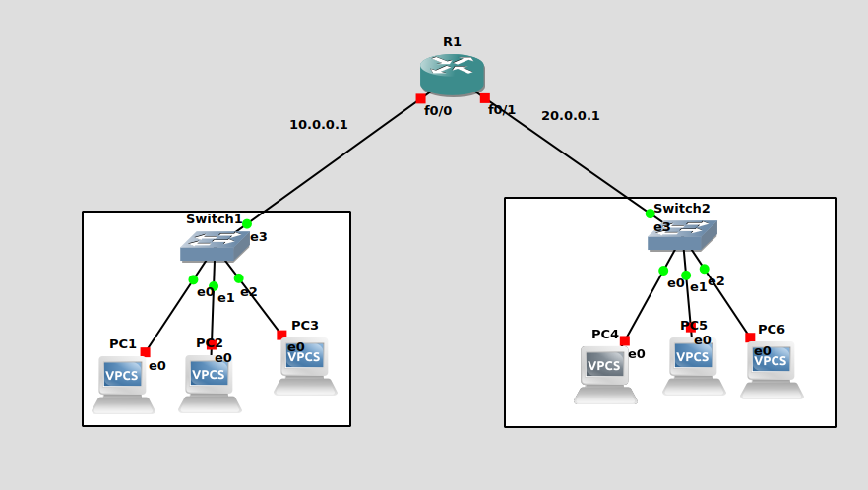
R1)
R1#config t
Enter configuration commands, one per line. End with CNTL/Z.
R1(config)#interface f0/0
R1(config-if)#ip address 10.0.0.1 255.255.255.0
R1(config-if)#no shut
R1(config-if)#exit
R1(config)#interface f0/1
R1(config-if)#ip address 20.0.0.1 255.255.255.0
R1(config-if)#no shut
R1(config-if)#exit
R1(config)#ip dhcp pool NAME
R1(dhcp-config)#network 10.0.0.0 255.255.255.0
R1(dhcp-config)#default-router 10.0.0.1
R1(dhcp-config)#end

R1#config t
Enter configuration commands, one per line. End with CNTL/Z.
R1(config)#ip dhcp pool NAME1
R1(dhcp-config)#network 20.0.0.0 255.255.255.0
R1(dhcp-config)#default-router 20.0.0.1

PC1)
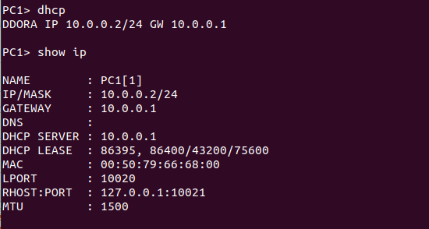
PC3)
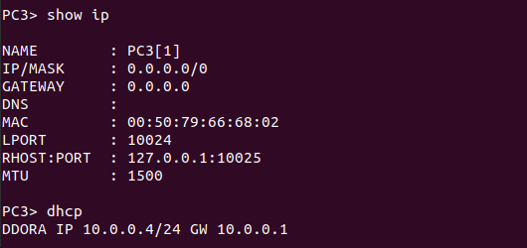
PC4)
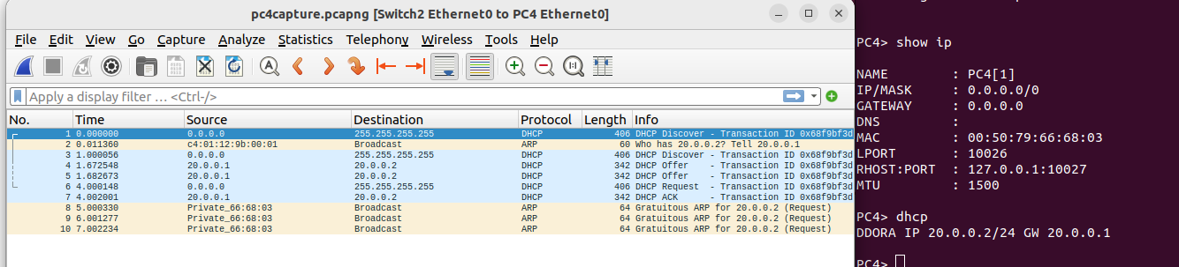
.

Q4)
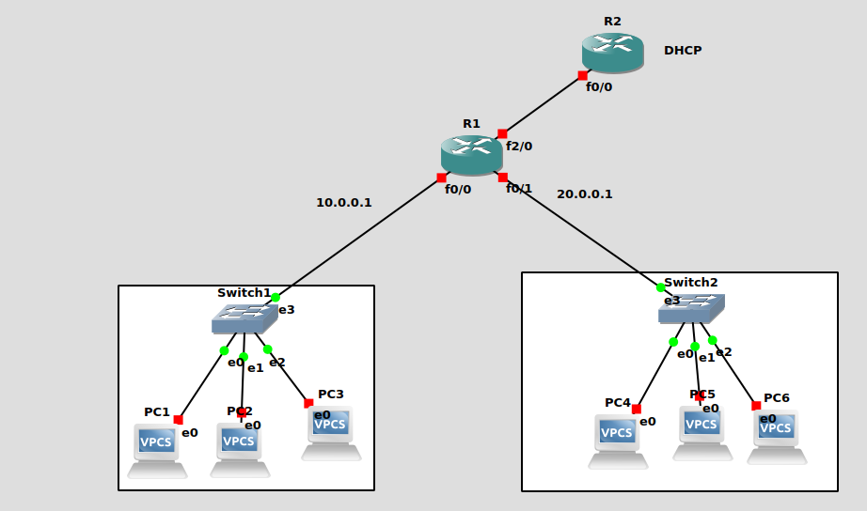
.

PC1)
PC1> dhcp
DDORA IP 10.0.0.3 GW 10.0.0.1

