LAB 9> Design of VLANs Using GNS3
Satwik Saurav 210905272

EG)
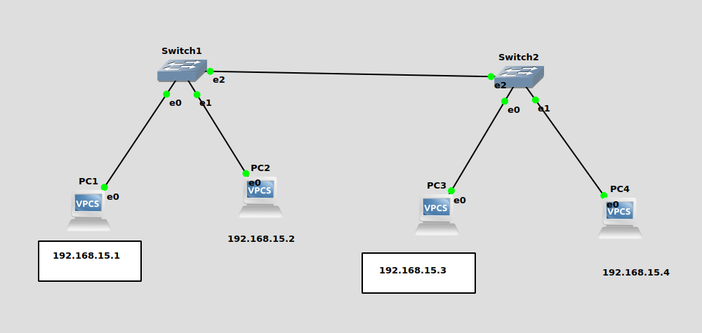
.
PC1 and PC2 are connected to switch1. PC3 and PC4 are connected to switch2.
But pc1 and pc3 should be not accessible by other systems so we use vlan.
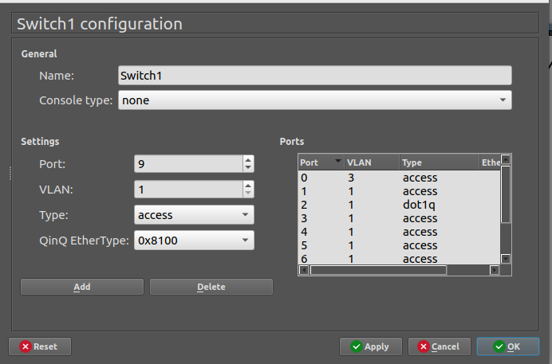
Switch 1 and switch 2 are connected to each other using a trunk port(dot1q)

SO PC1 can ping PC3 but cannot ping pc2
PC1> ip 192.168.15.1
PC2> ip 192.168.15.2
PC3 : 192.168.15.3 255.255.255.0
PC4 : 192.168.15.4 255.255.255.0

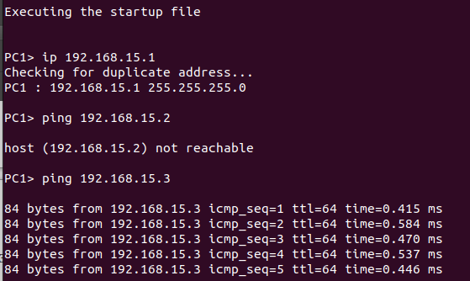

Q1)
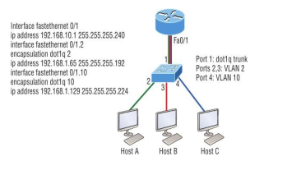

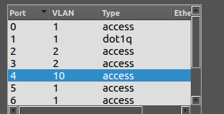
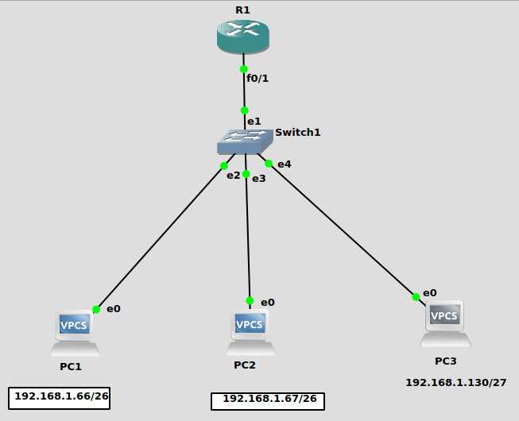
PC1 and PC2 in same vlan and PC3 in different VLAN.
Our aim is to connect PC1 PC2 and PC3.
PC1> ip 192.168.1.66 255.255.255.192 192.168.1.65
Checking for duplicate address...
PC1 : 192.168.1.66 255.255.255.192 gateway 192.168.1.65
PC2> ip 192.168.1.67 255.255.255.192 192.168.1.65
Checking for duplicate address...
PC2 : 192.168.1.67 255.255.255.192 gateway 192.168.1.65

PC3> ip 192.168.1.130 255.255.255.224 192.168.1.129
Checking for duplicate address...
PC3 : 192.168.1.130 255.255.255.224 gateway 192.168.1.129

R1#config t
Enter configuration commands, one per line. End with CNTL/Z.
R1(config)#interface f0/1
R1(config-if)#ip address 192.168.10.1 255.255.255.240
R1(config-if)#no shut
R1(config)#interface f0/1.2
R1(config-subif)#encapsulation dot1q 2
R1(config-subif)#ip address 192.168.1.65 255.255.255.192
R1(config-subif)#no shut
R1(config-subif)#exit
R1(config)#interface f0/1.10
R1(config-subif)#encapsulation dot1q 10
R1(config-subif)#ip address 192.168.1.129 255.255.255.224
R1(config-subif)#no shut
R1(config-subif)#exit
R1(config)#exit
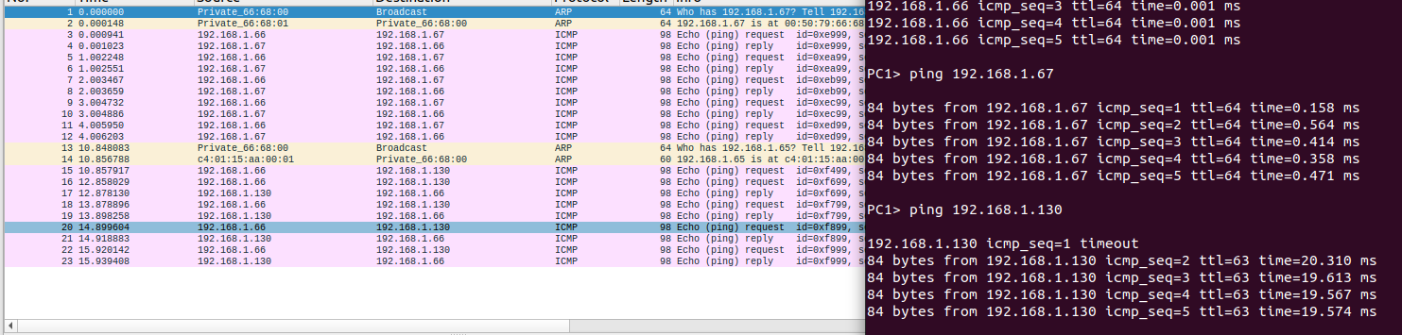
We can ping from pc1 to pc2 and pc3 and the same from pc3 and pc2. This shows the pcs on different VLANs are connected. Inter VLAN connection.
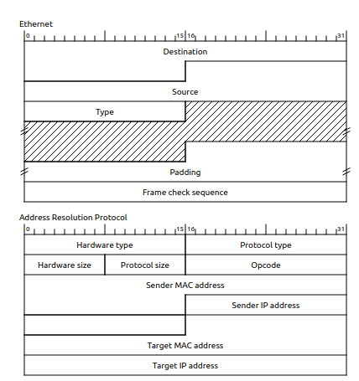

Q2)
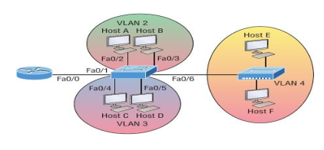

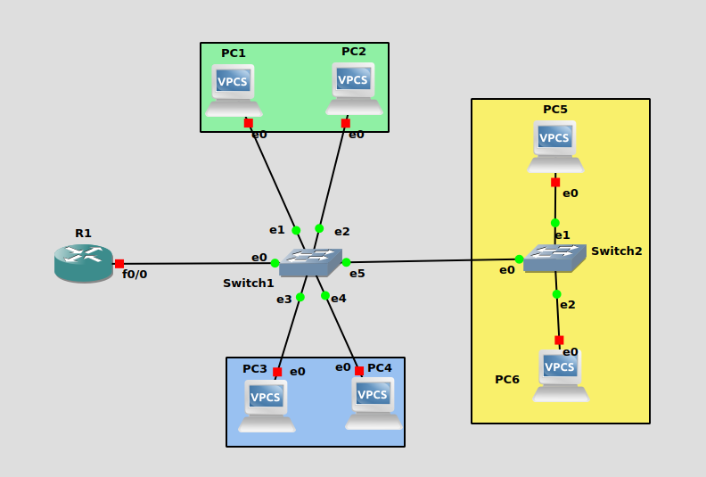
S1)
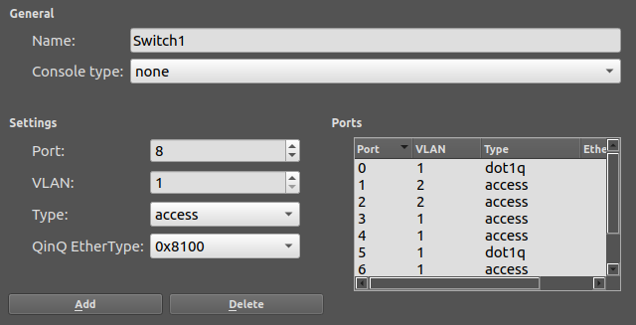
S2)
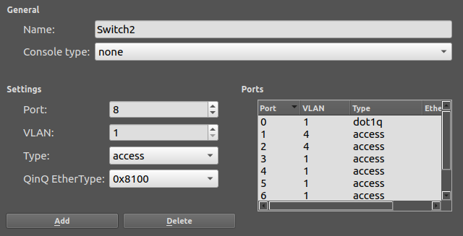
.
PC1 : 10.0.0.2 255.255.255.0 gateway 10.0.0.1
PC2 : 10.0.0.3 255.255.255.0 gateway 10.0.0.1
PC3 : 10.0.1.2 255.255.255.0 gateway 10.0.1.1
PC4 : 10.0.1.3 255.255.255.0 gateway 10.0.1.1
PC5 : 10.0.2.2 255.255.255.0 gateway 10.0.2.1
PC6 : 10.0.2.3 255.255.255.0 gateway 10.0.2.1

R1#config t
R1(config)#interface f0/0
R1(config-if)#ip address 192.168.1.65 255.255.255.0
R1(config-if)#do wr

R1(config-if)#no shut
R1(config-if)#end

R1#config t
Enter configuration commands, one per line. End with CNTL/Z.
R1(config)#interface f0/0.2
R1(config-subif)#encapsulation dot1q 2
R1(config-subif)#ip address 10.0.0.1 255.255.255.0
R1(config-subif)#do wr
R1(config-subif)#no shut
R1(config-subif)#exit
R1(config)#interface f0/0.3
R1(config-subif)#encapsulation dot1q 3
R1(config-subif)#ip address 10.0.1.1 255.255.255.0
R1(config-subif)#do wr
Building configuration...
R1(config-subif)#no shut
R1(config-subif)#
R1(config-subif)#exit
R1(config)#interface f0/0.4
R1(config-subif)#encapsulation dot1q 4
R1(config-subif)#ip address 10.0.2.1 255.255.255.0
R1(config-subif)#do wr
R1(config-subif)#no shut
R1(config-subif)#exit
R1(config)#end

