LAB 11> NAT
Satwik 210905272

STATIC NAT
Ping from loopback on R1 to R2
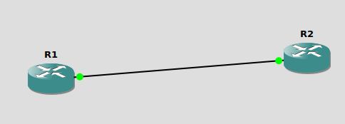

R2 ip address: 200.0.0.10/24

R1 sends as 200.0.0.1/24

loopback for R1: 10.0.0.1

10.0.0.1 sends to 200.0.0.10 as 200.0.0.1. so the sent packet and returning packet both are translated inside with a NAT table.

R1#config t

R1(config)#int loopback0
R1(config-if)#ip address 10.0.0.1 255.0.0.0
R1(config-if)#ip nat inside
R1(config-if)#exit

R1(config)#int f0/0
R1(config-if)#ip address 200.0.0.1 255.255.255.0
R1(config-if)#no shut
R1(config-if)#ip nat outside
R1(config-if)#exit
R1(config)#ip nat inside source static 10.0.0.1 200.0.0.1
R1(config)#end

R2(config)#int f0/0
R2(config-if)#ip address 200.0.0.10 255.255.255.0
R2(config-if)#no shut

NOW PINGING FROM LOOPBACK0
R1#ping
Protocol [ip]: ip
Target IP address: 200.0.0.10
Repeat count [5]:
Datagram size [100]:
Timeout in seconds [2]:
Extended commands [n]: Y
Source address or interface: 10.0.0.1
Type of service [0]:
Set DF bit in IP header? [no]:
Validate reply data? [no]:
Data pattern [0xABCD]:
Loose, Strict, Record, Timestamp, Verbose[none]:
Sweep range of sizes [n]:
Type escape sequence to abort.
Sending 5, 100-byte ICMP Echos to 200.0.0.10, timeout is 2 seconds:
Packet sent with a source address of 10.0.0.1
!!!!!
Success rate is 100 percent (5/5), round-trip min/avg/max = 64/64/68 ms

R1#show running-config
Building configuration...

Current configuration : 1915 bytes
!
version 12.4
service timestamps debug datetime msec
service timestamps log datetime msec
no service password-encryption
!
hostname R1
!
boot-start-marker
boot-end-marker
!
!
no aaa new-model
memory-size iomem 5
no ip icmp rate-limit unreachable
ip cef
!
!
!
!
no ip domain lookup

PING from PC1 and PC2 to R2
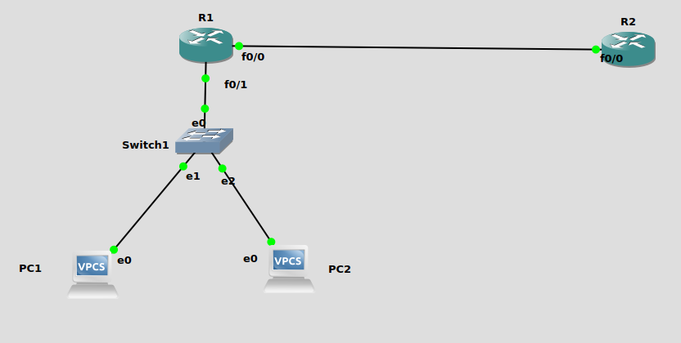

DYNAMIC NAT
Ping from loopback on R1 to R2
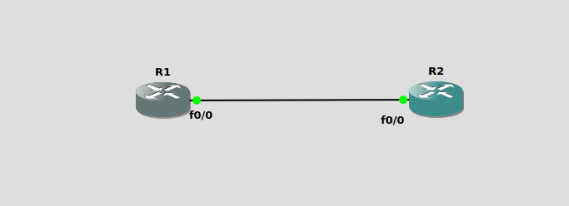
http://www.9tut.com/configure-nat-gns3-lab
http://www.9tut.com/nat-questions

R2>
R2(config)#int f0/0
R2(config-if)#ip address 200.0.0.10 255.255.255.0
R2(config-if)#no shut
R2(config-if)#end

R1>
R1#config t
Enter configuration commands, one per line. End with CNTL/Z.
R1(config)#ip nat pool CNLAB 200.0.0.1 200.0.0.10 netmask 255.255.255.0
R1(config)#
*Mar 1 00:02:36.663: %LINEPROTO-5-UPDOWN: Line protocol on Interface NVI0, changed state to up
R1(config)#access-list 1 permit 192.168.0.0 0.0.0.255
R1(config)#ip nat inside source list 1 pool OSLAB
R1(config)#int loopback0
R1(config-if)#
*Mar 1 00:04:15.855: %LINEPROTO-5-UPDOWN: Line protocol on Interface Loopback0, changed state to up
R1(config-if)#ip address 192.168.0.1
% Incomplete command.

R1(config-if)#ip address 192.168.0.1 255.255.255.0
R1(config-if)#no shut
R1(config-if)#exit
R1(config)#int f0/0
R1(config-if)#ip nat outside
R1#ping
Protocol [ip]:
Target IP address: 200.0.0.10
Repeat count [5]:
Datagram size [100]:
Timeout in seconds [2]:
Extended commands [n]: y
Source address or interface: 192.168.0.1
Type of service [0]:
Set DF bit in IP header? [no]:
Validate reply data? [no]:
Data pattern [0xABCD]:
Loose, Strict, Record, Timestamp, Verbose[none]:
Sweep range of sizes [n]:
Type escape sequence to abort.
Sending 5, 100-byte ICMP Echos to 200.0.0.10, timeout is 2 seconds:
Packet sent with a source address of 192.168.0.1
.!!!!
Success rate is 80 percent (4/5)

PING from PC1 and PC2 to R2

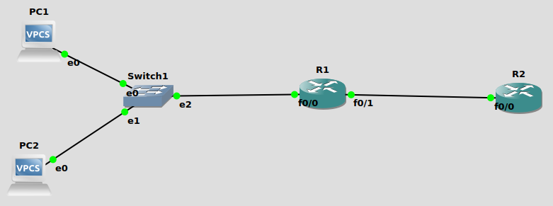
ping from pc1 to r2

