LAB-4>Network Data Analysis using tcpdump

1. While tcpdump host your_host is running in one command window, run ping 127.0.0.1 from
another command window. From the ping output, is the 127.0.0.1 interface on? Can you see any
ICMP message sent from your host in the tcpdump output? Why?

-> Since, we use ping and it remains in the localhost, we cannot detect it in the tcmp output.

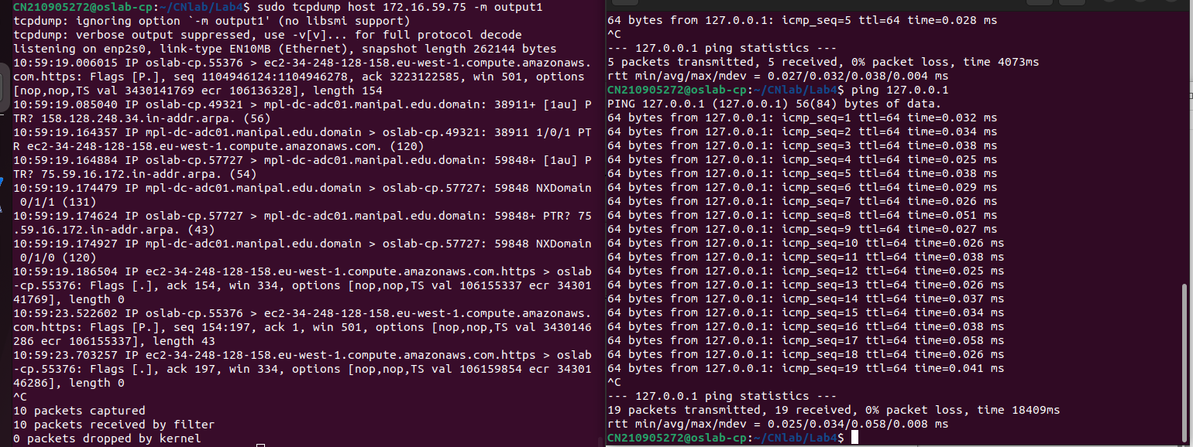
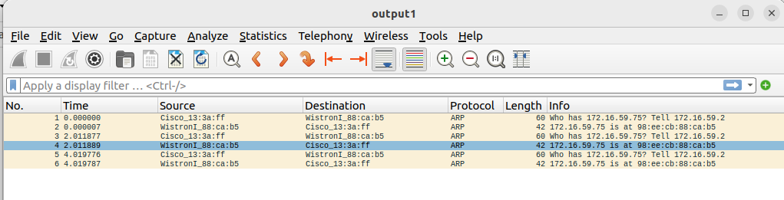

2. While tcpdump host your_host is running to capture traffic from your machine, execute telnet
128.238.66.200. Note there is no host with this IP address in the current configuration of the lab
network. Save the tcpdump output of the first few packets for the lab report. After getting the
necessary output, terminate the telnet session. From the saved tcpdump output, describe how the
ARP timeout and retransmission were performed. How many attempts were made to resolve a
non-existing IP address?

Ping to non existent ip address 172.16.59.69 . The source makes three attempts to get a response (mac address and other details) from the device at the address.

3. Briefly explain the purposes of the following tcpdump expressions.

a. tcpdump udp port 520
filters output for port 520

b. tcpdump -x -s 120 ip proto 89

c. tcpdump -x -s 70 host ip addr1 and (ip addr2 or ip addr3)
d. tcpdump -x -s 70 host ip addr1 and not ip addr2

