LAB 7>Study of Domain Name Server

Configure the below topology to setup DNS server. R1 will use R2 as DNS server to make
DNS resolutions.

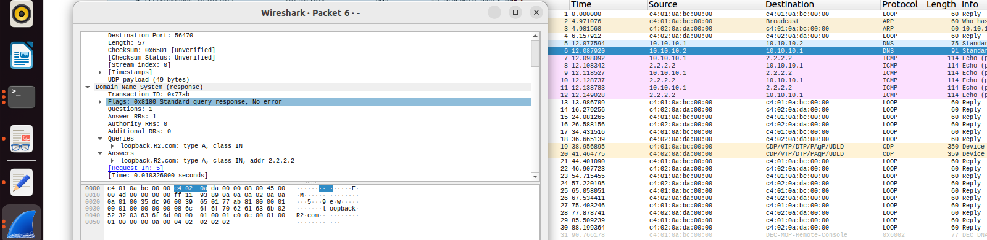

QUESTION>

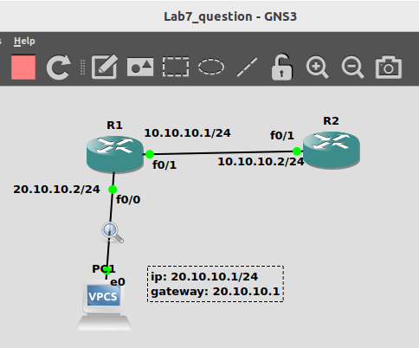

COMMANDS:>

PC1> ip 20.10.10.1 255.255.255.0 20.10.10.2

R1#config t
R1(config)#interface f0/1
R1(config-if)#ip address 10.10.10.1 255.255.255.0
R1(config-if)#no shut
R1(config-if)#do wr
R1(config-if)#end

R2#config t
R2(config)#interface f0/1
R2(config-if)#ip address 10.10.10.2 255.255.255.0
R2(config-if)#no shut
R2(config-if)#do wr
R2(config-if)#end

R2#config t
R2(config)#ip dns server
R2(config)#ip host server.R2.com 10.10.10.2
R2(config)#no shut
R2(config)#end

R1#config t
R1(config)#ip route 0.0.0.0 0.0.0.0 10.10.10.2
R1(config)#end

R2#config t
R2(config)#ip route 20.10.10.0 255.255.255.0 10.10.10.1
R2(config)#end

PC1> ping 10.10.10.2

PC1> ip dns 10.10.10.2

PC1> ping server.R2.com
