LAB 5> Computer Network Design using HUB in GNS3
210905272
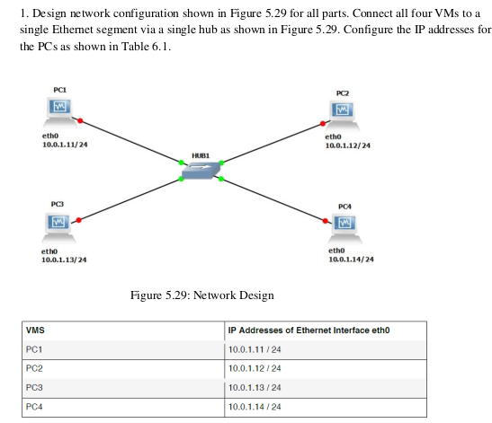
a. On PC1, view the ARP cache with show arp

The Address Resolution Protocol cache has no entries since no broadcast message has been sent out.

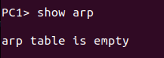

b. Start Wireshark on PC1-Hub1 link with a capture filter set to the IP address of PC2.

Initially empty
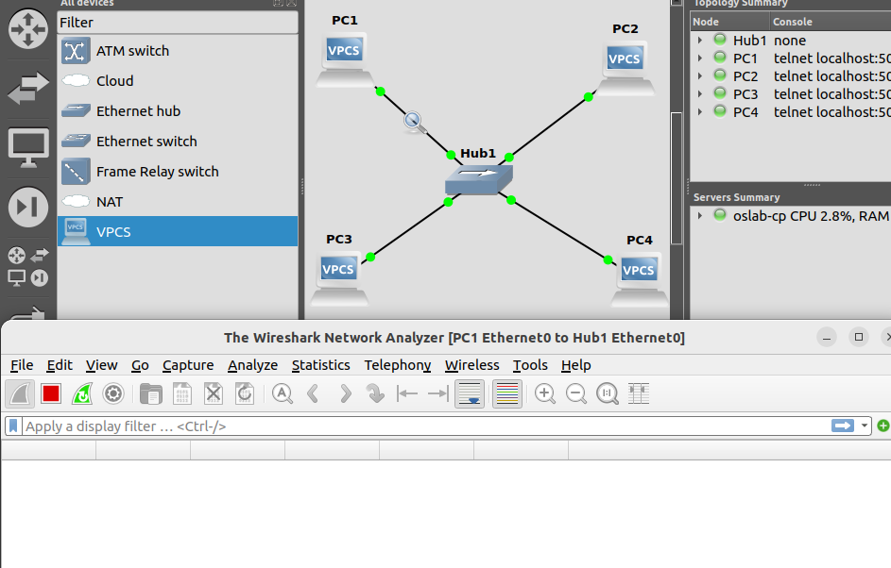
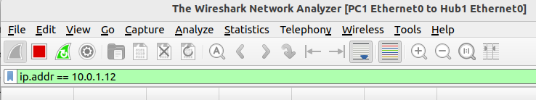
c. Issue a ping command from PC1 to PC2

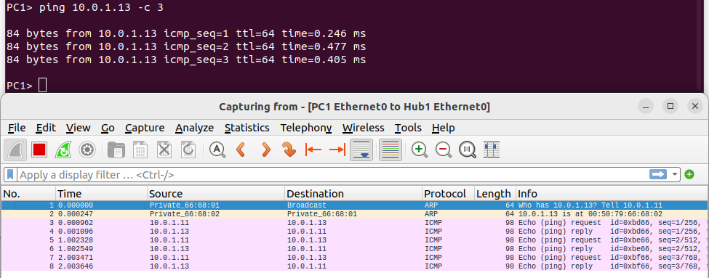
ping 10.0.1.13 -c 3
sends 3 packets from pc1(10.0.1.11) to pc3(10.0.1.13)
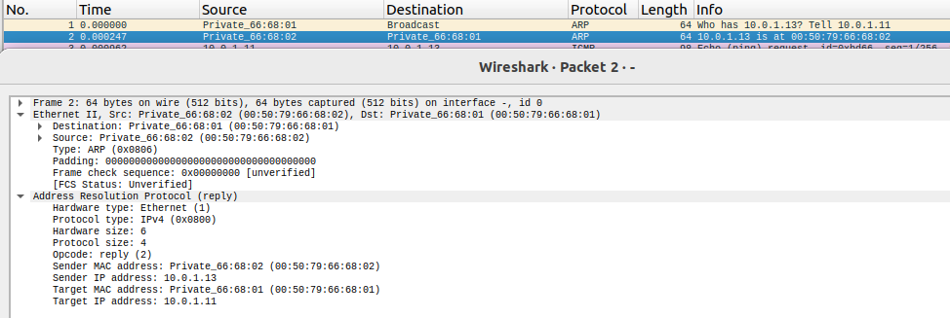
DST: 00:50:79:66:68:02
SRC: 00:50:79:66:68:01
Destination: Private_66:68:01 (00:50:79:66:68:01)
Source: Private_66:68:02 (00:50:79:66:68:02)
Type: ARP (0x0806)

d. View the ARP cache again with the command arp -a.
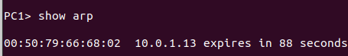

e. Save the results of Wireshark.
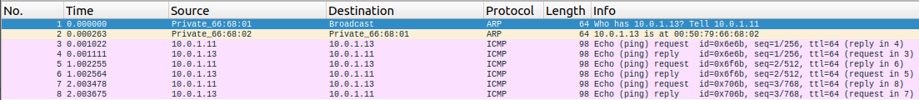

2. To observe the effects of having more than one host with the same (duplicate) IP address in a network.
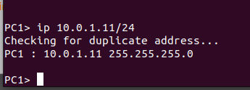

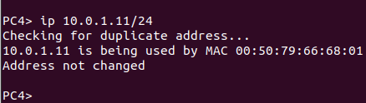

Two PC on the same network cannot have the same address. Addresses are unique.

a. Delete all entries in the ARP cache on all Pcs.
reset ARP
ARP entries reset themselves in 2 minutes
b. Run Wireshark on PC3-Hub1 link and capture the network traffic to and from the duplicate IP
address 10.0.1.11.
c. From PC3, issue a ping command to the duplicate IP address, 10.0.1.11, by typing
PC3% ping 10.0.1.11 –c 5
d. Stop Wireshark, save all ARP packets and screenshot the ARP cache of PC3 using arp –a command: PC3% arp – a
e. When you are done with the exercise, reset the IP address of PC4 to its original value as given
in Table 6.1.

3. To test the effects of changing the netmask of a network configuration.

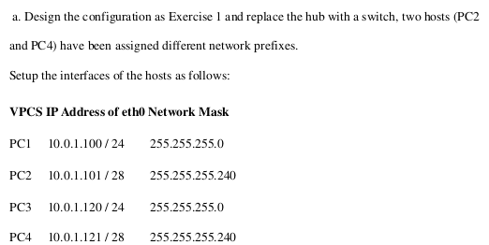
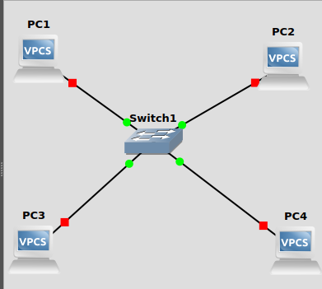

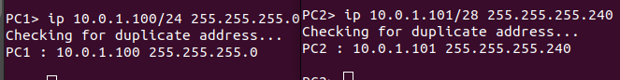
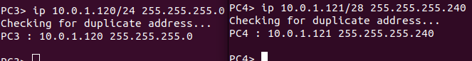
.

b. Run Wireshark on PC1-Hub1 link and capture the packets for the following scenarios
i. From PC1 ping PC3.

ping 10.0.1.120/24 -c 1
84 bytes sent
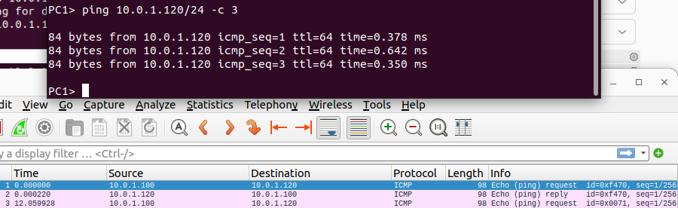
ii. From PC1 ping PC2.
ping 10.0.1.101/28 -c 3
SPECIAL CASE: should not ping since networkmasks are different. In binary the masked bits are the same. First 4 bits match in net Id of pc2 and host id of pc1.
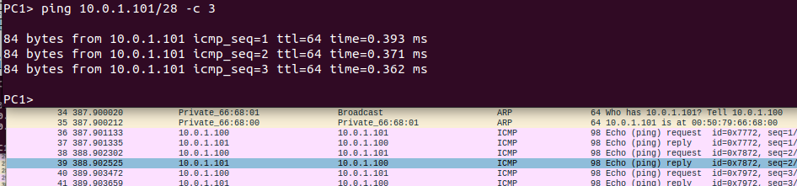

iii. From PC1 ping PC4.PC1 cannot reach PC2 since they have different network prefixes.
ping 10.0.1.121/28 -c 3
Different network prefixes. Different subnets mask value
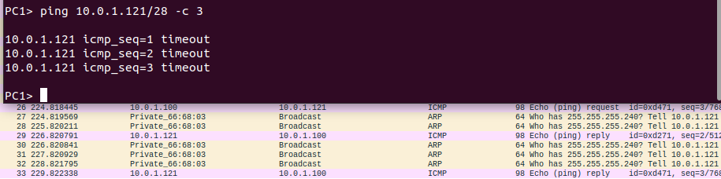
iv. From PC4 ping PC1.


v. From PC2 ping PC4.
Ping packets sent from pc2 to pc4 but cannot be captured using current setup of wireshark since it is capturing for pc1 to switch and it is not involved

vi. From PC2 ping PC3.
Ping packets sent from pc2 to pc3 but cannot be captured using current setup of wireshark since it is capturing for pc1 to switch and it is not involved

c. Save the Wireshark output to a text file (using the “Packet Summary” option from “Print”) , and save the output of the ping commands. Note that not all of the above scenarios are successful. Save all the output including any error messages.

d. When you are done with the exercise, reset the interfaces to their original values as given Table 6.1. (Note that /24 corresponds to network mask 255.255.255.0. and /28 to network mask 255.255.255.240).

PC1> ip 10.0.1.11/24
PC2> ip 10.0.1.12/24
PC3> ip 10.0.1.13/24
PC4> ip 10.0.1.14/24

