LAB 10> Study of Dynamic Routing Protocols using GNS3
Satwik 210905272

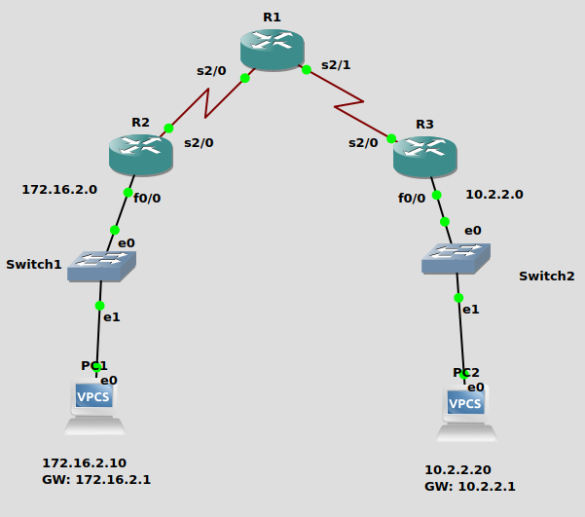

R1#conf t
R1(config)#int s1/0
R1(config-if)#ip add 100.1.1.2 255.255.255.0
R1(config-if)#no shut
R1(config-if)#int s1/1
R1(config-if)#ip address 20.1.1.1 255.255.255.0
R1(config-if)#no shut
R1(config-if)#exit
R1(config)#router rip
R1(config-router)#version 2
R1(config-router)#network 20.1.1.0
R1(config-router)#network 100.1.1.0

R2#config t
R2(config)#int f1/0
R2(config-if)#ip address 172.16.2.1 255.255.0.0
R2(config-if)#no shut
R2(config-if)#int s2/0
R2(config-if)#ip address 100.1.1.1 255.255.255.0
R2(config-if)#no shut
R2(config-if)#exit
R2(config)#router rip
R2(config-router)#version 2
R2(config-router)#network 172.16.0.0
R2(config-router)#network 100.1.1.0

R3#config t
R3(config)#int s2/0
R3(config-if)#ip add 20.1.1.2 255.255.255.0
R3(config-if)#no shut
R3(config-if)#int f1/0
R3(config-if)#ip add 10.2.2.1 255.255.255.0
R3(config-if)#no shut
R3(config-if)#exit
R3(config)#router rip
R3(config-router)#ver 2
R3(config-router)#network 10.2.2.0
R3(config-router)#network 20.1.1.0

OSPF
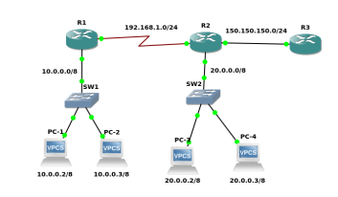

R1#config t
Enter configuration commands, one per line. End with CNTL/Z.
R1(config)#router ospf 200
R1(config-router)#network 10.0.0.0 0.255.255.255 area 0
R1(config-router)#network 192.168.1.0 0.0.0.255 area 0.0.0.0
R1(config-router)#exit

R2#config t
Enter configuration commands, one per line. End with CNTL/Z.
R2(config)#router ospf 200
R2(config-router)#network 20.0.0.0 0.255.255.255 area 0
R2(config-router)#network 192.168.1.0 0.0.0.255 area 0
R2(config-router)#network 150.150.150.0 0.0.0.255 area 1
R2(config-router)#exit
R2(config)#exit
R2#

R3#config t
*Mar 1 00:09:11.359: %SYS-5-CONFIG_I: Configured from console by console
R3#config t
Enter configuration commands, one per line. End with CNTL/Z.
R3(config)#router ospf 200
R3(config-router)#network 150.150.150.0 0.0.0.255 area 1
R3(config-router)#exit
R3(config)#exit

PC1 : 10.0.0.2 255.0.0.0

PC2 : 10.0.0.3 255.0.0.0

PC3 : 20.0.0.3 255.0.0.0

PC4 : 20.0.0.2 255.0.0.0

OSPF_1

