1. select * from Crime where Status = 'Open';



1. select count(IncidentType) as total_number_of_incidents from Crime;



1. select distinct IncidentType from Crime;

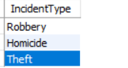

1. select * from Crime where IncidentDate BETWEEN '2023-09-01' AND '2023-09-10';



1. select c.IncidentType as Incident, s.Name, s.Age from Crime c join Suspect s on c.CrimeID = s.CrimeID order by s.Age desc;

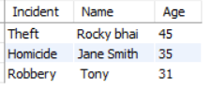

1. select avg(s.Age) as Average_age_of_persons from Suspect s;



1. select IncidentType, count(IncidentType) as Count from Crime where Status = 'Open' group by IncidentType;



1. select Name from Victim where Name like '%Doe%' UNION select Name from Suspect where Name like '%Doe%';



1. select s.Name from Suspect s join Crime c on c.CrimeID = s.CrimeID where c.Status = 'Open' OR c.Status = 'Closed' group by s.Name ;



1. select c.IncidentType from Crime c join Suspect s on s.CrimeID = c.CrimeID where s.Age BETWEEN 30 AND 35 group by c.IncidentType;

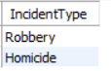

1. select s.Name from Suspect s join Crime c on s.CrimeID = c.CrimeID where c.IncidentType = 'Robbery' group by s.Name;



1. select IncidentType from Crime where Status = 'Open' group by IncidentType Having count(*) > 1;



NULL

1. select distinct s.Name, c.IncidentType from Crime c join Suspect s on c.CrimeID = s.CrimeID join Victim v on v.Name = s.Name;



1. select c.IncidentType, v.*, s.* from Crime c left join Suspect s on s.CrimeID = c.CrimeID left join Victim v on v.crimeID = s.CrimeID;



1. select c.IncidentType from Crime c join Suspect s on c.CrimeID = s.CrimeID join Victim v on c.CrimeID = v.CrimeID where s.Age > ALL(select v.Age from Victim v where v.CrimeID = c.CrimeID);

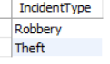

1. select s.SuspectID, s.Name, count(distinct c.IncidentType) as Num_incidents from Crime c join Suspect s on c.CrimeID = s.CrimeID where s.SuspectID IS NOT NULL group by s.SuspectID, s.Name Having count(distinct c.IncidentType) > 0;



NULL NULL NULL

1. select c.IncidentType from Crime c left join Suspect s on c.CrimeID = s.CrimeID where s.SuspectID is null;



1. SELECT DISTINCT CrimeID

FROM Crime c1 WHERE IncidentType = 'Homicide'

AND NOT EXISTS (

SELECT 1

FROM Crime c2 WHERE c2.CrimeID = c1.CrimeID

AND c2.IncidentType <> 'Homicide' )

AND EXISTS ( SELECT 1

FROM Crime c3

WHERE c3.CrimeID = c1.CrimeID AND c3.IncidentType = 'Robbery' );



1. SELECT c.IncidentType, s.SuspectID, s.Name FROM crime c LEFT JOIN Suspect s ON c.CrimeID = s.CrimeID ORDER BY c.CrimeID , s.SuspectID;

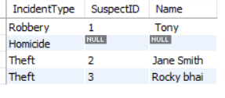

1. SELECT s.SuspectID, s.Name, c.IncidentType FROM Suspect s JOIN Crime c ON s.CrimeID = c.CrimeID WHERE c.IncidentType IN ('Robbery', 'Theft');

