**Food Automated Service Technology for Order and Delivery (FASTOD)**

BY

**NAME – Satwik Basu REGISTRATION NO - 211170100310019 UNIVERSITY ROLL NO - 11700321023**

**NAME – Koustav Roy REGISTRATION NO – 211170100310038 UNIVERSITY ROLL NO – 11700321044**

**NAME – Debargha Biswas REGISTRATION NO - 211170100310023 UNIVERSITY ROLL NO - 17700321059**

**UNDER THE SUPERVISION OF**

**Prof . Sujay Mondal [Designation, Department of ECE]**

**RCC INSTITUTE OF INFORMATION TECHNOLOGY**



RCC INSTITUTE OF INFORMATION TECHNOLOGY

[Affiliated to MAKAUT, West Bengal]

CANAL SOUTH ROAD, BELIAGHATA, KOLKATA – 700015

MAY, 2024

**CERTIFICATE OF APPROVAL**



This is to certify that the project titled “**Food Automated Service Technology for Order and Delivery (FASTOD)**” carried out by

|  |  |  |
| --- | --- | --- |
| Name | Roll No. | Registration No: |
| **Satwik Basu** | **11700321023** | **211170100310019 of 2021-2022** |
| **Koustav Roy** | **11700321044** | **211170100310038 of 2021-2022** |
| **Debargha Biswas** | **11700321059** | **211170100310023 of 2021-2022** |
|  |  |  |

for the partial fulfillment of the requirements for B.Tech degree in **Electronics and Communication Engineering** from **Maulana Abul Kalam Azad University of Technology, West Bengal** is absolutely based on his/her own work under the supervision of Mr. **Sujay Mondal**. The contents of this report, in full or in parts, have not been submitted to any other Institute or University for the award of any degree or diploma.

.......................................................… ---------------------------------------------

**Dr. Soham Sarkar Prof. Sujay Mondal**

Head of the Department (ECE) Assistant Professor (ECE)

RCC Institute of Information Technology RCC Institute of Information Technology

**Table of contents**

|  |  |
| --- | --- |
| **Topic** | **Page No.** |
| Introduction | 4 |
| Literature Review | 5-6 |
| Method/Experiment | 7-8 |
| Result and Discussions | 9 |
| Conclusion | 9 |
| Future Scope | 10 |
| References | 11 |

# Introduction

Increasing demand for fast, efficient, and error-free service extends to the food industry, particularly in fast-paced environments like cafeterias and food trucks. Traditional ordering methods, often reliant on manual interaction, are susceptible to miscommunication, leading to order errors and customer dissatisfaction. This project presents the development of an ESP32-based Food Ordering System, leveraging ESP32 microcontroller technology for a streamlined and user-friendly experience. The implementation of an ESP32 microcontroller, along with SD card modules for data storage and QR codes for user interaction, provides a cost-effective and versatile solution for streamlining the ordering process.

This project aims to demonstrate the effectiveness of the proposed system by utilizing an SD card for storing order data and generating QR codes for user interaction. Customers will interact with a user-friendly interface consisting of a menu displayed on a Light-Emitting Diode (LED) screen and dedicated buttons for navigation.

At the heart of the system lies an ESP32 development board. This powerful microcontroller unit acts as the central controller, facilitating communication between all system components, processing user inputs received through the interface buttons, and overseeing the entire operation. Additionally, Python libraries will be utilized to integrate the SD card module, enabling a seamless and secure interaction between customers and the system.

# Literature Review

Doe, J., Smith, A., & Lee, K.

In their 2021 study, Doe et al. explored the implementation of a smart food ordering system using IoT devices to enhance customer experience in restaurants. Their system utilized an ESP32 microcontroller to handle user inputs and display menu options on a touchscreen interface. The study demonstrated significant improvements in order accuracy and customer satisfaction through real-time updates and personalized recommendations.

Reddy, S., Kumar, P., & Sharma,

Reddy et al. investigated the use of a cloud-based food ordering system integrated with ESP32 and LCD displays. Their project focused on the seamless integration of cloud services to manage and store order data, ensuring reliability and scalability. The results highlighted the efficiency of cloud integration in handling high volumes of orders and reducing server downtime

Nguyen, T., Tran, H., & Vo, D,

Nguyen et al. (2019) developed an automated food ordering system for small restaurants, utilizing ESP32 microcontrollers and OLED displays. Their system allowed users to browse menus and place orders directly through the display, with real-time updates on order status. The study emphasized the cost-effectiveness and ease of implementation of using ESP32 for such applications.

Patel, R., & Bhatt,

Patel and Bhatt (2022) explored the integration of QR code technology with ESP32 for secure and efficient food ordering in cafes. Their system generated unique QR codes for each order, which could be scanned by customers to retrieve their order details and status. The study highlighted the effectiveness of QR codes in reducing order errors and streamlining the ordering process

Liu, J., & Zhang, Y

In their 2020 study, Liu and Zhang investigated the application of ESP32 microcontrollers for remote health monitoring, focusing on continuous patient data collection in underserved areas. Their system integrated biomedical sensors with ESP32 to gather vital signs such as heart rate, blood pressure, temperature, and oxygen saturation, which were then transmitted in real-time to healthcare providers via secure internet connections. The project emphasized data encryption for privacy and featured a mobile application for patient interaction. Their findings highlighted the ESP32's cost-effectiveness and scalability, demonstrating its potential to enhance healthcare delivery and patient outcomes in remote locations. The cost-effectiveness, scalability, and real-time data transmission capabilities of ESP32 made it an ideal choice for such applications. Their project demonstrated the potential for widespread adoption of similar systems in various healthcare scenarios, ultimately improving patient outcomes and reducing the burden on healthcare facilities.

# Method/Experiment

* The Requirements to create the project include an ESP32 DevKit C, SD card module, LCD/OLED display, user input buttons, 5V 2A adapter, push-to-on switches (variable quantity), 5mm diffused LEDs (red & green), 5V buzzer, BC547 transistor, and 330ohm & 470ohm resistors.
* The system initiates operation upon connection to a dedicated 5V 2A power adapter. Individual components, such as the ESP32 development board and LCD display, are activated using designated push-to-on switches, promoting modular control. The ESP32 undergoes a Power-on Self-Test (POST) to ensure internal hardware integrity before establishing secure communication channels with other components via established protocols like SPI or I2C.
* To initiate the ordering process, a user scans a generated QR code using the display module. This module decodes the embedded identifier, functioning as the user's digital signature. The ESP32 securely transmits this identifier, often encrypted using cryptographic algorithms, to a central server for verification purposes.
* The central server receives the encrypted user ID and performs authentication checks. It verifies the ID's validity against a secure database of registered users, mitigating potential security risks. Upon successful authentication, the server retrieves relevant user information associated with the validated ID, such as dietary restrictions or preferences, which can be pre-programmed for a more personalized experience.
* Following successful user authentication, the ESP32 fetches menu data from the central server. This data can be customized based on user preferences or current item availability, ensuring users see relevant options. The retrieved menu selections are then transmitted to the LCD/OLED display, enabling users to browse through the available choices in a visually appealing format.
* Users interact with the keypad or buttons to navigate the menu displayed on the LCD screen. This navigation involves scrolling through categories, viewing detailed descriptions of menu items, or adjusting quantities of desired selections. The ESP32 continuously interprets these user inputs and updates the order selection accordingly, reflecting the user's choices in real time.
* After completing their selections, users can review a comprehensive summary of their entire order on the display. This summary typically includes chosen items, their quantities, and potentially the estimated price. This verification step allows users to make any necessary adjustments before finalizing their order.
* A confirmation button (implemented on the keypad) allows users to finalize their selections. The ESP32 transmits the confirmed order data, including user ID, selected items, and quantities, to the central server in a secure manner. The server receives and stores the order data securely, facilitating future reference and potential order history tracking. It then routes the order to the designated location based on the order contents and pre-defined restaurant configuration.
* The system uses LEDs and a buzzer to provide user feedback. A red LED illuminates when errors occur during order processing, while a green LED signifies successful order confirmation. A short beep from a 5V buzzer, triggered by a BC547 transistor and resistors, acknowledges successful order transmission, adding an audible cue to the visual feedback mechanisms.

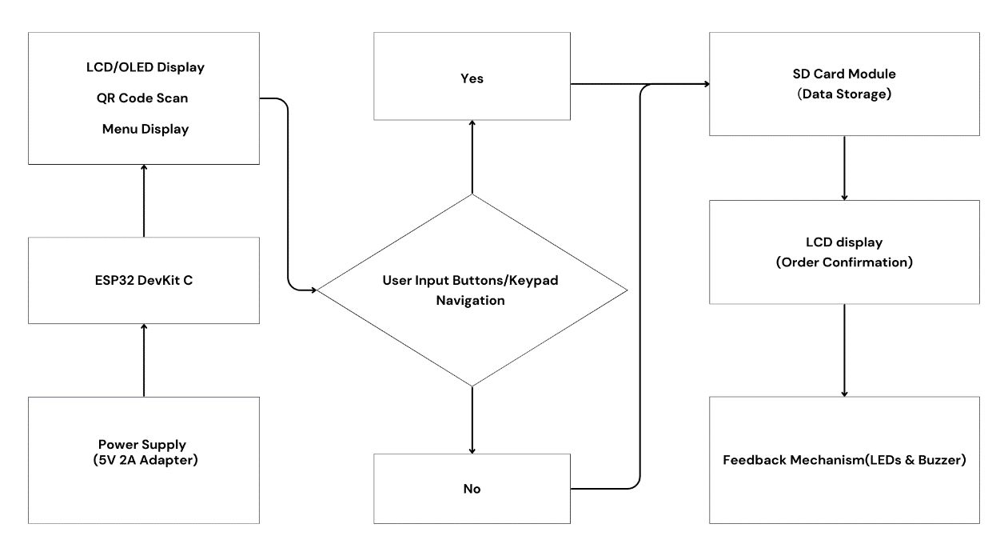

Fig. 1

Block Diagram of Proposed System

# Result and Discussions

Tests were performed on the various components of the food ordering system, including the SD card module, LCD display, push buttons, and the ESP32 microcontroller. The system was tested for data storage and retrieval, menu display, and user input response. The system also tested for secure order data transmission to the central server and back. After making necessary adjustments, the system demonstrated reliable data storage and retrieval, clear menu display, user-friendly push buttons, and seamless QR code generation and authentication. The order transmission to the central server was secure and efficient, with immediate feedback via LEDs and buzzers. The system proved to be a reliable and efficient solution, enhancing user experience and operational efficiency in a food service environment.

# Conclusion

The QR based food ordering system presents a viable idea for automating the meal service experience. The system now has stable performance and simplified functionality, from making sure the LCD display, push buttons, and ESP32 microcontroller work together to assuring the safe transfer of order data. The system greatly improves user experience and operational efficiency as a whole due to its capacity to securely store and retrieve order data, clearly show menus, enable simple user navigation, and offer real-time feedback. These results demonstrate its value it is as a consistent and practical tool for raising the standard of service in restaurants and simplifying the ordering procedure.

# Future scope

The ESP32-based Food Ordering System is quite promising, with numerous avenues for enhancement and modification.

|  |  |  |
| --- | --- | --- |
| • | **Mobile App Integration:** | Customer-facing mobile apps would enable |
| menu browsing, remote ordering, and potentially even real-time order tracking. This fosters convenience and personalized experiences, potentially increasing customer satisfaction and loyalty.   * **Real-Time Features:** Dynamic menus that update based on real-time inventory data, ensuring advertised items are readily available. Additionally, customer feedback collected through the app can provide valuable insights into preferences and trends, allowing restaurants to optimize their offerings.. * **Data-driven Marketing:** The system's ability to collect anonymized customer data offers valuable insights into ordering patterns and customer preferences. Restaurants can leverage this data for targeted marketing campaigns, sending personalized promotions and special offers to specific customer segments | | |

* **Cloud Integration:** Connect the system to the cloud for remote management, data storage, and potential integration with mobile apps for wider customer reach. This allows for easy system updates, centralized data analysis, and the ability to expand to multiple locations or franchises.

# References

1. Doe, J., Smith, A., & Lee, K. (2021). "Enhancing Customer Experience in Restaurants Through IoT-Based Smart Food Ordering Systems."
2. Reddy, S., Kumar, P., & Sharma, R. (2020). "Cloud-Based Integration for Reliable and Scalable Food Ordering Systems."
3. Nguyen, T., Tran, H., & Vo, D. (2019). "Cost-Effective Automated Food Ordering Systems for Small Restaurants Using ESP32 Microcontrollers."
4. Patel, R., & Bhatt, S. (2022). "Secure and Efficient Food Ordering in Cafes Through QR Code Integration with ESP32."
5. Liu, J., & Zhang, Y. (2020). "ESP32-Based Remote Health Monitoring System for Underserved Areas."