**GITAM Website**

1. **Data Analysis**
   1. **Agenda for the Application:**

The following website gives the overall overview of the college. It specifies about all the 3 campuses of GITAM at Vishakhapatnam, Hyderabad, and Banglore. This website can be used for many purposes like:

* Login into the GITAM portal
* Register or create an account for GITAM
* Get information about all 3 campuses
* Get the contact details of campuses
  1. **Data to be captured:**
     + Name
     + Email id
     + Password
     + Username
     + Branch
     + College ID

The following data is captured from the students of GITAM for giving the access to the website.

1. **Requirement Specification Documents**
   1. **Software Requirements Specification Documents**
      * **UML Diagram:**

**Class Diagram:**

The class diagram is the main building block of object-oriented modelling. It is used for general conceptual modelling of the structure of the application, and for detailed modelling translating the models into programming code. Class diagrams can also be used for data modelling. The classes in a class diagram represent both the main elements, interactions in the application, and the classes to be programmed.

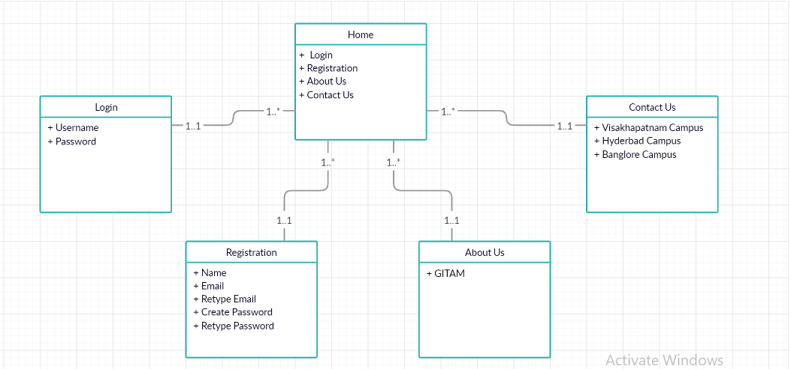

* **Classes in above diagram are:**

1. **Home**
2. **Login**
3. **Registration**
4. **About Us**
5. **Contact Us**
   1. **Functional Requirements Specification Documents**
   * **Wire Frames:**

A wireframe is a schematic or blueprint that is useful for helping the programmers and designers to think and communicate about the structure of the software or website you are building.

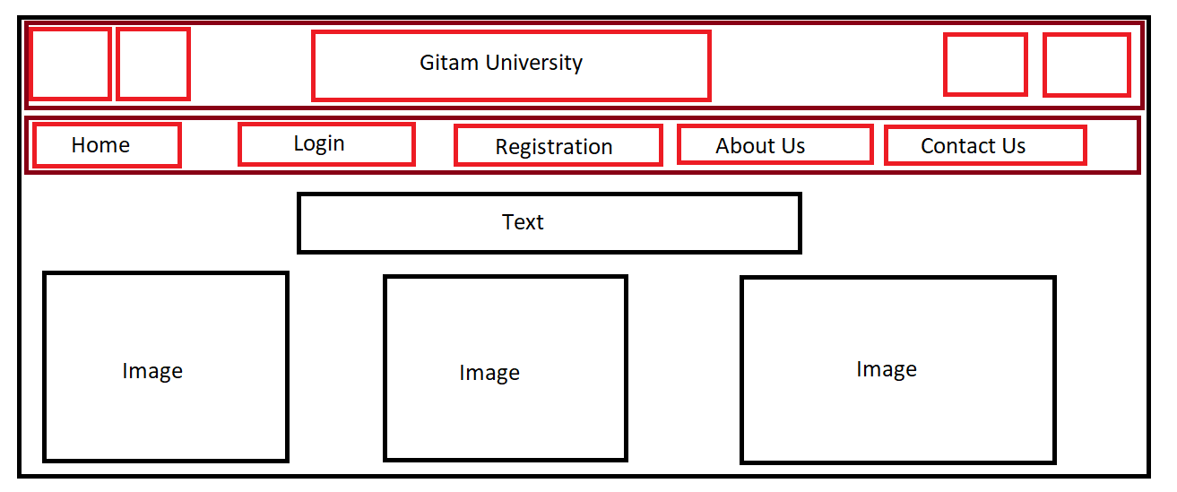

The following wireframe is the homepage of GITAM website. It has subpages such as HOME, LOGIN, REGISTRATION, ABOUT US, and CONTACT US. It also contains 3 images representing the 3 campuses of GITAM.

**Project Example:**

**HOME Page:**



This is the Home Page of GITAM, containing various subpages like LOGIN, REGISTRATION, ABOUT US, and CONTACT US. Also shows the 3 campuses of GITAM.

**LOGIN Page:**

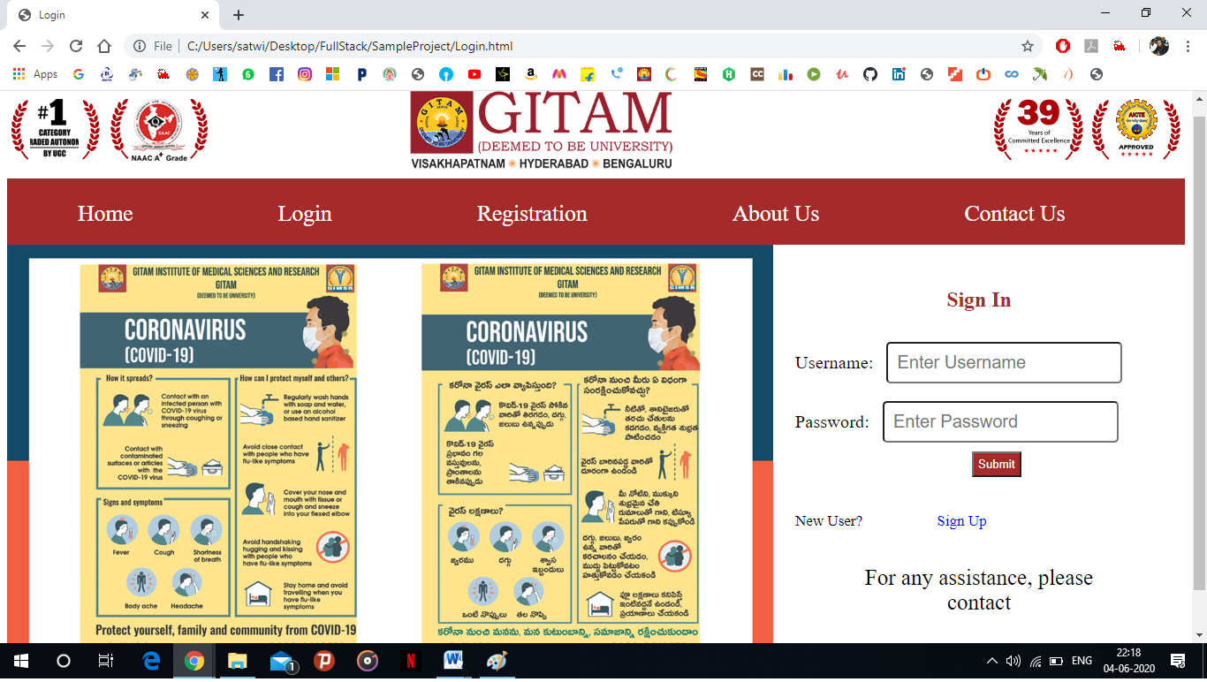

This is the LOGIN page of GITAM. Here the user has to specify his/her Username and Password. If the user is new he/she can Sign Up for GITAM portal.

**REGISTARTION Page:**

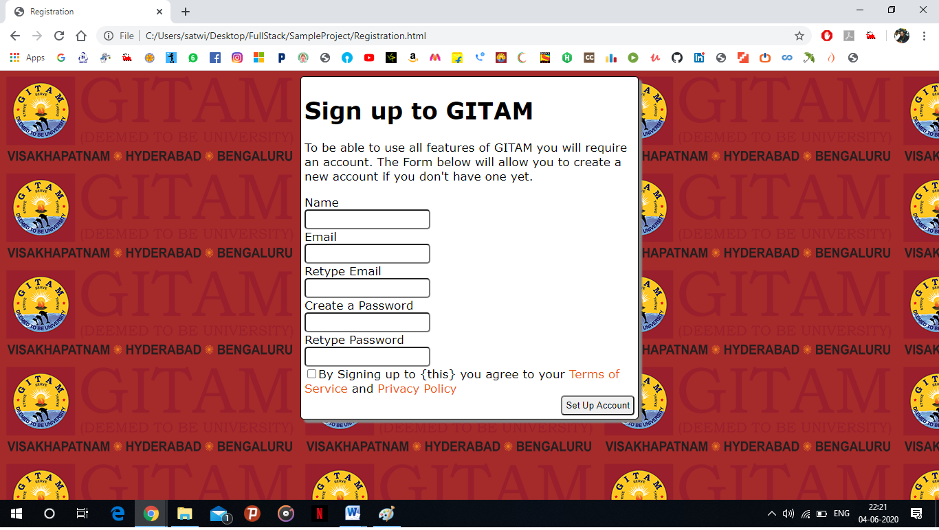

In this page the user can register for GITAM, by specifying his/her Name, Email and Password.

**ABOUT US Page:**



In this page you can get information about GITAM.

**CONTACT US Page:**

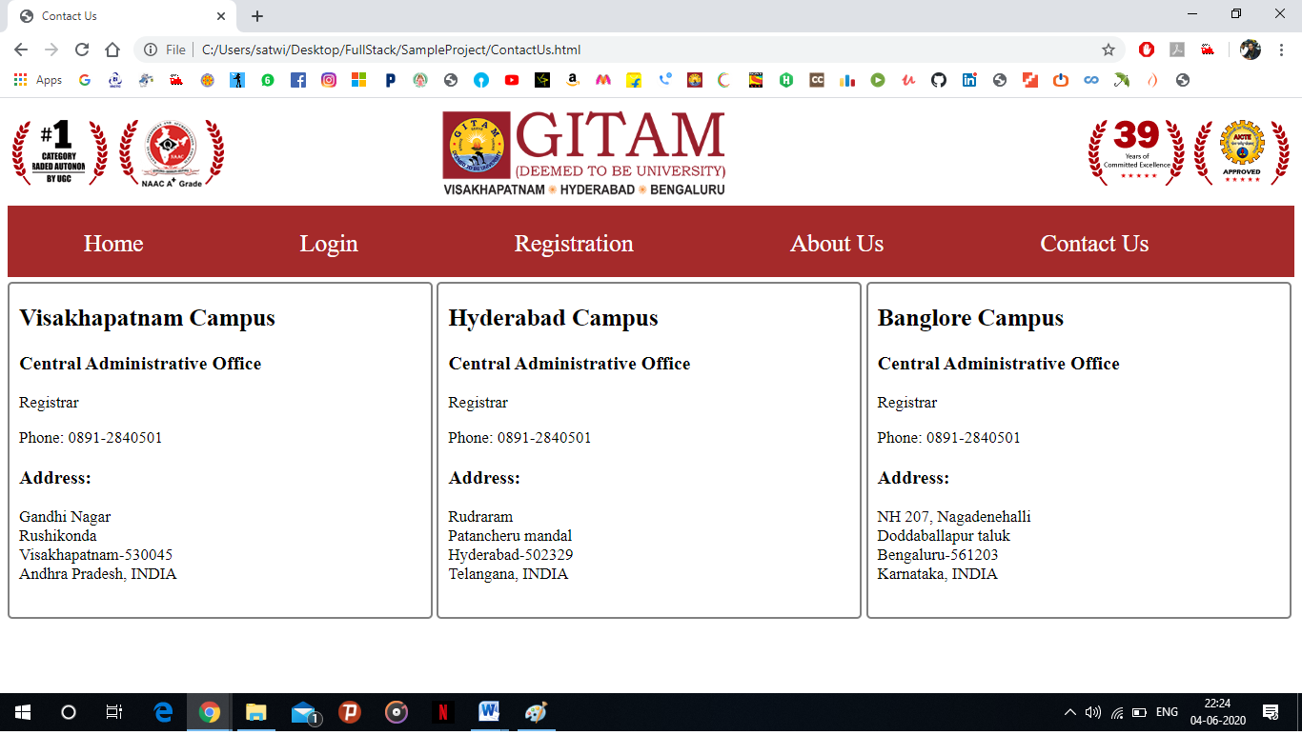

In this page one can get the contact details about all the 3 campuses of GITAM.