**Clustering-Based Speech Emotion Recognition by Incorporating Learned Features and Dee**

Importing required packages

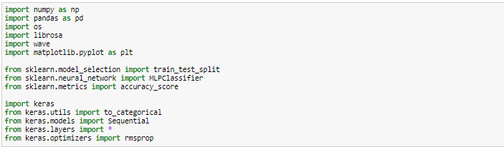

Generate lstm model

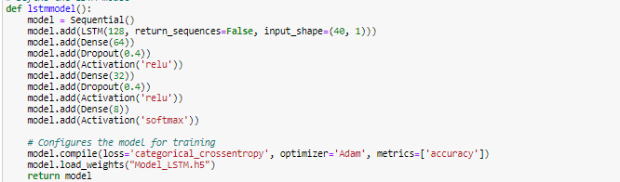

Extract the features

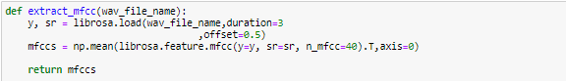

Upload the dataset



Applying the model to dataset and predict Speech Emotion Recognition



