PROJECT MARINER
  - Power-Sector Cyber Risk Intelligence for Insurance Underwriting
Concept proposal for internal evaluation • 29 October 2026

1. Executive summary

Project Mariner is a proposed decision-support product for insurers and brokers evaluating cyber and operational risk associated with power-sector organisations and renewable-energy portfolios. It combines authorised insured disclosures, asset/control evidence, public or licensed threat intelligence and exposure context into a traceable underwriting dossier. It does not claim to know a facility’s vulnerabilities from public data alone and does not replace specialist engineering surveys.

2. Insurance problem

Power-sector cyber insurance risk can span business interruption, physical damage, third-party liability, incident response, data loss, supply-chain dependencies and recovery failure. Insurers may receive uneven questionnaires and limited visibility into OT controls, asset criticality and recovery readiness. Public information can help screen exposure but cannot establish the control posture of a specific site.

3. Proposed solution

Mariner identifies the insured entity and asset scope, collects approved disclosures and evidence, enriches them with legitimate public/paid threat and company information, maps risk scenarios to potential loss pathways, records uncertainty, and produces an underwriter-reviewed summary. It supports—not automates—the underwriting decision.

4. Target users

- Commercial insurers writing cyber, property, energy, renewable-asset or business-interruption coverage.
- Reinsurers and specialty markets assessing portfolio accumulation and correlated power-sector exposures.
- Insurance brokers and risk engineering teams preparing consistent submissions.
- Utilities, independent power producers, solar/wind fleet owners and EPC/O&M organisations as assessed entities or data providers.

5. What data can be accessed, and how?
Data type | Potential access route | Use and limitation
Company/asset footprint | Websites, annual reports, regulator filings, public permits and licensed datasets | Identify disclosed assets/geographies; verify source and date.
Threat intelligence | CISA, NCSC, ENISA, CERTs, vendor advisories and licensed feeds | Map sector threats to disclosed asset/software classes; threat does not prove compromise.
Vulnerability data | NVD/CVE, vendor advisories and authorised scanner summaries | Map known issues to disclosed product/version; no active scanning without written authorisation.
Security controls | Insurer questionnaire, control attestations, ISO/SOC evidence or authorised assessment summaries | Record whether self-reported or independently assessed; do not infer unseen controls.
OT/ICS architecture | Customer-provided high-level diagrams, inventories and security assessment summaries | Formal authorisation, secure transfer, least privilege; no operational credentials.
Incident/loss history | Insured/broker submissions, claims and approved anonymised loss datasets | Apply confidentiality, privacy, retention and permitted-use controls.
Operational resilience | BCP, backup/recovery evidence, restoration tests and vendor dependencies | Distinguish document existence from successfully tested controls.
Grid/market context | Public grid operator reports, regulators, outage notices and approved datasets | Context only; do not infer facility compromise.
External exposure signals | Approved passive DNS/certificate metadata or licensed datasets after legal review | Preliminary screening only; verify ownership and false positives.

6. Data acquisition workflow
Insurer/broker submission + insured consent
↓
Entity resolution and asset scope confirmation
↓
Public/paid data enrichment + approved evidence uploads
↓
Provenance, freshness, confidence and data-quality checks
↓
Threat-to-exposure mapping + scenario analysis
↓
Underwriting dossier with uncertainty and missing evidence
↓
Human underwriter / risk engineer review

7. Insurance-relevant cyber scenarios
Scenario | Evidence to assess | Potential insurance relevance
Ransomware / IT-to-OT disruption | Segmentation, remote access, backups, incident response | Business interruption, response and restoration costs.
Vendor/remote-access compromise | MFA, privileged access, vendor access governance and logs | Operational disruption and third-party liability.
Control-system compromise | High-level architecture, patching/compensating controls, change management | Potential physical/operational consequences; specialist OT review required.
Loss of monitoring | Monitoring coverage, alert handling and response procedures | Detection delay and potentially longer incident duration.
Supply-chain dependency | Critical vendors, software lifecycle, vulnerability handling | Correlated exposure across insured portfolios.
Recovery failure | Tested recovery objectives, backup isolation and restoration evidence | Business interruption duration and restoration cost.

8. Risk analysis and outputs

- Exposure profile: sector, geography, asset type, operational criticality and disclosed dependencies.
- Control-evidence matrix: claimed control, evidence source/date, assurance level and gaps.
- Threat relevance: sector threats and vulnerability information mapped to disclosed technologies, with caveats.
- Scenario assessment: event pathway, potential impact dimensions, mitigating controls and uncertainty.
- Data confidence: freshness, completeness, source reliability and conflicting evidence.
- Underwriter dossier: risk summary, follow-up questions, evidence gaps and human-reviewed risk tier.

Do not present a numeric score as an actuarially validated probability or expected loss unless supported by suitable claims/loss data, model validation, calibration and actuarial review.

9. Technology architecture

Layer | Candidate stack | Purpose
Ingestion | Python, FastAPI, secure file upload, approved APIs | Collect disclosures and public/authorised data.
Entity resolution | Python matching rules, PostgreSQL | Resolve company/site/vendor identity and confidence.
Knowledge store | PostgreSQL; graph store only if justified | Store assets, dependencies, controls, findings and provenance.
Threat enrichment | Approved feeds and public advisories | Map threat/vulnerability data to disclosed technology.
Risk engine | Rules and scenario matrices; calibrated models only if data supports | Explainable assessment; separate evidence from inference.
LLM layer | Approved LLM with retrieval and source citations | Summarise evidence and draft questions; no autonomous underwriting.
UI/reporting | Streamlit for POC; enterprise UI later | Underwriter workspace and dossier.
Security | RBAC, encryption, tenant separation, audit and retention | Protect sensitive insured data.

10. POC plan

- Create a fictional solar operator submission with synthetic assets, controls, incident history and recovery evidence.
- Use a small curated set of public advisories plus synthetic vulnerability examples; do not scan real companies or facilities.
- Generate an evidence matrix with source, date, confidence and applicability.
- Assess 3–5 scenarios such as ransomware-driven interruption, vendor remote-access compromise and delayed recovery.
- Produce a risk dossier with missing evidence and follow-up questions for human review.
- Measure traceability, false matches, completeness and reviewer time—not predictive loss accuracy without validated data.

11. Compliance, privacy and ethical boundaries

- Use public data within its terms and licensed feeds within contract terms.
- Obtain written permission for insured technical data and any security testing; no active scanning in the POC.
- Minimise personal and sensitive infrastructure data; encrypt, restrict access, set retention and maintain audit logs.
- Separate verified fact, self-attestation, independent assessment, model inference and unknowns.
- Do not expose detailed site vulnerabilities to unauthorised parties.
- Require underwriter, actuarial and OT-risk-engineering review before use in pricing, coverage or binding terms.
- Review applicable insurance, privacy, cybersecurity, model-risk and cross-border data rules with qualified specialists.

12. Commercial model and validation

Potential models include per-submission assessment fees, annual insurer/broker subscriptions, portfolio monitoring and risk-engineering support. Pricing, market size, data licensing and willingness to pay are unvalidated. Interview underwriters, cyber risk engineers, brokers and renewable-asset owners before expanding beyond a synthetic-data prototype.

13. Differentiation and risks

Mariner’s proposed differentiator is a power-sector-specific evidence-provenance workflow that maps cyber threats and control evidence to insurance-relevant scenarios and data gaps. It is not a vulnerability scanner, threat-intelligence feed or actuarial model by itself. Public data can be stale or misattributed; cyber threat relevance does not equal compromise or quantified loss probability; and underwriting models require actuarial governance.

14. IdeaTank submission summary

Project Mariner is a proposed power-sector cyber-risk intelligence platform for insurers and brokers. It combines authorised insured disclosures, asset/control evidence and legitimate public or licensed threat intelligence to create source-traceable underwriting dossiers for utilities and renewable-energy portfolios. It maps relevant cyber scenarios to potential business-interruption and operational consequences, highlights missing evidence and supports underwriter review. The initial POC uses fictional data and curated public advisories; it does not scan live infrastructure or claim actuarially validated loss prediction.

15. Initial reference sources

- CISA Known Exploited Vulnerabilities Catalog: https://www.cisa.gov/known-exploited-vulnerabilities-catalog
- NIST National Vulnerability Database: https://nvd.nist.gov/
- ENISA publications and threat landscape: https://www.enisa.europa.eu/
- NIST Cybersecurity Framework: https://www.nist.gov/cyberframework
- NIST AI Risk Management Framework: https://www.nist.gov/itl/ai-risk-management-framework

Underwriting Use Case — From Cyber Evidence to an Insurance Decision
Mariner is designed as an underwriting decision-support layer, not an autonomous accept/decline engine. It translates cyber and operational-resilience evidence into a structured view of insurability, key loss pathways, evidence gaps and follow-up questions for commercial insurance providers. The underwriter retains decision authority.

Target Insurance Products and Decisions
- Cyber insurance: assess ransomware, credential compromise, third-party access, incident response and recovery readiness.
- Property and business interruption (BI): examine cyber-triggered operational disruption, dependency concentration and plausible downtime pathways, subject to policy wording.
- Power/energy sector specialty covers: help structure risk engineering review for generation companies, renewable operators, transmission/distribution businesses and energy service providers.
- Renewal and portfolio review: compare evidence quality and risk drivers across renewal periods, insured entities or a portfolio—without presenting the output as a validated actuarial score unless calibrated and independently validated.

Proposed Underwriting Outputs
- Evidence-linked risk dossier: each material observation is tied to a source, timestamp, confidence level and relevance rationale.
- Scenario-based risk view: e.g., ransomware disrupting business systems used for dispatch coordination; compromise of a vendor remote-access path; loss of monitoring or delayed restoration. These are scenarios for review, not predictions that an attack will occur.
- Control-evidence map: identify whether MFA, privileged-access controls, segmentation, backups, restoration testing, incident response and vendor governance are documented, absent or unverified.
- Business-interruption pathway: map critical services and dependencies to potential outage duration drivers, recovery bottlenecks and concentration risks; avoid unsupported monetary loss estimates.
- Underwriter question pack: prioritized questions and evidence requests tailored to gaps in the submission.
- Decision support: configurable indicators such as 'refer to OT specialist', 'request evidence', or 'eligible for standard review'. These are workflow prompts, not binding underwriting decisions.
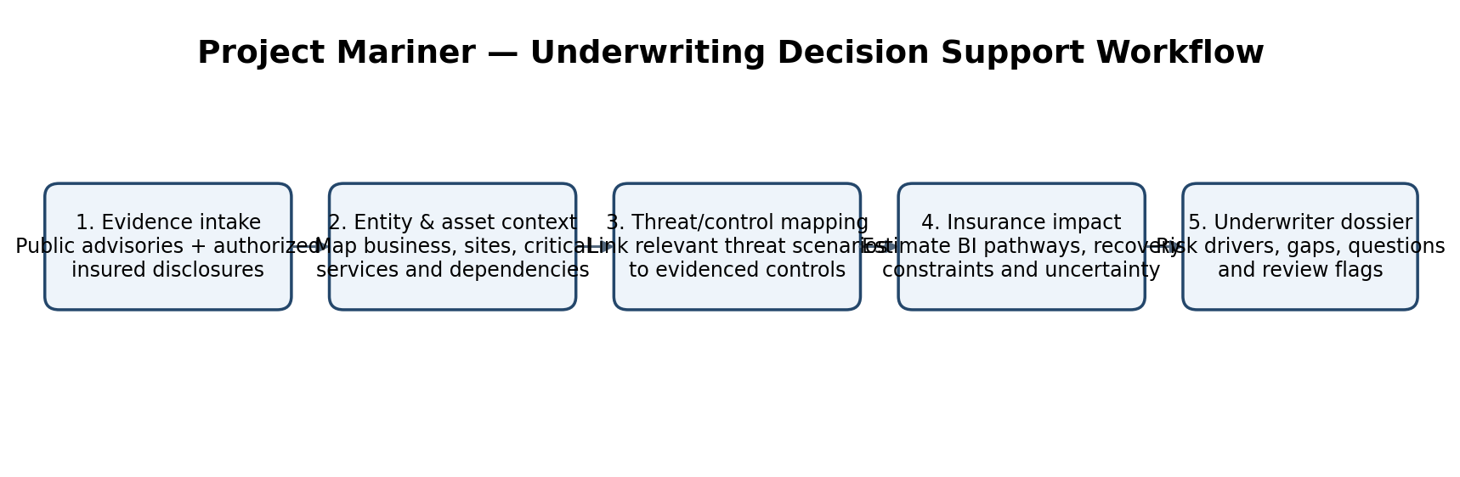

Data Access Strategy — Practical and Defensible
Mariner should begin with public information and synthetic/authorized evidence. It must not depend on privileged access to power infrastructure, and it should never actively scan live utility or energy OT networks as part of the MVP.

Potential Data Sources and Access Routes
Data category | Access route | Use and limitation
Public threat intelligence | CISA advisories/KEV, NVD/CVE, ENISA, national CERTs, vendor security advisories and public incident reports | Map disclosed vulnerabilities and threat techniques to relevant technologies; public data rarely proves that a specific insured is exposed.
Public company / sector context | Company websites, annual reports, regulatory filings, public procurement and regulator publications | Establish business model, sites, critical services and dependencies; coverage may be incomplete or out of date.
Insured-submitted evidence | Questionnaires, control attestations, architecture summaries, asset inventories, incident response plans and recovery-test summaries, supplied with authorization | Most useful for underwriting; validate ownership, date, completeness and supporting evidence.
Security assessment evidence | Customer-approved exports or reports from authorized vulnerability assessments, external attack-surface providers or security tools | Use only within written scope and contractual permissions; prefer summarized findings over raw sensitive telemetry.
Claims and loss data | Licensed insurer/claims datasets or anonymized customer-approved historical records | Potentially useful for calibration and validation; do not claim actuarial accuracy without sufficient data and governance.
Operational context | Public reliability reports, regulator/market-operator material and customer-authorized high-level dependency diagrams | Supports scenario context, not real-time operational monitoring or control.
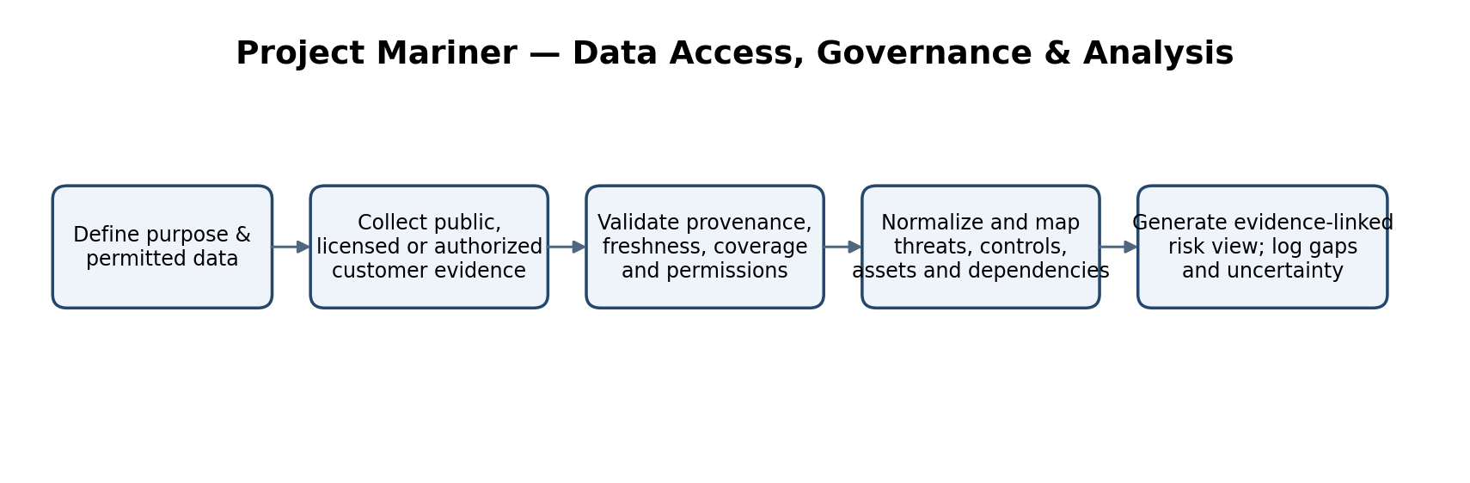

MVP Build Plan
- Phase 1 — Synthetic proof of concept: create fictional power-sector submissions for a solar operator, a generation company and a utility-like entity; curate a small set of public advisories; seed known evidence gaps and control weaknesses.
- Phase 2 — Evidence mapping: implement source capture, timestamping, entity/technology mapping, confidence labels and explainable scenario-to-control links.
- Phase 3 — Underwriter workbench: generate a concise risk dossier, follow-up questions, evidence-gap checklist and referral flags for human review.
- Phase 4 — Controlled pilot: use a small number of consenting insured submissions under legal, privacy, cybersecurity and model-risk review. Keep customer data segregated and access-logged.
- Phase 5 — Validation: compare outputs with experienced cyber underwriters and OT-risk engineers; measure evidence extraction accuracy, false-positive rate, usefulness of follow-up questions and time saved. Only add numeric risk scoring after defined calibration and validation.

Illustrative Underwriting Decision Flow
- Submission received → confirm scope, permissions and data completeness.
- Evidence mapped → identify relevant threats, controls and business dependencies.
- Material uncertainty found? If yes, request evidence or refer to cyber/OT-risk engineering; do not silently fill gaps with assumptions.
- Scenario review → consider plausible business interruption and recovery pathways against the actual coverage wording.
- Underwriter decision → accept, price, add conditions/exclusions, request further information or decline according to the insurer's own rules and authority.

Risk, Governance and Boundaries
- No unauthorized access, credential testing, active scanning or probing of real power-sector assets. Any technical assessment must be customer-authorized, contractually scoped and performed by approved specialists.
- Public vulnerability disclosure is not proof of exploitability at a specific insured. A generation anomaly is not proof of a cyberattack. Mariner must distinguish observed facts, inferences and unknowns.
- Do not expose detailed critical-infrastructure topology or sensitive OT information in broad-access reports. Apply least privilege, encryption, retention limits, audit logging and customer-specific data segregation.
- Human review is mandatory for material underwriting decisions. Provide explanations, source links, confidence, recency and correction/appeal paths.
- Model governance should include versioning, repeatable tests, drift monitoring, independent review and a documented process for handling stale or conflicting evidence.
- Any risk score is initially a prioritization aid, not a probability of loss or expected-loss estimate. Actuarial claims require appropriate licensed data, exposure definitions, calibration and validation.

Value Hypothesis and Commercial Model
Potential value to insurers includes faster triage of submissions, more consistent evidence review, better-targeted follow-up questions, clearer referral to specialist reviewers and more traceable underwriting files. These are hypotheses to test in a pilot—not demonstrated savings or guaranteed loss reduction.
- Possible commercial routes: per-submission assessment, annual underwriter-workbench subscription, portfolio/renewal review, or integration with an insurer's submission and policy workflow.
- Pilot measures: analyst time per submission, percentage of findings with traceable evidence, reviewer agreement, false-positive burden, missing-evidence detection, and underwriter-rated usefulness.
- Before commercialization: confirm insurer demand, data rights, legal/regulatory constraints, internal EXL overlap, security architecture, procurement requirements and willingness to pay.

Illustrative Report Structure for an Insurer
- Executive view: sector/entity context, scope and evidence coverage.
- Key risk drivers: only evidence-backed items, ranked by relevance and confidence.
- Scenario analysis: threat → exposed dependency/control gap → possible operational consequence → insurance-relevant questions.
- Controls and recovery: evidence status for access control, segmentation, backup/restore, incident response, vendor access and exercises.
- Open questions: prioritized evidence requests and specialist referral triggers.
- Limitations: data freshness, blind spots, assumptions, confidence and items not assessed.

