**D.Tej kiran**

**192110625**

**Experiment-5**

Create a simple cloud software application for Library book reservation system for SIMATS library using any Cloud Service Provider to demonstrate SaaS

**IMPLEMENTATION:**

**Step-1:**

Go to zoho.com.

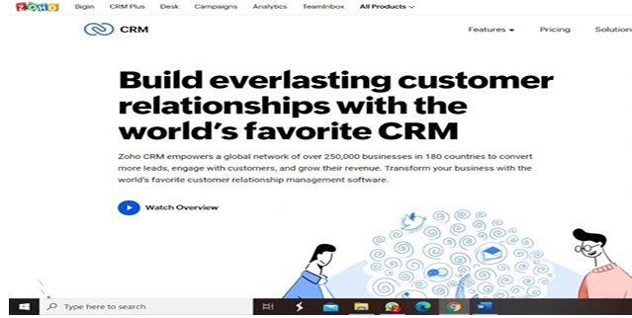

**Step-2:**

Log into the zoho.com

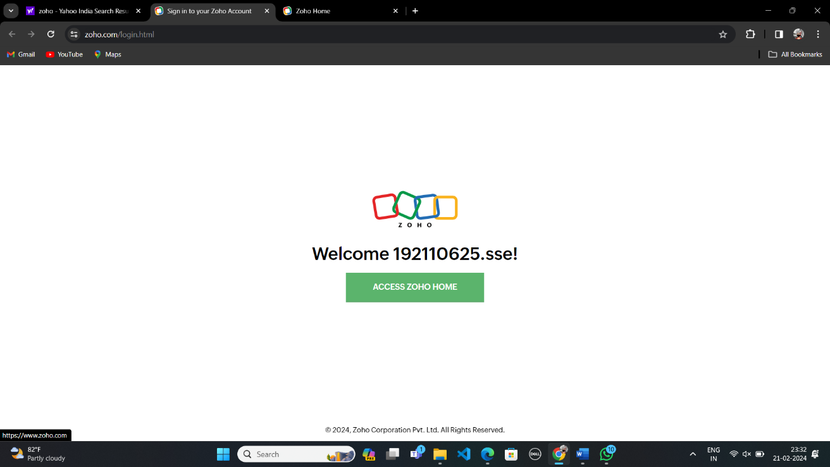

**Step-3:**

Select one application step.

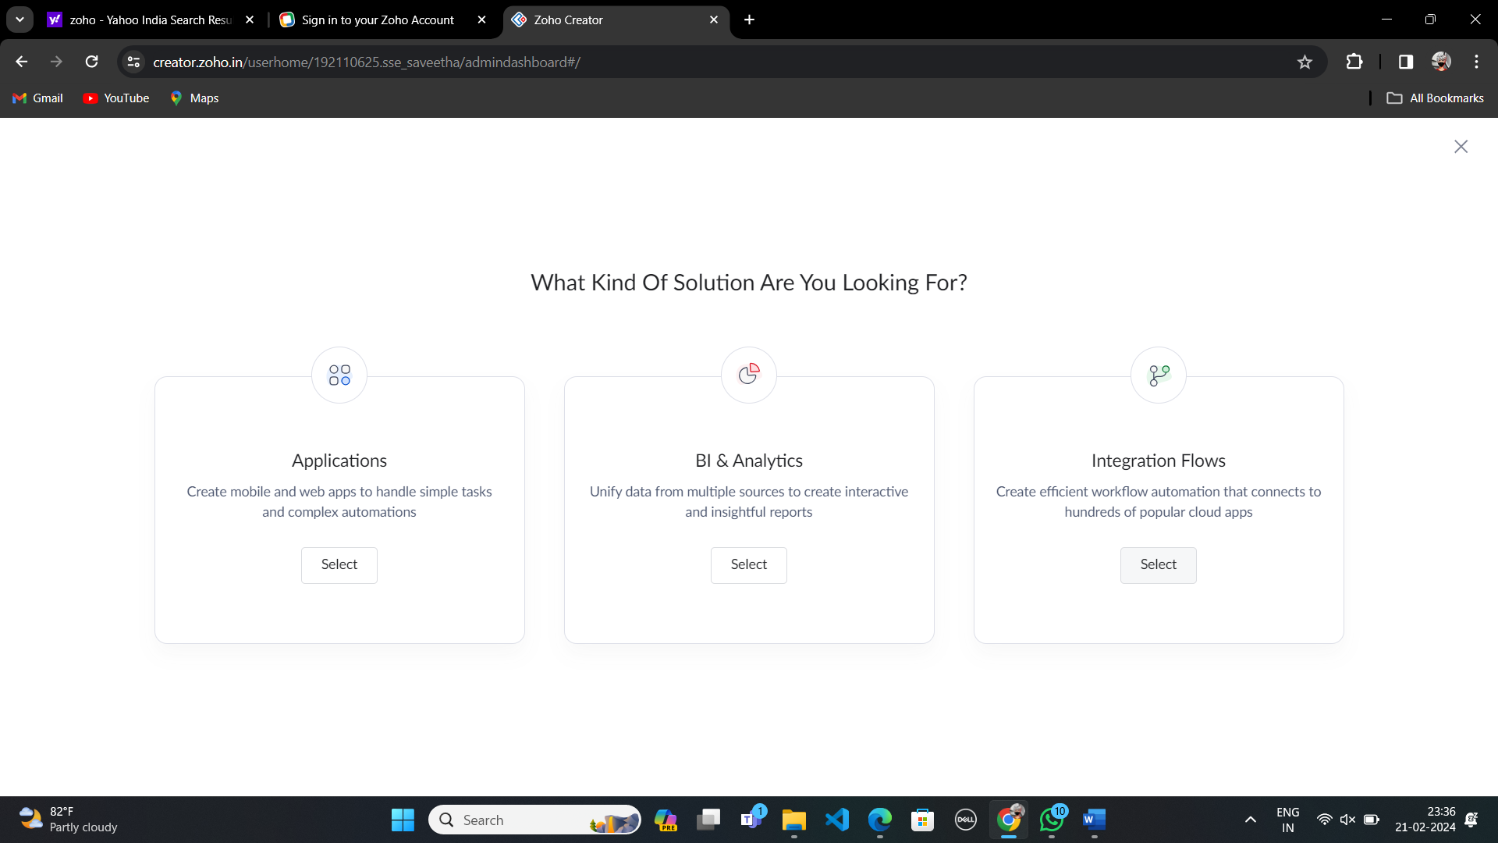

**Step-4:**

Enter application name as SIMATS LIBRARY.

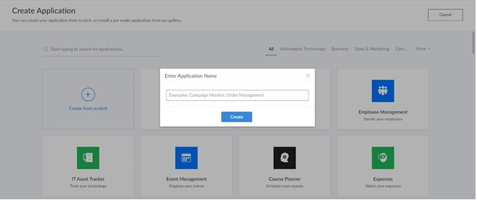

**Step-5:**

Created new application flight reservation system.

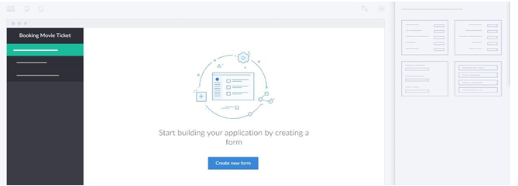

**Step-6:**

Select one form.

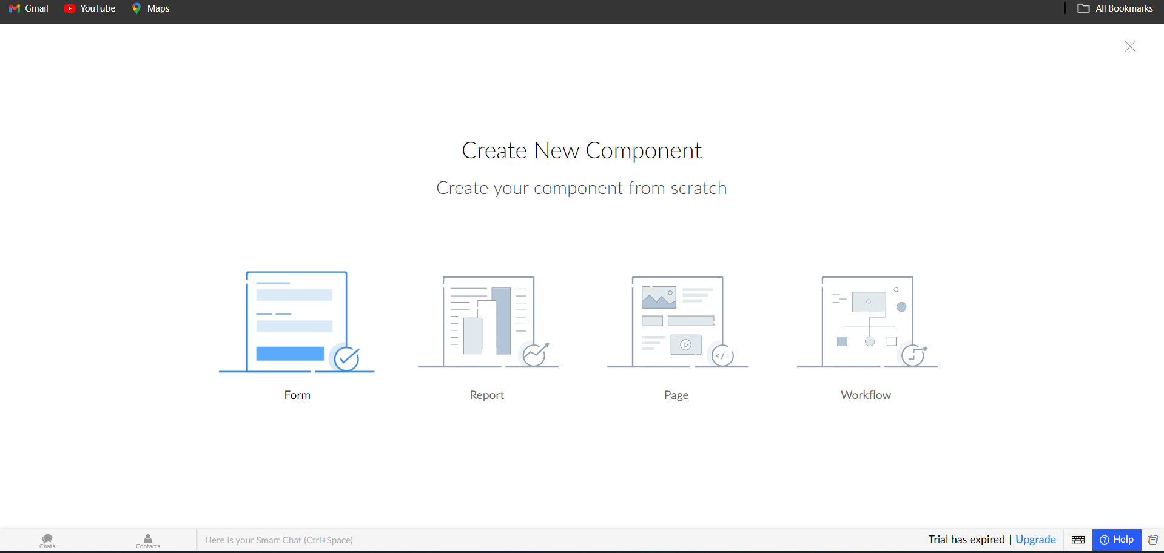

**Step-7:**

Enter name form name as Student info.

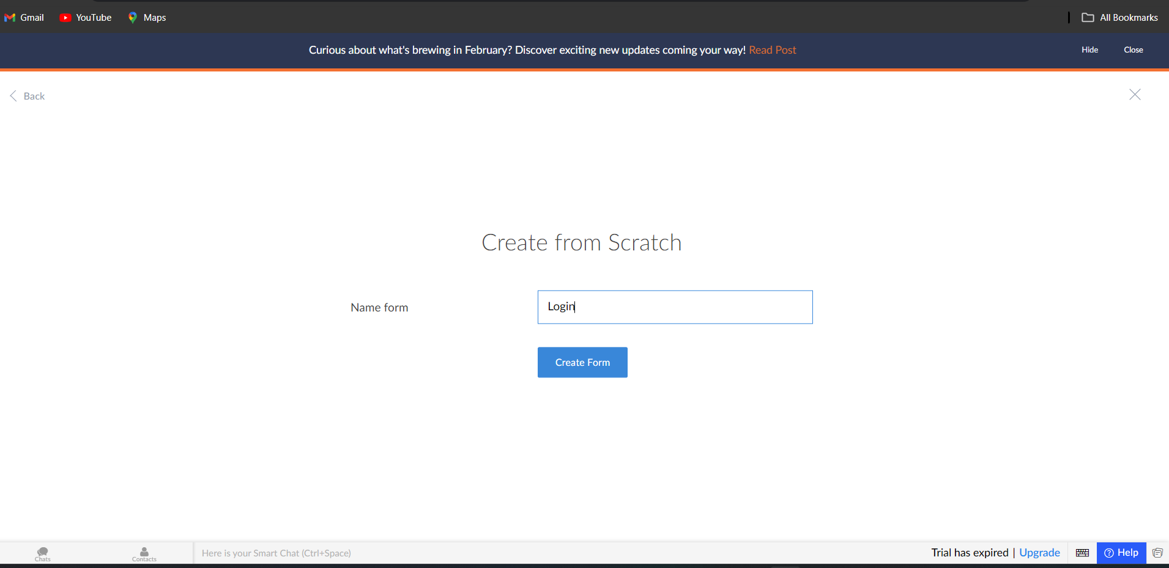

**Step-8:**

Create Student Info form.

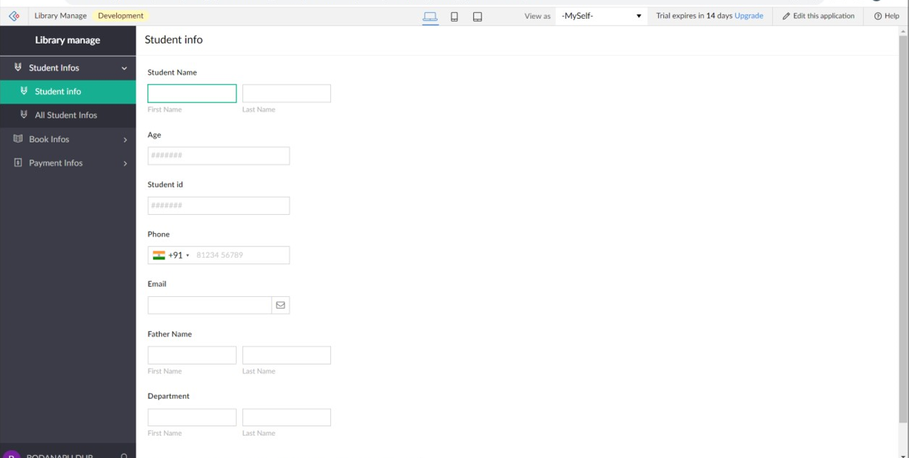

**Step-9:**

Create a new form and name it as Book info.

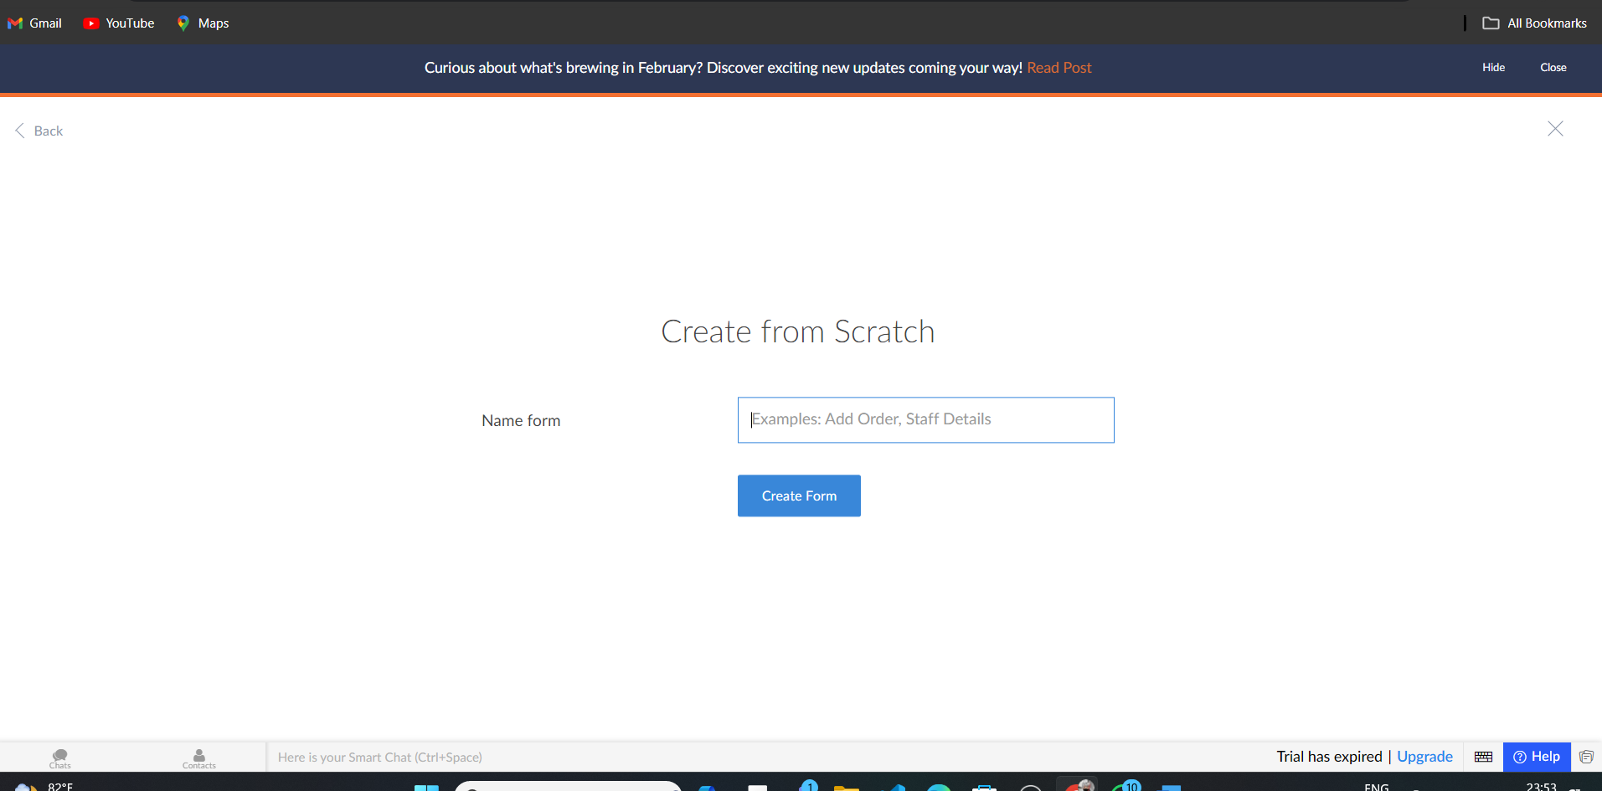

**Step-10:**

Create Book info form.

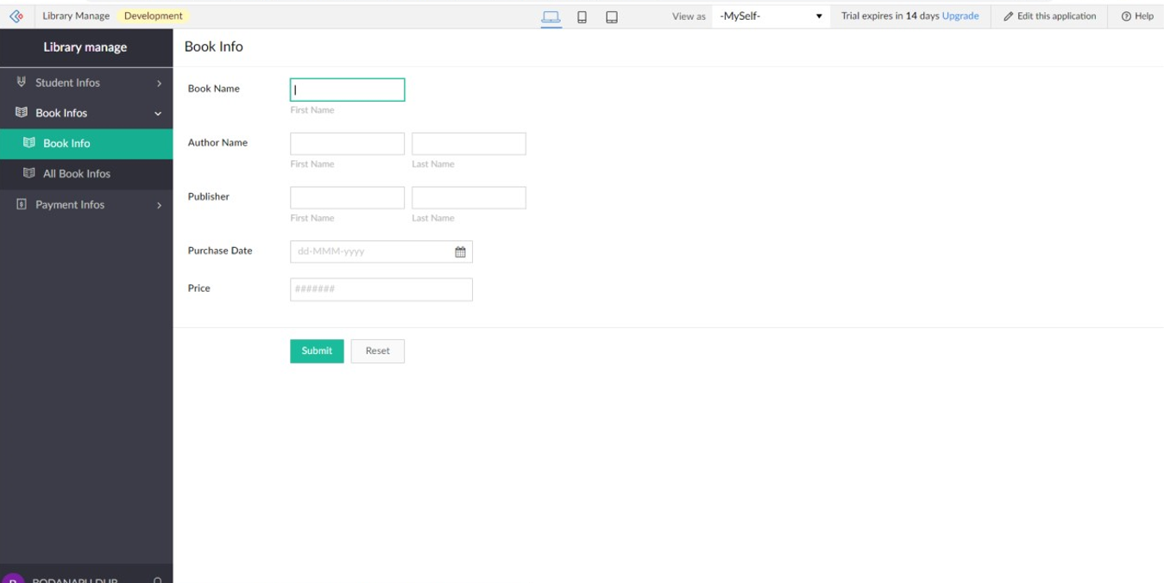

**Step-11:**

Create a new form and name it asPayment info.



**Step-12:**

Create payment info form.

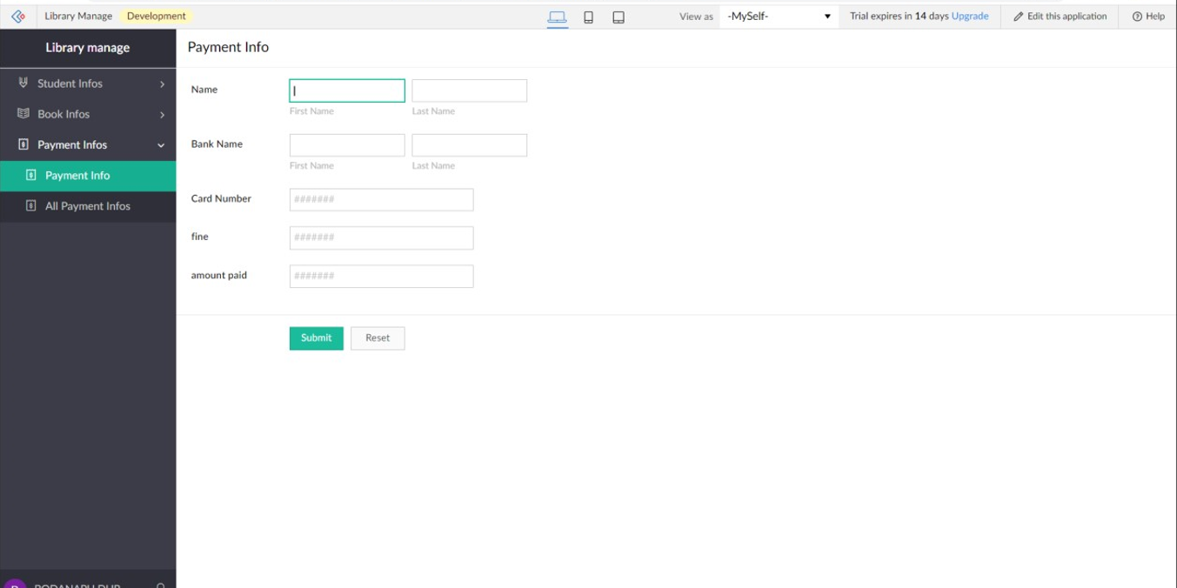

**Final form**

