EXP NO: 25  DECIMAL TO BINARY CONVERSION   
**AIM:**To write a C program to implement decimal to binary conversion.  
**ALGORITHM:**  
1) Check if your number is odd or even.  
2)  If it's even, write 0 (proceeding backwards, adding binary digits to the left of the result).   
3)   Otherwise, if it's odd, write 1 (in the same way).  
4)   Divide your number by 2 (dropping any fraction) and go back to step 1. Repeat until your original number is 0.   
**PROGRAM:**  
#include<stdio.h>     
#include<stdlib.h>   
int  
main()  
  
  
{   
  
  
int  
a[10],n,i;     
  
  
printf("Enter  
the number to convert: ");     
  
  
scanf("%d",&n);     
  
  
for(i=0;n>0;i++)     
  
  
{     
  
  
a[i]=n%2;     
  
  
n=n/2;     
  
  
}     
  
  
printf("\nBinary  
of Given Number is=");     
  
  
for(i=i-1;i>=0;i--)     
  
  
{     
  
  
printf("%d",a[i]);     
  
  
}     
  
  
return  
0;   
  
  
}  
**INPUT:**&**OUTPUT:**

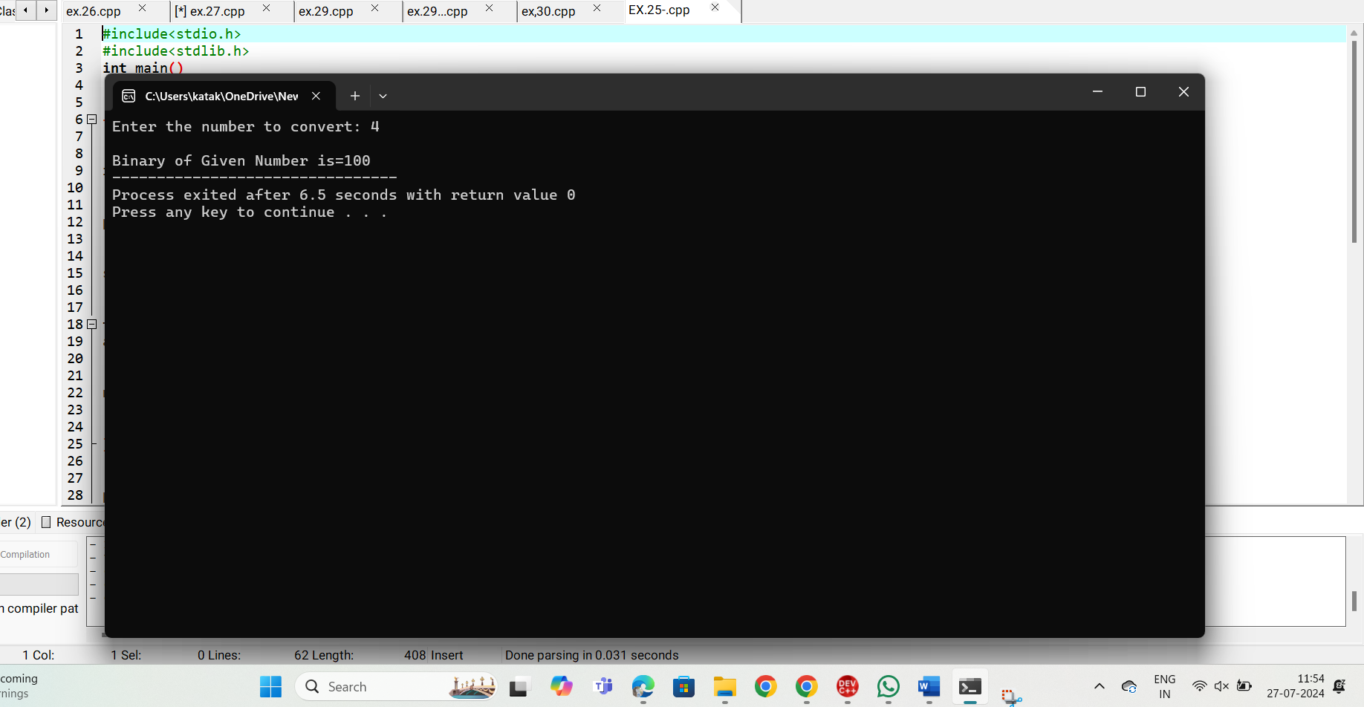  
  
**RESULT:**Thus the program was executed successfully using DevC++.