**CPU PERFORMANCE**  
**EXP NO: 32**  
**AIM:**To write a C program to implement CPU performance measures.  
**ALGORITHM:**  
Step 1: start   
Step 2:Declare the necessary variables: cr  
(clock rate), p (number of processors), p1 (a copy of the number of  
processors), i (loop variable), and cpu (array to store CPU times).  
  
  
Step 3: Initialize the cpu array elements to 0.  
Step 4: Prompt the user to enter the number of processors (p).  
Step 5: Store the value of p in p1.  
Step 6: Start a loop from 0 to p-1:  
      a. Prompt the user to enter the cycles per instruction (cpi) for the current processor.  
      b. Prompt the user to enter the clock rate (cr) in GHz for the current processor.  
      c. Calculate the CPU time (ct) using the formula: ct = 1000 * cpi / cr.  
      d. Display the CPU time for the current processor.  
      e. Store the CPU time in the cpu array at index i.  
Step 7: Set max as the first element of the cpu array.  
Step 8:Start a loop from 0 to p1-1:  
      a. If the CPU time at index i is less than or equal to max, update max to the current CPU time.  
Step 9: Display the processor with the lowest execution time (max).  
Step 10: Exit the program.   
**PROGRAM:**  
  #include <stdio.h>  
int  
main()  
  
  
{  
  
  
  float cr;  
  
  
  int p,p1,i;  
  
  
  float cpu[5];  
  
  
  float cpi,ct,max;  
  
  
  int n=1000;  
  
  
  for(i=0;i<=4;i++)  
  
  
  {  
  
  
      cpu[5]=0;  
  
  
  }  
  
  
  printf("\n Enter the number of processors:");  
  
  
  scanf("%d",&p);  
  
  
  p1=p;  
  
  
  for(i=0;i<p;i++)  
  
  
{  
  
  
    printf("\n Enter the Cycles per  
Instrcution of processor:");  
  
  
  scanf("%f",&cpi);  
  
  
  printf("\n Enter the clockrate in  
GHz:");  
  
  
  scanf("%f",&cr);  
  
  
  ct=1000*cpi/cr;  
  
  
  printf("The CPU time is: %f",ct);  
  
  
  cpu[i]=ct;  
  
  
}  
  
  
max=cpu[0];  
  
  
for(i=0;i<p1;i++)  
  
  
{  
  
  
    if(cpu[i]<=max)  
  
  
    max=cpu[i];  
  
  
}  
  
  
printf("\n  
The processor has lowest Execution time is: %f ", max);  
  
  
    return 0;  
  
  
}  
**INPUT & OUTPUT:**

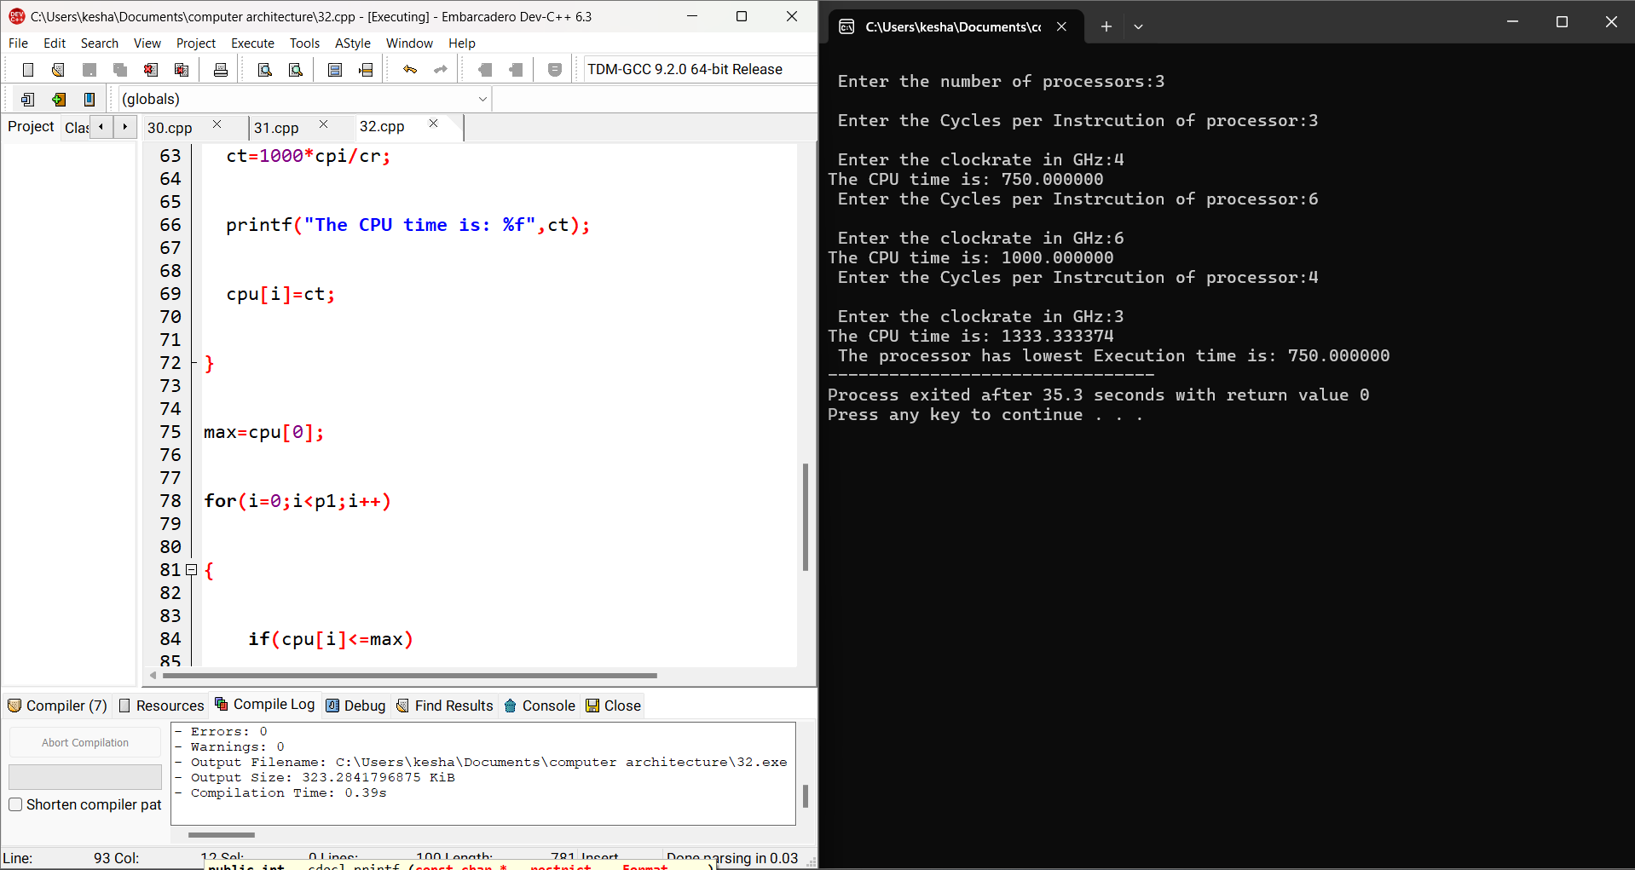  
**RESULT:**Thus the program was executed successfully using DevC++.    
.