Introduction

This document provides the requirement specifications for Bike Loan Portal which are required to understand the specifications and implement the functionality as required.

Scope

The scope of this application is built to help the users get Bike Loan Service. In this platform users will have access to apply for loan after making their profile.

Actors

* User
* Admin

Business Understanding

This application will have Admin and User side, both having different functions.

|  |  |
| --- | --- |
| Admin Functions | User Functions |
| Admin Login | User Login |
| Admin Signup | User Signup |
| View Loan | Add Profile |
| Edit Loan | View Profile |
| View Loan | Edit Profile |
| Delete Loan | Delete Profile |
|  | Add Documents |
|  | View Documents |
|  | Edit Documents |
|  | Delete Documents |
|  | Apply New Loan |
|  | View Applied Loan |
|  | Edit Loan |
|  | Delete Loan |

Technology Stack

|  |  |  |
| --- | --- | --- |
| Development | Framework | Version |
| Front End | Angular | 10+ |
| Server Side | Spring Boot | 2 |
| Database | MySQL | 8 |

**Use Case Diagram**

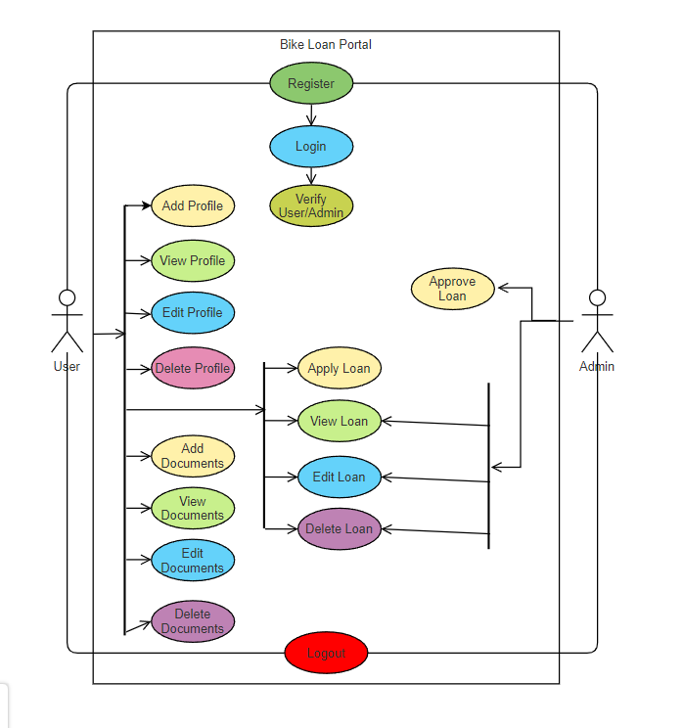

**Activity Diagram**

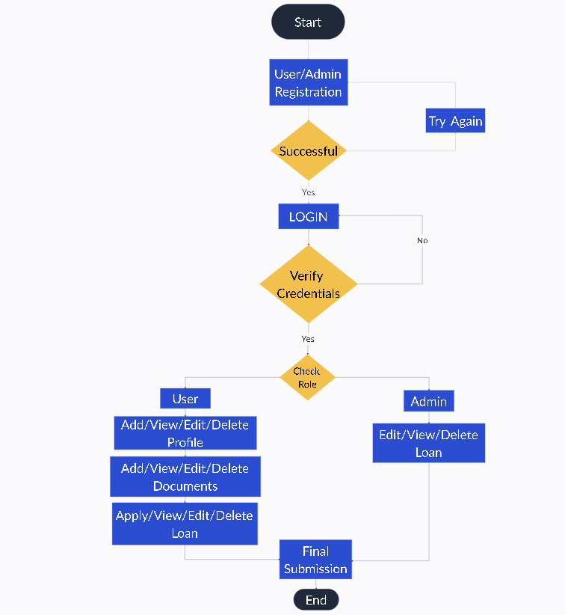

**State Diagram**

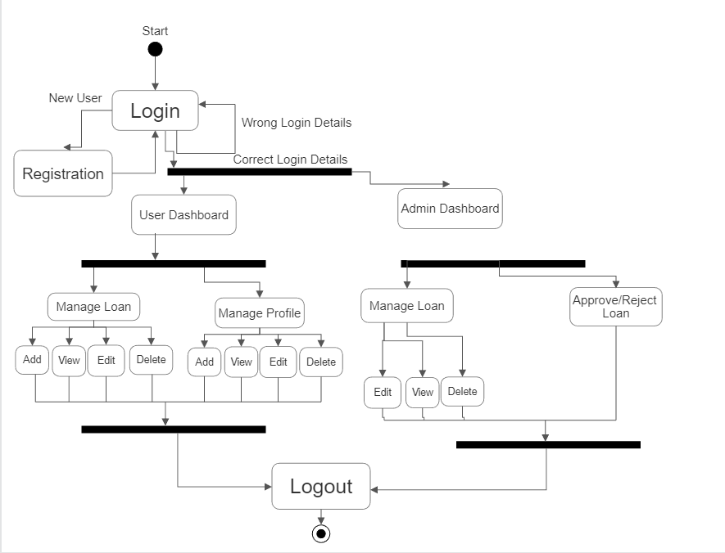

**Sequence Diagram**

1. Admin

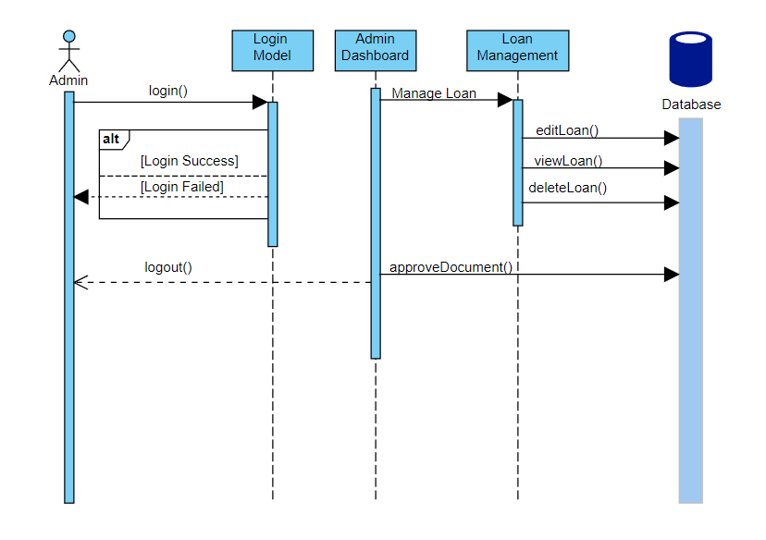

1. User

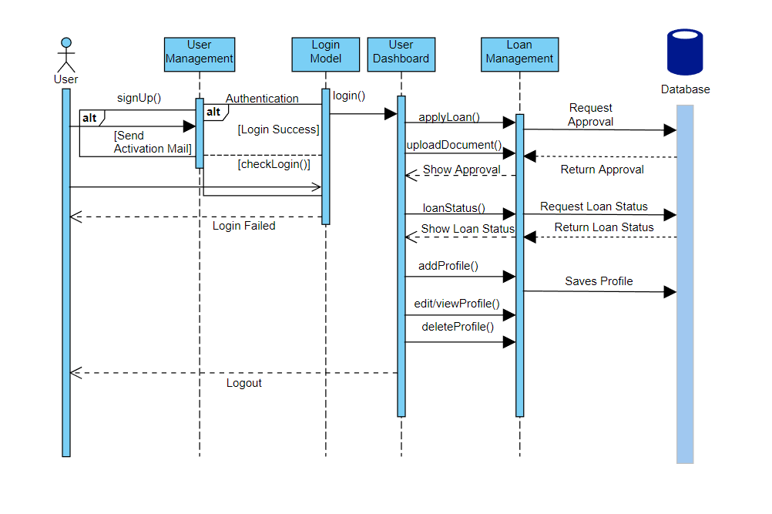

**ER Diagram**

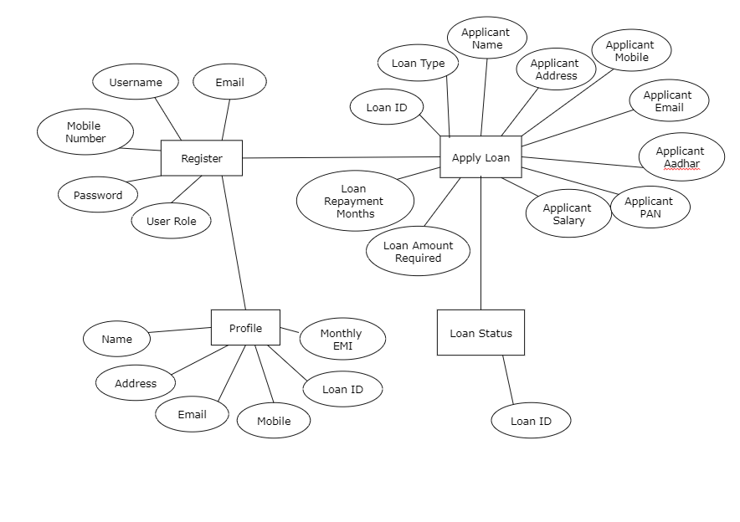

**Database Diagram**