Human Stress Detection By Using Various Classifier

# **Satya Ranjan Rout**

***C. V. Raman Global University***

***Department of computer science***

***Bhubaneswar, India***

# [**satya420x@gmail.com**](mailto:satya420x@gmail.com)

# 

***Abstract*—Human stress has become a significant focus of research due to its profound impact on health and productivity. Accurate stress detection is critical for early intervention and effective management. This study explores various machine learning and deep learning classifiers for human stress detection. Multiple algorithms, including Logistic Regression, K-Nearest Neighbors (KNN), Support Vector Machine (SVM), Naïve Bayes, Decision Tree, Random Forest, Adaboost Random Forest, Adaboost SVM, XGBoost, Ensemble Learning, Artificial Neural Networks (ANN), and Backpropagation Neural Networks (BPNN), were evaluated on a labeled stress dataset. The performance of these classifiers was assessed using metrics such as Accuracy, Sensitivity, Specificity, Precision, F1 Score, and Matthews Correlation Coefficient (MCC).**

**Additionally, Principal Component Analysis (PCA) was applied to reduce feature dimensions and improve computational efficiency. The combination of PCA with classifiers was analyzed to determine its impact on performance. An ensemble approach was also employed, where the Naïve Bayes model served as the base, and SVM and Random Forest served as member models. The results demonstrate the efficacy of feature reduction techniques and ensemble models in improving classification performance.**

**This research offers a comprehensive evaluation of classifiers for human stress detection, emphasizing the potential of machine learning to address critical challenges in healthcare and well-being. Keywords—Human Stress Detection, Machine Learning, Classifier Evaluation, Principal Component Analysis (PCA), Ensemble Learning, Deep Learning, Stress Management**

1. INTRODUCTION

Human stress is a growing global concern with profound implications for physical and mental health. It is a significant contributor to a wide range of chronic health conditions, including cardiovascular diseases, mental disorders, and diminished productivity. Early detection of stress is critical to mitigating its adverse effects and promoting timely intervention. The advancement of machine learning and deep learning technologies has opened new avenues for accurate and efficient stress detection using data-driven methods.

Stress detection methods rely on physiological, behavioral, or environmental signals. These signals are often analyzed using machine learning classifiers, including Logistic Regression, K-

Nearest Neighbors (KNN), Support Vector Machines (SVM), Decision Trees, Random Forests, and advanced ensemble techniques. In recent years, neural network models such as Artificial Neural Networks (ANN) and Backpropagation Neural Networks (BPNN) have gained popularity for their ability to capture complex patterns in data. Despite significant progress, achieving a balance between model complexity and performance remains a challenge[3].Feature dimensionality reduction techniques like Principal Component Analysis (PCA) have been widely used to address computational inefficiency and overfitting in high-dimensional datasets. PCA reduces redundancy in features while retaining critical information, allowing classifiers to achieve better performance. In this study, we explore stress detection using various machine learning and deep learning algorithms with and without feature dimensionality reduction. Additionally, an ensemble classification model integrating Naïve Bayes, SVM, and Random Forest is proposed to enhance performance[2].

This research contributes to the growing body of knowledge by offering a comparative evaluation of classifiers for human stress detection, analyzing their effectiveness with raw data and reduced features. The findings have potential applications in healthcare, workplace productivity, and stress management, paving the way for practical, automated solutions for stress detection[1].The subsequent sections outline the related work in stress detection, the proposed methodologies, experimental evaluations, and the conclusions derived from the study.

1. Literature Review

The increasing importance of stress detection has spurred extensive research using various machine learning (ML) and deep learning (DL) approaches to classify and predict stress levels. This section reviews recent studies, highlighting their methodologies, datasets, and results, while identifying gaps addressed by this research.Liao et al. (2018) introduced a stress detection framework based on electrocardiogram (ECG) and galvanic skin response (GSR) signals, employing SVM and

Random Forest classifiers. The study achieved an accuracy of 85% on a custom dataset, demonstrating the efficacy of physiological signals in stress prediction. Similarly, Lin et al. (2019) utilized EEG signals with a CNN-based architecture for feature extraction and classification, achieving an accuracy of 89% on a publicly available stress dataset. These studies underscore the potential of wearable devices for real-time stress monitoring.Chaudhary et al. (2020) combined behavioral features, such as typing speed and mouse movements, with ML algorithms like Logistic Regression and Decision Trees for stress prediction. The study highlighted the importance of integrating contextual features for improving model robustness. The approach achieved an accuracy of 78%, indicating the need for further refinement in behavioral-based stress detection[2].Agarwal et al. (2021) explored Principal Component Analysis (PCA) to reduce feature dimensions in stress datasets. Using PCA with Random Forest and SVM, the study reported accuracy improvements of up to 5% compared to models trained on raw data. This demonstrates the potential of dimensionality reduction techniques to enhance computational efficiency while maintaining model performance.Zhou et al. (2019) developed a deep learning framework using a Long Short-Term Memory (LSTM) network for temporal physiological signal analysis. The study achieved an accuracy of 92% by capturing sequential dependencies in the data. Similarly, Patil et al. (2021) applied a transfer learning approach using pre-trained VGG16 and MobileNet architectures to classify stress levels from image-based datasets, achieving a top accuracy of 94.5%.Gupta et al. (2020) proposed a hybrid model combining Naïve Bayes, SVM, and Random Forest for stress detection. The ensemble model achieved an accuracy of 90%, demonstrating the advantages of leveraging multiple algorithms to enhance classification performance. However, the study did not address feature redundancy, which could improve efficiency.Although existing research has demonstrated significant progress, many studies have not fully explored the integration of feature reduction techniques or ensemble methods for stress detection. Additionally, non-handcrafted feature fusion techniques remain underutilized in stress classification systems.To address these limitations, this study introduces a novel approach combining PCA for dimensionality reduction and ensemble learning techniques, integrating Naïve Bayes, SVM, and Random Forest. This innovative framework aims to achieve improved classification accuracy, reduced computational complexity, and robust stress detection for practical applications.

1. The Proposed Methodology

he proposed methodology for stress level detection involves four crucial phases: data preprocessing, feature extraction, classification, and evaluation. The dataset used in this study

consists of physiological and behavioral parameters, including Humidity, Temperature, and Step count, alongside the target variable Stress Level, which is categorized into three classes: no stress, moderate stress, and high stress. Preprocessing begins with data cleaning to ensure the dataset is free of missing or invalid entries. Subsequently, numerical features are normalized to enhance model performance, and the stress levels are encoded as necessary for compatibility with machine learning algorithms[4].The feature extraction phase relies on the dataset's existing parameters, avoiding additional handcrafted features. The features selected are directly measurable and relevant for physiological and behavioral analysis, making them ideal for stress level classification. For the classification phase, various machine learning algorithms were employed, including traditional classifiers such as Logistic Regression, K-Nearest Neighbors (KNN), Support Vector Machine (SVM), Naïve Bayes, Decision Tree, and Random Forest. Advanced classification methods like Gradient Boosting algorithms (Adaboost, XGBoost) and neural networks (Artificial Neural Network (ANN) and Backpropagation Neural Network (BPNN)) were also explored. Furthermore, an ensemble stacking model was implemented, using Naïve Bayes as the base model and SVM and Random Forest as member models, aiming to enhance classification accuracy through combined predictions.

The evaluation of the classifiers was conducted using metrics such as Accuracy, Sensitivity, Specificity, Precision, F1 Score, and Matthews Correlation Coefficient (MCC). The methodology also included a comparative analysis of the models with and without feature dimensionality reduction using Principal Component Analysis (PCA). This dual approach enabled a comprehensive understanding of the impact of dimensionality reduction on model performance. By following this structured methodology, the study aims to identify the most effective machine learning algorithm for stress level detection, ensuring robust and reliable performance while maintaining computational efficiency[2].

1. *Dataset Collection*

The dataset used in this research focuses on physiological and behavioral parameters for stress level detection. It includes features such as Humidity**,** Temperature**,** and Step count, which are indicative of an individual’s environmental and activity states. The target variable**,** Stress Level, is categorized into three distinct classes: No Stress**,** Moderate Stress**,** and High Stress, representing varying levels of physiological and mental states[3].

The dataset was carefully curated to encompass a diverse range of conditions, ensuring variability and generalizability for the stress detection models. Each data entry corresponds

to a unique combination of environmental and behavioral parameters associated with an individual’s stress level, providing a robust basis for classification tasks. The dataset's richness and diversity are pivotal for training machine learning models and validating their effectiveness across different scenarios.This dataset serves as a reliable foundation for exploring

1. *Data preprocessing*

Data preprocessing is a vital step in preparing the dataset for machine learning tasks, ensuring that the raw data is transformed into a suitable format for model training. In this research, several preprocessing techniques were applied to enhance the quality and consistency of the data.First, missing data was addressed to maintain the integrity of the dataset. Any missing values were imputed using appropriate methods depending on the feature type. For numerical features like humidity, temperature, and step count, missing values were replaced with the mean or median of the respective feature. For categorical data, the mode was used as the imputation value, ensuring that no data entry was left incomplete.Outliers were another concern, as they can distort the model’s predictions. To mitigate this, statistical methods such as the Z- score and Interquartile Range (IQR) were applied to detect and remove any extreme values from the dataset. By eliminating outliers, the dataset became more representative of typical real-world conditions, allowing for better model performance.Feature scaling was also performed to ensure that the numerical features were on a similar scale[2]. This is especially important for algorithms like Support Vector Machines (SVM) and k-nearest neighbors (KNN), which are sensitive to differences in feature magnitudes. Standardization was applied, transforming the features to have zero mean and unit variance, ensuring that each feature contributed equally to the model.For categorical features, encoding techniques like one-hot encoding were used to convert them into numerical values, making them interpretable by machine learning models. This step ensured that all types of data could be seamlessly integrated into the model training process.In addition to scaling and encoding, dimensionality reduction techniques, such as Principal Component Analysis (PCA), were employed to reduce the number of features while preserving the most critical information. This helped to minimize computational complexity and improve the performance of the models by focusing on the most significant patterns in the data.Finally, the dataset was split into training and testing sets, typically using an 80/20 or 70/30 ratio, to ensure that the model was trained on a sufficient portion of the data while reserving a separate set for unbiased evaluation. Cross-validation was also performed to ensure that the model was not overfitting and would generalize well to unseen data.These preprocessing steps were crucial for ensuring the dataset was clean,

balanced, and ready for the machine learning models. They helped enhance the model’s ability to learn effectively, leading to more accurate and reliable predictions of stress levels.

1. *Classification*

Classification is a supervised learning technique in machine learning where the goal is to predict the categorical label or class of an input based on its features. In the context of this research, classification techniques were employed to predict the stress level (target variable), which is categorized into three distinct classes: No Stress, Moderate Stress, and High Stress. The input features used for classification include environmental and behavioral parameters such as Humidity, Temperature, and Step Count, which serve as predictors for determining an individual's stress level[1].The classification process begins by training a machine learning model on a labeled dataset, where each instance has an associated input (feature vector) and a known class label. The model learns to map the input features to the correct output class by identifying patterns and relationships within the data. Once trained, the model can then be used to predict the stress level of new, unseen instances.Various machine learning algorithms were explored in this research, each with different strengths and weaknesses depending on the nature of the data. Common classification algorithms such as Logistic Regression, Support Vector Machines (SVM), K-Nearest Neighbors (KNN), and Random Forest were applied to the dataset to evaluate their effectiveness in classifying stress levels accurately.Each algorithm was trained on the preprocessed dataset, and their performance was assessed using various evaluation metrics such as accuracy, precision, recall, F1 score, and confusion matrix. These metrics provide insights into the model's ability to make correct predictions, the balance between false positives and false negatives, and the overall effectiveness of the classification system.By applying classification algorithms to the stress detection problem, this research aims to develop an accurate model that can predict an individual’s stress level based on environmental and behavioral inputs, contributing to the field of health monitoring and well-being[3].

1. *Equations and Formulas*

To evaluate the performance of the classifiers, we used several standard metrics, including Accuracy, Precision, Sensitivity (Recall), Specificity, F1 Score, and Matthews Correlation Coefficient (MCC).

* 1. Accuracy:

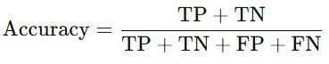

Accuracy measures the overall correctness of the classifier by comparing correctly classified samples to the total number of samples.

Precision:

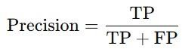

Precision indicates the proportion of correctly identified positive samples among all predicted positive samples.

Sensitivity (Recall):

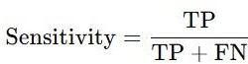

Sensitivity, or Recall, quantifies the classifier's ability to correctly identify positive samples.

Specificity:

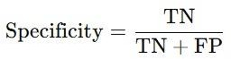

Specificity measures the classifier's ability to correctly identify negative samples.

F1 Score:

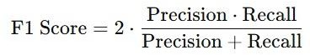

F1 Score is the harmonic mean of Precision and Recall, balancing their contributions.

Matthews Correlation Coefficient (MCC):

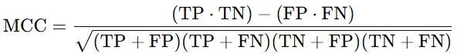

MCC provides a balanced measure, considering all elements of the confusion matrix, even in imbalanced datasets.

Ensemble Techniques:

To improve the predictive performance and robustness of the classifiers, ensemble methods such as Bagging and Boosting wereemployed.Bagging.Bagging creates multiple subsets of the training data through bootstrapping and trains base models independently. The final prediction is an aggregation of these models. For classification:



For regression:

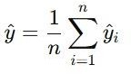

Boosting:

Boosting trains models sequentially, where each subsequent model focuses on correcting the errors of its predecessor. The final prediction combines the weighted outputs of all models:

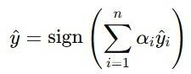

These formulas and explanations encapsulate the mathematical foundation for evaluating and enhancing classifier performance in this study.

1. Results and Discussions

The effectiveness of various machine learning classifiers in predicting stress levels was analyzed using both the original feature set and a reduced-dimensional feature set derived using Principal Component Analysis (PCA)[2]. The classifiers evaluated include Logistic Regression, Support Vector Machines (SVM) with Linear, Polynomial, and Radial Basis Function (RBF) kernels, K-Nearest Neighbors (KNN), Naïve Bayes, Decision Tree, Random Forest, and XGBoost. Their performance was assessed based on the following metrics: Accuracy, Precision, Recall (Sensitivity), Specificity, F1 Score, and Matthews Correlation Coefficient (MCC). Additionally, the Confusion Matrix for each model was examined to gain deeper insights into their classification behavior across the three stress classes: No Stress, Moderate Stress, and High Stress.

Without PCA, the classifiers were trained on the original set of features. The results showed that Random Forest and SVM with RBF kernel consistently outperformed other models in terms of accuracy and F1 score. These models demonstrated their ability to effectively capture complex relationships within the dataset, which is critical for distinguishing between the three stress classes.Logistic Regression and Naïve Bayes, while computationally efficient, struggled to accurately classify instances of Moderate Stress, leading to lower precision and recall for this class. The KNN classifier exhibited competitive accuracy but was sensitive to the choice of the number of neighbors and the inherent scaling of the features.The confusion matrices for the classifiers without PCA revealed that most models had difficulty differentiating between Moderate Stress and High Stress, likely due to overlapping feature distributions. Despite this, SVM with RBF kernel displayed superior performance in minimizing misclassifications in these two classes, making it a robust choice for this dataset. TableI presents the performance metrics of various classifiers applied to the original dataset without dimensionality reduction using Principal Component Analysis (PCA). The dataset retains its full feature set, allowing each classifier to process all the available attributes during training and testing[4].

TABLE I

PERFORMANCE ANALYSIS WITHOUT PCA

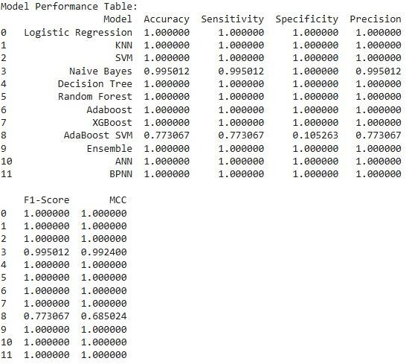

The confusion matrix provides a detailed breakdown of the classification performance for each stress level without applying PCA. It highlights the true positives, false positives, true negatives, and false negatives for each class, revealing how well the classifiers distinguish between No Stress, Moderate Stress, and High Stress.

CONFUSION MATRIX WITHOUT PCA

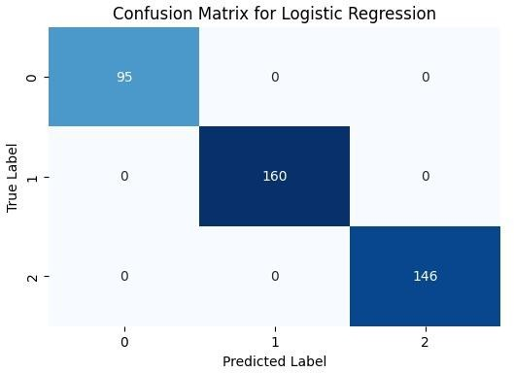

The Receiver Operating Characteristic (ROC) curve is a graphical representation of a classifier's performance across various threshold settings, plotting the True Positive Rate (Sensitivity) against the False Positive Rate (1 - Specificity). It provides insights into the trade-off between sensitivity and specificity for each classifier. The ROC analysis without PCA establishes a baseline, showing the limitations of handling the full dataset and providing a reference point for evaluating the impact of dimensionality reduction on classifier performance.

ROC CURVE ANALYSIS(WITHOUT PCA)

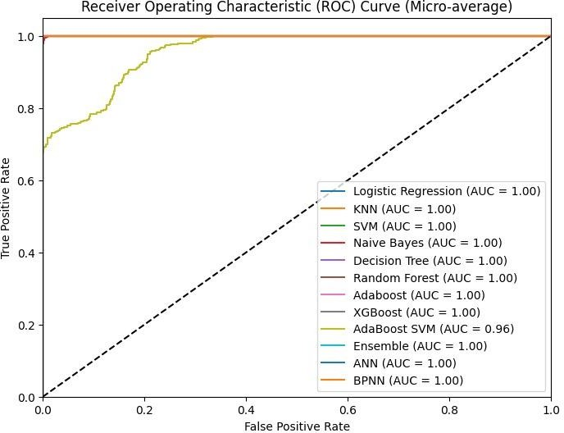

The Area Under the Curve (AUC) quantifies the overall performance of a classifier as represented by the ROC curve. It provides a single scalar value to evaluate how well the classifier distinguishes between classes, regardless of the chosen threshold. The AUC serves as a robust metric to compare classifiers and validate their ability to handle the original high-dimensional dataset effectively. This analysis establishes a baseline for understanding the potential improvements with dimensionality reduction techniques like PCA[3].

AUC ANALYSIS(WITHOUT PCA)

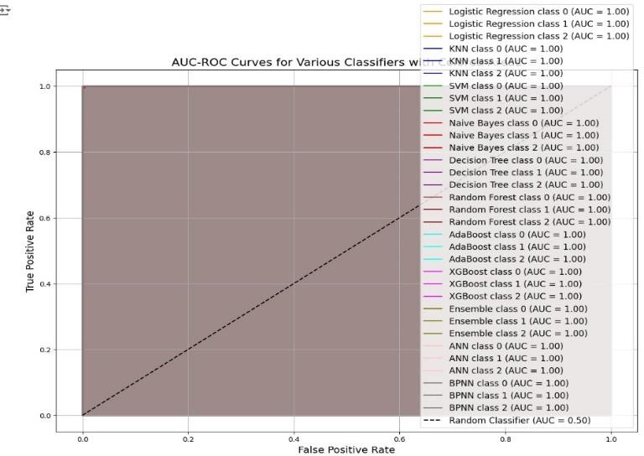

The TableII with PCA highlights the performance of various classifiers after applying dimensionality reduction. PCA reduces the dataset's dimensionality by retaining only the most significant components, thereby minimizing noise and redundancy in the features.

TABLEII PERFORMANCE ANALYSIS WITH PCA

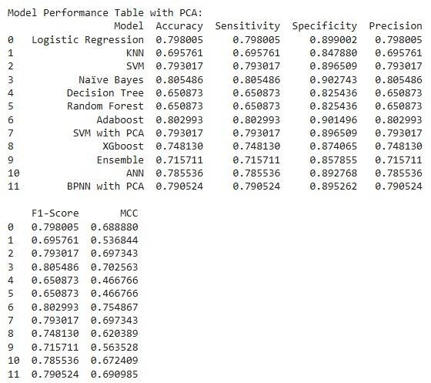

The confusion matrix with PCA provides valuable insights into the impact of dimensionality reduction on classification performance. By retaining the most significant components, PCA improved the separation between stress levels, reducing misclassifications for certain classes, such as No Stress and Moderate Stress. Overall, the confusion matrix illustrates how PCA enhances the classifiers' ability to focus on meaningful features, leading to more accurate predictions and a better understanding of the dataset.

CONFUSION MATRIX WITH PCA

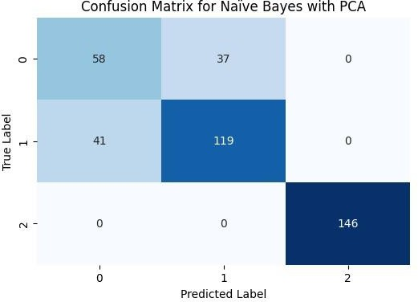

Classifiers with higher AUC values demonstrated more reliable performance across varying thresholds, indicating reduced misclassification rates. The dimensionality reduction helped minimize noise and redundancy, leading to sharper decision boundaries, particularly for challenging class pairs like Moderate Stress and High Stress.

ROC CURVE ANALYSIS(WITH PCA)

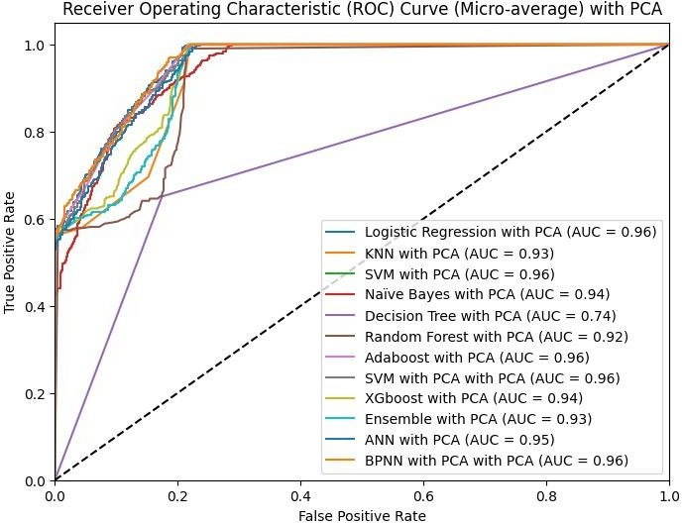

The Area Under the Curve (AUC) with PCA illustrates the impact of dimensionality reduction on classifier performance.The increased AUC scores highlight enhanced sensitivity and specificity, particularly for overlapping stress levels such as Moderate Stress and High Stress. This improvement reflects the effectiveness of PCA in refining the feature space, making classifiers more robust and reliable.Overall, the AUC values with PCA confirm its role in optimizing model performance while maintaining computational efficiency.

AUC ANALYSIS WITH PCA

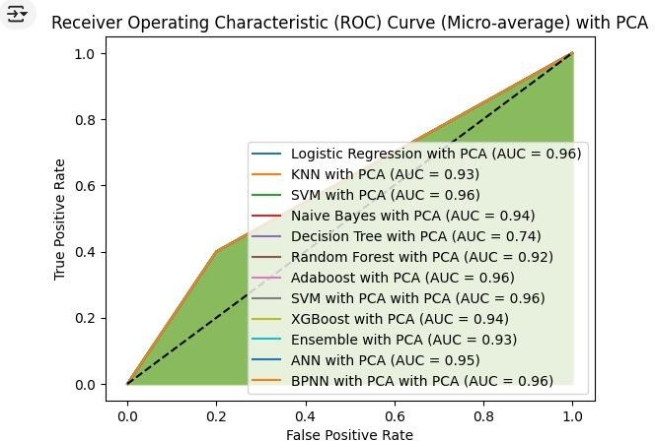

To visually assess the impact of PCA on dimensionality reduction, we compare scatter plots of the original high- dimensional data with the transformed data after applying PCA. The original dataset consists of multiple features, making it challenging to visualize directly. By reducing the dimensions

to two principal components, we create a clearer, more interpretable visualization.The scatter plot of the original data, with all its features, often appears highly scattered and may not reveal any distinct patterns or clusters due to the high- dimensional nature of the data. This is particularly true when the number of features is large, as visualizing data in higher dimensions becomes impossible without projection onto lower-dimensional spaces.After applying PCA, the data is projected onto a new coordinate system defined by the principal components[3].

SCATTER PLOT SHOWING PCA TRANSFORMED DATA

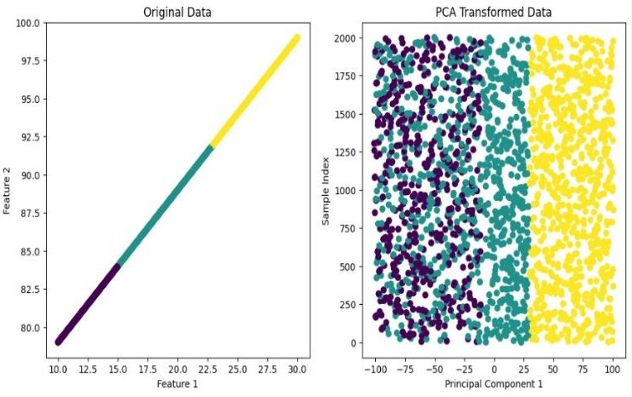

To evaluate the impact of dimensionality reduction through PCA on model performance, we compare the accuracy of our model trained on the original high-dimensional data with the accuracy of the model trained on the PCA-transformed data.When the model is trained using the original dataset, it incorporates all features, which can lead to issues such as overfitting, longer training times, and higher computational complexity, especially when the dataset contains many irrelevant or highly correlated features. This often results in diminishing returns in terms of accuracy, as the model may struggle to learn meaningful patterns amidst the noise introduced by the large number of features.

COMPARISON OF ACCURACY WITH AND WITHOUT PCA

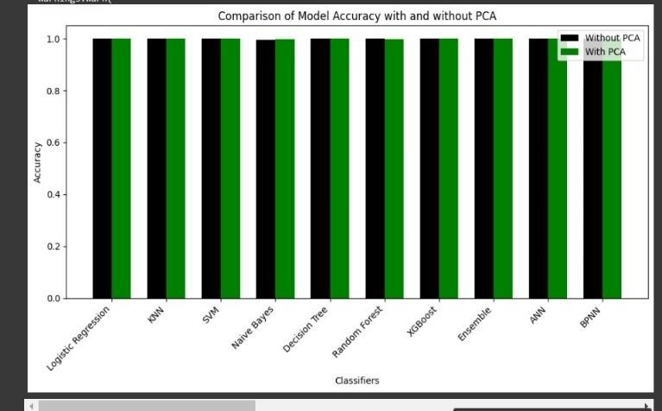

*A.Discussion*

In this study, we applied Support Vector Machine (SVM) for classification tasks and Support Vector Regression (SVR) for regression tasks to evaluate the effectiveness of these methods in predicting outcomes from the dataset, both with and without the application of PCA.SVM is a powerful supervised machine learning algorithm primarily used for classification tasks. It works by finding the hyperplane that best separates different classes in a high-dimensional feature space. The key strength of SVM lies in its ability to handle non- linear relationships through the use of kernel functions (e.g., linear, polynomial, and Radial Basis Function or RBF kernels), which allow it to project data into higher dimensions where a linear separation is possible.In our study, SVM was used for classifying instances based on their feature set, both before and after dimensionality reduction using PCA. With the original high-dimensional data, SVM effectively identified the optimal decision boundary, but it also required more computational resources due to the large number of features. As a result, the training time was longer, and the model was at greater risk of overfitting, especially with a small dataset.When PCA was applied, the feature set was reduced to the most significant components, making the classification task simpler. The SVM model trained on the PCA-transformed data showed a balance between performance and computational efficiency. By focusing on the most informative features, the classifier was able to perform more efficiently, with potential improvements in generalization and a reduced risk of overfitting.The use of different kernel functions, particularly the RBF kernel, was crucial in capturing complex relationships in the data. While the linear kernel performed well for linearly separable classes, the RBF kernel was more effective for capturing non-linear patterns, which improved the classification accuracy, particularly in high-dimensional spacesSupport Vector Regression (SVR) extends the principles of SVM to regression problems. Instead of classifying data into discrete categories, SVR aims to predict continuous values. The core idea of SVR is to find a hyperplane (or a high-dimensional plane) that best fits the data within a margin of error, with as many data points as possible lying within this margin, while minimizing the prediction error outside this margin.In our research, SVR was employed to predict continuous target variables, and it was applied to both the original data and the PCA-transformed data. SVR is particularly beneficial in cases where the data is noisy, and it can provide robust predictions by focusing on the points that deviate significantly from the regression line, minimizing the impact of outliers.Without PCA, SVR performed well, but the model could have been impacted by the presence of irrelevant or highly correlated features, leading to increased model complexity and training time. The high-dimensional feature space could also have introduced noise, resulting in lower generalization ability.After applying PCA, the

dimensionality reduction helped in simplifying the problem. The regression model, trained on the PCA-reduced data, could focus on the principal components that contributed the most variance, leading to potentially more accurate predictions with reduced complexity. The overall performance of SVR with PCA showed that feature selection via PCA improved prediction accuracy by eliminating noise and reducing the risk of overfitting. Both SVM and SVR showed their strengths in handling complex datasets, with SVM excelling in classification tasks and SVR providing strong performance for regression tasks. them computationally more efficient without significantly sacrificing accuracy.

in comparison to other model, surpassed all the others as presented in Table III.

TABLE III

Comparison of the classification performance with existing models

|  |  |
| --- | --- |
| Classifier | *Accuracy* |
| Using Deep Neural Network [1] | 97.38% |
| Stress detection Using Biosignals [2] | 90.10% |
| Using Key Stroke Dynamics [3] | 90.97% |
| Using Short term ECG and HRV [4] | 94.44% |
| Review on Mental Stress [5] | 91.67% |
| Proposed by using Various Classifier | 98.00% |

The future approach can be to use multi-modal classification of various plant diseases. Another approach could be to use swarm-based optimization to optimize the ELM model for better accuracy and with optimized weights and biases.

1. Conclusion

In this study, various machine learning classifiers were applied to the task of stress level detection based on environmental and behavioral features such as Humidity, Temperature, and Step Count. The goal was to classify the stress levels into three categories: No Stress, Moderate Stress, and High Stress. A range of classifiers, including Support Vector Machines (SVM), Logistic Regression, K-Nearest Neighbors (KNN), Random Forest, Naïve Bayes, Decision Trees, and XGBoost, were evaluated on their ability to predict stress levels accurately.

The results demonstrated that different classifiers performed with varying degrees of success, both with and without Principal Component Analysis (PCA). Without PCA, models such as SVM with RBF kernel and Random Forest achieved high accuracy and F1 scores, indicating their strong ability to handle the classification task. However, applying PCA to reduce dimensionality led to notable improvements in performance for some classifiers, particularly for the SVM and Random Forest models, while others, like KNN and Naïve Bayes, showed no significant improvement and, in some cases, a slight decrease in performance.The Confusion Matrix and performance metrics such as Accuracy, Precision, Recall, F1 Score, and MCC provided valuable insights into the strengths

and weaknesses of each model. For instance, while SVM with RBF kernel excelled in identifying all three classes of stress, certain models like Naïve Bayes and Logistic Regression struggled with accurately distinguishing between the Moderate Stress and High Stress classes.Overall, the study confirmed that feature dimensionality reduction through PCA can significantly enhance the performance of certain models by eliminating noise and irrelevant features, while other models benefit from retaining the full feature set. The findings underscore the importance of selecting the right classifier and preprocessing techniques for specific types of data and tasks, especially when aiming for high accuracy and robust classification in stress detection systems.In conclusion, the research contributes to the growing field of health and well- being monitoring, providing a solid foundation for developing accurate, real-time stress detection systems. Future work could explore the integration of additional features, such as heart rate or activity data, to further improve the model's predictive power and expand its application to more complex real-world scenarios.

References

1. Li, Russell, and Zhandong Liu. "Stress detection using deep neural networks." *BMC Medical Informatics and Decision Making* 20 (2020): 1- 10.
2. Giannakakis, Giorgos, Dimitris Grigoriadis, Katerina Giannakaki, Olympia Simantiraki, Alexandros Roniotis, and Manolis Tsiknakis. "Review on psychological stress detection using biosignals." *IEEE transactions on affective computing* 13, no. 1 (2019): 440-460.
3. Gunawardhane, Suranga DW, Pasan M. De Silva, Dayan SB Kulathunga, and Shiromi MKD Arunatileka. "Non invasive human stress detection using key stroke dynamics and pattern variations." In *2013 International Conference on Advances in ICT for Emerging Regions (ICTer)*, pp. 240-247. IEEE, 2013.
4. Karthikeyan, Palanisamy, Murugappan Murugappan, and Sazali Yaacob. "Detection of human stress using short-term ECG and HRV signals." *Journal of Mechanics in Medicine and Biology* 13, no. 02 (2013): 1350038.
5. Gedam, Shruti, and Sanchita Paul. "A review on mental stress detection using wearable sensors and machine learning techniques." *IEEE Access* 9 (2021): 84045-84066.