“Mental Health Analysis Using Machine Learning Models”
A Project Report submitted in partial fulfillment of the requirements for the award of the degree of

BACHELOR OF TECHNOLOGY
IN
COMPUTER SCIENCE AND ENGINEERING
(Specialization in Artificial Intelligence & Machine Learning / Data Science)

Submitted by
M. V. S. Satya Mrudula (2023000597)
G. Rishikar Reddy (2023001672)
D. Vivek (2023002218)
T. S. L. Priyanka (2023004539)

Under the esteemed guidance of
Dr. M. Ramakrishna Murty, Professor



Department of Artificial Intelligence and Data Science
GITAM School of CSE, GITAM (Deemed to be University),
Visakhapatnam
2026



DECLARATION

I hereby declare that the project report entitled “Mental Health Analysis Using Machine Learning Models” is an original work done in the Department of Artificial Intelligence and Data Science, GITAM School of CSE, GITAM (Deemed to be University), submitted in partial fulfillment of the requirements for the award of the degree of B.Tech. in Computer Science and Engineering (AI&ML/DS). The work has not been submitted to any other college or University for the award of any degree or diploma.

Date:

Registration No. | Name | Signature
2023000597 | M. V. S. Satya Mrudula
2023001672 | G. Rishikar Reddy
2023002218 | D. Vivek
2023004539 | T. S. L. Priyanka
DEPARTMENT OF COMPUTER SCIENCE AND ENGINEERING/ DEPARTMENT OF ARTIFICIAL INTELLIGENCE AND DATA SCIENCE
GITAM School of CSE
GITAM (Deemed to be University)
CERTIFICATE
This is to certify that the project report entitled “Mental Health Analysis Using Machine Learning Models” is a bonafide record of work carried out by M. V. S. Satya Mrudula (2023000597), G. Rishikar Reddy (2023001672), D. Vivek (2023002218) and T. S. L. Priyanka (2023004539) students submitted in partial fulfillment of requirement for the award of degree of Bachelor of Technology in Computer Science and Engineering (AI&ML/DS).
Date :
Project Guide Head of the Department
ACKNOWLEDGEMENT
We are very thankful to our project guide, Dr. M. Ramakrishna Murty, professor at the Department of Artificial Intelligence and Data Science GITAM School of CSE for the guidance constructive feedback and constant encouragement during this capstone project. Dr. M. Ramakrishna Murty’s suggestions during the project reviews about expanding data sources and choosing current models have directed the course of this work.
We are grateful to the Head of the Department and to all faculty members of the Department of Artificial Intelligence and Data Science for the environment and resources that made this project possible. We also thank the project coordinators for arranging the review process.
Finally we are thankful to families and friends for families and friends patience and support, throughout this project.
TABLE OF CONTENTS
S.No. | Description | Page No.
1. | Abstract | 1
2. | Introduction | 1
3. | Literature Review | 2
4. | Problem Identification & Objectives | 3
5. | Existing System | 5
6. | Proposed System | 5
7. | System Architecture | 8
8. | Tools/Technologies Used | 13
9. | Conclusion | 14
10. | References | 15

1. ABSTRACT
Mental health concerns often go unnoticed until people speak up about symptoms or get a check. Early screening can spot those who might be at risk for depression, anxiety and stress.. Today screening mostly uses questionnaires and the eye of a clinician. This project looks at whether machine-learning models can mix data about a person’s age, habits, lifestyle, school or work situation, friends and feelings to help screening. The plan is to use two data streams. One stream will take the questionnaire answers and feed them into an FT-Transformer. The other stream will take the free-form text and feed it into DeBERTa. The two model outputs will then be joined to give predictions, for depression, anxiety and stress. The goal is to explain what drives those predictions so that screening and professional decisionsre clearer. At this point both data sets have been. The models chosen. Next steps are to clean the data build the models merge them and test how well they work.
2. INTRODUCTION
2.1 Background
Mental health is an important part of being healthy overall but conditions like depression, anxiety and stress are often not noticed. A lot of people do not ask for help until their symptoms get bad and regular checking for these issues is not always possible in schools, colleges or offices. Identifying people who might be at risk on can help them get the right care quickly.
Machine learning can help with this kind of checking by looking for patterns in data that show a persons situation and experiences. Questionnaires collect information about age, habits, how someone lives, their school or work life and their social life in a way.. Written words from a person, like how they describe their feelings or thoughts can tell us things that a fixed questionnaire might miss. Looking at both of these together can give an understanding than looking at either one alone.
2.2 Need for the System
Screening that depends on a single questionnaire can miss useful information, and clinical records are not always available outside health services. Faculty, counsellors and workplace support teams need a way to make the screening process more systematic. A system that uses both structured responses and written psychological text, and that gives clear, readable outputs, can support these decisions while leaving the final judgement to trained professionals.
2.3 Justification of the Title
The title “Mental Health Analysis Using Machine Learning Models” describes the main parts of the work. The machine-learning models learn the relationship between the input data and the screening outcomes, rather than relying on fixed scoring rules. The analysis is directed at mental health, specifically the three conditions of depression, anxiety and stress. The word “analysis” reflects that the system examines the inputs to estimate risk, and that its outputs are intended as decision-support information rather than a diagnosis.
2.4 Scope of the Project
The project covers the selection and preparation of the questionnaire and psychological text datasets, the choice of FT-Transformer and DeBERTa as the two analysis models, the combination of their outputs, and the evaluation of the resulting predictions. It does not cover clinical diagnosis, treatment recommendations or the deployment of the system in a live clinical setting. Predictions are intended only to support screening and professional decision-making.
3. LITERATURE REVIEW
3.1 Machine Learning for Depression and Anxiety Prediction
Several studies have explored the use of machine learning to identify symptoms related to depression, anxiety and stress. ShamsEldin et al. (2025) [1] investigated the prediction of these three conditions using psychometric data. Their study used 39,775 anonymised responses collected through the DASS-42 questionnaire along with demographic information. Five classification algorithms, including Support Vector Machine (SVM), Random Forest, Decision Tree, K-Nearest Neighbours and Naive Bayes, were compared. SVM achieved the highest reported accuracy, with 99.3% for depression, 98.9% for anxiety and 98.8% for stress. The study demonstrates how questionnaire responses can be used for mental health screening. However, the reliability of questionnaire-based labels and the need for external validation must also be considered.
Nemesure et al. (2021) [2] explored the prediction of depression and anxiety using routine electronic health records. Their approach combined multiple machine learning models and used SHAP (SHapley Additive exPlanations) to understand the contribution of individual features to the predictions. The reported ROC-AUC values were 0.67 for major depressive disorder (MDD) and 0.73 for generalised anxiety disorder (GAD). The findings suggest that demographic and biomedical information can provide useful signals for identifying mental health risks. At the same time, the moderate prediction performance indicates that further improvements and validation are necessary.
3.2 Behavioural and Long-Term Mental Health Prediction
Bailey and Strunk (2023) [3] studied the prediction of anxiety and depression symptoms over a twelve-month period during the COVID-19 pandemic. The research considered 1,200 adults from the United States and examined 68 baseline demographic and psychosocial variables. The researchers used Elastic Net regression with repeated cross-validation to identify relevant predictors. Their results showed test R² values of 0.7818 for anxiety and 0.7691 for depression. The study highlighted the importance of factors such as stress, sleep and psychological vulnerabilities when analysing mental health. However, the pandemic-specific setting and follow-up limitations may affect how well the findings apply to other populations.
Ahmed and Ahmed (2023) [4] proposed a lightweight system for depression screening using smartphone application usage data. Their approach, called Mon Majhi, collected approximately seven days of application usage history and used machine learning to identify possible depression-related patterns. The study involved 100 Bangladeshi students and used LightGBM along with feature selection techniques such as Boruta and SHAP for model interpretation. The reported recall was 82.4%, precision was 75.0% and F1-score was 78.5%. This research shows that everyday behavioural patterns can provide additional information for mental health screening. However, the relatively small sample size limits the extent to which the results can be generalised.
3.3 Transformer Models for Questionnaire and Psychological Text Analysis
Recent developments in deep learning have introduced transformer-based architectures for handling different types of data. Two such developments are DeBERTa and FT-Transformer, which form the foundation of the proposed approach in this project.
He et al. (2020) introduced DeBERTa (Decoding-enhanced BERT with Disentangled Attention) [5]. Unlike conventional BERT-based models, DeBERTa uses separate representations for the content and position of words through disentangled attention. This helps the model understand relationships between words within a sentence more effectively. Since psychological text may contain information about emotions, thoughts and personal experiences, DeBERTa is selected for analysing the textual input in this project.
The research paper Revisiting Deep Learning Models for Tabular Data (2021) [6] examined deep learning approaches for structured datasets and introduced the FT-Transformer (Feature Tokenizer Transformer). The model converts individual features into token representations and processes them using transformer layers. This makes it suitable for analysing structured questionnaire responses containing multiple demographic, behavioural and psychological variables. In this project, FT-Transformer is selected to process questionnaire data and identify patterns associated with depression, anxiety and stress.
Both models are intended for different types of input. DeBERTa focuses on understanding psychological text, whereas FT-Transformer handles structured questionnaire data. Their separate roles make them suitable for the two input streams proposed in this project.
3.4 Summary and Research Gap
Table 3.1 summarises the reviewed work and the gap that this project addresses.
Table 3.1: Summary of Reviewed Literature
Ref. | Research Focus | Approach / Model | Main Contribution | Limitation
[1] | Psychometric screening | SVM, Random Forest, Decision Tree, KNN, Naive Bayes | Prediction of depression, anxiety and stress using DASS-42 | Self-reported labels and need for external validation
[2] | Health-record-based prediction | Stacked ML, XGBoost, SHAP | Prediction of depression and anxiety using routine health records | Moderate discrimination and limited generalisation
[3] | Long-term symptom prediction | Elastic Net | Identification of baseline factors associated with symptoms over 12 months | Pandemic-specific context and follow-up limitations
[4] | Smartphone-based screening | LightGBM, Boruta, SHAP | Depression screening using smartphone application activity | Small sample size and questionnaire-based labels
[5] | Psychological text processing | DeBERTa | Disentangled attention for improved contextual text representation | Applied to psychological text analysis in this project
[6] | Structured data processing | FT-Transformer | Transformer-based architecture for tabular data | Applied to questionnaire analysis in this project
The literature shows that prediction of these conditions is established, but the two kinds of input are usually studied separately. This project therefore combines structured questionnaire responses and psychological text in one framework and predicts all three conditions.
4. PROBLEM IDENTIFICATION & OBJECTIVES
4.1 Problem Identification
Mental-health concerns may remain unrecognised until individuals report symptoms or receive professional evaluation. The problem addressed in this project is whether machine-learning models can combine demographic, behavioural, lifestyle, academic or workplace, social and psychological factors to identify individuals who may be at risk of depression, anxiety or stress, and whether they can do so in a way that explains the contributing factors.
4.2 Aim of the Project
The aim is to investigate whether machine-learning models can support early screening for possible depression, anxiety and stress by using relevant demographic, behavioural, lifestyle, academic or workplace, social and psychological factors.
4.3 Objectives
- Analyse questionnaire data using the FT-Transformer model.
- Analyse psychological text data using the DeBERTa model.
- Combine the outputs of both models to generate predictions for depression, anxiety and stress.
4.4 Feedback from Review 1 and Actions Taken
The feedback received from the guide and reviewers in Review 1 [7] was used to shape the current scope. Table 4.1 lists the feedback and the corresponding actions.
Table 4.1 : Review 1 feedback and actions taken
S.No. | Feedback received in Review 1 | Action taken
1 | Expand the project beyond questionnaire-based analysis. | Added psychological text data as an additional source alongside questionnaire data.
2 | Avoid relying on older models such as SVM and Logistic Regression; explore updated models from research papers. | Selected DeBERTa for text analysis and FT-Transformer for questionnaire analysis.
3 | Include only information that the team can clearly explain and justify. | Planned two separate models whose outputs are combined to predict depression, anxiety and stress.
4.5 Requirement Analysis
The requirements derived from the objectives and from the Review 1 feedback are listed in Table 4.2.
Table 4.2 : Functional requirements of the system
S.No. | Requirement | Purpose
1 | Use the benchmark questionnaire and psychological text datasets. | Provide the inputs for both models
2 | Inspect data formats, missing values, labels and data quality. | Ensure the data are fit for modelling
3 | Preprocess structured questionnaire responses and psychological text. | Prepare each stream for its model
4 | Analyse questionnaire data using FT-Transformer. | Produce the questionnaire-based output
5 | Analyse psychological text using DeBERTa. | Produce the text-based output
6 | Combine model outputs to predict depression, anxiety and stress. | Give one result per condition
7 | Provide clear and readable outputs. | Make results usable by screening staff
5. EXISTING SYSTEM
5.1 Current Approaches
Screening for depression anxiety and stress is commonly carried out with questionnaires that are scored manually or with simple statistical rules. Where machine learning has been applied many studies use a data source, typically questionnaire or clinical records together with conventional classifiers such, as Support Vector Machines and Logistic Regression. Table 5.1 summarises these approaches and their drawbacks.
Table 5.1 : Existing approaches and their drawbacks
Existing approach | Main drawback
Standardised questionnaire scoring | Relies on one structured source; written expression of feelings is not used.
Questionnaire-based machine learning with SVM or Logistic Regression | Older models that may not capture complex relationships as effectively as recent architectures.
Clinical-record prediction | Depends on records that are not available for many screening settings.
Single-source prediction | Predictions are not combined with a second, complementary source of information.
Existing methods often depend on one data source and an older model. They usually don’t mix information with psychological text in a way that is easy to read. Most of the time the results are not combined into a clear output.
6. PROPOSED SYSTEM
6.1 Overview
The proposed system extends questionnaire-based analysis by adding text as a second data source. Two separate models are used, each suited to its data type. An FT-Transformer analyses the questionnaire responses and DeBERTa analyses the psychological text. The outputs of the two models are then combined to generate predictions for depression, anxiety and stress.
6.2 Modules of the Proposed System
- Data validation: checks the questionnaire and text datasets for data formats missing values, labels and data quality.
- Questionnaire pipeline: preprocesses the responses and analyses them with the FT-Transformer.
- Text pipeline: preprocesses the psychological text and analyses it with DeBERTa.
- Integration module: combines the outputs of both models to produce predictions for depression, anxiety and stress.
- Output module: presents the predictions, in an readable form.
6.3 Datasets
Two datasets are used in this project as shown in Table 6.1.
The dataset collection is finished.
The next step is to confirm the labels check the data formats and resolve any data-quality issues.
Table 6.1 : Datasets used in the project
Dataset | Content | Use in the project
Benchmark questionnaire dataset | Responses covering demographic, behavioural, lifestyle, academic or workplace, social and psychological factors | Input to the FT-Transformer for questionnaire analysis
Psychological text dataset | Written psychological text | Input to DeBERTa for text analysis
6.4 Proposed Methodology
The questionnaire data and the psychological text data each travel through their separate pipelines, a process that helps keep the information clear.
The FT-Transformer examines the questionnaire data while DeBERTa examines the text and the outputs from the FT-Transformer and DeBERTa are then merged to produce predictions, for depression, anxiety and stress.
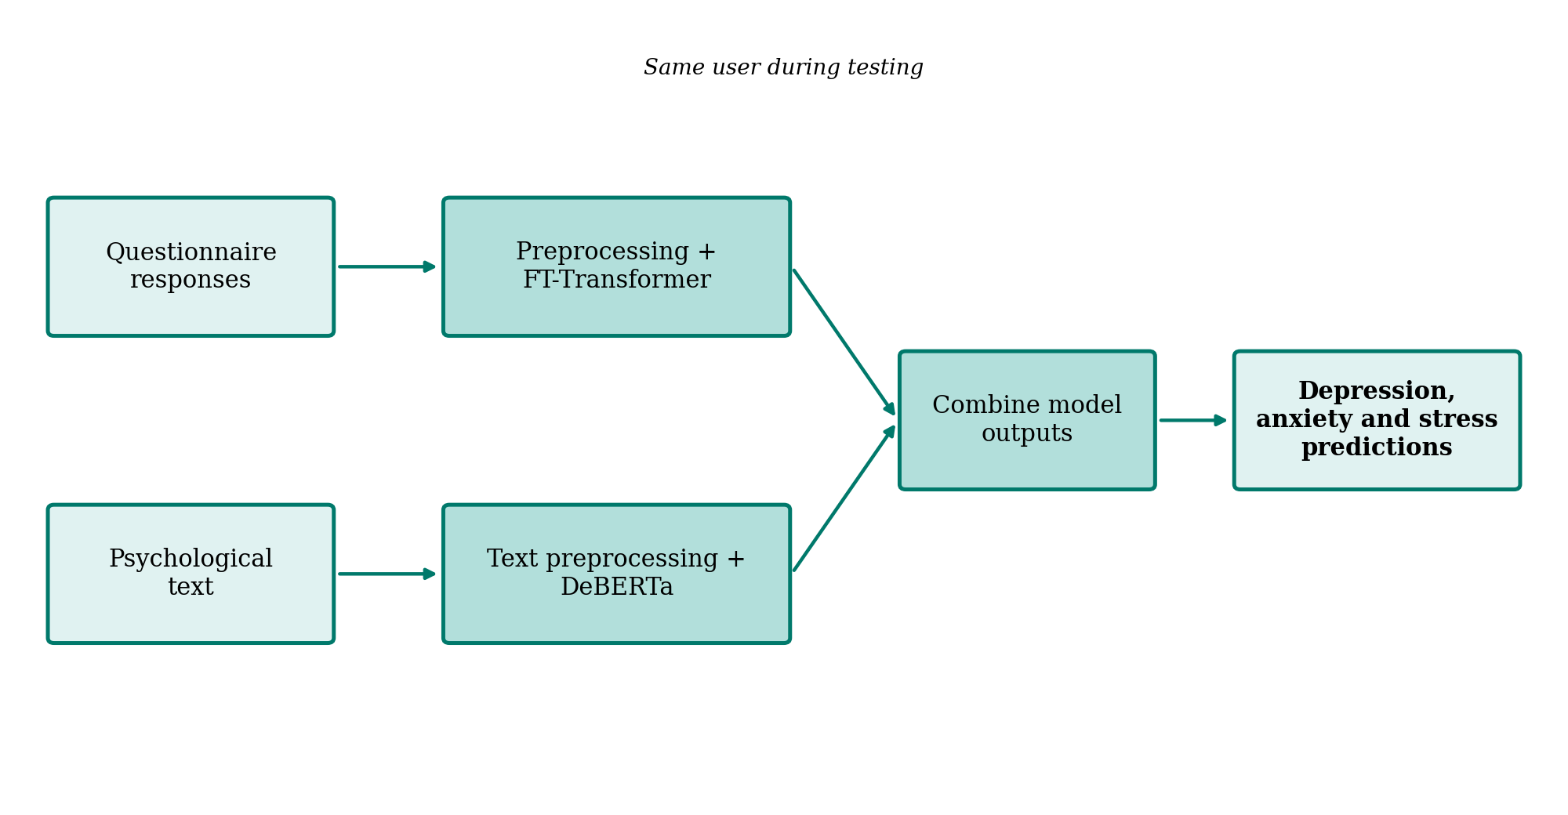
Figure 6.1 : Proposed methodology
6.5 Combination of Model Outputs
During testing the questionnaire responses and psychological text come from the user. Each model gives its output. Then in the integration stage these outputs are put together to form one prediction for each condition. The exact way we combine them will be decided after running baseline experiments. We’ll share that method along, with the results.
6.6 Evaluation Plan
We will compare the models using metrics that work well for screening tasks (see Table 6.2). The evaluation will also look for missing data, uneven class distribution, data leakage and whether error rates differ across subgroups.
Table 6.2 : Planned evaluation of the models
Task | Model | Planned metrics
Questionnaire-based prediction of depression, anxiety and stress | FT-Transformer | Accuracy, precision, recall, F1-score, ROC-AUC
Text-based prediction of depression, anxiety and stress | DeBERTa | Accuracy, precision, recall, F1-score, ROC-AUC
Combined prediction | Integration of both model outputs | Same metrics, compared with each single-model output
6.7 Improvement over the Existing System
Table 6.3 compares the existing and the proposed system.
Table 6.3 : Comparison of the existing and the proposed system
Aspect | Existing system | Proposed system
Data used | Single structured source, or clinical records | Questionnaire responses and psychological text
Models | Support Vector Machine, Logistic Regression | FT-Transformer and DeBERTa
Predictions | Usually one condition at a time | Depression, anxiety and stress
Output | Score or category with little context | Clear and readable outputs for screening staff
Decision making | Depends on the individual assessor | Decision support, with professional review of results
7. SYSTEM ARCHITECTURE
7.1 Project Workflow
The implementation follows the workflow shown in Figure 7.1.
The questionnaire and psychological text pipelines run separately. Their outputs meet in the combined output stage.
Table 7.1 shows the status of each stage at the time of this review.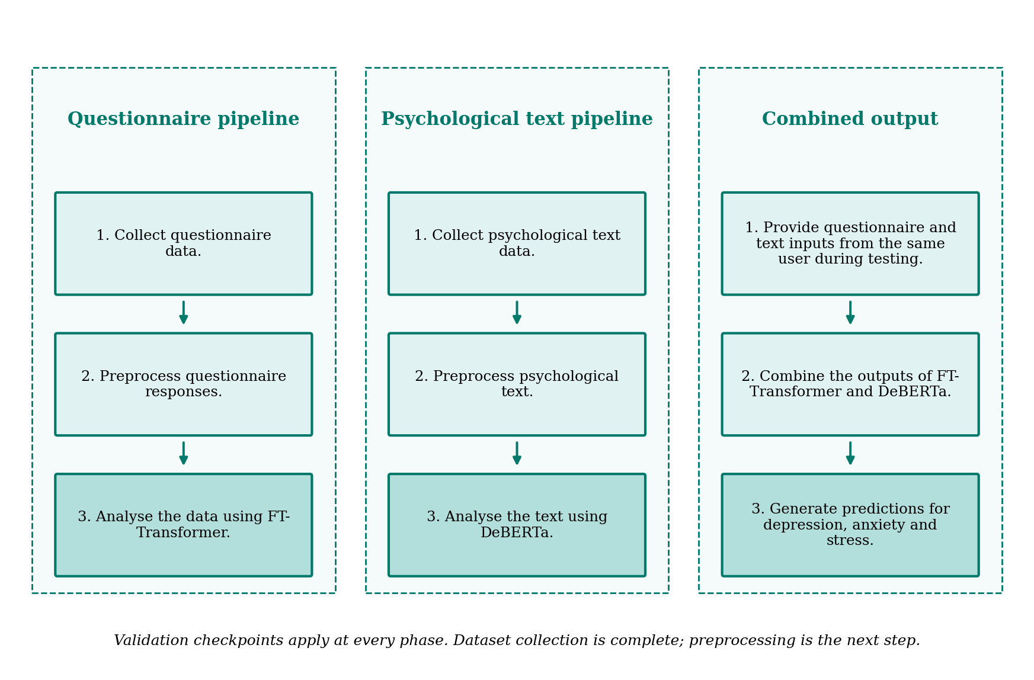
Figure 7.1 : Proposed project workflow
- Validation checkpoints: verify that the data formats are correct that no values are missing that labels are accurate and that overall data quality is good before each analysis stage.
- Expected deliverables: a questionnaire, text datasets, trained FT-Transformer and DeBERTa models combined predictions, for depression, anxiety and stress and results that can be reproduced for the next review.
Table 7.1 : Project workflow and status
Stage | Activity | Status
1 | Collection of the questionnaire and psychological text datasets | Completed
2 | Data inspection and preprocessing of both datasets | Next step
3 | Model development with FT-Transformer and DeBERTa | Planned
4 | Integration of model outputs | Planned
5 | Testing and evaluation | Planned
6 | Presentation of results and review | Planned
7.2 Data Flow Diagram
Figure 7.2 shows the way data moves from one part to another. While testing the same user fills out a questionnaire. Also provides some psychological text. The answers from the questionnaire are cleaned up. Given to the FT-Transformer. The psychological text is also cleaned up. Given to DeBERTa. The results, from both models are then put together to predict depression, anxiety and stress. Table 7.2 lists the parts that make up the data flow.
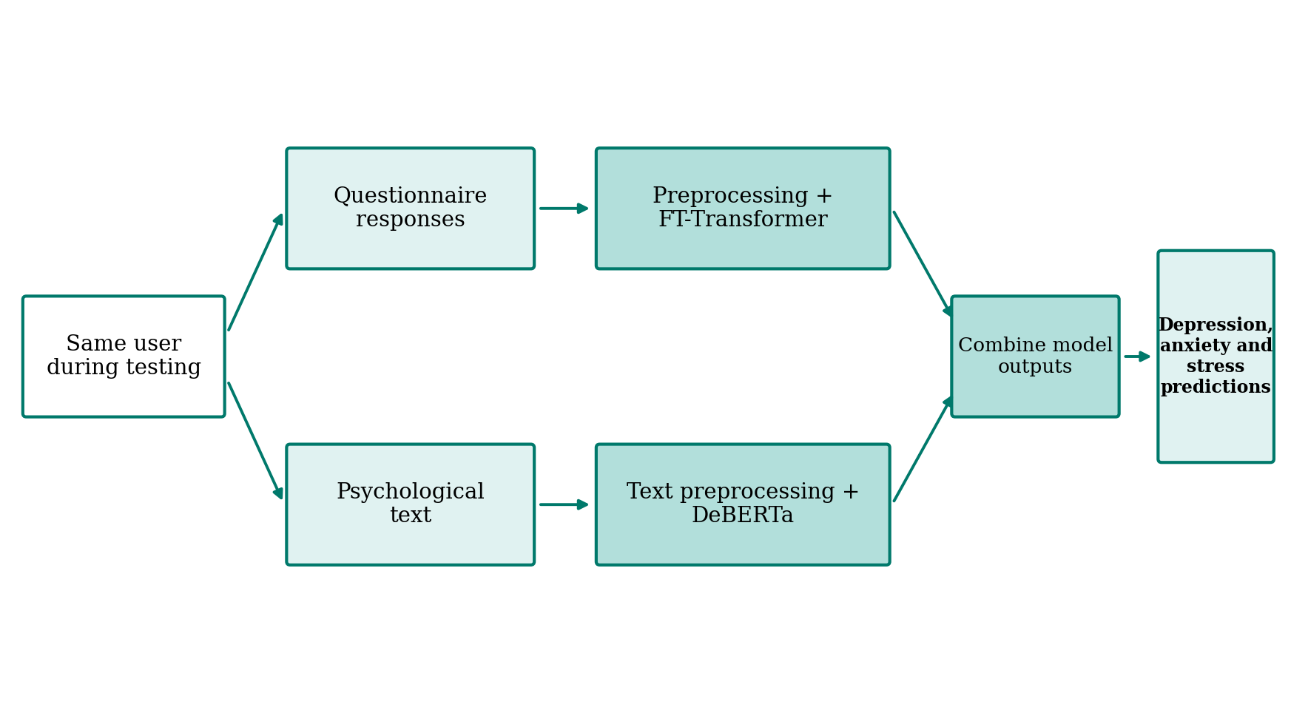
Figure 7.2 : Conceptual data flow diagram of the proposed system
Table 7.2 : Main components of the data flow
Component | Description
Input | Questionnaire responses and psychological text from the same user
Processing | Preprocessing of each data stream and data-quality checks
Prediction | Analysis with the FT-Transformer and DeBERTa
Integration | Combination of the two model outputs
Output | Predictions for depression, anxiety and stress
7.3 Use Case Diagram
Figure 7.3 shows the conceptual use case design. I notice that the user is the actor. Requesting a mental-health screening involves analysing the questionnaire responses, with the FT-Transformer analysing the text with DeBERTa and combining both predictions. Table 7.3 lists the use cases.
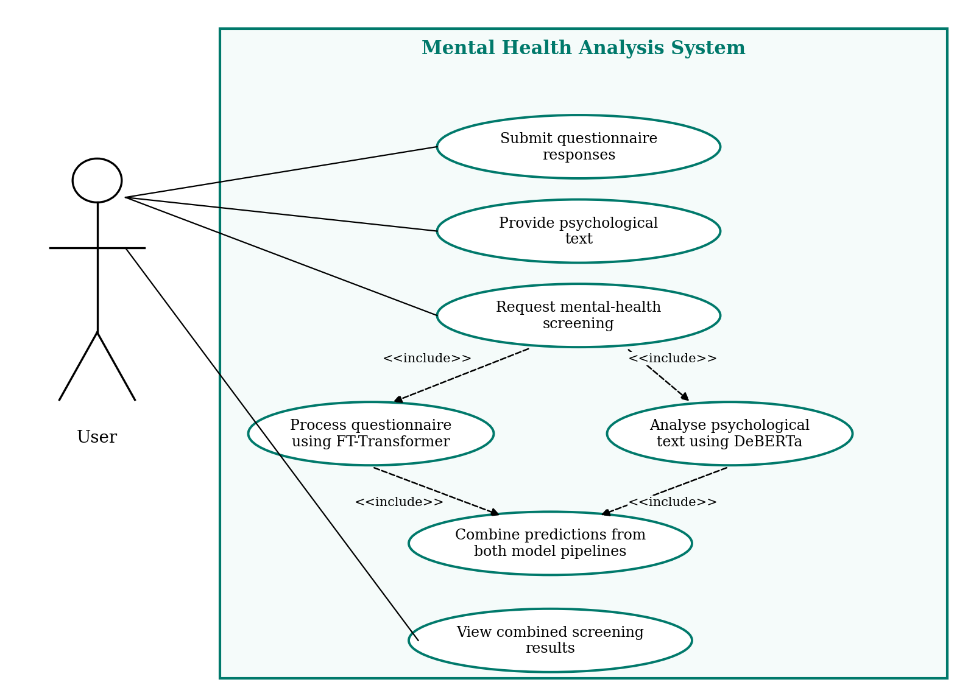
Figure 7.3 : Use case diagram of the proposed system
Table 7.3 : Use cases of the system
Use case | Description
Submit questionnaire responses | The user provides the structured questionnaire responses
Provide psychological text | The user provides written psychological text
Request mental-health screening | The user starts the screening, which includes the two analyses below
Process questionnaire using FT-Transformer | Included in the screening request
Analyse psychological text using DeBERTa | Included in the screening request
Combine predictions from both model pipelines | Included in the screening request
View combined screening results | The user sees predictions for depression, anxiety and stress
7.4 Sequence Diagram
Figure 7.4 shows how the user, the frontend interface the two analysis models and the integration module work together. The user fills out the questionnaire adds the text and then asks for a screening. The frontend interface takes each of these inputs. Sends them to their respective models. Each model makes a prediction based on its input. Then both predictions go to the integration module. The integration module puts them together to create a result. That combined result is sent back to the user. It’s a step-, by-step process. User gives input models analyse, module combines user gets results.
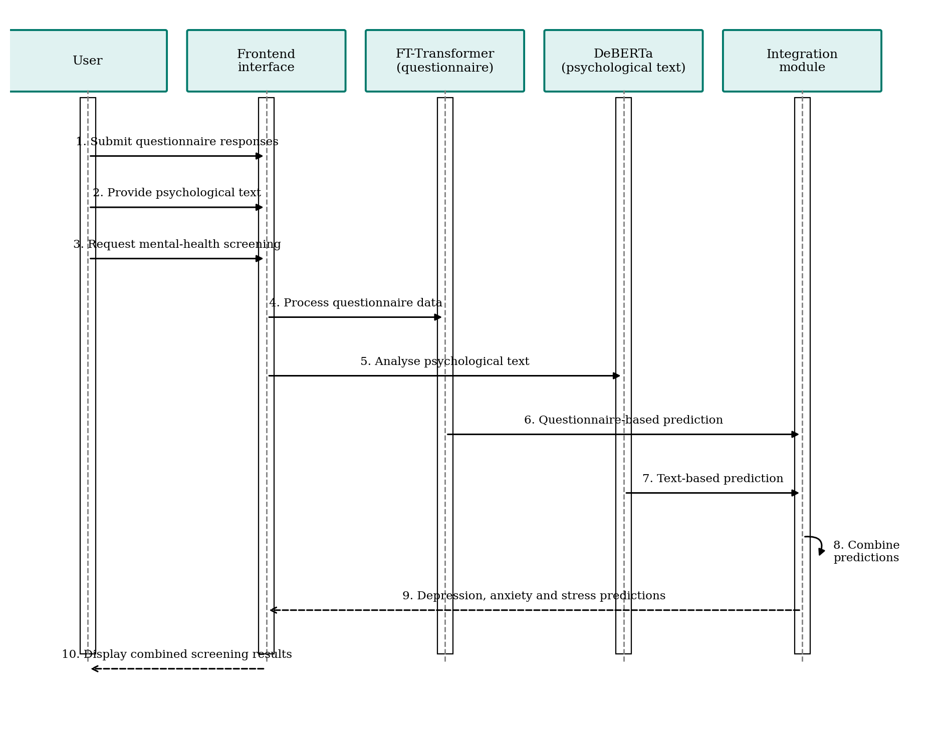
Figure 7.4 : Sequence diagram of the mental-health screening process
7.5 Activity Diagram
Figure 7.5 shows the activity of the screening process across four swimlanes. After the user submits both inputs and requests a screening the questionnaire responses and the psychological text are preprocessed in parallel. The questionnaire data are checked for validity; if the check fails the record is flagged for correction. Otherwise the FT-Transformer analyses the data. DeBERTa analyses the text. The integration stage then combines the two outputs generates predictions, for depression, anxiety and stress and displays them to the user.
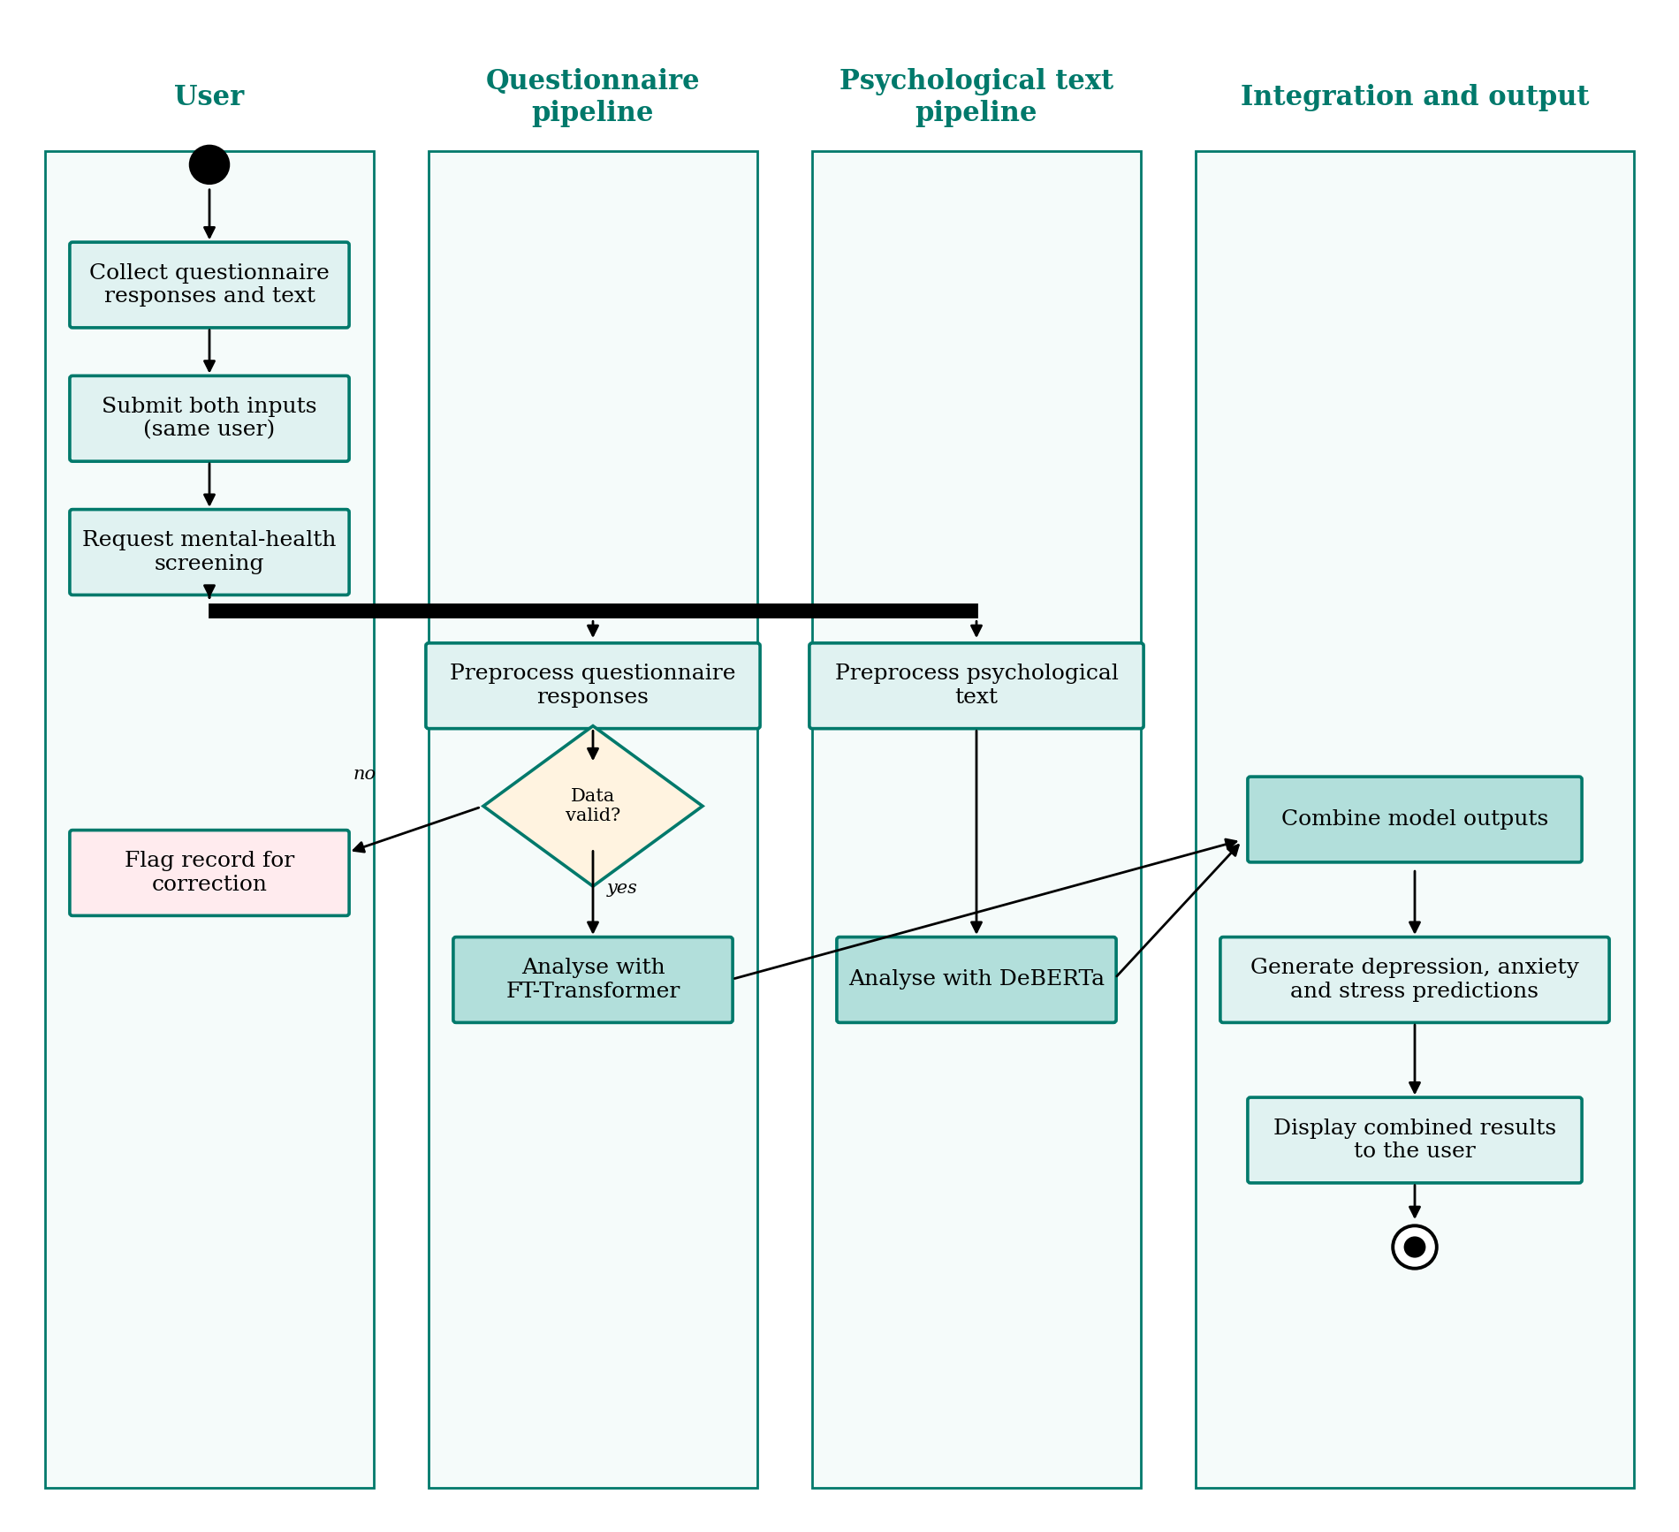
Figure 7.5 : Activity diagram of the mental-health screening process
8. TOOLS/TECHNOLOGIES USED
8.1 Tools
The tools selected for the project are listed in Table 8.1 along with their significance in the work.
Table 8.1 : Tools used and their significance
Tool | Significance in the project
Python | Main programming language for data processing and model development
Pandas | Loading, cleaning and transforming the datasets
NumPy | Numerical operations on arrays and feature matrices
Matplotlib | Plotting of data distributions and results
Seaborn | Statistical visualisation for exploring data quality and relationships
Scikit-learn | Data splitting, evaluation metrics and supporting utilities
8.2 Algorithms
The two analysis models selected for the project are listed in Table 8.2.
Table 8.2 : Algorithms used and their role
Algorithm | Input data | Role in the project
FT-Transformer | Questionnaire data | Analyses structured responses for screening
DeBERTa | Psychological text | Analyses written psychological text for screening
9. CONCLUSION
9.1 Conclusion
This project looks at whether machine-learning models can help with screening for depression, anxiety and stress by mixing questionnaire data with psychological text. The FT-Transformer is used to analyse questionnaire data while DeBERTa is used to analyse text. The outputs from the FT-Transformer and DeBERTa are combined to create predictions for depression, anxiety and stress. These predictions are meant to give decision-support information for screening and for review.
The work completed far includes the following:
- The collection of the questionnaire dataset and the psychological text dataset is finished.
- The choice of models is finished: FT-Transformer for questionnaire data and DeBERTa, for text.
- The planned methodology and workflow are ready.
9.2 Work Plan and Timeline
The work plan is given in Table 9.1. The timeline is provisional and will be updated to match the actual progress and the schedule approved by the guide.
Table 9.1 : Work plan and timeline
Task | Task owner | Status
Problem identification and scope | Team | Done / reviewed
Literature survey and research gaps | Team | Done / reviewed
Project objectives and workplan | Team | Done / reviewed
Requirement analysis and dataset audit | Assigned members | Done / reviewed
Tools, algorithms and system design | Assigned members | Planned
Proposed methodology and workflow | Team | Planned
Baseline experiments and evaluation | Assigned members | Planned
Phase 1 closure / project exhibition | Team | Planned
9.3 Next Actions
The next actions are to confirm the dataset and permissions, finalise the labels and feature dictionary, implement the baseline models, and present reproducible results at the next review. Data preprocessing is the next step, followed by model development, integration, testing and evaluation.
9.4 Disclosure Statements
- I will maintain academic honesty by doing my own work and avoiding plagiarism, cheating, unauthorised collaboration and the falsification of information.
- I will properly acknowledge and cite all sources I use, including information from the internet, books, software and AI tools.
- I will use institutional resources responsibly and only for authorised academic or research activities. I understand that I am responsible for my own actions and decisions.
10. REFERENCES
[7] Team 5 (GSCSE, GITAM), “Mental Health Analysis Using Machine Learning Models,” Capstone Project Introduction, Review 2, GITAM School of CSE, GITAM (Deemed to be University), Visakhapatnam, Oct. 29, 2026.
[1] T. ShamsEldin et al., “Artificial intelligence for predicting depression, anxiety and stress using psychometric data,” Scientific Reports, vol. 15, Art. no. 37282, 2025, doi: 10.1038/s41598-025-21301-1.
[2] M. D. Nemesure, M. V. Heinz, R. Huang, and N. C. Jacobson, “Predictive modeling of depression and anxiety using electronic health records and a novel machine learning approach with artificial intelligence,” Scientific Reports, vol. 11, Art. no. 1980, 2021, doi: 10.1038/s41598-021-81368-4.
[3] B. Bailey and D. R. Strunk, “Predicting anxiety and depression over 12 months of the COVID-19 pandemic: A machine learning study,” Journal of Clinical Psychology, vol. 79, pp. 2388–2403, 2023, doi: 10.1002/jclp.23555.
[4] M. S. Ahmed and N. Ahmed, “A Fast and Minimal System to Identify Depression Using Smartphones: Explainable Machine Learning-Based Approach,” JMIR Formative Research, vol. 7, Art. no. e28848, 2023, doi: 10.2196/28848.
[5] P. He, X. Liu, J. Gao, and W. Chen, “DeBERTa: Decoding-enhanced BERT with Disentangled Attention,” arXiv:2006.03654, 2020. [Online]. Available: https://arxiv.org/abs/2006.03654
[6] Y. Gorishniy, I. Rubachev, V. Khrulkov, and A. Babenko, “Revisiting Deep Learning Models for Tabular Data,” arXiv:2106.11959, 2021. [Online]. Available: https://arxiv.org/abs/2106.11959

