Here come a sample screenshot of a CRM.

Login Page

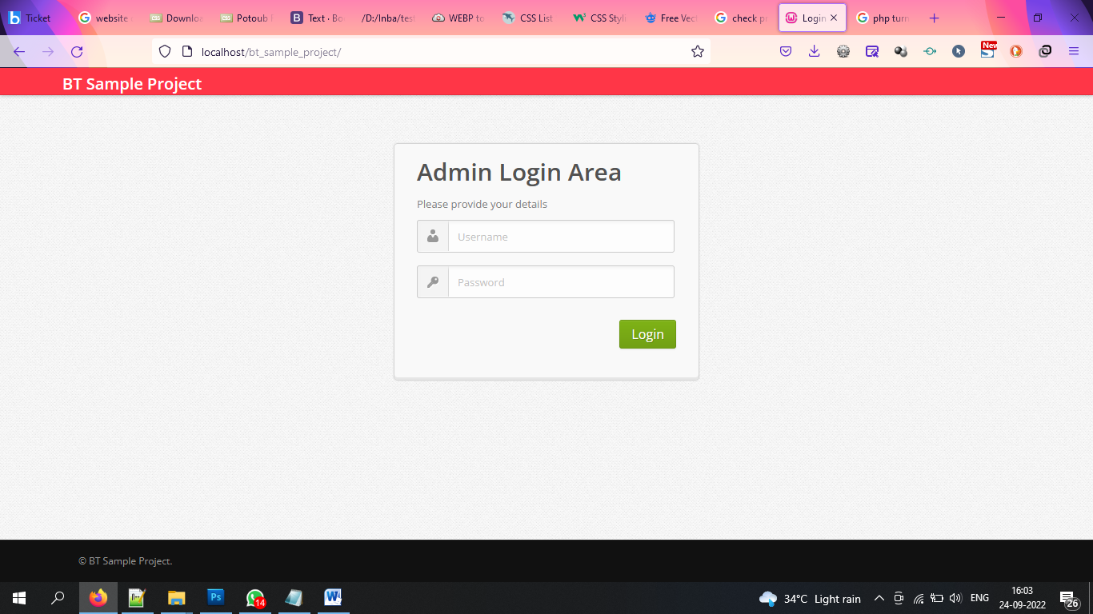

Dashboard

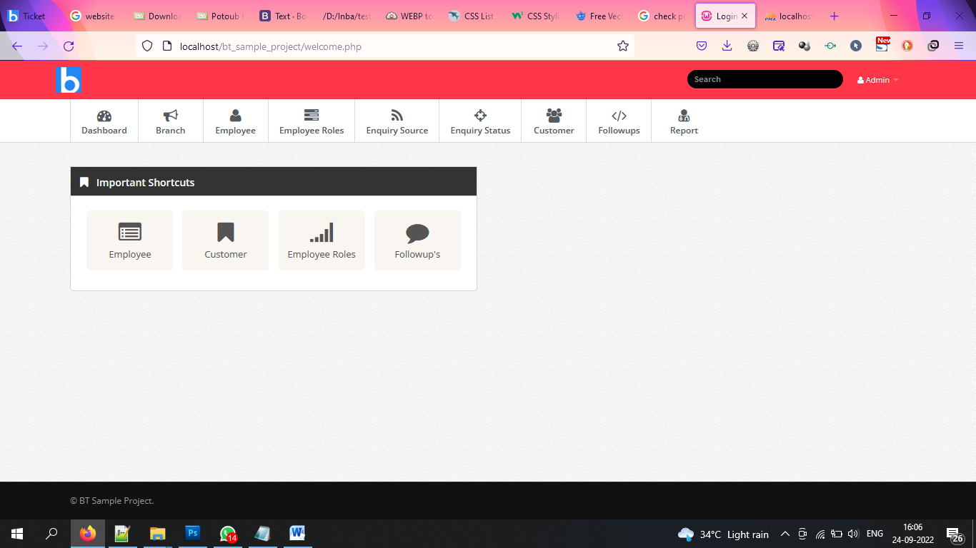

Employee Details

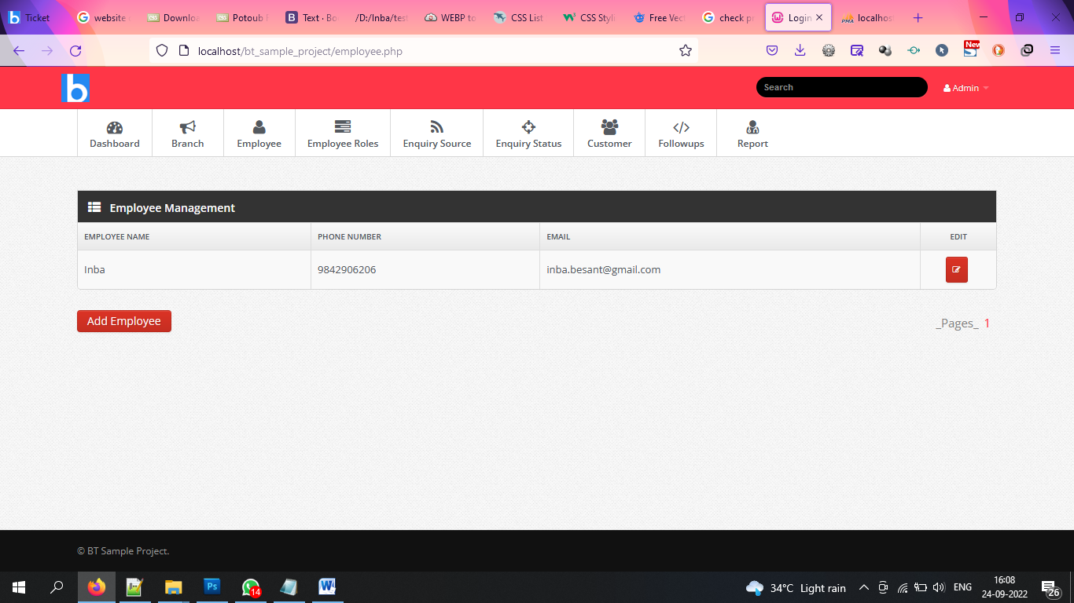

Edit Employee Details

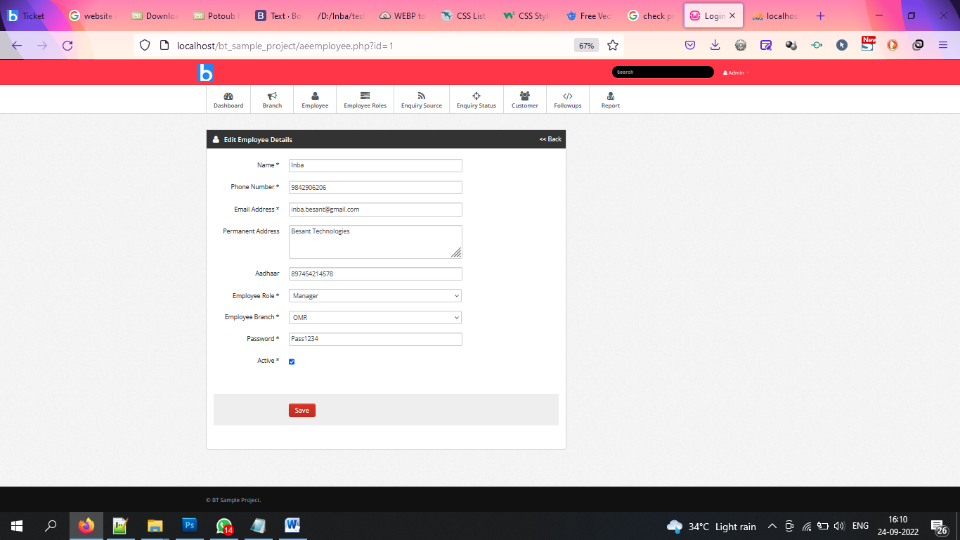

1. Same way as you did for employee details create a page for Employee Roles provide an option to ADD, EDIT and DELETE.
2. In Employee details display the role option in select box.