7COM1079-0901-2025 - Team Research and Development Project

Final report title: The Relationship Between Alcohol Consumption and Academic Performance Among Secondary School Students.

Group ID: A216
Dataset number: DS241

Prepared by:

- Satya Prasad Narasala (24154759)
- Rohit Kasturi (24069584)
- Sathwika Matta (24158144)
- Pavan Nunsavath (24166942)

University of Hertfordshire
Hatfield, 2025

Table of Contents
1.Introduction 3
1.1 Problem Statement & Motivation 3
1.2 The Dataset 3
1.3 Research Question 3
1.4 Null & Alternative Hypotheses 3
2.Background research 4
2.1 Review of Relevant Research Papers 4
2.2 Why This Research Question Is of Interest 4
3. Visualisation 5
3.1 Appropriate Graphs for the Research Question 5
3.2 Purpose and Insights 6
3.3 Key Observations 6
4. Analysis 6
4.1 Statistical Test Used and Justification 6
4.2 Hypothesis Outcome and Interpretation of Results 7
5. Evaluation – Group’s Experience 7
5.1 What Went Well 7
5.2 Points for Improvement 7
5.3 Group’s Time Management 7
5.4 Project’s Overall Judgement 7
5.5 Changes in Group Allocation 8
5.6 Comment on the GitHub Log Output 8
6. Conclusions 8
6.1 Results Explained 8
6.2 Interpretation of the Results 8
6.3 Limitations and Future Work 8
7. References 9
Appendices 9
Appendix A: R code 9
Appendix B: 16

1.Introduction

1.1 Problem Statement & Motivation
Academic performance is affected by behavioural, social, demographic, lifestyle, and other factors, with alcohol consumption being a significant factor. Excessive teenage drinking has been linked to reduced cognitive skills, impaired memory, and lower academic achievement (DeRicco & Sciandra, 2016). Understanding this impact is crucial for educators, parents, and teenagers themselves. As secondary school students commonly experiment with alcohol consumption, analysing how drinking relates to final grades can offer valuable insights into potential academic risks. This study uses real-world student data to investigate whether alcohol consumption is associated with their final academic performance.

1.2 The Dataset
This study uses the “Student Alcohol Consumption” dataset, which contains information about secondary school students, including their personal background, parents' occupation and education, study habits and alcohol consumption levels. It mainly focuses on weekday and weekend drinking and their academic performance measured by final grade (G3). The data gives a good mix of behavioural, social and academic factors, allowing us to check if alcohol consumption has any real connection to student grades.

1.3 Research Question
The research question focuses on understanding whether students alcohol consumption has a statistically significant relationship with academic performance. We aim to see if drinking patterns show any meaningful connection to how well students perform in their final grades and whether higher alcohol intake corresponds to lower grades.

1.4 Null & Alternative Hypotheses
In order to answer the RQ, the hypotheses below are formulated.

Null Hypothesis H0: There is no significant relationship between alcohol consumption and final grade(G3).
Alternate Hypothesis H1: There is a significant relationship between alcohol consumption and final grade(G3).
The hypothesis will be tested using a non-parametric Spearman Rank correlation test and pearsons correlation test. But conclusions are based on Spearman's rank correlation.

2.Background research

2.1 Review of Relevant Research Papers
Several studies have investigated how alcohol consumption affects student performance. Paschall et al. (2005) found that adolescent drinking is associated with impaired cognitive functioning and poorer academic outcomes. Similarly, Martins et al. (2008) reported that students engaging in frequent alcohol use were more likely to have reduced school engagement and lower grades. Studies specifically using the Portuguese student alcohol dataset (Cortez & Silva, 2008) highlighted that lifestyle variables such as alcohol use, family support, and study time predict academic success.
Other educational data-mining research also supports the link between behavioural factors and academic performance. Romera et al. (2016) emphasised that substance use patterns among adolescents correlate with risk-taking behaviour, which influences school achievement. Together, these findings indicate that examining alcohol consumption offers meaningful insight into academic risk factors. This research builds upon prior studies by analysing weekday vs. weekend drinking separately and applying non-parametric correlation methods suitable for ordinal alcohol measures.

2.2 Why This Research Question Is of Interest
Despite extensive research on teenage or student alcohol use, fewer studies distinguish between weekday and weekend drinking patterns. Exploring both provides a more nuanced understanding of short-term vs. sustained behavioural effects on academic performance. Additionally, most existing studies use linear methods, even though alcohol measures are ordinal. This creates a methodological gap: the need for non-parametric monotonic analysis. Addressing this gap, the current study uses Spearman correlation to better reflect the data structure. Understanding these relationships may support intervention strategies in schools and guide future work on behavioural predictors of academic success

3. Visualisation

3.1 Appropriate Graphs for the Research Question

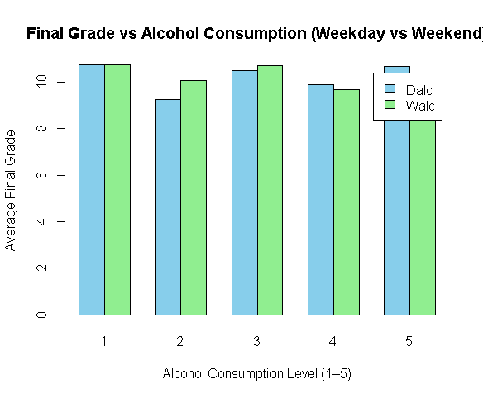

Figure 1 illustrates the grouped barplot comparing mean final grades at each alcohol level for weekday (Dalc) and weekend (Walc) drinking.

Students who report the lowest alcohol consumption (level 1) have slightly higher average grades compared to those at higher drinking levels. As alcohol levels increase from 1 to 5, the average grade shows a small decline, but the differences are not large. This reflects the weak negative correlation detected in the statistical results.

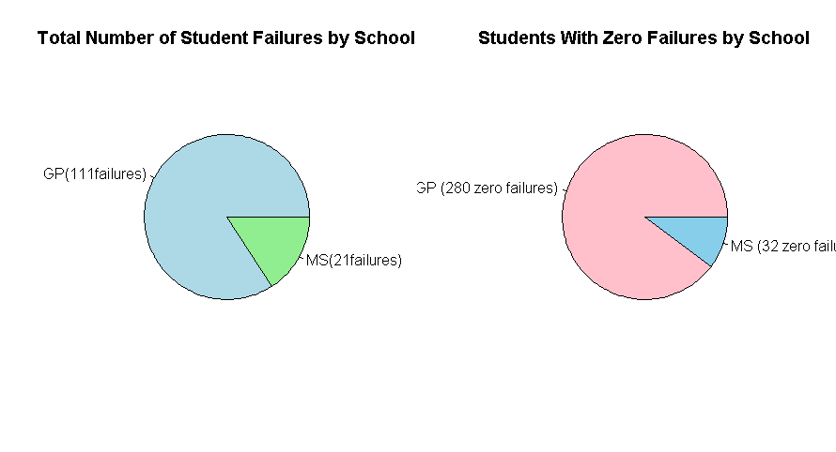

Figure 2: Pie chart for (Left) Total number of past failures by school; (Right) count of students with zero past failures by school. visualises the comparison of students failed and not failed, highlighting differences in how many students passes and how many failed by schools.

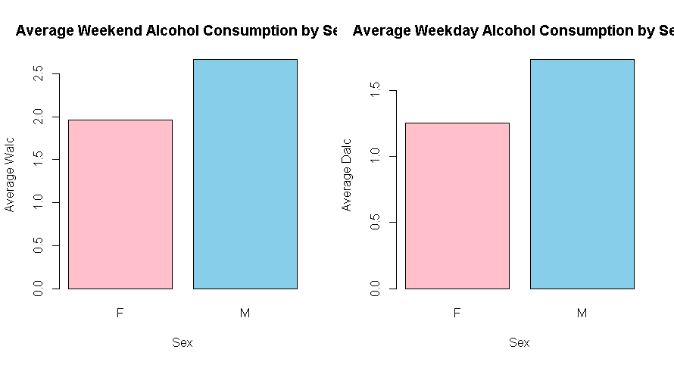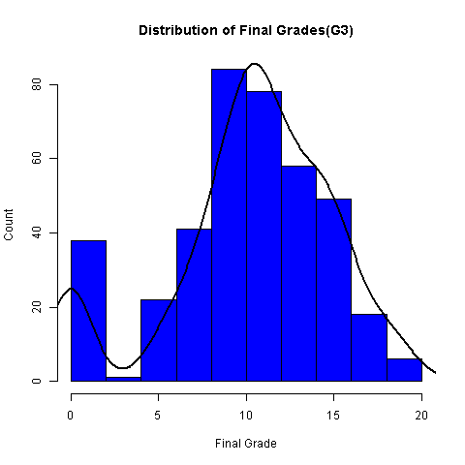
Fig3.1(Barplot by sex): (Left)Mean weekend and weekday alcohol consumption by sex (M vs F).
Fig3.2(Histogram with density curve): (Right) Histogram of Final Grades (G3) with density overlay. Shows that the majority of students achieve middle-range grades, with fewer very low or very high scores.

3.2 Purpose and Insights
The visualisations help reveal patterns between alcohol consumption and academic performance. The grade distribution identifies typical performance levels, while bar charts show how average grades vary across drinking levels. Differences between male and female alcohol use and school-level failure patterns provide additional context, supporting interpretation of the correlation results.

3.3 Key Observations
The visualisations show that final grades follow a moderately right-skewed distribution, with most students scoring in the middle range. Higher alcohol consumption levels correspond to slightly lower average grades, supporting the statistical finding of weak negative correlations. Additionally, male students consistently consume more alcohol than female students, and most failures occur in the larger school (GP). These visual patterns align with the statistical analysis and provide additional context for interpreting the relationship between alcohol use and academic performance.

4. Analysis

4.1 Statistical Test Used and Justification

A Spearman rank correlation test was used because both alcohol consumption variables (weekday and weekend) are measured on an ordinal scale from 1 to 5. This makes Spearman’s non-parametric approach more appropriate than Pearson’s linear correlation. Pearson correlation was still computed as a secondary check for linear trends and confidence intervals, but Spearman’s p-value determines hypothesis outcomes.

4.2 Hypothesis Outcome and Interpretation of Results
The Spearman’s Rank coefficient test revealed a statistically significant relationship.
For weekend drinking, N = 382, Spearman’s ρ = –0.1045, p = 0.03797. For weekday drinking, N = 382, Spearman’s coefficient = –0.1209, p = 0.01618. Pearson 95% confidence intervals were narrow and included small negative values. In both cases, p < 0.05. Therefore, we reject the null hypothesis (H₀) and accept the alternative hypothesis. There is statistically significant evidence of a monotonic negative relationship between alcohol consumption and final grades. The relationship is weak, it is statistically detectable that is grades tend to decrease slightly as alcohol use increases.

5. Evaluation – Group’s Experience

5.1 What Went Well
Our team collaborated effectively, especially during the data cleaning and analysis stages. The division of tasks according to their strengths allowed members to focus on specific components such as R coding, visualisation, and literature review. Regular discussions helped ensure all analyses aligned with the research question. The final correlation testing and interpretation were completed accurately using both Spearman and Pearson methods. GitHub is used to track the proof of work.

5.2 Points for Improvement
A key area for improvement would be early planning and scheduling. While the development of the project was effective, there were some difficulties to be dealt with in contributions and version control. Some tasks, such as background research and interpretation writing, were completed closer to the deadline than would be ideal. Future projects should incorporate more structured weekly goals and earlier merging of individual contributions to reduce the need for last-minute revisions.

5.3 Group’s Time Management
Time management improved throughout the project when the tasks were assigned individually, and then things got easier. Initial delays meant statistical analysis was completed under time pressure. A more consistent workflow earlier would improve efficiency and reduce stress.

5.4 Project’s Overall Judgement
Overall, the project successfully achieved its objectives. However, an initial weakness in planning reduced the depth of analysis. The group analysed a real educational dataset, applied appropriate statistical tests, coordinated and interpreted results correctly. The work met academic standards and produced meaningful insights.

5.5 Changes in Group Allocation

There are no changes to the original group.

5.6 Comment on the GitHub Log Output
The GitHub activity graph shows a steady pace of contributions from all the team members. Frequent commits indicate a progress in development and learning from feedback. The log ensures transparent versioning and allows accountability shared among all members throughout the project. Full commit history for this project is given in Appendix B.

- Commit Message: [Performed dataset analysis and added descriptive statistics for alcohol consumption and student grades.] This commit tells that we have analysed the dataset and did data wrangling like renaming columns.
- Commit Message: [Updated code with all the visualisations and statistical tests.] This tells us that we have done all the visualisations and statistical tests like Spearman's rank and pearson coefficient tests.

6. Conclusions

6.1 Results Explained
Both weekday and weekend alcohol consumption showed statistically significant results with p-value = 0.037 and 0.0167, but weak negative correlations with final academic performance. This suggests that increases in alcohol use are linked to small decreases in grades. Although the effect sizes are modest, the consistency between the two variables strengthens the reliability of this finding. Therefore, we reject the null hypothesis and accept the alternative hypothesis.

6.2 Interpretation of the Results
The results indicate that higher alcohol consumption correlates with lower academic outcomes, even if the relationship is not strong. This may reflect the impact of alcohol drinking on study habits, concentration, or school engagement. As both weekday and weekend alcohol drinking showed similar trends, alcohol consumption may broadly affect students academic performance.

6.3 Limitations and Future Work
The dataset is self-reported, which may introduce bias and cannot establish a direct effect between alcohol consumption and grades. The alcohol measures use a simple 1–5 scale, reducing precision. Future work could apply regression models with additional variables or investigate whether alcohol effects differ across demographic subgroups.

7. References

• Cortez, P. & Silva, A. (2008) Using Data Mining to Predict Secondary School Student Performance. University of Minho.
• Paschall, M. et al. (2005) ‘Effects of alcohol use on academic performance’, Addictive Behaviors, 30(12), pp. 2157–2167.
• Romera, E. et al. (2016) ‘Risk behaviours and school performance among adolescents’, Educational Psychology Review, 28(1), pp. 123–140.
• Martins, S. et al. (2008) ‘Adolescent substance use and academic performance’, Journal of Studies on Alcohol and Drugs, 69(1), pp. 71–78.

Appendices

Appendix A: R code

# Load required libraries
library(ggplot2)
library(dplyr)

# 1. DATA LOADING AND PREPARATION

cat("=== LOADING DATASET ===\n\n")

# Read dataset
data <- read.csv("student-mat.csv")

# Display dataset structure
cat("--- STUDENT ALCOHOL DATASET ---\n")
cat("Columns:", paste(colnames(data), collapse=", "), "\n")
cat("Dimensions:", nrow(data), "rows x", ncol(data), "columns\n\n")

str(data)
summary(data)

# Check for missing values
cat("\nMissing values per column:\n")
print(colSums(is.na(data)))

# checking the unique values of each columns.
for (col in colnames(data)){
cat(col,":",length(unique(data[[col]])), "\n", sep = "")
}

# 2. DATA CLEANING AND SELECTION

cat("=== DATA CLEANING ===\n\n")

# Remove missing values (if any)
data_clean <- na.omit(data)
cat("Rows after removing NA:", nrow(data_clean), "\n\n")

# Select variables relevant to research question
data_clean <- data_clean[, c("school","sex", "age", "studytime", "failures", "goout","Dalc", "Walc", "G1", "G2", "G3")]

num_cols <- c("age","studytime","failures","goout",
"Dalc","Walc","G1","G2","G3")

for (col in num_cols) {
data_clean[[col]] <- as.numeric(data_clean[[col]])
}

# Renaming columns
colnames(data_clean)[colnames(data_clean) == "Dalc"] <- "Weekday_Alcohol"
colnames(data_clean)[colnames(data_clean) == "Walc"] <- "Weekend_Alcohol"
colnames(data_clean)[colnames(data_clean) == "G3"] <- "Final_Grade"

cat("--- FINAL CLEANED DATASET ---\n")
str(data_clean)
head(data_clean, 8)

# 3. DESCRIPTIVE STATISTICS

cat("\n\n=== DESCRIPTIVE STATISTICS ===\n\n")

# Weekday Alcohol (Dalc)
describe_var <- function(x, label){
cat("\n--", label, "--\n")
cat("n:", sum(!is.na(x)), "\n")
cat("Mean:", round(mean(x, na.rm = TRUE), 2), "\n")
cat("SD:", round(sd(x, na.rm = TRUE), 2), "\n")
cat("Median:", median(x, na.rm = TRUE), "\n")
cat("Min:", min(x, na.rm = TRUE), "\n")
cat("Max:", max(x, na.rm = TRUE), "\n")
}

describe_var(data_clean$Weekday_Alcohol, "Weekday Alcohol (Dalc)")
describe_var(data_clean$Weekend_Alcohol, "Weekend Alcohol (Walc)")
describe_var(data_clean$Final_Grade, "Final Grade (G3)")

# 4. VISUALIZATIONS
cat("=== CREATING VISUALIZATIONS ===\n\n")

# scatter plot categorised by sex (your original graph)

sex_colors <- ifelse(data_clean$sex == "F", "red", "blue")

plot(data_clean$Weekend_Alcohol, data_clean$Final_Grade,
col = adjustcolor(sex_colors, alpha.f = 0.7),
pch = 19,
main = "Weekend Alcohol Consumption vs Final Grade",
xlab = "Weekend Alcohol (Walc)",
ylab = "Final Grade (G3)")
legend("topright",
legend = c("Female", "Male"),
col = c("red", "blue"),
pch = 19)

# Histogram plot of Weekday Alcohol.

par(mfrow = c(1, 2))

hist(data_clean$Weekday_Alcohol,
main = "Distribution of Weekday Alcohol Consumption",
xlab = "Dalc Level",
ylab = "Frequency",
col = "steelblue",
border = "black",
breaks = seq(0.5, 5.5, by = 1))

cat("Displayed: Histogram of Weekday Alcohol\n")

hist(data_clean$Weekend_Alcohol,
main = "Distribution of Weekend Alcohol Consumption",
xlab = "Walc Level",
ylab = "Frequency",
col = "lightblue",
border = "black",
breaks = seq(0.5, 5.5, by = 1))
par(mfrow = c(1, 1))

# distribution of final grade(g3) histogram plot.
hist(data$G3,breaks = 10,col = "blue",main = "Distribution of Final Grades(G3)", xlab = "Final Grade", ylab = "Count",freq = TRUE, border = "Black")
dens<-density(data$G3)
scaled_y <- dens$y * diff(hist(data$G3, plot = FALSE)$breaks[1:2]) * length(data$G3)
lines(dens$x, scaled_y, lwd = 2)

#Box plot for final grade by study time.

boxplot(split(data_clean$Final_Grade, data_clean$studytime),
main = "Final Grade by Study Time",
xlab = "Study Time (1 = low, 4 = high)",
ylab = "Final Grade",
col = c("lightblue","lightgreen","khaki","lightpink"))

# Boxplot for final grades and no of failures
boxplot(split(data_clean$Final_Grade, data_clean$failures),
main = "Final Grade by Number of Past Failures",
xlab = "Failures",
ylab = "Final Grade",
col = "lightcoral")

# barplot for Average alcohol consumption on weekdays and weekends with respect to final grade.
par(mfrow = c(1, 2))

avg_grades_walc <- tapply(data_clean$Final_Grade, data_clean$Weekend_Alcohol, mean)

barplot(avg_grades_walc,
main = "Average Final Grade by Weekend Alcohol Level",
xlab = "Weekend Alcohol (Walc)",
ylab = "Average Grade",
col = "steelblue")

avg_grades_dalc <- tapply(data_clean$Final_Grade, data_clean$Weekday_Alcohol, mean)

barplot(avg_grades_dalc,
main = "Average Final Grade by Weekday Alcohol Level",
xlab = "Weekday Alcohol (Dalc)",
ylab = "Average Grade",
col = "steelblue")
par(mfrow = c(1, 1))

# Barplot for weekend drink by going out.
avg_walc_goout <- tapply(data_clean$Weekend_Alcohol, data_clean$goout, mean)

barplot(avg_walc_goout,
main = "Average Weekend Drinking by Going-Out Level",
xlab = "Going Out (1–5)",
ylab = "Average Weekend Alcohol Use",
col = "orange")

# barplot for Average alcohol consumption on weekdays and weekends with Sex.

par(mfrow = c(1, 2))
barplot(tapply(data_clean$Weekend_Alcohol, data_clean$sex, mean),
main = "Average Weekend Alcohol Consumption by Sex",
xlab = "Sex",
ylab = "Average Walc",
col=c("pink","skyblue"))

barplot(tapply(data_clean$Weekday_Alcohol, data_clean$sex, mean),
main = "Average Weekday Alcohol Consumption by Sex",
xlab = "Sex",
ylab = "Average Dalc",
col=c("pink","skyblue"))
par(mfrow = c(1, 1))

# Count total failures per school
failures_by_school <- tapply(data_clean$failures, data_clean$school, sum)
failures_by_school
# Pie chart for total failures by school
par(mfrow = c(1, 2))
pie(failures_by_school,
labels = paste(names(failures_by_school),
"(", failures_by_school, "failures)", sep=""),
main = "Total Number of Student Failures by School",
col = c("lightblue", "lightgreen"))

# Pie chart for total passed students % by school

zero_fail <- tapply(data_clean$failures == 0, data_clean$school, sum)
pie(zero_fail,
labels = paste(names(zero_fail), " (", zero_fail, " zero failures)", sep=""),
main = "Students With Zero Failures by School",
col = c("pink","skyblue"))
par(mfrow = c(1, 1))

# Combined Scatter plot Comparing Dalc & Walc Together

# Calculate mean final grade for each alcohol level
avg_dalc <- tapply(data_clean$Final_Grade, data_clean$Weekday_Alcohol, mean)
avg_walc <- tapply(data_clean$Final_Grade, data_clean$Weekend_Alcohol, mean)

# Combine into matrix for grouped barplot
grade_matrix <- rbind(avg_dalc, avg_walc)

# Create grouped barplot
barplot(grade_matrix,
beside = TRUE,
col = c("skyblue", "lightgreen"),
main = "Final Grade vs Alcohol Consumption (Weekday vs Weekend)",
xlab = "Alcohol Consumption Level (1–5)",
ylab = "Average Final Grade",
legend.text = c("Dalc", "Walc"))

cat("Displayed: Combined Scatterplot of Alcohol Consumption vs Final Grade\n")

# 5. CORRELATION ANALYSIS

cat("\n=== 5. CORRELATION ANALYSIS ===\n")

# Prepare complete-case masks
idx_wknd <- complete.cases(data_clean$Weekend_Alcohol, data_clean$Final_Grade)
idx_wkdy <- complete.cases(data_clean$Weekday_Alcohol, data_clean$Final_Grade)

n_wknd <- sum(idx_wknd)
n_wkdy <- sum(idx_wkdy)
cat("N (WeekendAlcohol vs FinalGrade):", n_wknd, "\n")
cat("N (WeekdayAlcohol vs FinalGrade):", n_wkdy, "\n\n")

# SPEARMAN CORRELATION TEST
spearman_wknd <- cor.test(data_clean$Weekend_Alcohol[idx_wknd],
data_clean$Final_Grade[idx_wknd],
method = "spearman", exact = FALSE)

spearman_wkdy <- cor.test(data_clean$Weekday_Alcohol[idx_wkdy],
data_clean$Final_Grade[idx_wkdy],
method = "spearman", exact = FALSE)

cat("-- Spearman Results --\n")
cat("Weekend Alcohol vs Final Grade: Spearman rho =", round(spearman_wknd$estimate, 4),
", p =", signif(spearman_wknd$p.value, 4), "\n")
cat("Weekday Alcohol vs Final Grade: Spearman rho =", round(spearman_wkdy$estimate, 4),
", p =", signif(spearman_wkdy$p.value, 4), "\n\n")

# PEARSON CORRELATION TEST
pearson_wknd <- cor.test(data_clean$Weekend_Alcohol[idx_wknd],
data_clean$Final_Grade[idx_wknd],
method = "pearson")

pearson_wkdy <- cor.test(data_clean$Weekday_Alcohol[idx_wkdy],
data_clean$Final_Grade[idx_wkdy],
method = "pearson")

cat("-- Pearson Results--\n")
cat("Weekend Alcohol vs Final Grade: r =", round(pearson_wknd$estimate, 4),", p =", signif(pearson_wknd$p.value, 4), "\n")
cat("Weekday Alcohol vs Final Grade: r =", round(pearson_wkdy$estimate, 4),", p =", signif(pearson_wkdy$p.value, 4), "\n\n")

# 6. INTERPRETATION (Prioritise Spearman)

cat("\n=== 6. INTERPRETATION ===\n")
interpret_spearman <- function(s_obj, label){
rho <- as.numeric(s_obj$estimate)
pval <- s_obj$p.value
if (pval < 0.05) {
cat(label, ": Spearman rho =", round(rho,4),
" statistically significant (p =", signif(pval,4),
"). Interpretation: evidence of a relationship between student grades and alcohol consumption.\n")
} else {
cat(label, ": Spearman rho =", round(rho,4),
" not statistically significant (p =", signif(pval,4),
"). Interpretation: no evidence of a relationship between student grades and alcohol consumption.\n")
}
}

interpret_spearman(spearman_wknd, "Weekend Alcohol vs Final Grade")
interpret_spearman(spearman_wkdy, "Weekday Alcohol vs Final Grade")

#Results in a table for better understanding.
summary_df <- data.frame(
test = c("Spearman_rho_wknd","Spearman_p_wknd","Pearson_r_wknd","Pearson_p_wknd",
"Spearman_rho_wkdy","Spearman_p_wkdy","Pearson_r_wkdy","Pearson_p_wkdy"),
value = c(as.numeric(spearman_wknd$estimate), spearman_wknd$p.value, as.numeric(pearson_wknd$estimate), pearson_wknd$p.value,
as.numeric(spearman_wkdy$estimate), spearman_wkdy$p.value, as.numeric(pearson_wkdy$estimate), pearson_wkdy$p.value)
)

print(table(summary_df))

Appendix B:

commit c40ffa077da9d1ed517d63b600d606e7c1df493b (HEAD -> main, origin/main, origin/HEAD)
Author: satya0201 <sn25abv@herts.ac.uk>
Date: Thu Dec 11 18:52:05 2025 +0000

updated the spearman test results.

commit eec67f2cbc63491ed977027d04cf412111879cff
Merge: f1a24a7 fe64b42
Author: satya0201 <sn25abv@herts.ac.uk>
Date: Thu Dec 11 18:47:24 2025 +0000

Updated code with all the visualisations and statistical tests. (#4)

Added all the new visualisations as per the RQ and interpreted two
statistical tests, which gave the results regarding rejecting or
accepting the null hypothesis.

commit fe64b42b6164d9b3000e8a0271b2dbbcc1ec896d (origin/satya0201-patch-1)
Author: satya0201 <sn25abv@herts.ac.uk>
Date: Thu Dec 11 18:44:37 2025 +0000

Updated code with all the visualisations and statistical tests.

commit f1a24a723894731edf3725dd52bf26da0c5174c7
Author: Rohit Kasturi <rk25acr@herts.ac.uk>
Date: Mon Dec 8 19:56:40 2025 +0000

Description

commit 6d31af153d75b65a0f8a318a8bc0210031c21ea0
Author: Rohit Kasturi <rk25acr@herts.ac.uk>
Date: Sun Dec 7 23:34:13 2025 +0000

Create Problem Statement

commit ab586a12b8e68e4f6477b662d5244b5850fa080c
Author: Rohit Kasturi <rk25acr@herts.ac.uk>
Date: Sun Dec 7 23:31:40 2025 +0000

Scatter Plot.R

commit 8f510e273df19f064d74a092f73d8db7eacb4a3e
Author: satya0201 <sn25abv@herts.ac.uk>
Date: Tue Dec 9 23:20:12 2025 +0000

added the interpretation to check the p-value and compare with the p-value threshold.

added the interpretation to check the p-value and compare with the p-value threshold. And finalise whether to accept or reject null and aternative hypothesis.

commit f4ef37f1adfb8b46c585632fa170bd5ef447e24b
Author: satya0201 <sn25abv@herts.ac.uk>
Date: Tue Dec 9 23:17:40 2025 +0000

added some visualisations and performed statistical tests.

commit 22baa06acc76e624af8060175d7f85fc25485730
Merge: 3f38e7c ccea2c1
Author: satya0201 <sn25abv@herts.ac.uk>
Date: Tue Dec 9 23:09:14 2025 +0000

Added descriptive statistics and did data wrangling. (#2)

Did some data cleaning and generated the descriptive statistics and
renamed required columns for the analysis.

commit ccea2c1fd3e7ccd36fcaf1418d2a3a120e0bff29 (origin/pavan-n-2002-patch)
Author: pavan-n-2002 <pn25aar@herts.ac.uk>
Date: Tue Dec 9 23:06:55 2025 +0000

Added descriptive statistics and did data wrangling.

Did some data cleaning and generated the descriptive statistics and renamed required columns for the analysis.

commit 3f38e7c6645424298fc30febc1d067e55068832c
Merge: 60556f4 a5a85a9
Author: satya0201 <sn25abv@herts.ac.uk>
Date: Tue Dec 9 22:35:34 2025 +0000

Performed dataset analysis and added descriptive statistics for alcoh… (#1)

This pull request includes the initial analysis of the dataset.

Data loading and preparation

Missing value checks

Descriptive statistics for Dalc, Walc, and G3

Basic data exploration outputs.

commit a5a85a9ec36040d8bfd26af44f5e6a0d8993e581 (origin/sathwikamatta-patch-1)
Author: sathwikamatta <sm25aed@herts.ac.uk>
Date: Tue Dec 9 22:32:37 2025 +0000

Performed dataset analysis and added descriptive statistics for alcohol consumption and student grades.

commit 60556f469749b3f4ac06e07383645b27d448dec5
Author: satya0201 <sn25abv@herts.ac.uk>
Date: Sun Dec 7 18:57:18 2025 +0000

Analysing , exploring, and visualising the data

Analysed the data, understood and explored the data, then visualised the data to find patterns.

commit f016d96e17ceaf262d7eac4ca9b3cc0b19a8d747
Author: satya0201 <sn25abv@herts.ac.uk>
Date: Thu Nov 27 15:53:30 2025 +0000

Upload data set

