**Install GIT & make sure it is added into PATH.**

**Section 0 -Use GIT as local VCS. Steps to follow:**

1. **Create a directory ‘project_dir’ & cd to ‘project_dir’.**

**Ans. 1.** 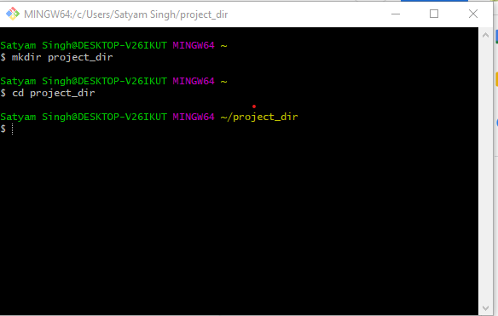

1. **Initialize git version database. (git init)**

**Ans.** 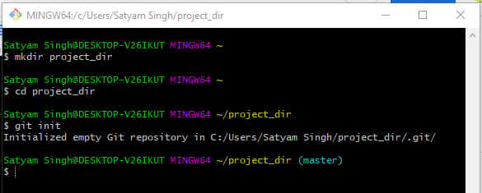

1. **Create a new file index.html.**

**Ans.** 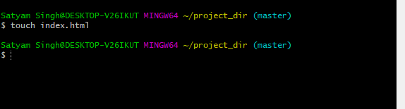

1. **Check the git status. You should find index.html as untracked file.**

**Ans.** 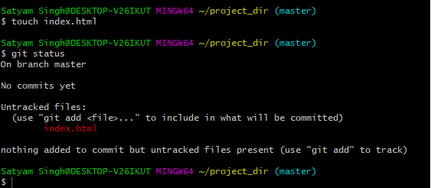

1. **Stage the index.html file.**

**Ans.** 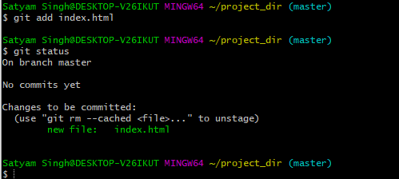

1. **Commit index.html**

**Ans.** 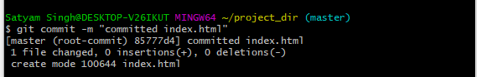

1. **Make few changes in index.html & create a new file info.txt file.**

**Ans.**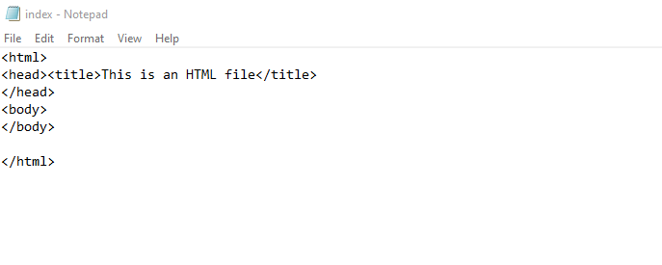



1. **Check git status. You should find index.html & info.txt as untracked files.**

**Ans.**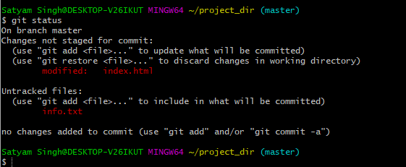

1. **Configure GIT to ignore all txt files.**

**Ans. **

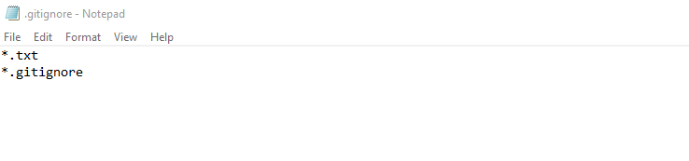

1. **Again check the git status. You should find only index.html as untracked file.**

**Ans.**

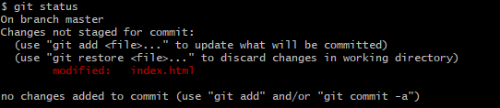

1. **State & commit index.html**

**Ans.** 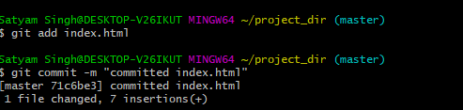

1. **Log all your comments so far.**

**Ans.** 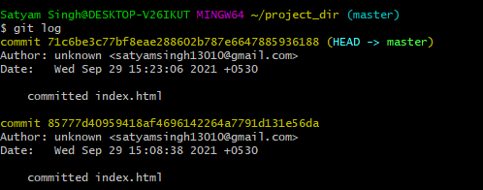

1. **Make some changes in index.html.**

**Ans.**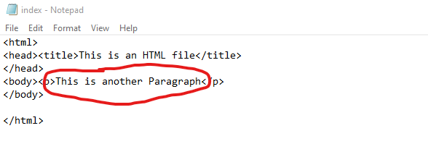

1. **Revert the change made in the previous step using git command.**

**Ans.**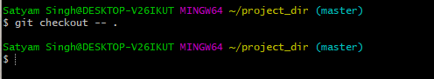

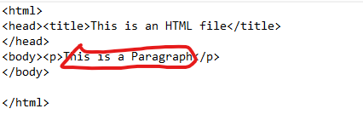

1. **Again change index.html.**

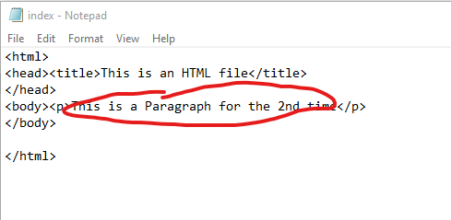

1. **Stage index.html**

**Ans. **

1. **Revert back the last stage.**

**Ans.** 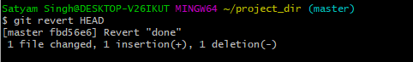

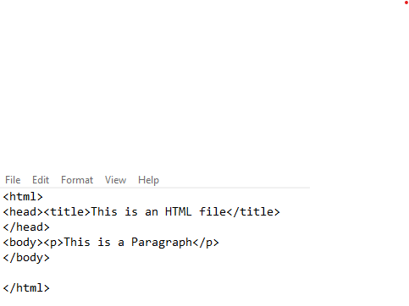

1. **Rename ‘add’ command to ‘my-add’.**

**Ans.**



1. **Using my_add command Stage index.html again & commit the changes.**

**Ans.** 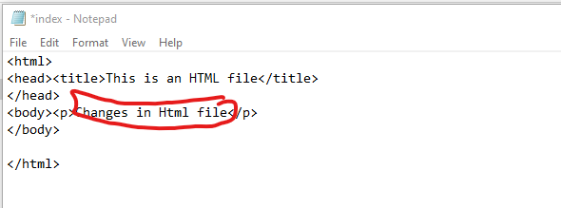

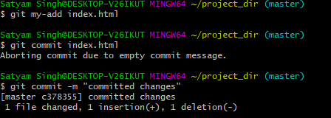

1. **Revert the last commit.**

**Ans.** 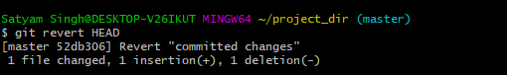

***GIT Branching***

**Objective: Commit HTML, CSS & JavaScript assignments into GIT.**

**SECTION-1 (HTML assignments) - Steps to follow:**

1. **First take a backup of your assignments & projects. This is required because due to incorrect GIT operation you may lose your files.**

**Ans. **

1. **Create an empty directory ‘Assignments’ & cd to ‘Assignments’.**

**Ans.** 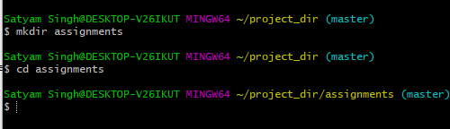

1. **Create a file README.txt inside ‘Assignments’ & write a few lines about the contents of ‘Assignments’ folder.**

**Ans.**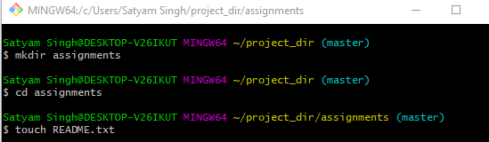

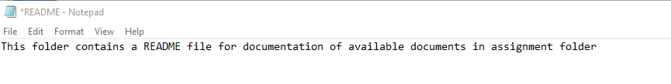

1. **Commit README.txt file.**

**Ans.**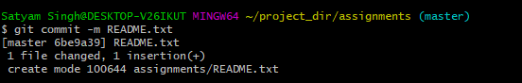

1. **Now create a new branch ‘html-assignments’.**

**Ans.**

1. **Switch to ‘html-assignments’ branch.**

**Ans.**

1. **Copy all HTML assignments inside ‘Assignments’ folder.**

**Ans. **

1. **Commit HTML assignments into ‘html-assignments’ branch.**

**Ans.**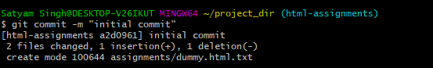

1. **Make minor changes into few files belonging to ‘html-assignments’ branch.**

**Ans.** 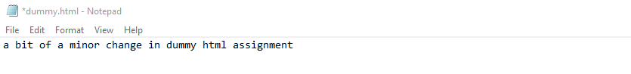

1. **Commit those changed files.**

**Ans.**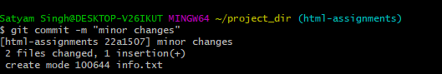

1. **Switch to master branch.**

**Ans.** 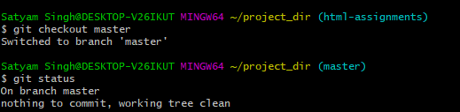

1. **Make minor changes into README.txt file & commit those changes into master.**

**Ans.** 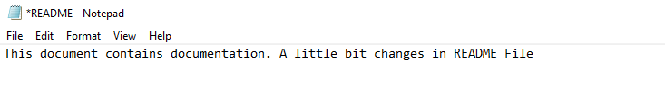

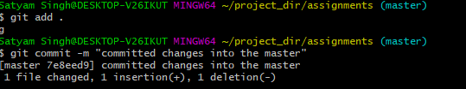

1. **Again switch to ‘html-assignments’ branch.**

**Ans.**

1. **Make minor changes into few files belonging to ‘html-assignments’ branch.**

**Ans.**

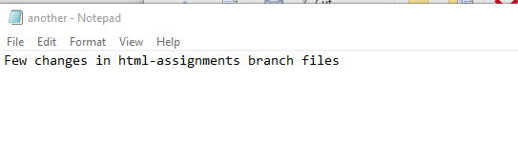

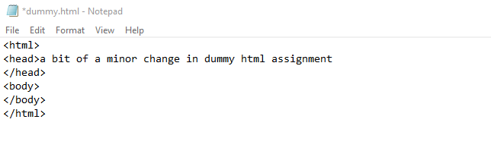

1. **Commit those changes.**

**Ans.** 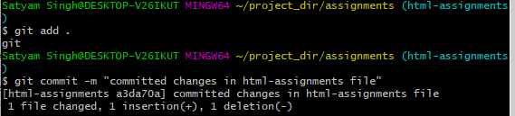

1. **Switch to master..**

**Ans.**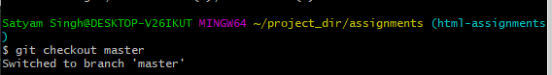

1. **Merge ‘html-assignments’ branch into master. Confirm all html assignments are shown in master.**

**Ans.**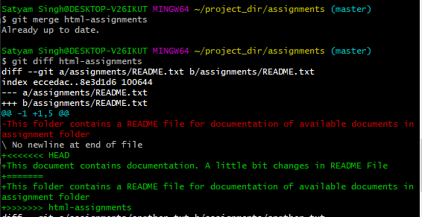

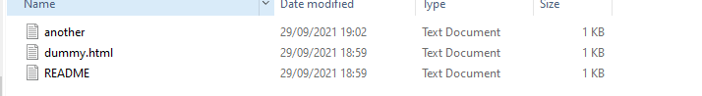

**the another and dummy files are shown**

1. **Finally delete the ‘html-assignments’ branch.**

**Ans.**

**SECTION-2 - (CSS assignments) Steps to follow:**

1. **Create a new branch ‘css-assignments’.**

**Ans.**

1. **Switch to ‘css-assignments’ branch.**

**Ans.**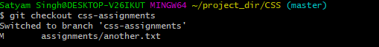

1. **Copy all CSS assignments inside ‘Assignments’ folder.**

**Ans.**

1. **Commit CSS assignments into ‘css-assignments’ branch.**

**Ans.** 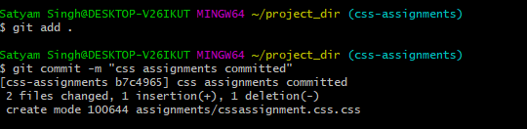

1. **Make minor changes into README.txt file on line 1 belonging to ‘css-assignments’ branch.**

**Ans.**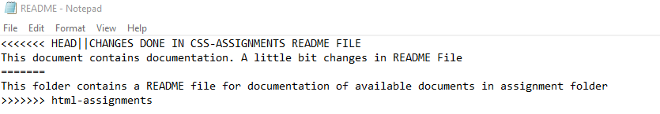

1. **Commit those changed files.**

**Ans.**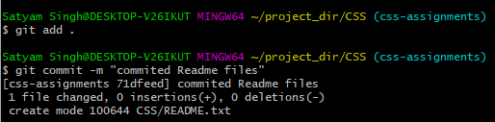

1. **Switch to master branch.**

**Ans.**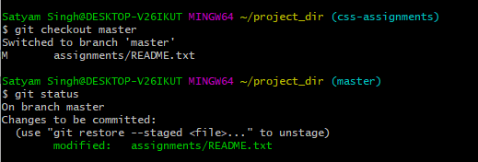

1. **Make minor changes into README.txt file on line 3 & commit those changes into master.**

**Ans.**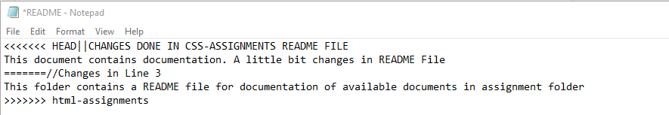

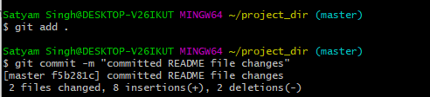

1. **Again switch to ‘css-assignments’ branch.**

**Ans. **

1. **Make minor changes into few files belonging to ‘css-assignments’ branch.**

**Ans.**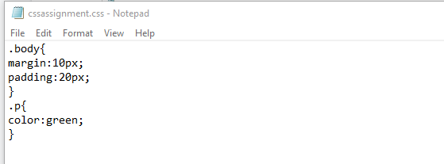

1. **Commit those changes.**

**Ans.**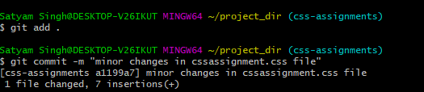

1. **Switch to master.**

**Ans.** 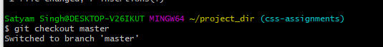

1. **Merge ‘css-assignments’ branch into master. Confirm all css assignments are shown in master.**

**Ans.** 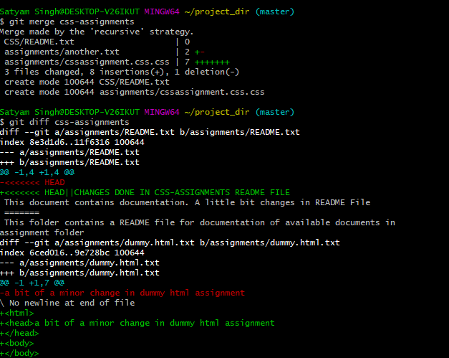

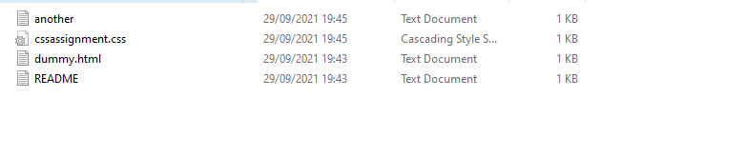**all files are present**

1. **Finally delete the ‘css-assignments’ branch.**

**Ans.**



**SECTION-3 - (JavaScript assignments) Steps to follow:**

1. **Create a new branch ‘js-assignments’.**

**Ans.**

1. **Switch to the ‘js-assignments’ branch.**

**Ans.**

1. **Copy all JavaScript assignments inside ‘Assignments’ folder.**

**Ans.**

1. **Commit JavaScript assignments into ‘js-assignments’ branch.**

**Ans.**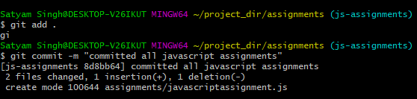

1. **Make minor changes into README.txt file on line 1 belonging to ‘js-assignments’ branch.**

**Ans. **

1. **Commit those changed files.**

**Ans.**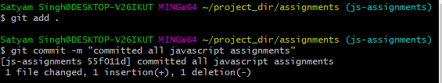

1. **Switch to master branch.**

**Ans.**

1. **Make minor changes into README.txt file on line 1 & commit those changes into master.**

**Ans.** 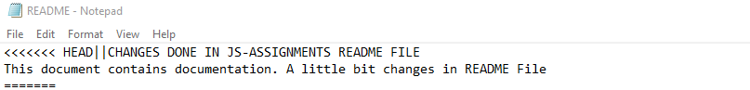

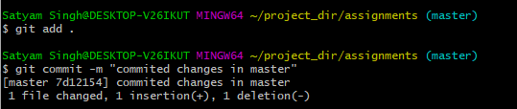

1. **Again switch to ‘js-assignments’ branch.**

**Ans. **

1. **Make minor changes into few files belonging to ‘js-assignments’ branch.**

**Ans.**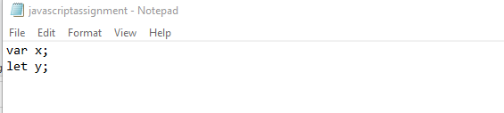

1. **Commit those changes.**

**Ans.**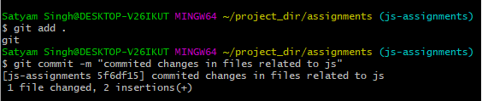

1. **Switch to master.**

**Ans.**

1. **Merge ‘js-assignments’ branch into master. Confirm all JavaScript assignments are shown in master.**

**Ans.**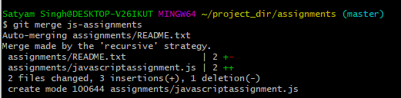

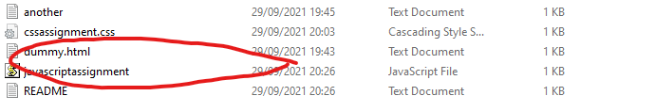

1. **Finally delete the ‘js-assignments’ branch.**

**Ans.**

***GIT Remoting***

**Objective: Pushing source code into GITHUB & collaborate team members.**

**SECTION-3 (Pushing assignments to remote repository) - Steps to follow:**

1. **Create a github account if you do not have already.**
2. **Login on into github account.**

**Ans.**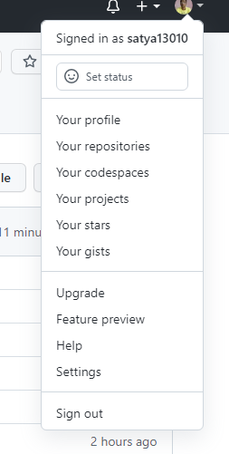

1. **Create new public repository ‘freshersbatch-oct16’.**

**Ans.**

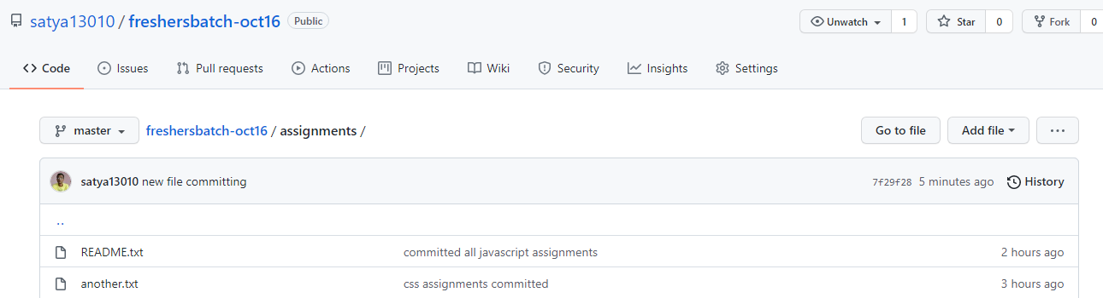

1. **Commit & push any sample file to this repository under ‘Assignments’ directory.**

**Ans.**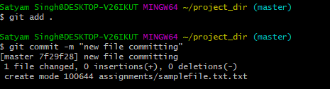

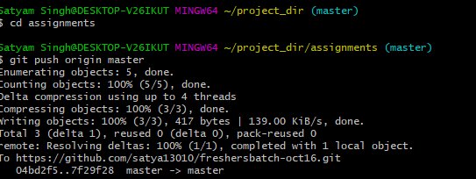

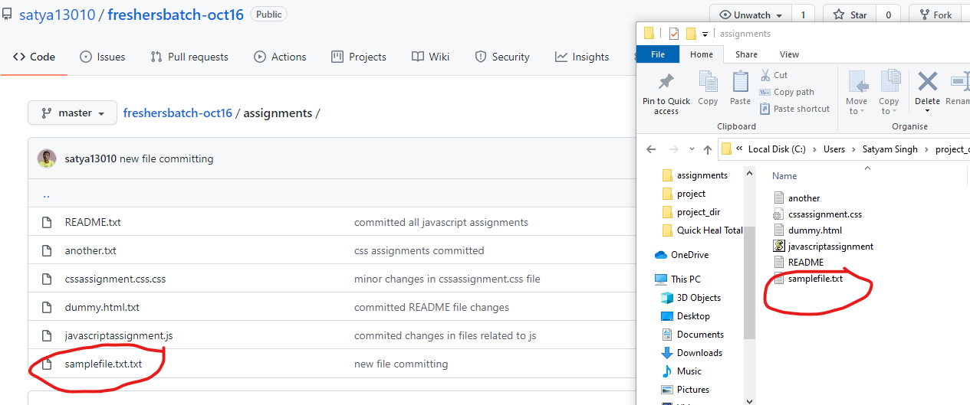

**SECTION-4 (Pushing source code to remote repository using Eclipse GIT plugin) - Steps to follow:**

1. **One developer from project team will create eclipse projects ‘SampleProj’ & add sample source code files. Then commit all files through eclipse GIT plugin.**
2. **Collaborate other team members with your github account so that they can also modify the committed files.**
3. **Other developers from same team will checkout all files from remote repository. This might get conflicts since certain files fail to merge. In such case, merge it manually.**
4. **Commit & push the ‘SampleProj’ project.**