**Garage Management System**

1. **Overview**

This project focuses on creating a **Garage Management System (GMS)** using Salesforce, designed to optimize vehicle service operations and customer management. By leveraging Salesforce's powerful features like **custom objects, workflows, automation tools, and dashboards**, the GMS will enhance operational efficiency, improve customer satisfaction, and support data-driven decision-making for garage businesses.

1. **Objective**

#### Business Goals:

* Centralize customer, vehicle, and service data in Salesforce.
* Automate workflows for booking, service updates, and billing.
* Provide real-time insights with custom reports and dashboards.

#### Specific Outcomes:

* **Custom Objects**: For managing vehicles, services, and inventory.
* **Automated Workflows**: For appointment confirmations, status updates, and low-stock alerts.
* **Role-Based Access**: Controlled access for customers, staff, and administrators.
* **Dashboards**: For tracking service performance, revenue, and customer trends

1. **Salesforce key features and concepts utilized**
2. **Custom Objects and Fields**:
   * Create objects like Customer, Vehicle, Service, and Inventory.
   * Add relationships and fields for storing relevant data.
3. **Automated Processes**:
   * **Workflow Rules**: Automate service status notifications.
   * **Process Builder**: Handle complex business logic.
   * **Flow Builder**: Guide users through multi-step processes.
4. **Validation Rules**:
   * Ensure data integrity (e.g., mandatory fields for service requests).
5. **Reports and Dashboards**:
   * Generate performance metrics and visualize trends.
6. **Security**:
   * Implement **Profiles** and **Permission Sets** for role-based access.
7. **App Builder**:
   * Create a customized app interface for garage management.
8. **Detailed steps to solution Design**

#### Step 1: Define Custom Objects

* **Customer Object**: Fields for Name, Contact Info, and Service History.
* **Appointment Object**: Fields for Make, Model, Year, VIN, and Customer Lookup.
* **Service Object**: Fields for Service Type, Status, Assigned Technician, and Cost.
* **Billing details and feedback Object**: Fields for Part Name, Quantity, and Reorder Level.

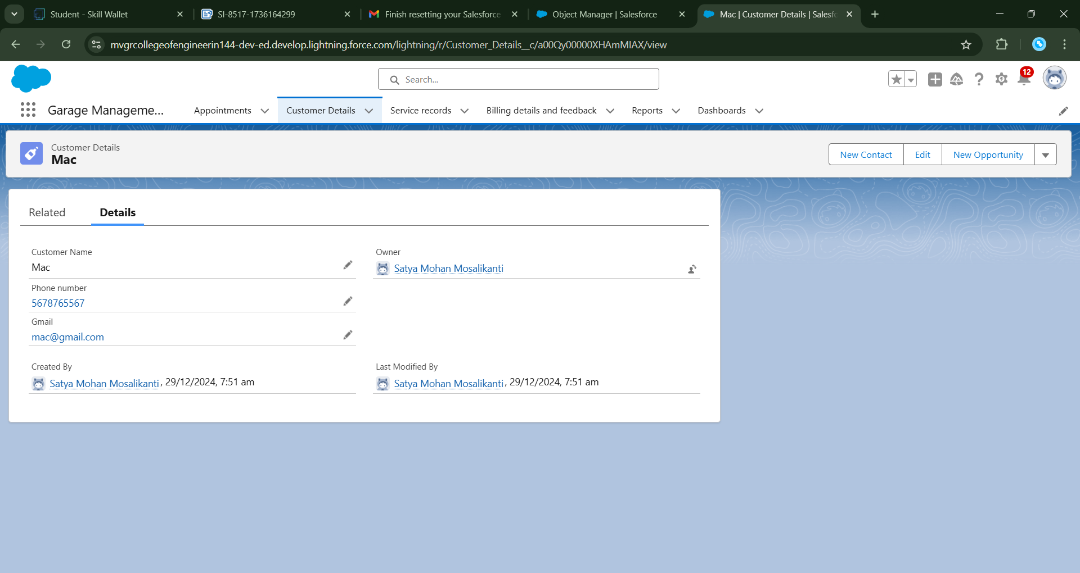

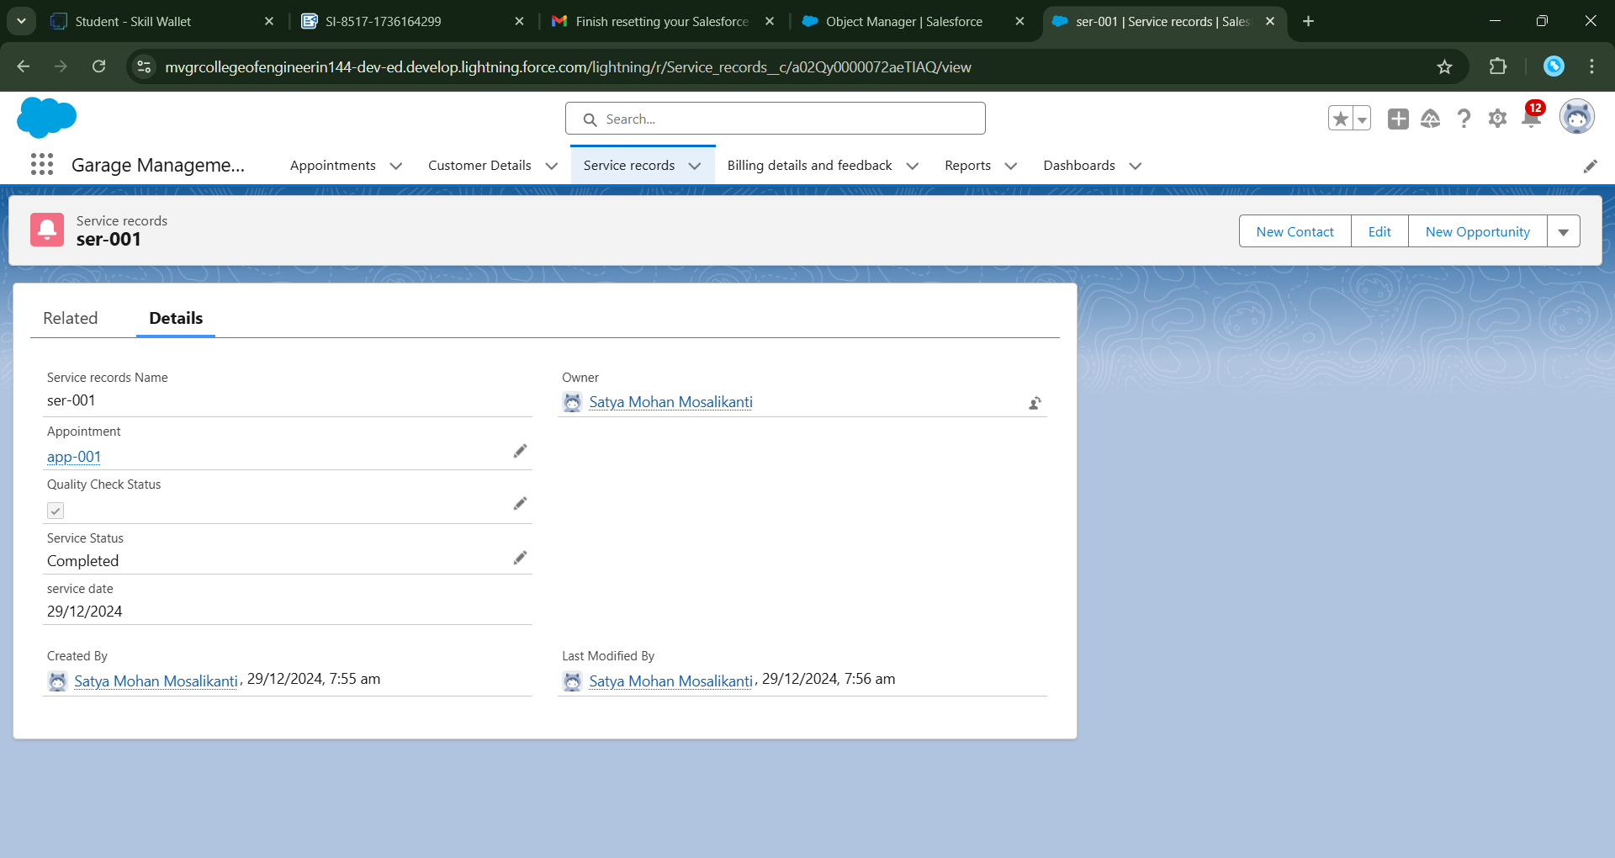

#### Step 2: Automate Key Processes

* Use **Workflow Rules** for sending automated emails and reminders.
* Create a **Flow** for managing service appointments, from booking to completion.
* Implement triggers or declarative automation for real-time stock updates.

#### Step 3: Design User Interface

* Use **Lightning App Builder** to create custom layouts for Customers, Vehicles, and Services.
* Add components like related lists and quick action buttons.

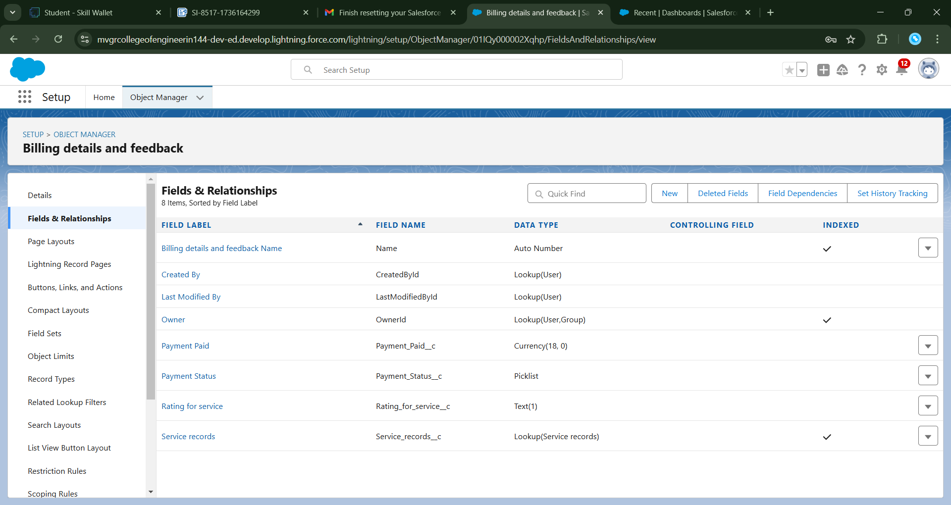

#### Step 4: Build Reports and Dashboards

* **Reports**: Service requests by type, top customers, inventory stock levels.
* **Dashboards**: Monthly revenue, technician performance, and pending services.

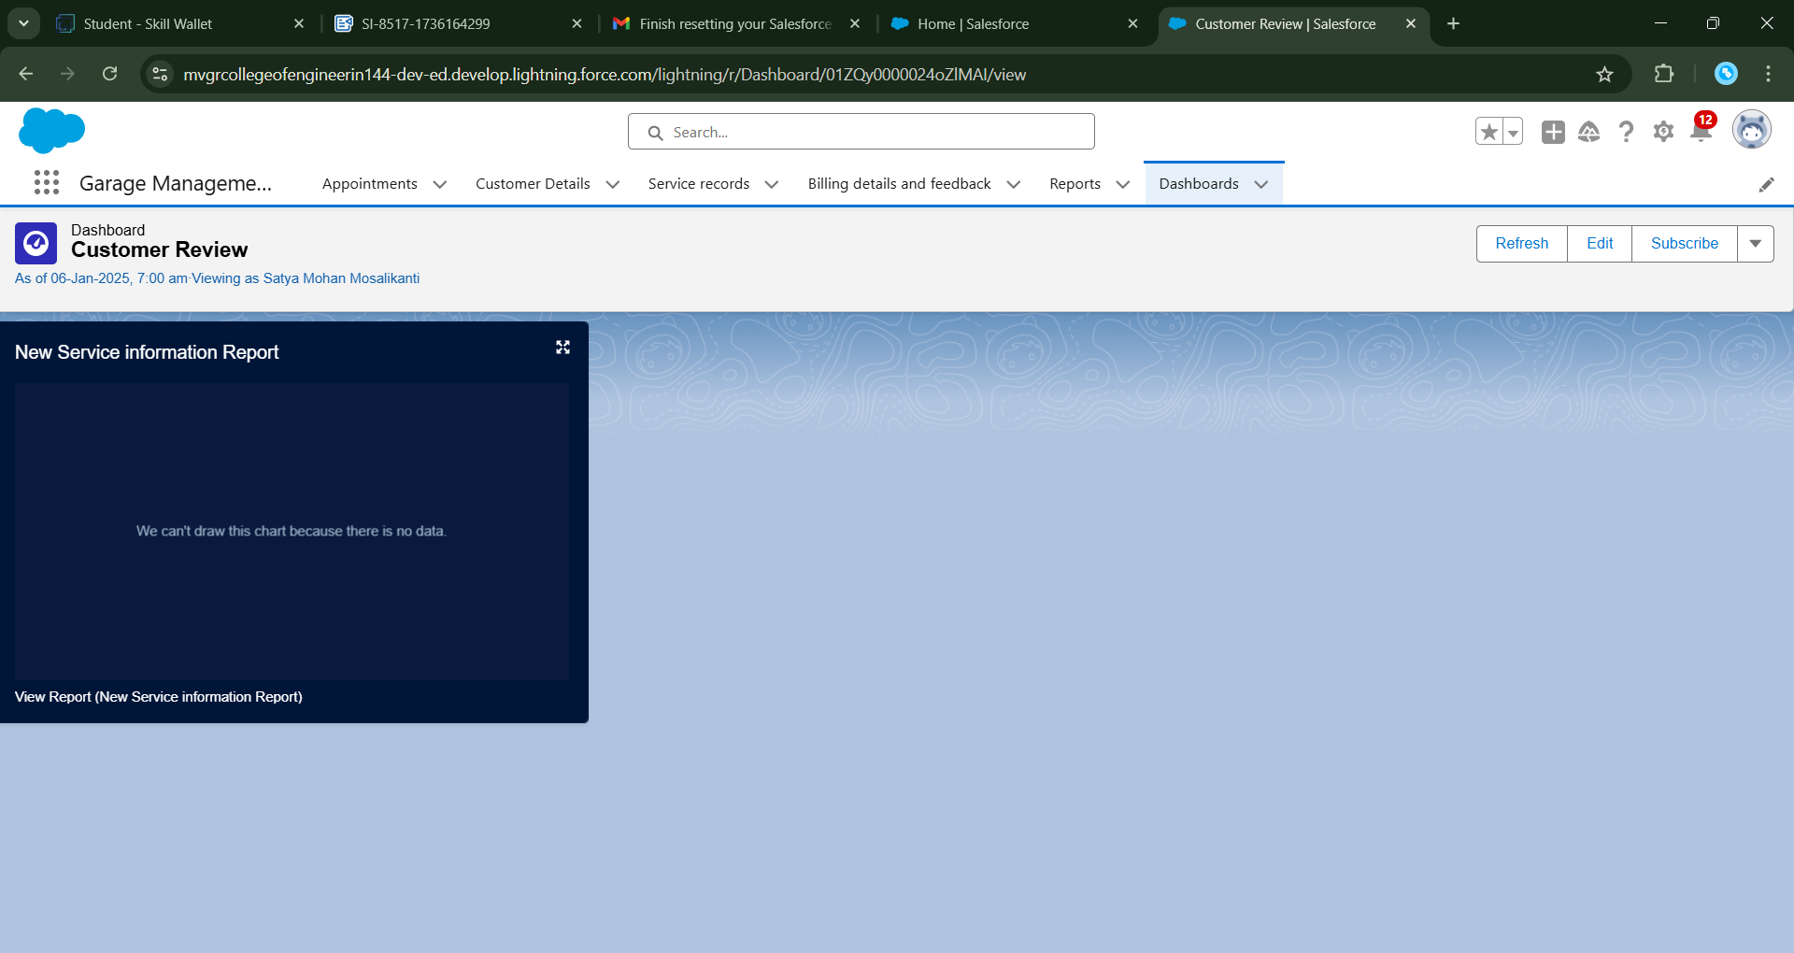

#### Step 5: Test and Deploy

* Perform **Unit Testing** for automation flows and triggers.
* Conduct **User Acceptance Testing (UAT)** with sample data.
* Deploy the solution using Salesforce change sets or deployment tools.

1. **Testing and Validation**

* **Unit Testing**: Apex Classes and Triggers for automation.
* **UI Testing**: Verify layouts and app functionality using test records.
* **Integration Testing**: Ensure seamless data flow between objects and automation processes.

1. **Key Scenarios Addressed by Salesforce in the Implementation Project**

* **Customer Management**:
  + Viewing a customer's service history and vehicle details in one place.
* **Service Booking and Updates**:
  + Automating the booking and status notification process.
* **Inventory Management**:
  + Triggering alerts for low-stock items.
* **Billing**:
  + Generating service invoices with pre-filled details.
* **Performance Monitoring**:
  + Using dashboards to track business and employee performance.

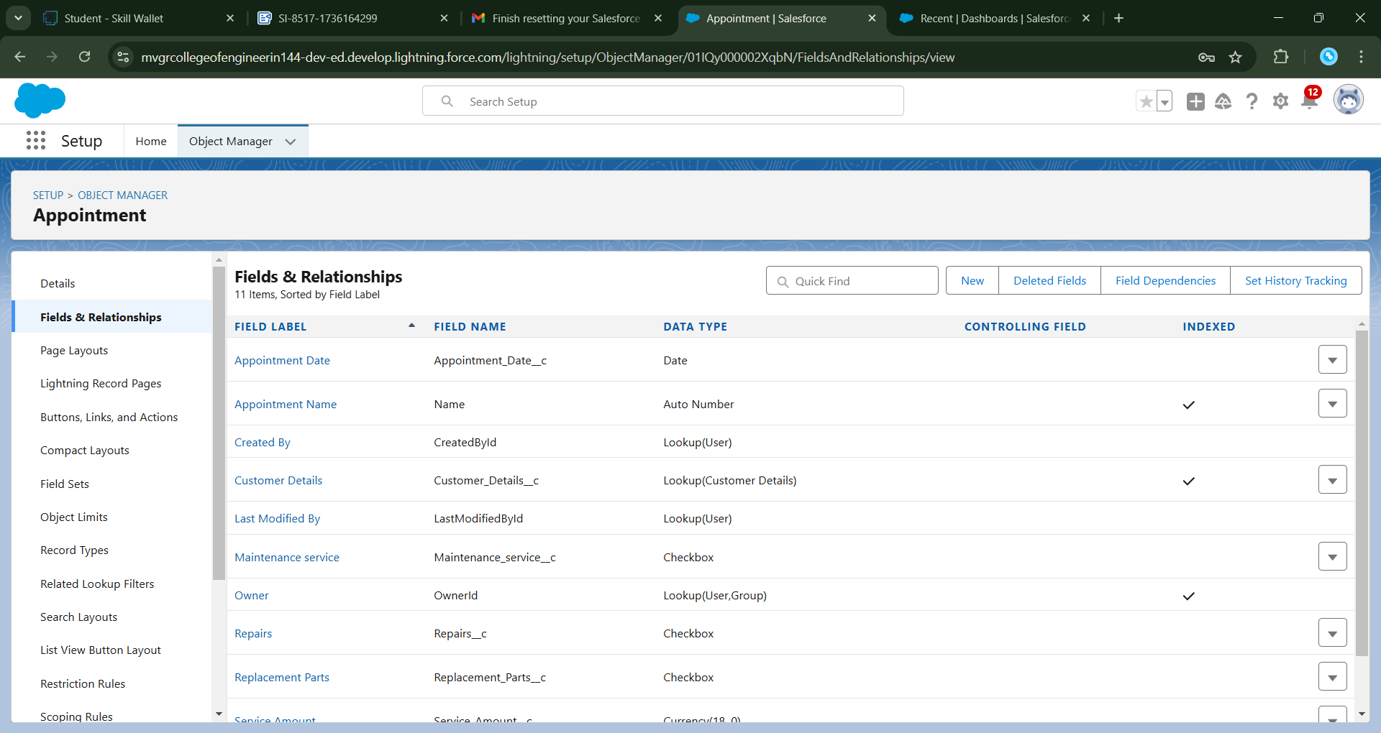

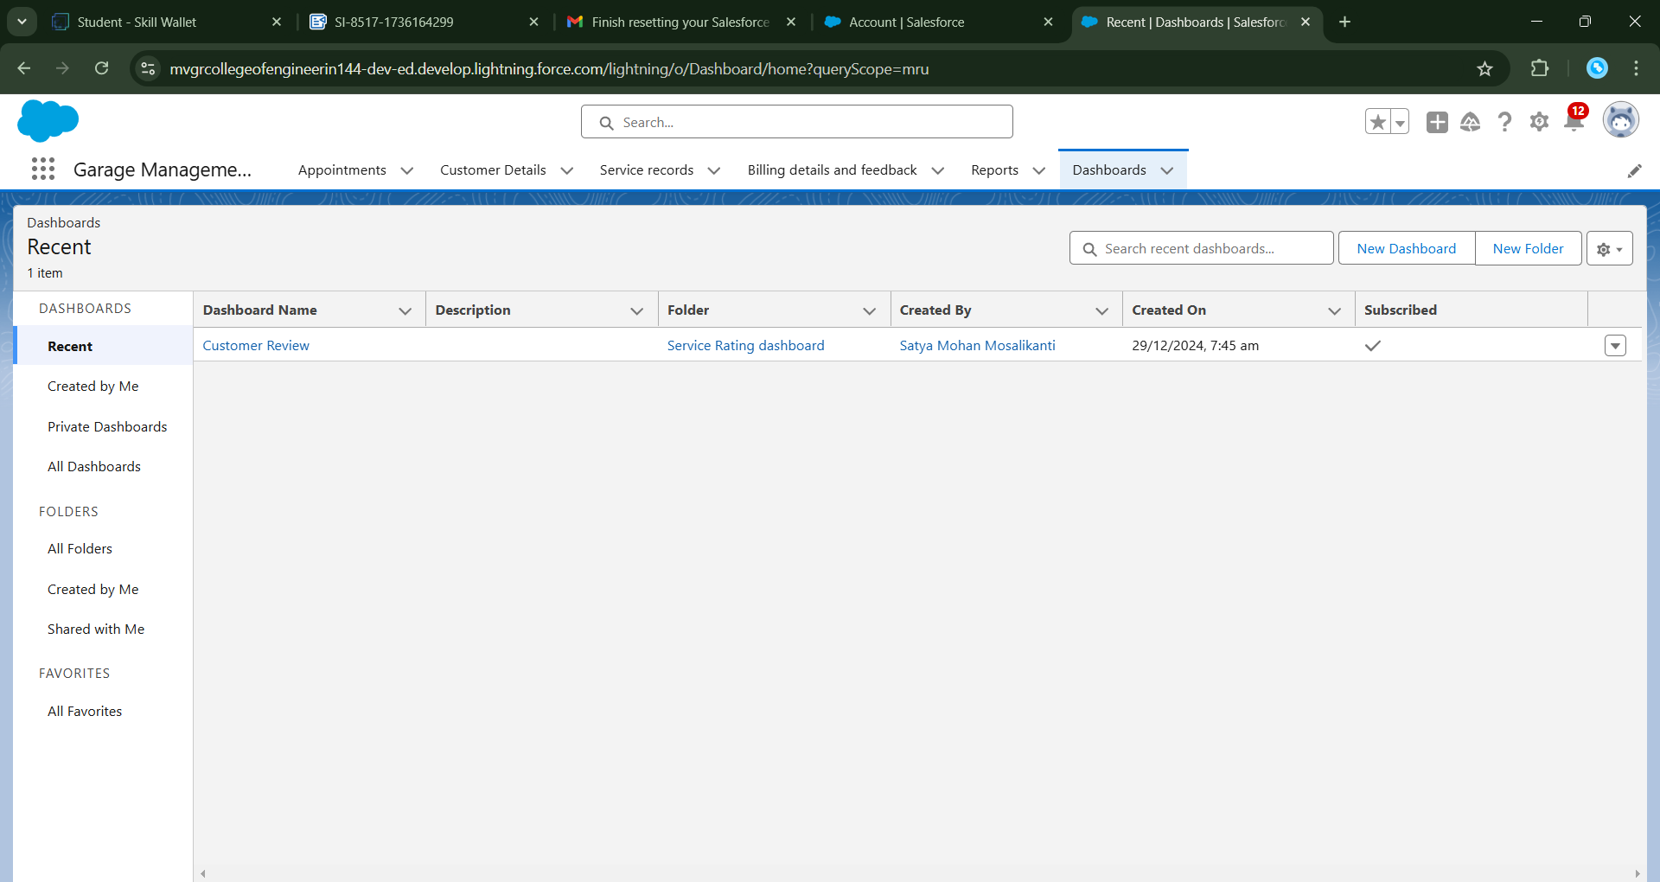

**Conclusion**

The **Garage Management System (GMS)** in Salesforce streamlines garage operations by leveraging the platform’s capabilities. It automates repetitive tasks, ensures accurate data management, and provides actionable insights through real-time analytics. This scalable and secure solution addresses key business challenges and enhances the overall customer experience.