How to install the Node project for jasmine and build system using grunt

- Install nodejs from https://nodejs.org/en/download/
- Install Ruby from https://rubyinstaller.org/
- Time to download the latest project with package.json file
- Once you have the updated project, `start ruby with command prompt`
- Locate to the folder where the project is being kept on your drive
- Start typing `npm install` in the command prompt (It will take some time to install all required packages to be installed)
- Type `grunt` in the command prompt which will listen to changes made to SCSS files and build the CSS distribution file
- Need to add build code for JavaScript files.
- Added node modules folder in .gitignore file
- Final project structure should look like this
- 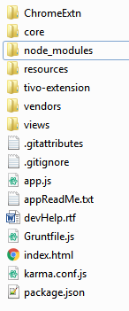
- Install karma globally `npm install -g karma-cli` `npm install –g karma` and `npm install -g jasmine-cli` `npm install -g jasmine` `npm install karma-jasmine --save-dev` Now you have Karma test runner and Jasmine test suit.
- ` karma start karma.conf.js` to start running test cases

