**1.Create a VM with availability set using the custom image with chrome Pre installed :**

* Creating a VM in East US **Availability Set.**

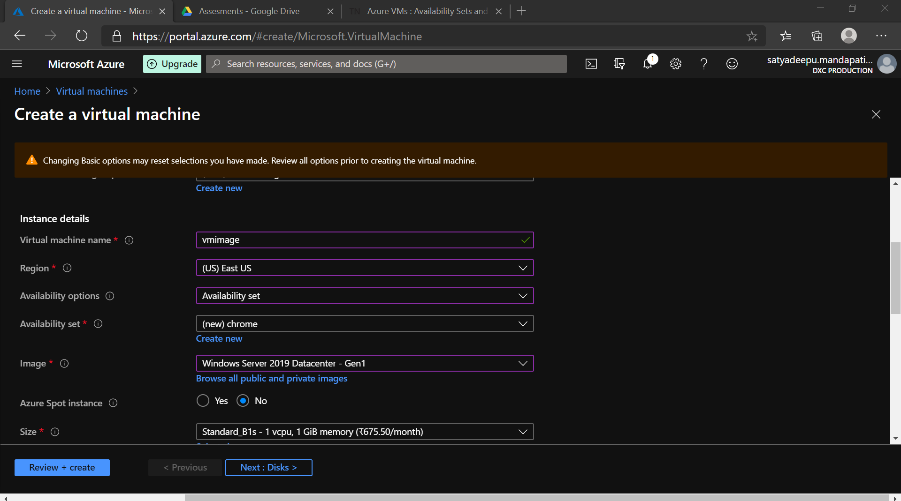

* Connecting the vm with Public IP Address by Remote desktop connection from local host

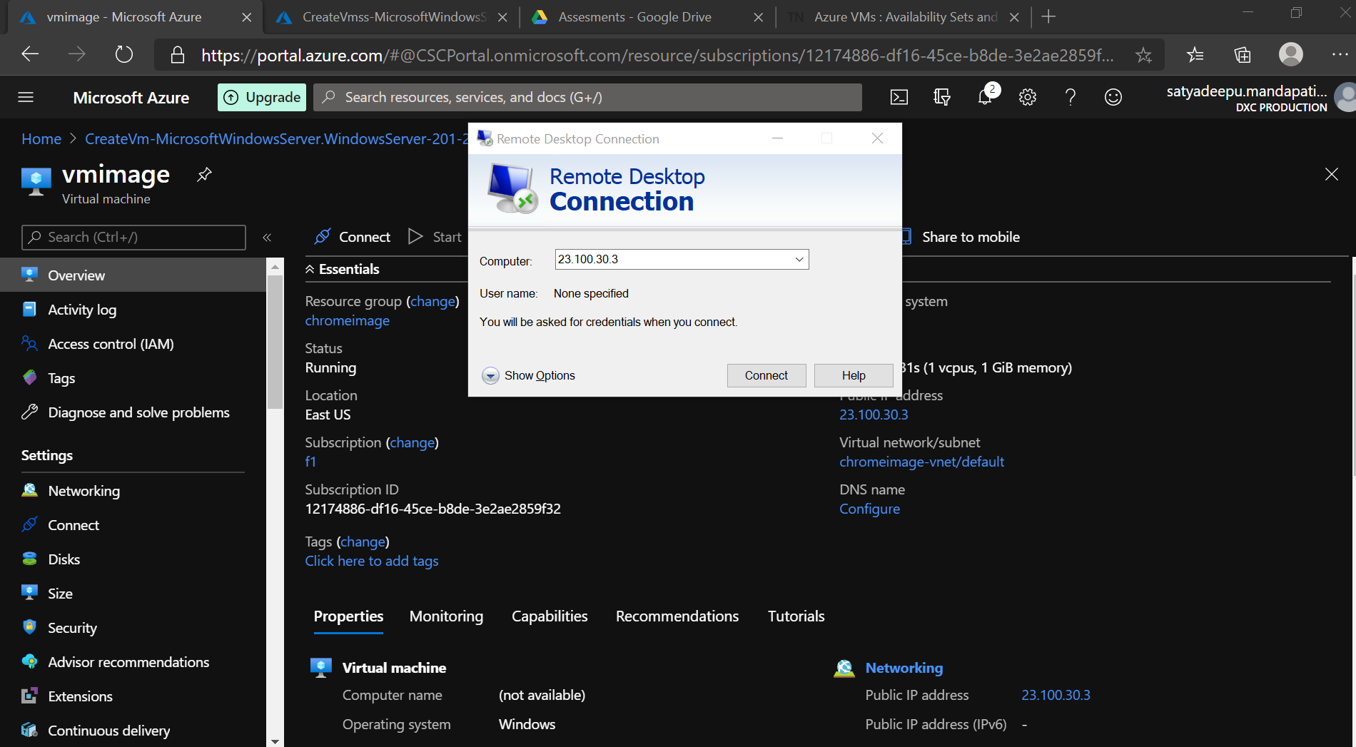

* Installing a **Chrome**  search engine in the VM

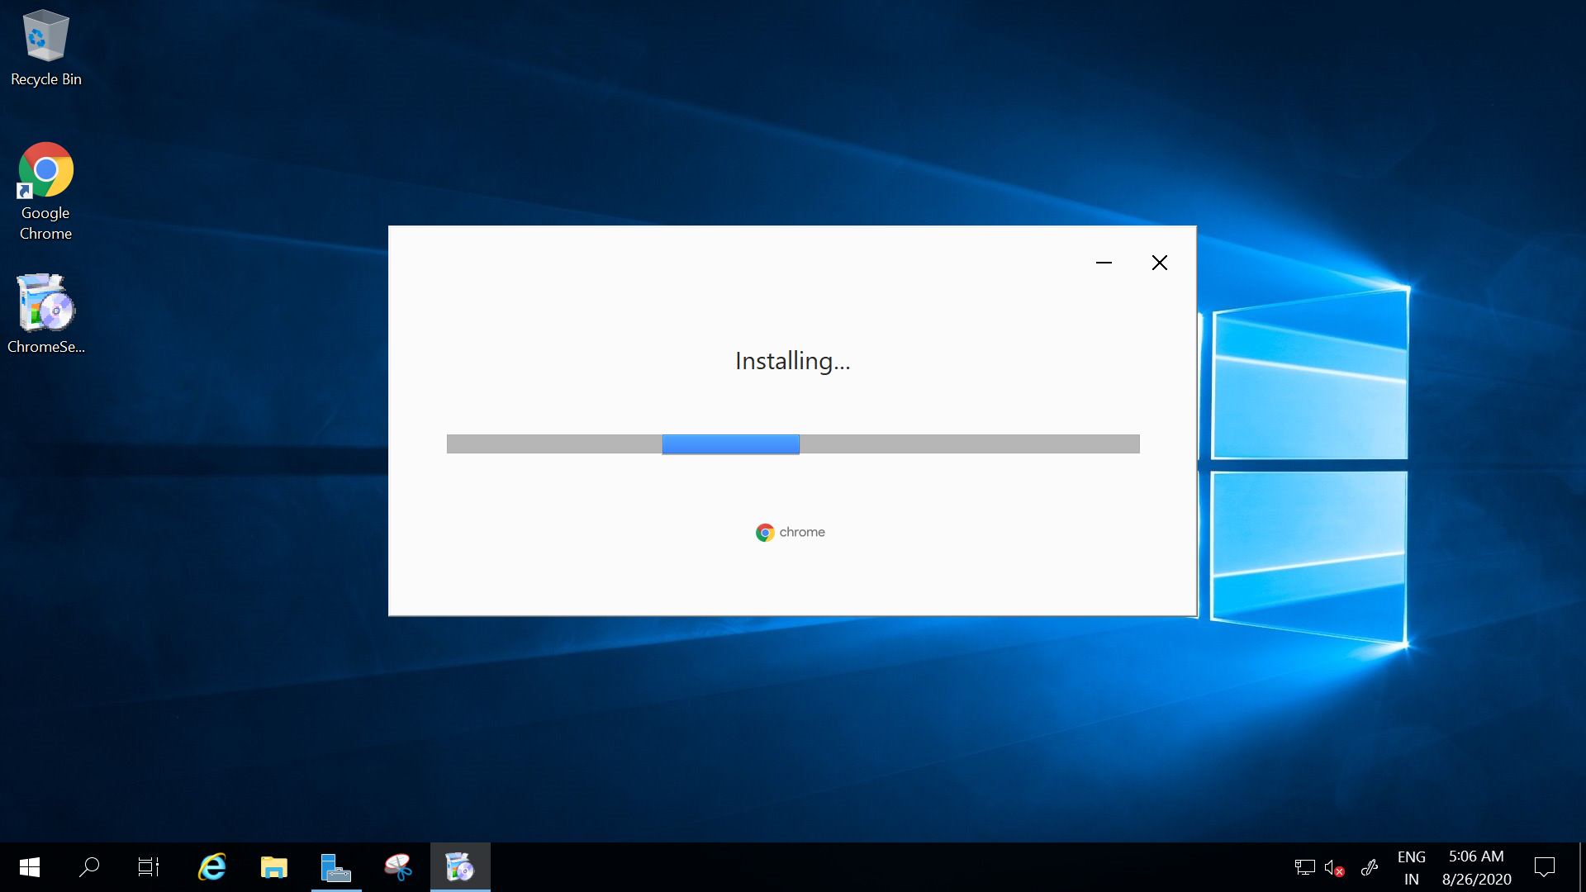

* Configuring **sysprep**  in VM for Image capture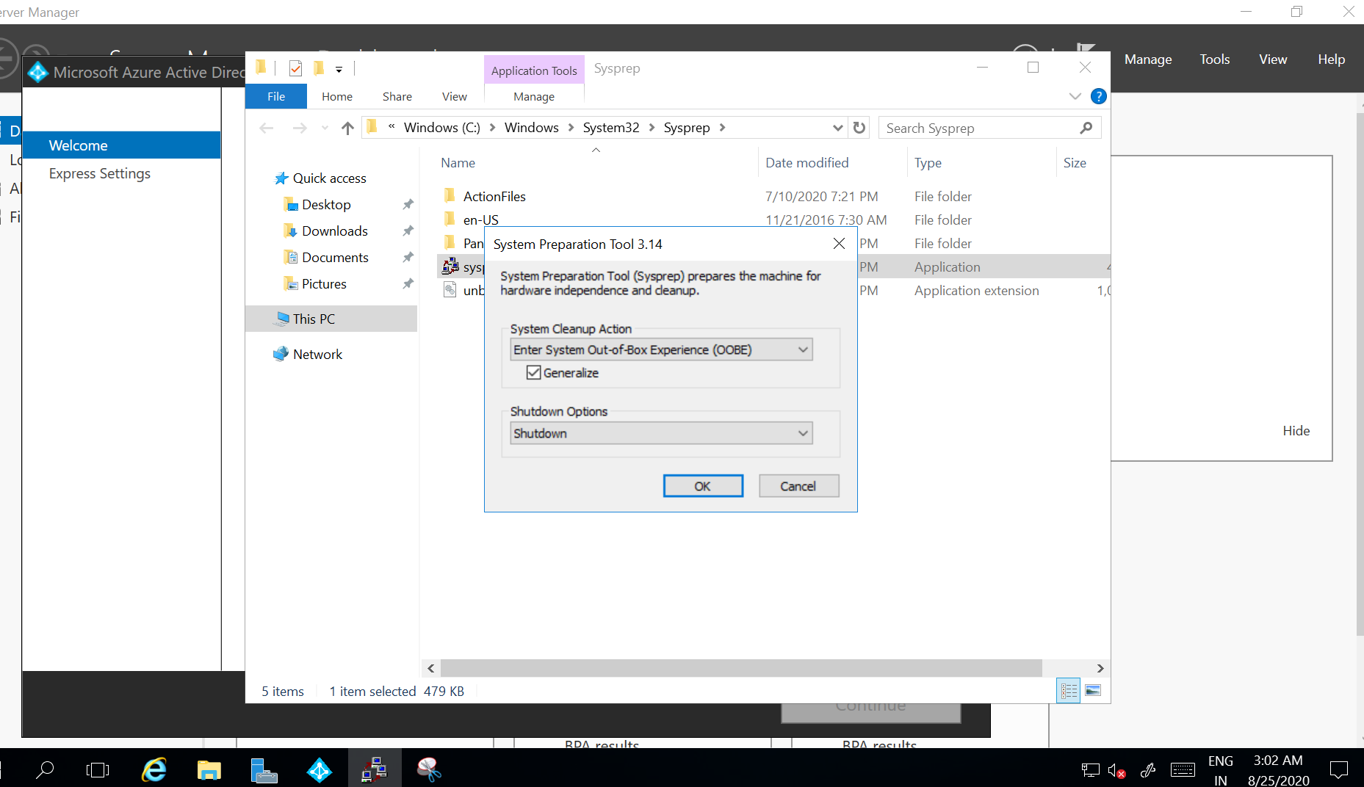
* Creating the image from the vm

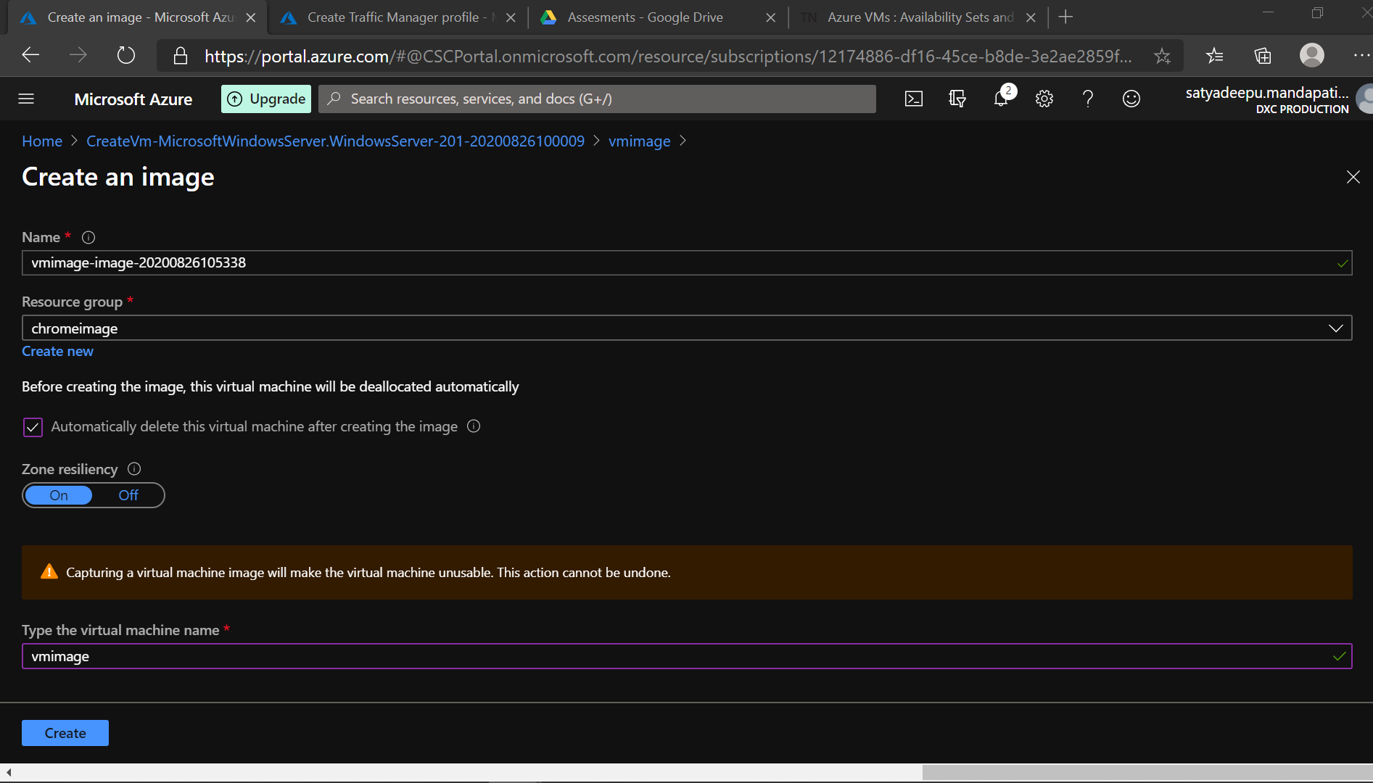

* A new VM is configured using existing VMimage

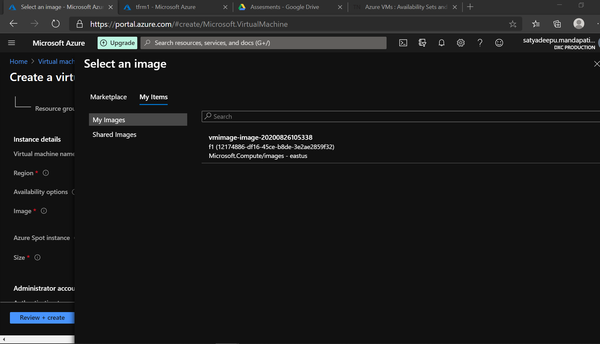

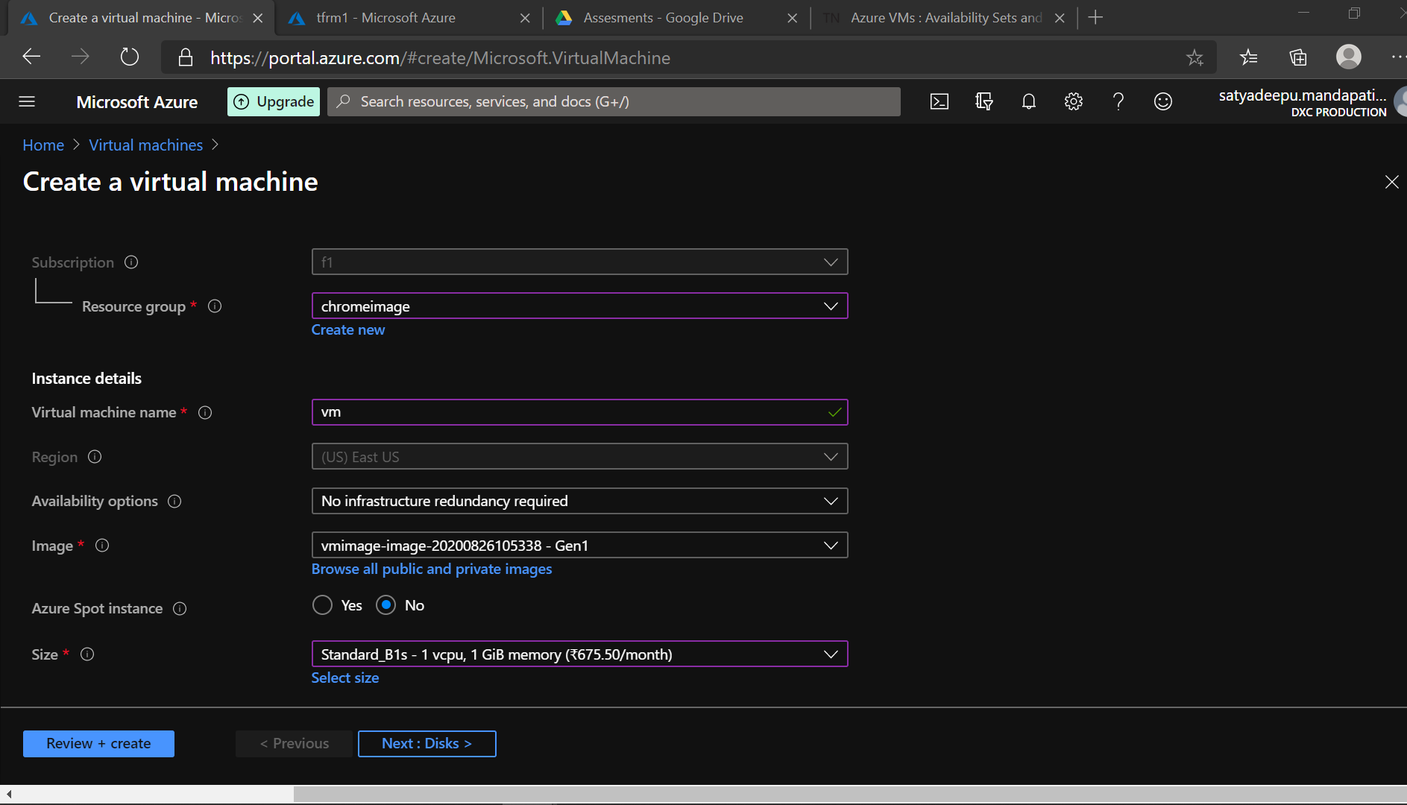

* Connecting to the new vm using its public ip address

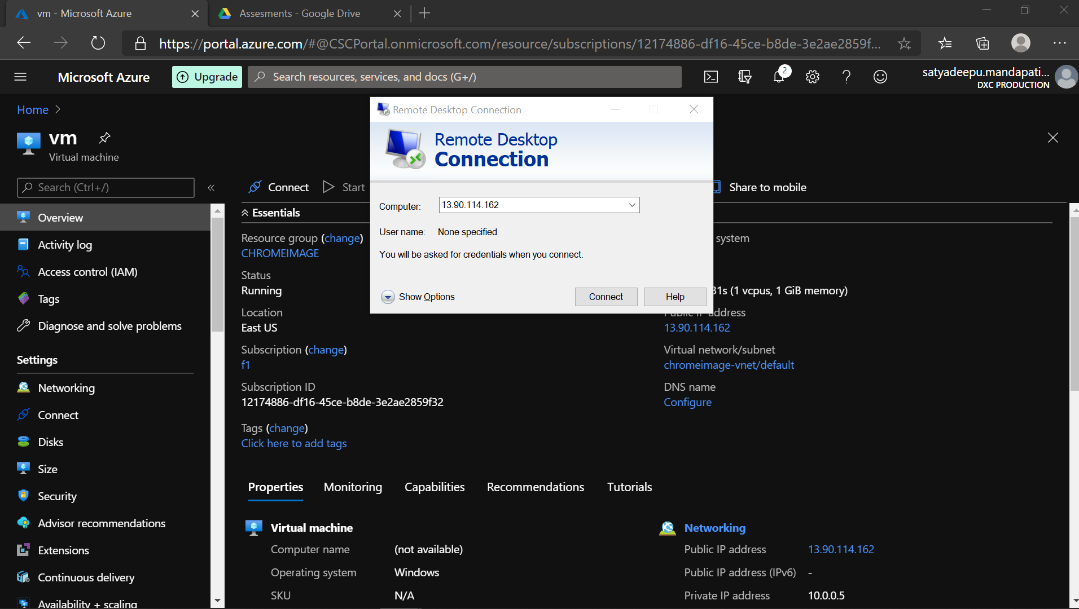

* The pre installed Chrome can be accessed in the New Vm

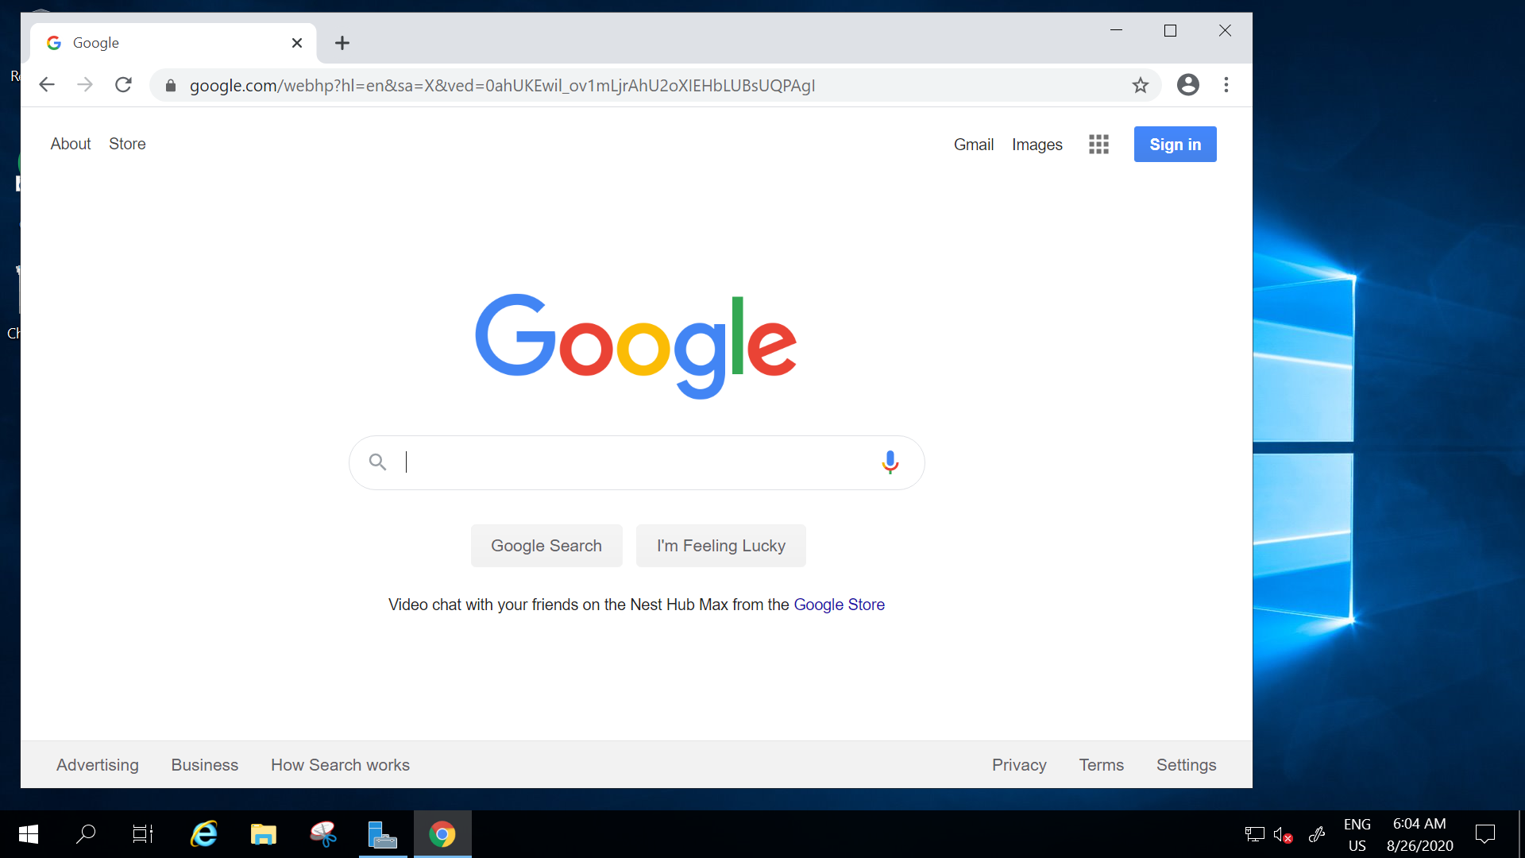

**2.Create a Virtual machine scale set with DS1-v2 standard**

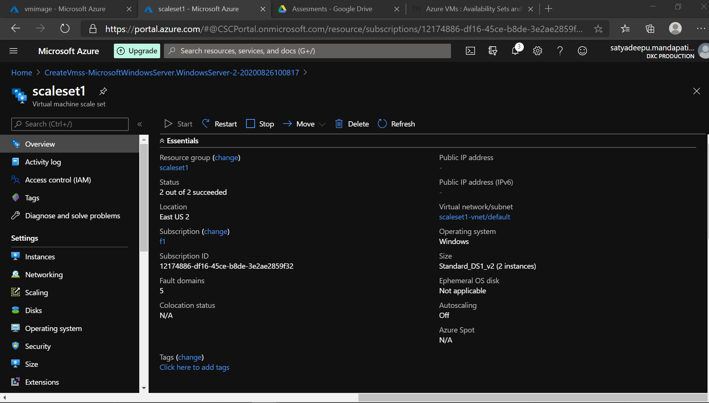

**3.Create a blob storage account with GRS standard and enable the blob soft delete with 15 days retention period also it should be able to connect with Azure storage explorer.**

* A blob storage account with GeO Redundant Replication Standard

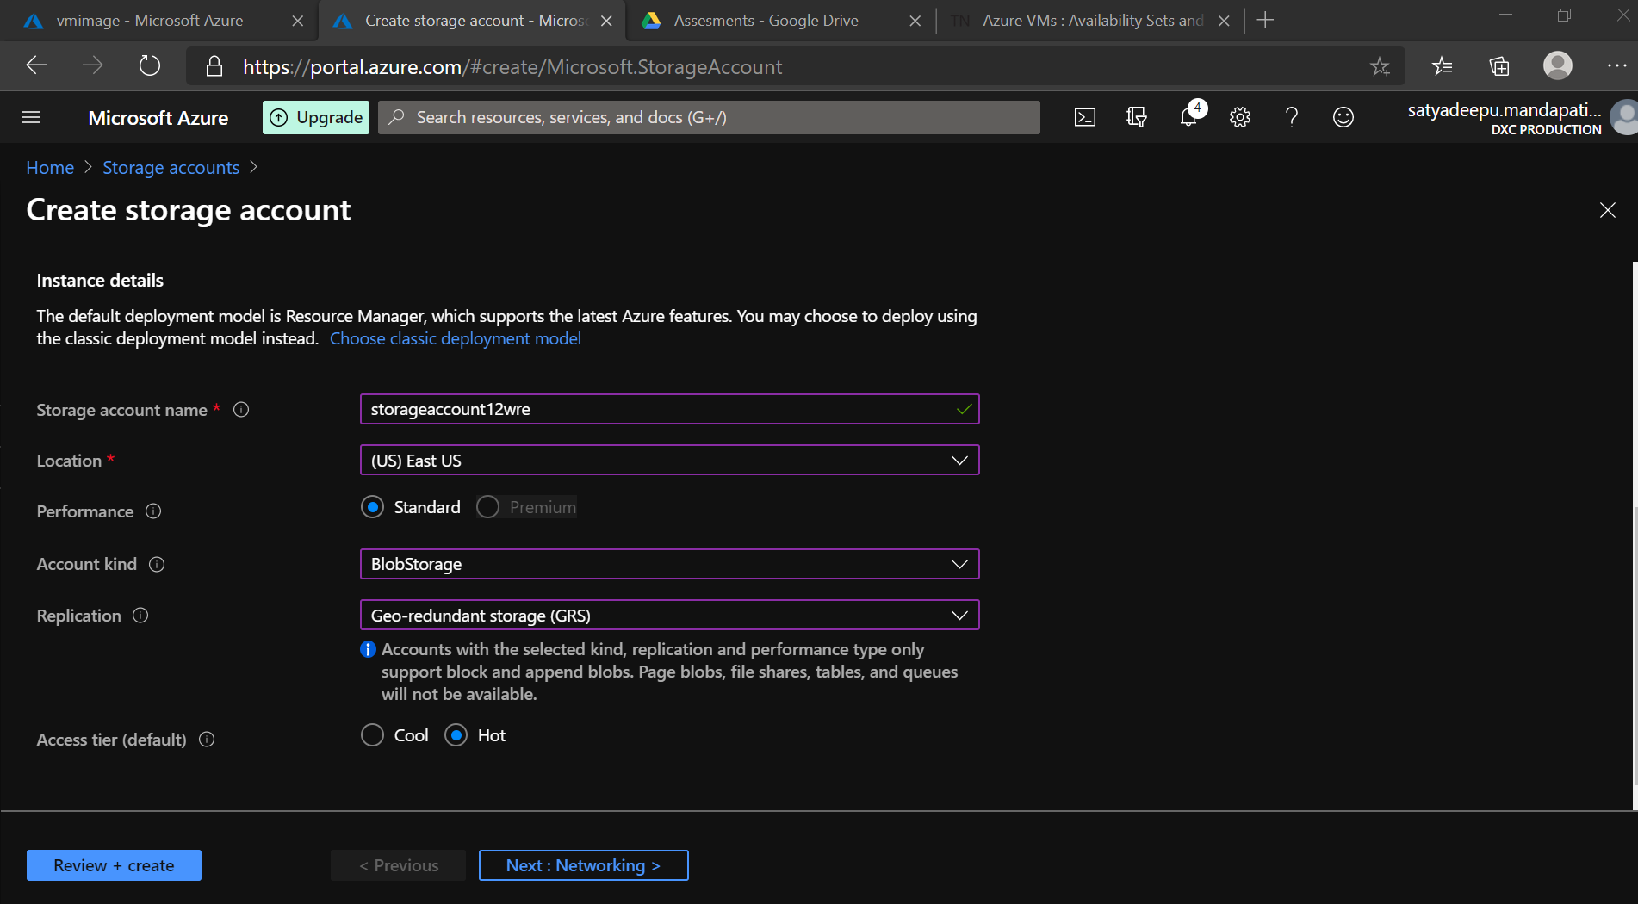

* The storage account is enabled with **Soft delete** with a Retention period of 15days

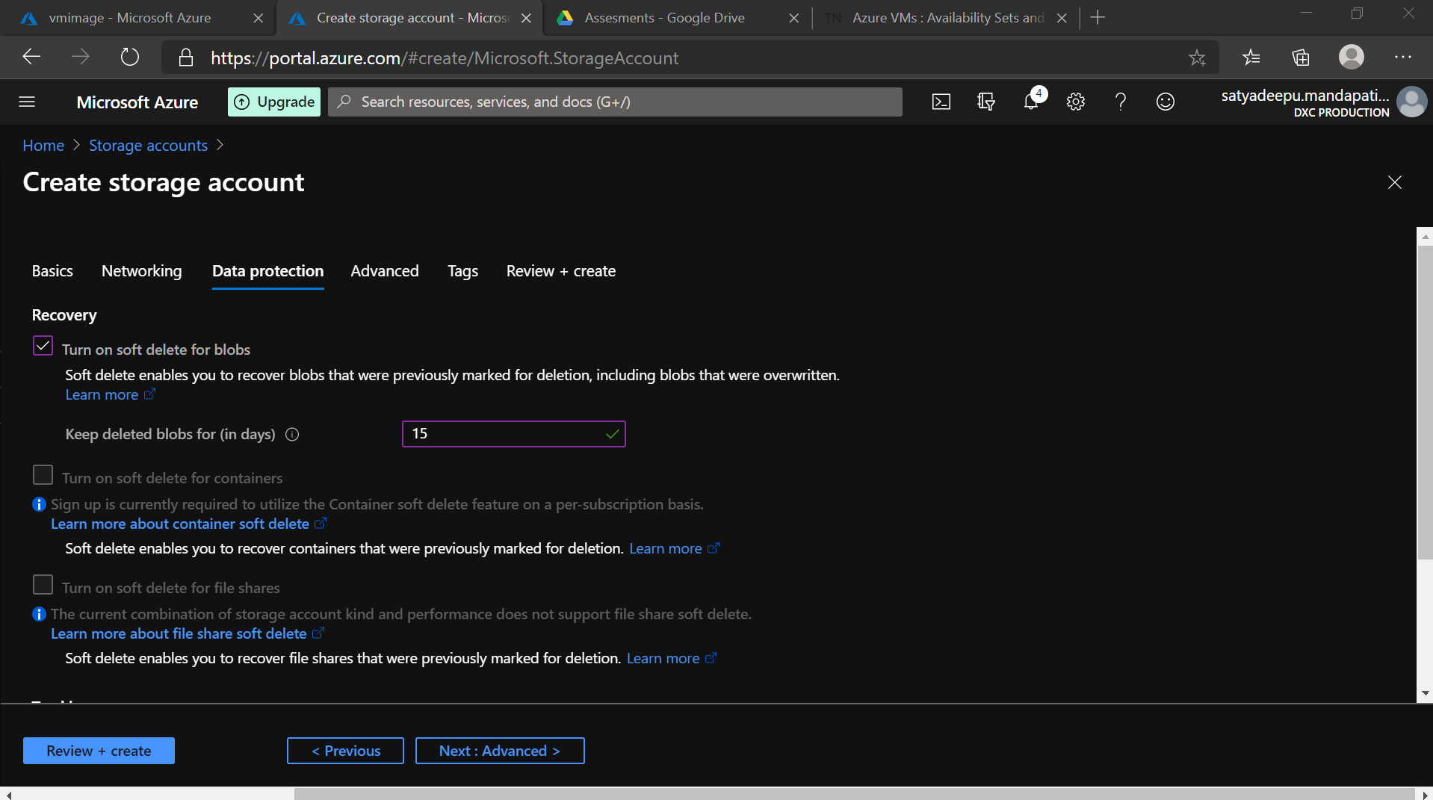

* A Image file in the Containers

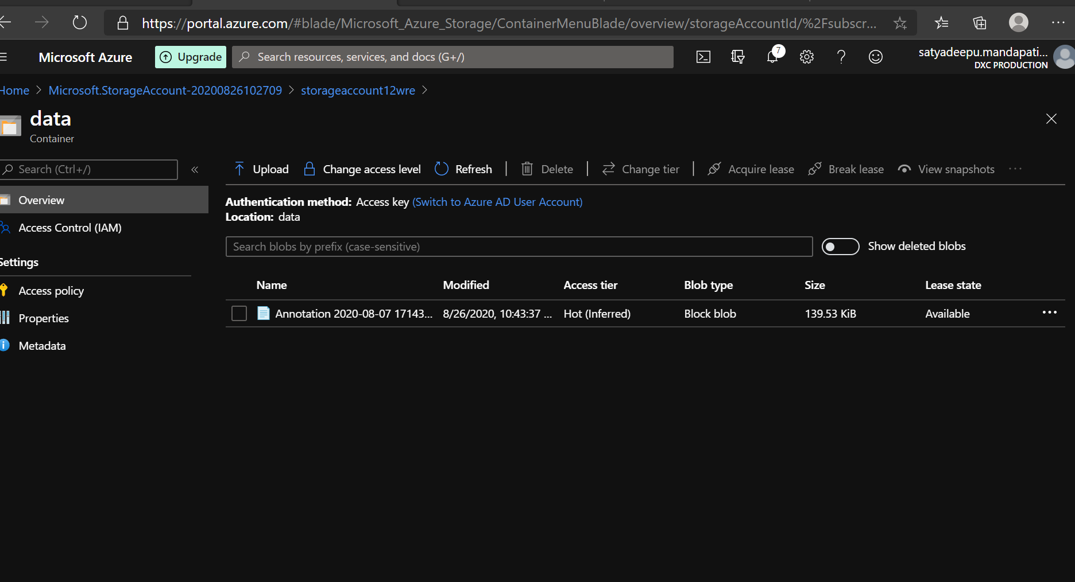

* Accessing the image files from a storage Explorer in Azure Storage Explorer

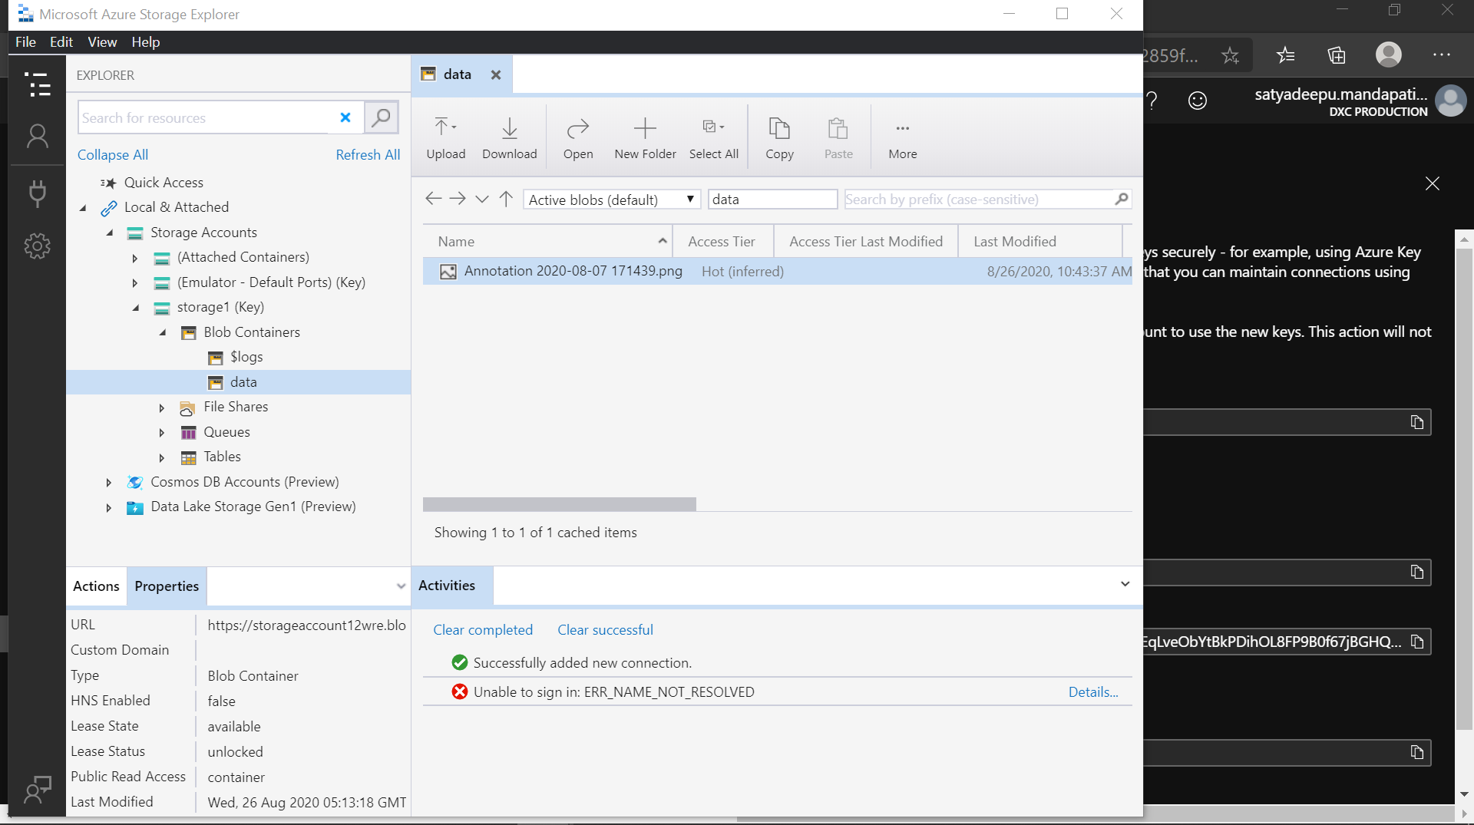

**4.Configure the Vnet and create 3 subnets in the Vnet**

* Creating a Virtual network

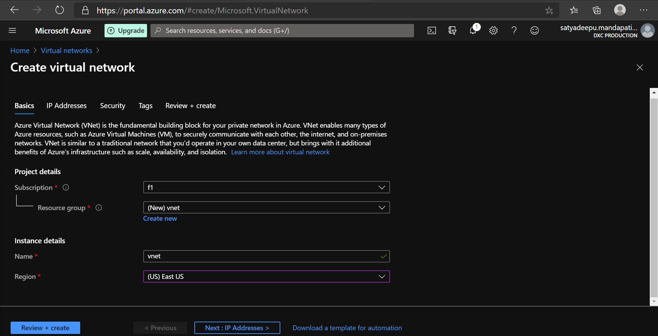

* In the **vnet** range (195.185.175.0/24) , creating Three **Subnets** in th ranges of **(**195.185.175.0/25 , 195.185.175.128/26 , 195.185.175.192/27)

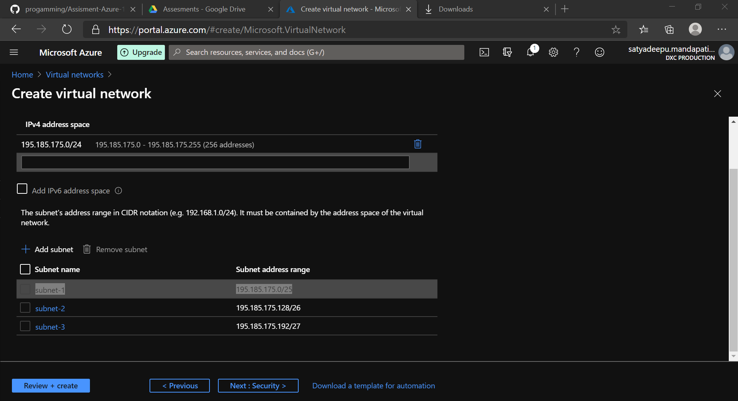

**5.Create a traffic manager with performance routing method**

* Traffic manager with Performance as the Standard routing Method

