Karnataka Gruhalakshmi Scheme
Beneficiary Integrity & Life-Proof Platform
Detailed Project Report | Target Operating Model, Solution Architecture, Process Flows and Application Build Prompt

Prepared for | Government of Karnataka - Gruhalakshmi Beneficiary Renewal & Household Consolidation Initiative
Prepared by | Consulting draft for proposal discussion
Version / Date | v1.0 | 15 June 2026
Document status | Concept DPR: for review, validation and scope finalisation; commercials excluded

1. Executive Summary
The Gruhalakshmi scheme is a high-scale social protection programme that provides monthly DBT support to eligible women heads of households. The proposed project introduces a renewed beneficiary registry, household-level de-duplication, configurable retention rules and periodic life-proof verification so that public funds continue to reach the correct, living, eligible beneficiary for each household.
The target design balances programme integrity with beneficiary inclusion. It enables self-service registration through mobile/web and assisted registration through Bangalore One, Karnataka One, Grama One and Panchayat offices. It also creates an operational model for notices, appeals, call-centre support and supervised exceptions before DBT cancellation.
The most important design principle is that the platform should not become merely a deactivation engine. It should be a transparent beneficiary integrity system: every decision must have reason codes, audit trails, clear notices, assisted resolution, and configurable policy rules approved by the Government.
Program design pillar | Recommended design response | Expected outcome
Single household entitlement control | Aadhaar-based registration, address proof capture, ration card linkage and household cluster matching. | Reduced duplicate benefits within a single household/address.
Configurable beneficiary retention | Policy engine to retain oldest, youngest, senior-most woman, ration-card head, or other rule approved by the department. | Policy agility without code changes and clear defensibility.
Periodic life-proof | Face/biometric/OTP-assisted life-proof cycle every two months or configurable interval. | Continued eligibility confirmation and DBT continuity for valid beneficiaries.
Assisted and inclusive channels | Service-centre, web, mobile, call-centre and grievance-assisted operations. | Lower exclusion risk for elderly, rural, digitally excluded and biometric-challenged beneficiaries.
Audit-ready governance | Consent, reason codes, notices, appeals, SLA dashboards and exception approvals. | Administrative defensibility and improved public trust.

2. Programme Context and Case for Change
The scheme is designed as a monthly DBT support programme for eligible women heads of households. The proposed renewal initiative responds to four risks observed in large welfare schemes: duplicate household-level claims, deceased beneficiaries continuing to receive payments, mismatch between identity/address records and scheme records, and inadequate visibility for field-level correction.
Relevant fact / current-state signal | Implication for the proposed platform
Government scheme pages state that Rs. 2,000 is paid through DBT to registered eligible beneficiaries; women named as head of household in Antyodaya, BPL and APL ration cards are eligible. | The new registry must preserve the original policy intent: one eligible household-level beneficiary receiving DBT transparently.
The 2026-27 Karnataka Budget analysis records Rs. 28,608 crore allocated for Gruha Lakshmi. | At this scale, even small leakage percentages create material fiscal exposure; automated controls are justified.
Recent reporting has highlighted the need for biometric verification and life-proof controls due to beneficiaries who may no longer be alive or eligible. | The platform should include periodic life-proof and death-record integration while maintaining an appeal path.
The Karnataka DBT app description confirms that GoK has a unified Direct Benefit Transfer platform and that beneficiaries can see bank seeding and scheme payments. | The proposed platform should integrate with DBT status flows rather than rebuild payment infrastructure.

3. Objectives, Scope and Guiding Principles
Objective | Description | Success indicator
Create a refreshed Gruhalakshmi beneficiary registry | Require all existing and new aspiring beneficiaries to register on the new portal using Aadhaar as ID/address anchor and optional supporting documents. | 100% of active beneficiary base migrated with validated status.
Detect multiple beneficiaries at the same address or household | Match Aadhaar address, ration card and optional proofs to build household clusters. | Duplicate clusters identified with confidence score and manual review queue.
Retain one beneficiary based on configurable criteria | Default rule may be oldest member of address, with ability to configure oldest, youngest, ration-card head, senior-most woman or exception rule. | No code change required for approved policy modification.
Perform periodic life-proof | Retained beneficiary re-verifies life-proof every two months or as configured. | Life-proof success/failure visible in scheme and DBT dashboard.
Provide equitable access channels | Enable self-service mobile/web and assisted service-centre registration. | High completion rates across rural/urban, elderly and low digital-literacy groups.
Guiding principles: beneficiary-first service design, no silent DBT cancellation, minimum necessary data, consent-led Aadhaar authentication, bilingual Kannada/English interface, accessibility-compliant UI, auditability by design and interoperability with existing Government platforms.

4. Target Operating Model
Operating layer | Key responsibilities | Owner / users
Beneficiary access | Mobile number login, OTP password, registration, document capture, life-proof, status viewing, grievance filing. | Beneficiary and assisted service centre operator.
Assisted front office | Register beneficiary, scan documents, capture biometric/face proof, explain notice, raise exception case. | Bangalore One, Karnataka One, Grama One, Panchayat offices.
Decision and workflow layer | Match proofs, create household clusters, apply retention criteria, issue notices, manage appeal queue. | Scheme administration and district officials.
Call-centre support | Search records, explain status, register complaints, schedule service-centre visit, support appeal documentation. | Call-centre agents and supervisors.
Governance and analytics | Dashboards, leakage analytics, inactive trends, exception approvals, audit extracts. | State admin, department leadership and audit teams.

5. End-to-End Process Flow
The recommended flow separates data capture, identity verification, address matching and policy decisioning. This enables transparent decision-making and avoids manual interpretation at the service counter.
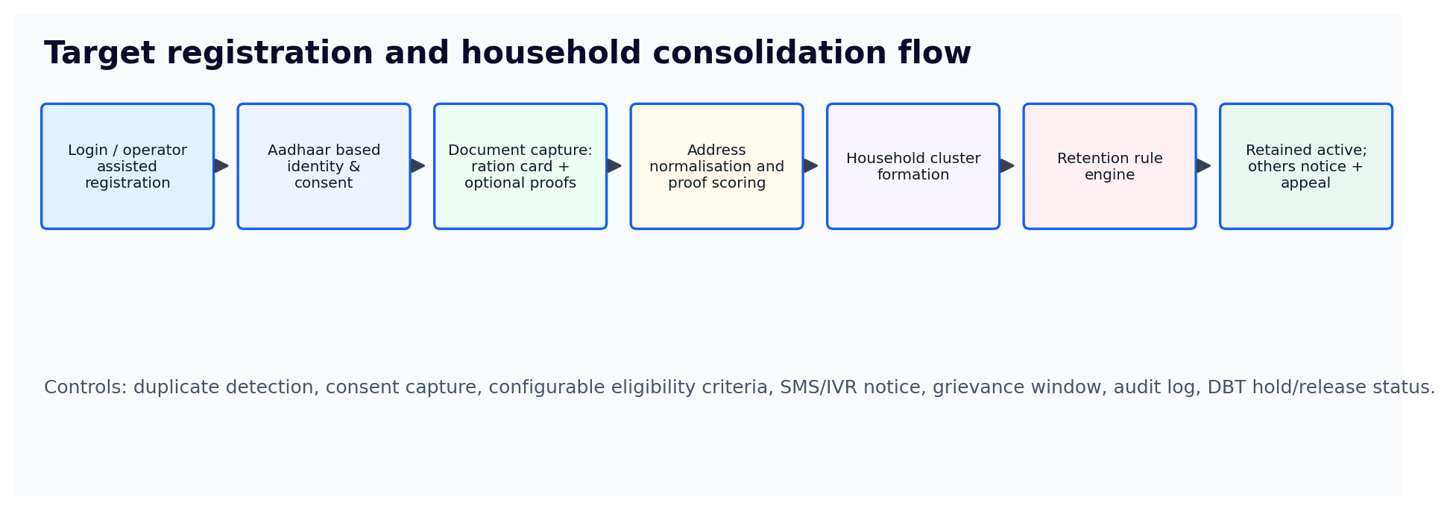
Figure 1: Target registration and household consolidation flow

6. Household Matching and Configurable Retention Rules
Address matching should not rely on exact text alone. Aadhaar address, ration card address and optional proofs should be normalised into structured fields. A confidence score should be calculated before automatic decisions are made. Lower-confidence clusters should move to a manual review queue.
Matching input | Treatment in platform | Decision contribution
Aadhaar address / resident details | Used as primary identity and address anchor subject to lawful authentication and consent. | Primary identity and de-duplication signal.
Ration card | Used as household/family proof where available. | Strong household relationship signal.
Electricity bill / property tax / rent proof / bank passbook | Optional supporting proof; weighted according to policy. | Improves confidence; not mandatory for eligible beneficiaries without such proof.
Mobile number | Used for login, OTP, notifications and call-centre contact. | Operational contact signal, not household determinant.
Geo-coded service-centre capture | Optional location metadata for assisted registrations. | Fraud pattern and audit signal only.

Retention rule option | Use case | Governance note
Oldest female member at address | Default rule proposed by the user; defensible when intent is senior household support. | Should be explicitly approved and published in beneficiary notice.
Youngest eligible female member | Possible policy option where support is targeted to younger family units. | Requires cabinet/department decision and public communication.
Existing ration-card head of household | Aligns to current eligibility records. | Lowest disruption but may not resolve record inaccuracies.
Senior-most living woman after death of beneficiary | Continuation rule where prior beneficiary has died. | Requires death confirmation and family transition workflow.
Manual exception approval | Used for disputed households, abandoned women, separated households, tenants, or address mismatch. | Mandatory audit trail, district approval and renewal review.

7. Periodic Life-Proof Verification
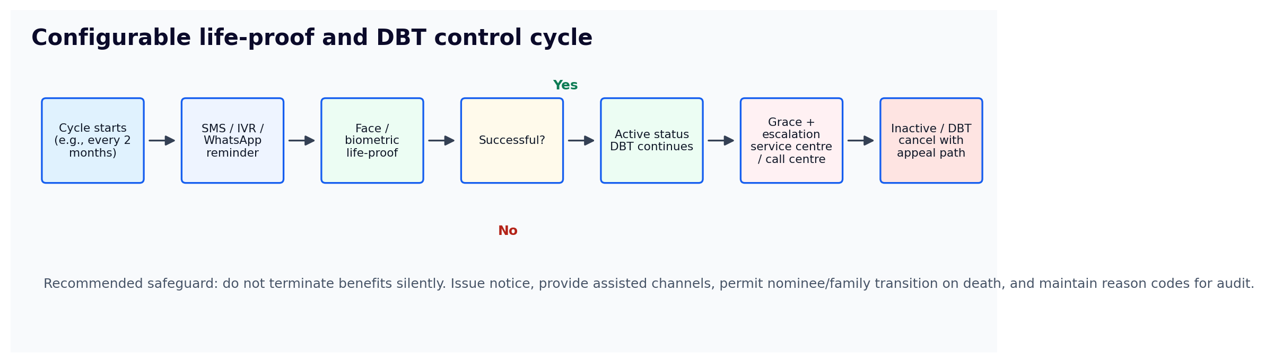
Figure 2: Configurable life-proof and DBT control cycle
Life-proof stage | Recommended policy design | Beneficiary protection
Reminder | Trigger SMS/IVR/WhatsApp 15 days before due date; repeated alerts in Kannada and English. | Beneficiary has sufficient notice and channel choice.
Verification | Face authentication, biometric authentication at assisted centre, or approved alternative for exceptional cases. | Avoids exclusion for elderly or biometric-challenged beneficiaries.
Grace period | Configurable grace window, e.g., 15 or 30 days, with call-centre intervention. | Prevents abrupt cancellation due to technical or access failure.
Inactive status | Mark inactive only after expiry of due date plus grace period, with reason code. | Decision is explainable and appealable.
DBT update | Send active/inactive status to DBT integration layer. | Payment control is automated but auditable.

8. Application Functional Scope
Module | Core capabilities | Primary users
Beneficiary portal / mobile app | Mobile OTP login, language selection, application form, Aadhaar consent, document upload, life-proof, status, notice, appeal. | Beneficiaries and family helpers.
Service-centre operator console | Assisted registration, document scanning, biometric/face capture, print acknowledgement, appointment support. | Bangalore One, Karnataka One, Grama One, Panchayat staff.
Scheme admin console | Configure retention rules, life-proof intervals, document weights, district-wise rollout, exception approvals. | State and district administrators.
Call-centre console | Beneficiary search, status explanation, complaint logging, callback, service-centre referral, appeal intake. | Call-centre agents and supervisors.
Matching and decision engine | Address normalisation, household clustering, duplicate detection, confidence scoring, rule application. | Platform services.
Notification engine | SMS, IVR, WhatsApp, email, printed notice templates, language preference. | All beneficiaries and staff.
DBT integration layer | Active/inactive flag, payment hold/release, reconciliation and exception logs. | DBT and scheme officials.
Analytics and audit | Leakage dashboard, duplicate clusters, inactive trend, SLA, appeals, district performance, audit exports. | Leadership, PMO, audit teams.

9. High-Level Architecture
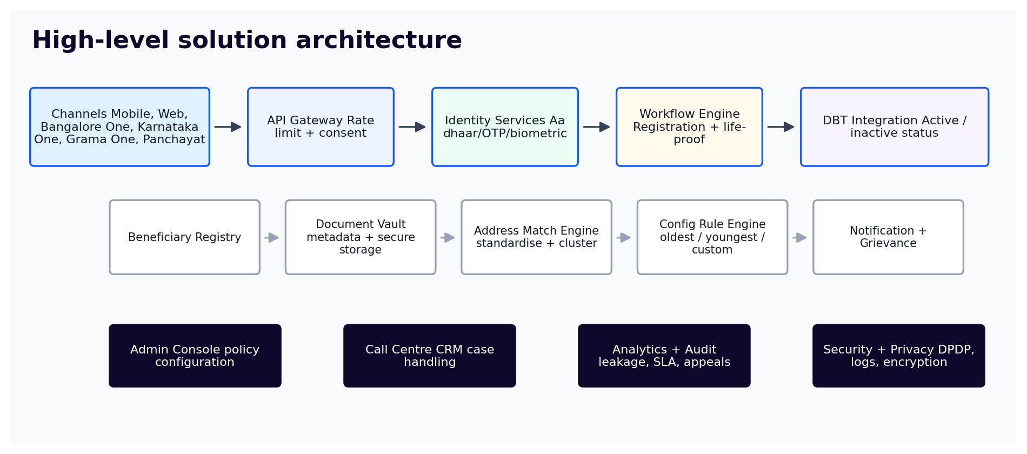
Figure 3: High-level solution architecture
Component | Design recommendation | Reason
API gateway | Central gateway with consent logging, throttling, encryption and application monitoring. | Protects citizen services and provides operational resilience.
Identity services | Use approved Aadhaar authentication/offline verification modes and alternatives where mandated. | Ensures lawful and interoperable identity verification.
Data store | Store minimum necessary demographic data, hashed/tokenised Aadhaar reference, document metadata and workflow state. | Reduces privacy risk and supports DPDP principles.
Document vault | Secure object storage for proof documents with role-based access and retention schedules. | Supports audit without uncontrolled document sharing.
Rule engine | No-code configuration for retention criteria, document weighting, life-proof cycle and grace period. | Provides policy agility.
Audit layer | Immutable event logs for consent, authentication, decisions, notices, appeals and DBT updates. | Supports grievance handling and external audit.

10. Representative Screen Concepts
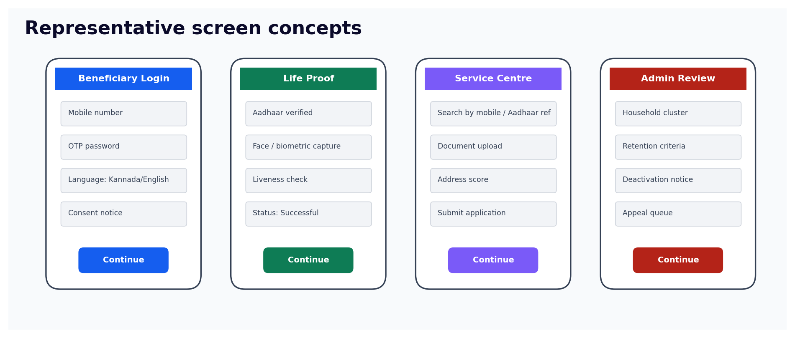
Figure 4: Conceptual screens for beneficiary, service-centre and admin users

11. Privacy, Security and Inclusion Controls
Control area | Requirement | Implementation note
Consent and notice | Capture clear consent before Aadhaar authentication and explain purpose/data use. | Store consent version, timestamp, language and channel.
Data minimisation | Collect only data needed for scheme eligibility, verification and grievance management. | Avoid storing raw biometric data; store authentication result/reference only.
Aadhaar safeguards | Follow UIDAI requirements for requesting entities and approved devices/services. | Certified biometric devices, encrypted transmission and retention controls.
DPDP alignment | Provide notice, purpose limitation, access control, breach response and grievance pathway. | Design for data fiduciary accountability.
Inclusion | Provide assisted centres, family helper mode, call-centre support and manual exception queue. | Avoid exclusion due to disability, age, connectivity or biometric failure.
Accessibility | High-contrast UI, large fonts, Kannada/English, screen-reader labels and voice guidance. | Supports elderly and visually challenged beneficiaries.

12. Dashboards, MIS and Governance
Dashboard | Key metrics | Governance action enabled
Registration command centre | Applications received, completed, pending, rejected, channel mix, district/taluk split. | Rollout control and bottleneck resolution.
Household integrity dashboard | Duplicate clusters, confidence score buckets, retained/deactivated counts, exception cases. | Leakage reduction and policy review.
Life-proof dashboard | Due, completed, failed, grace period, inactive, DBT cancelled, appeals. | Payment continuity and exclusion-risk monitoring.
Call-centre dashboard | Call volumes, first-call resolution, complaints by reason, aging, escalations. | Service quality and grievance reduction.
Audit dashboard | Authentication attempts, consent logs, manual overrides, admin changes, DBT reconciliation. | Internal audit and external review support.

13. Implementation Roadmap
Phase | Duration | Activities | Outputs
Phase 0: Policy and design validation | 2-3 weeks | Confirm eligibility rules, retention criteria, notices, appeal process, privacy/legal review and integration owners. | Approved functional design, data dictionary and governance charter.
Phase 1: MVP build | 8-10 weeks | Build beneficiary registration, service-centre console, Aadhaar/OTP integration stubs, document upload, rule engine and admin configuration. | Working MVP for limited pilot.
Phase 2: Pilot rollout | 6-8 weeks | Pilot in selected urban/rural districts, test service-centre workflow, call centre, notifications and DBT status integration. | Pilot report, refined SOPs and risk register.
Phase 3: Statewide migration | 12-16 weeks | Wave-based migration, mass communications, service-centre scheduling, monitoring and exception management. | Migrated active registry and operational dashboards.
Phase 4: Optimisation | Ongoing | Analytics, fraud pattern detection, periodic life-proof operations, enhancement backlog. | Stable BAU operations and monthly governance pack.

14. Key Risks and Mitigations
Risk | Potential impact | Mitigation
Incorrect household clustering | Wrong beneficiary deactivated. | Use confidence thresholds, manual review for low-confidence clusters and appeal before DBT cancellation.
Biometric failure / digital exclusion | Eligible beneficiaries unable to verify. | Assisted centres, alternate verification, exception workflow and field outreach.
Privacy concerns | Public trust and legal risk. | Consent-led, purpose-limited design; avoid biometric storage; audit and data retention controls.
DBT reconciliation delays | Wrong payment status or delayed cancellation/release. | Daily reconciliation, error queue and payment exception dashboard.
Political/administrative sensitivity | High grievance volumes and public concern. | Transparent communications, grievance SLA and district-level escalation.
Service-centre overload | Long queues and incomplete migration. | Appointment slots, mobile self-service, staggered district waves and call-centre triage.

15. Application Build Prompt
Build a production-grade web and mobile-ready Gruhalakshmi Beneficiary Integrity Platform for the Government of Karnataka. The platform must support four user groups: Beneficiary, Service Centre Operator, Call Centre Agent/Supervisor and Scheme Administrator. Beneficiaries log in using mobile number and OTP, select Kannada or English, capture consent, register or renew using Aadhaar as ID/address proof, upload optional proofs such as ration card or other address documents, view status, complete periodic life-proof verification and file an appeal. Service Centre Operators perform assisted registration at Bangalore One, Karnataka One, Grama One and Panchayat offices, scan/upload documents, capture approved biometric/face verification result, print acknowledgements and schedule follow-ups. Call Centre users search beneficiary records, explain status, register grievances, open appeal cases and escalate exceptions. Scheme Admin users configure retention rules (oldest member, youngest member, ration-card head, senior-most woman, manual exception), document weightages, life-proof interval, grace period, notice templates and district rollout waves. The backend must include beneficiary registry, address normalisation, household clustering, rule engine, workflow engine, notification engine, DBT integration layer, audit logs, dashboards, role-based access control, consent logs, data minimisation, encryption, no raw biometric storage, and DPDP/Aadhaar compliance safeguards. Create responsive screens, APIs, database schema, admin dashboards, test data and deployment scripts. Use clear reason codes, audit trail, bilingual UI and high-contrast accessibility.

16. Source Notes
- Government of Karnataka, Department of Women and Child Development - Gruhalakshmi scheme page: Rs.2,000 DBT, eligibility and registration context.
- PRS India Karnataka Budget Analysis 2026-27: Rs.28,608 crore allocation towards Gruha Lakshmi.
- UIDAI authentication ecosystem and authentication FAQ: Aadhaar authentication, consent and face authentication context.
- PIB UIDAI guidance: informed consent before Aadhaar authentication.
- DBT Karnataka app description: unified DBT platform and beneficiary payment/bank seeding status.
- Indian Express and Times of India June 2026 reports: programme integrity context including life-proof/biometric verification and deceased/ineligible beneficiary risk.

