
MUTUAL FUND ANALYTICS
CAPSTONE PROJECT
Bluestock Fintech Internship - Final Project Report
━━━━━━━━━━━━━━━━━━━━━━━━━━━━

Submitted by | Doddi Satya Sai Sri
Program | B.Tech - Computer Science & Engineering (Data Science)
Institution | Centurion University of Technology and Management
Project period | 2026
A complete analytics workflow: ETL -> SQL -> EDA -> Fund Performance -> Advanced Risk -> Power BI

Executive Summary
End-to-end mutual fund analytics platform
This project develops a complete Mutual Fund Analytics Platform that transforms multi-source financial data into decision-ready insights. The workflow covers data ingestion, validation, cleaning, SQL-based analysis, exploratory data analysis, fund performance evaluation, advanced risk analytics, investor behaviour analysis, and interactive visualization in Power BI.
The solution uses Python and Pandas for data engineering, SQLite and SQL for structured analysis, Jupyter Notebook for statistical and financial analytics, and Power BI for stakeholder reporting. Advanced components include Historical Value at Risk (VaR), Conditional Value at Risk (CVaR), rolling Sharpe analysis, investor cohort analysis, SIP continuity analysis, a risk-based fund recommender, and sector concentration analysis using the Herfindahl-Hirschman Index (HHI).
The final dashboard provides four required analytical pages - Industry Overview, Fund Performance, Investor Analytics, and SIP & Market Trends - together with a NAV detail drill-through page. The project demonstrates practical capability across data engineering, financial analytics, business intelligence, and version-controlled delivery.

Project snapshot
₹81 L Cr | ₹31K Cr | 1,908 | 26.12 Cr
Industry AUM | SIP Inflow | Schemes | Folios
These headline values are the project brief values used on the Industry Overview page for the December 2025 industry context. Dataset-derived calculations are used for the analytical outputs and risk metrics presented later in this report.

Core deliverables
- Cleaned and validated mutual fund datasets and ETL scripts
- SQLite schema and analytical SQL queries
- EDA and fund performance notebooks
- Advanced_Analytics.ipynb with risk and investor analytics
- Interactive Power BI dashboard and exports
- Final report, presentation, documented GitHub repository

Table of Contents
No. | Section | Page
1 | Introduction, Problem Statement, Objectives & Scope | 4
2 | Data Sources, Dataset Inventory & Architecture | 5
3 | ETL, Data Cleaning & Validation | 6
4 | Database Design, SQL Analysis & EDA | 7
5 | Fund Performance Analytics | 8
6 | Advanced Risk Analytics - VaR & CVaR | 9
7 | Investor Advanced Analytics & Recommender | 10
8 | Rolling Sharpe & Sector Concentration Risk | 11
9 | Power BI Dashboard - Industry Overview | 12
10 | Power BI Dashboard - Fund Performance | 13
11 | Power BI Dashboard - Investor Analytics | 14
12 | Power BI Dashboard - SIP & Market Trends | 15
13 | Drill-through, Key Findings & Business Interpretation | 16
14 | Recommendations, Limitations & Future Enhancements | 17
15 | Conclusion, Deliverables & References | 18

Abbreviations
Abbreviation | Meaning
AMFI | Association of Mutual Funds in India
AUM | Assets Under Management
CAGR | Compound Annual Growth Rate
CVaR | Conditional Value at Risk
DAX | Data Analysis Expressions
EDA | Exploratory Data Analysis
HHI | Herfindahl-Hirschman Index
NAV | Net Asset Value
SIP | Systematic Investment Plan
VaR | Value at Risk

1. Introduction, Problem Statement, Objectives & Scope

1.1 Introduction
Mutual funds provide professionally managed exposure to equity, debt and hybrid investment strategies. As participation grows, analysts and investors need tools that combine return, risk, benchmark, AUM, portfolio and investor behaviour information in a single analytical workflow. Raw financial datasets are not directly decision-ready; they require validation, transformation, integration and contextual interpretation.
The capstone therefore implements an end-to-end analytics platform rather than a single model or dashboard. The system connects data engineering, SQL, statistical analysis, financial risk metrics and business intelligence so that both scheme-level and industry-level questions can be answered consistently.

1.2 Problem Statement
Selecting funds only on historical return can be misleading. A robust comparison must consider volatility, downside loss, risk-adjusted return, benchmark behaviour, portfolio concentration and the investor context. At the same time, business teams need to monitor industry AUM, SIP participation, transaction behaviour and fund-house trends. The project addresses this need through one reusable data platform.

1.3 Objectives
- Ingest and validate all provided mutual fund datasets and selected NAV API data.
- Clean, standardize and organize data for repeatable analysis.
- Design a relational data model and execute analytical SQL queries.
- Perform EDA across fund, AUM, SIP, investor and benchmark dimensions.
- Compare schemes using return, volatility, Sharpe, Sortino, Alpha, Beta and drawdown.
- Extend analysis using VaR, CVaR, rolling Sharpe, cohort, SIP continuity and HHI.
- Build a simple risk-based fund recommender.
- Create a professional interactive Power BI dashboard with slicers, tooltips and drill-through.

1.4 Scope
The analysis covers the 40 mutual fund schemes represented in the project performance dataset, historical NAV observations, industry AUM and SIP trends, investor transactions, benchmark values and equity portfolio holdings. The system is intended for analytics demonstration and skill development; it is not personal investment advice.

2. Data Sources, Dataset Inventory & Architecture
The project uses a set of interconnected CSV datasets representing fund metadata, NAV history, industry-level AUM and SIP activity, category inflows, folio counts, scheme performance, investor transactions, portfolio holdings and benchmark indices. AMFI code is the primary scheme identifier used to connect multiple datasets.
Dataset | Role | Rows | Key fields
01_fund_master.csv | Fund dimension | 40 schemes | Fund house, scheme, category, plan, benchmark, risk
02_nav_history.csv | NAV history | ~46,000 | AMFI code, date, NAV
03_aum_by_fund_house.csv | Industry AUM | ~90 | Fund house, date, AUM, schemes
04_monthly_sip_inflows.csv | SIP industry | 48 | Monthly SIP inflow, accounts, SIP AUM
05_category_inflows.csv | Category flows | 144 | Category, month, net inflow
06_industry_folio_count.csv | Folio counts | 21 | Equity, debt, hybrid and total folios
07_scheme_performance.csv | Performance | 40 | Return, Sharpe, Alpha, Beta, drawdown
08_investor_transactions.csv | Investor activity | 32,778 | Investor, date, type, amount, geography, demographics
09_portfolio_holdings.csv | Portfolio holdings | 322 | Stock, sector, weight percentage
10_benchmark_indices.csv | Benchmarks | ~8,050 | Index, date, close value
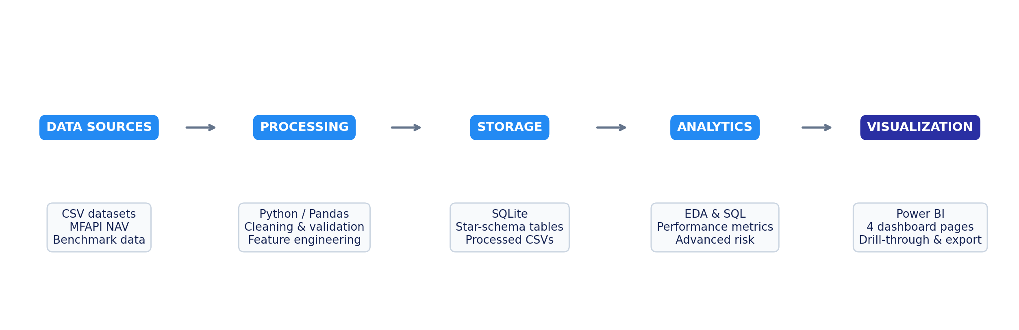
Figure 1. End-to-end project architecture
Investor transaction data is synthetic for educational analysis, while fund identifiers, scheme names, benchmarks and several market/industry attributes are based on public financial sources. This distinction is important when interpreting investor-level findings.

3. ETL, Data Cleaning & Validation

3.1 Extraction
All ten project datasets were ingested with Pandas. Initial profiling printed shape, data types and sample records for each table. Selected recent NAV data was also fetched through the MFAPI service to demonstrate API-based ingestion alongside static CSV ingestion.

3.2 Transformation
- Parsed date fields and standardized time-series ordering by AMFI code and date.
- Validated NAV values and removed duplicate or invalid records.
- Forward-filled missing NAV observations where required for non-trading days.
- Standardized investor transaction types to SIP, Lumpsum and Redemption.
- Validated transaction amounts and important categorical fields such as KYC status.
- Checked performance metrics for valid numeric types and reasonable ranges.
- Validated AMFI-code consistency across master, NAV, transaction and performance data.
- Created processed CSV outputs for notebooks, SQL and Power BI.

3.3 Data Quality Controls
Control | Implementation
Identifier integrity | AMFI codes cross-checked against the fund master
Date consistency | Chronological sorting and datetime conversion
Missing data | Appropriate handling of missing NAV and analytical fields
Duplicate control | Duplicate records checked during cleaning
Numeric validity | Return, NAV, amount and ratio fields converted and validated
Reproducibility | Reusable scripts and project-relative paths

3.4 Load
Cleaned data was written to the processed-data layer and loaded into SQLite for structured querying. The same processed datasets were reused by Jupyter notebooks and Power BI, helping maintain consistency between statistical outputs and dashboard visuals.

4. Database Design, SQL Analysis & Exploratory Data Analysis

4.1 Database Design
SQLite was used to implement a compact analytical data model. The design separates descriptive fund attributes from fact-style datasets such as NAV, transactions and performance. A date dimension supports time-based analysis, while AMFI code provides the core scheme-level join key.
The SQL layer supports business questions such as fund-house comparisons, category analysis, transaction summaries, investor participation and scheme-level performance. A schema file and analytical query file are maintained in the repository so that the database logic is reproducible.

4.2 Exploratory Data Analysis
EDA examined AUM growth, SIP behaviour, fund categories, investor demographics, transaction types, geographic participation, return distributions and benchmark relationships. The data includes major fund houses such as SBI, HDFC, ICICI Prudential, Nippon India, Axis, Kotak Mahindra, Aditya Birla Sun Life, UTI, Mirae Asset and DSP.
- Industry AUM increased substantially across the 2022-2025 period represented in the dashboard.
- SIP inflows and SIP AUM show strong growth, supporting the interpretation of increasing systematic participation.
- Investor transactions can be segmented by state, city tier, age group and transaction type.
- Equity categories show materially higher return volatility than liquid and short-duration debt categories.
- Fund-level risk-return relationships motivate the later use of Sharpe, Sortino, VaR and CVaR rather than raw return alone.

4.3 Analytical Outputs
Artifact | Purpose
EDA_Analysis.ipynb | Exploratory charts and business insights
queries.sql | Analytical SQL queries
data_dictionary.md | Column definitions and sources
Performance_Analytics.ipynb | Fund metrics, benchmark comparison and scorecard

5. Fund Performance Analytics
Fund performance was assessed using multiple return and risk measures. CAGR represents annualized growth, standard deviation measures volatility, Sharpe Ratio measures return per unit of total risk, Sortino Ratio focuses on downside risk, Alpha measures return above benchmark expectation, Beta measures market sensitivity, and Maximum Drawdown captures the worst peak-to-trough decline.

5.1 Top Fund Scorecard Results
Rank | Fund | 3Y CAGR | Sharpe | Fund Score
1 | Mirae Asset Large Cap - Regular | 33.99% | 1.46 | 60.50
2 | Kotak Flexicap - Regular | 29.58% | 1.32 | 59.38
3 | ICICI Pru Midcap - Regular | 31.77% | 1.19 | 56.25
4 | HDFC Mid-Cap Opportunities - Regular | 32.43% | 1.10 | 54.12
5 | Mirae Asset Tax Saver - Regular | 29.17% | 1.25 | 53.25
Mirae Asset Large Cap Fund - Regular - Growth ranked first in the generated scorecard, combining a strong three-year CAGR with the highest Sharpe Ratio among the top-ranked funds. The scorecard intentionally combines multiple performance dimensions so that a scheme is not rewarded only for high return.

5.2 Interpretation
- Higher Sharpe and Sortino values indicate better risk-adjusted performance.
- Positive Alpha suggests return generated beyond benchmark expectation.
- Maximum Drawdown is essential for understanding investor experience during market stress.
- Expense ratio affects investor outcomes and was included in the composite scoring logic.
- Risk-return evaluation should be interpreted jointly with category and investor risk appetite.
The Power BI Fund Performance page converts these metrics into an interactive scorecard, scatter plot, return ranking and benchmark comparison, making the analytical results accessible to non-technical stakeholders.

6. Advanced Risk Analytics - Historical VaR & CVaR
Historical VaR at the 95% level was calculated as the fifth percentile of each scheme's daily return distribution. CVaR was calculated as the mean return for observations at or below the VaR threshold. VaR estimates a downside threshold; CVaR describes the severity of losses once that threshold is exceeded.
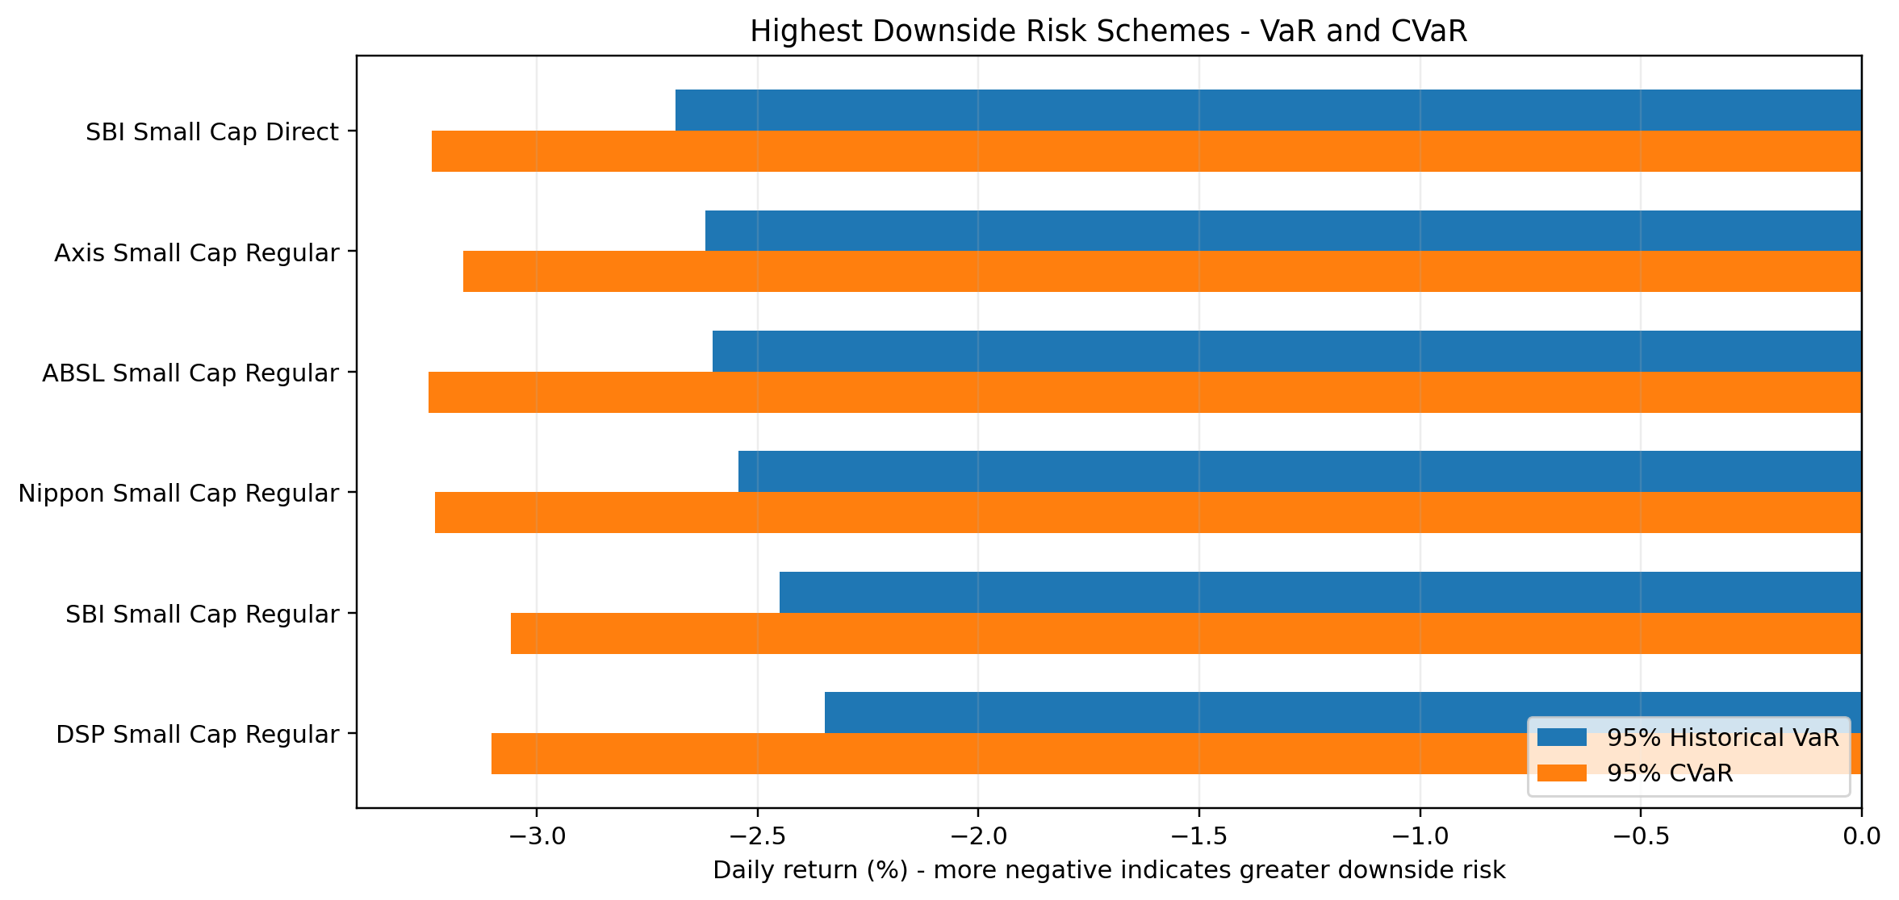
Figure 2. Schemes with the largest estimated downside risk
The most negative Historical VaR among the analysed schemes was approximately -2.69% for SBI Small Cap Fund - Direct Plan - Growth. ABSL Small Cap Fund - Regular - Growth recorded a CVaR of approximately -3.25%, representing one of the largest average losses within the worst five percent of observed daily-return outcomes.
The results show a clear category pattern: small-cap equity schemes dominate the higher-downside-risk group, while liquid and short-duration debt schemes show materially smaller VaR and CVaR magnitudes. This demonstrates why category and volatility should be considered when comparing funds with similar headline returns.

6.1 Why CVaR Adds Value
VaR alone does not indicate how severe a loss can become beyond the threshold. CVaR directly summarizes the average of extreme downside observations and therefore provides a more informative view of tail risk. The two measures are best interpreted together rather than as standalone forecasts.

7. Investor Advanced Analytics & Fund Recommender

7.1 Investor Cohort Analysis
Investors were grouped by the year of their first observed transaction. For the required 2024 and 2025 cohorts, the analysis calculated average SIP amount, total invested amount and the most preferred fund by invested amount.
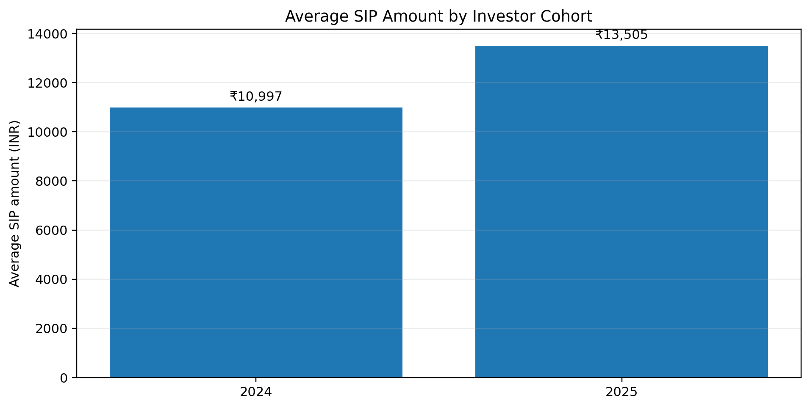
Figure 3. Average SIP amount for 2024 and 2025 investor cohorts
Cohort | Avg SIP | Total Invested | Preferred Fund
2024 | ₹10,996.89 | ₹2,258,062,304 | Axis Small Cap Fund - Regular - Growth
2025 | ₹13,505.21 | ₹18,992,635 | Axis Midcap Fund - Regular - Growth
The 2025 cohort has a higher average SIP amount, while the 2024 cohort has a much larger cumulative invested amount because it has a longer observed transaction history. The preferred schemes also differ between cohorts, illustrating how cohort analysis can uncover behavioural differences that are hidden in aggregate totals.

7.2 SIP Continuity Analysis
For investors with at least six SIP transactions, gaps between consecutive SIP dates were calculated. Investors with unusually large gaps were flagged as At-Risk. This approach can help an investment platform identify possible discontinuation behaviour and trigger reminders or investor-engagement actions.

7.3 Simple Fund Recommender
A reusable Python script accepts a Low, Moderate or High risk appetite and returns the top three matching funds ranked by Sharpe Ratio. The model is deliberately transparent and rule-based; it demonstrates how analytical metrics can support a recommendation workflow while keeping the decision logic interpretable.

8. Rolling Sharpe & Sector Concentration Risk

8.1 Rolling 90-Day Sharpe Ratio
A rolling 90-day Sharpe Ratio was calculated for five selected funds using the required formula: rolling mean return divided by rolling standard deviation, multiplied by the square root of 252. Unlike a single full-period Sharpe Ratio, the rolling measure shows how risk-adjusted performance changes through time.
The rolling analysis is useful because market regimes are not constant. A fund may have a strong overall Sharpe Ratio while still experiencing periods of weak or negative risk-adjusted performance. The generated chart is saved as rolling_sharpe_chart.png in the reports folder and is available as a supporting analytical output.

8.2 Sector Concentration - HHI
Sector concentration was calculated for equity funds using HHI = Σ(weightᵢ²), after aggregating holding weights by sector. A larger HHI indicates that more portfolio weight is concentrated in fewer sectors, which may increase exposure to sector-specific shocks.
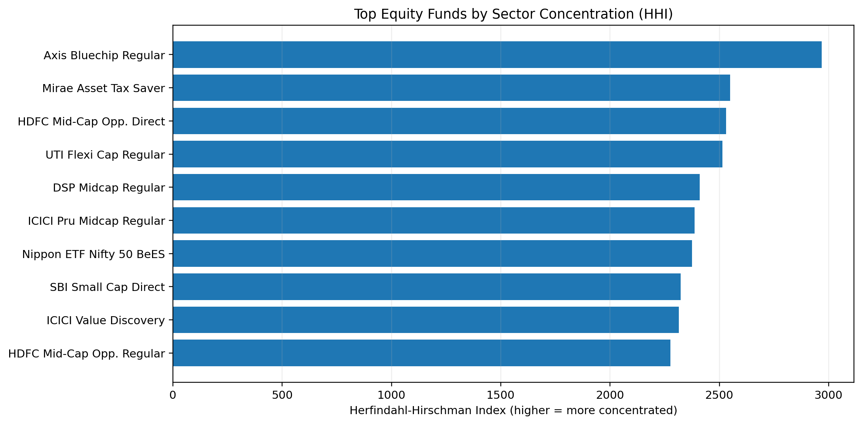
Figure 4. Equity funds with the highest sector concentration
Axis Bluechip Fund - Regular - Growth recorded the highest HHI in the generated output at approximately 2967.69. Mirae Asset Tax Saver Fund and HDFC Mid-Cap Opportunities Fund - Direct - Growth followed. HHI should be interpreted as a concentration indicator based on the available portfolio holdings rather than a complete measure of total portfolio risk.

9. Power BI Dashboard - Industry Overview
The first dashboard page provides a management-level view of industry scale and growth. The required KPI cards show Total AUM, latest SIP inflow, total schemes and investor folios. The page also contains an industry AUM trend and AUM by fund house, allowing users to move quickly from headline values to the major fund-house distribution.
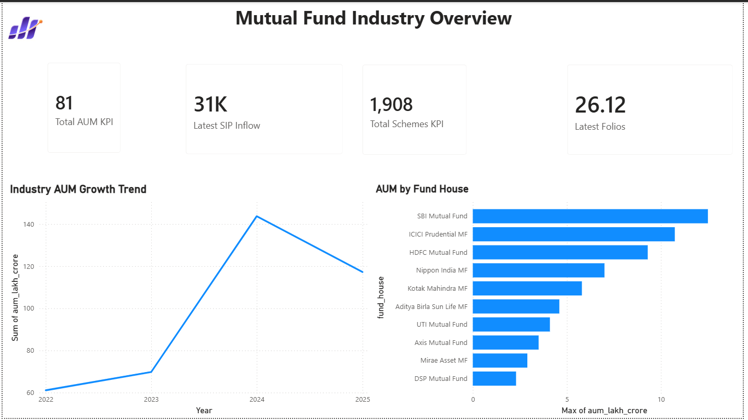
Figure 5. Mutual Fund Industry Overview dashboard
The KPI values displayed in the final project dashboard are ₹81 lakh crore AUM, approximately ₹31K crore SIP inflow, 1,908 schemes and 26.12 crore folios. The accompanying trend visual summarizes the 2022-2025 industry trajectory, while the fund-house bar chart highlights the major AMCs represented in the data.

10. Power BI Dashboard - Fund Performance
The Fund Performance page is designed for scheme comparison. The risk-versus-return scatter plot positions funds by return and volatility, the scorecard table provides scheme details, and slicers allow filtering by fund house, category and plan. A NAV-versus-benchmark trend visual supports time-series comparison, while the return ranking highlights leading schemes.
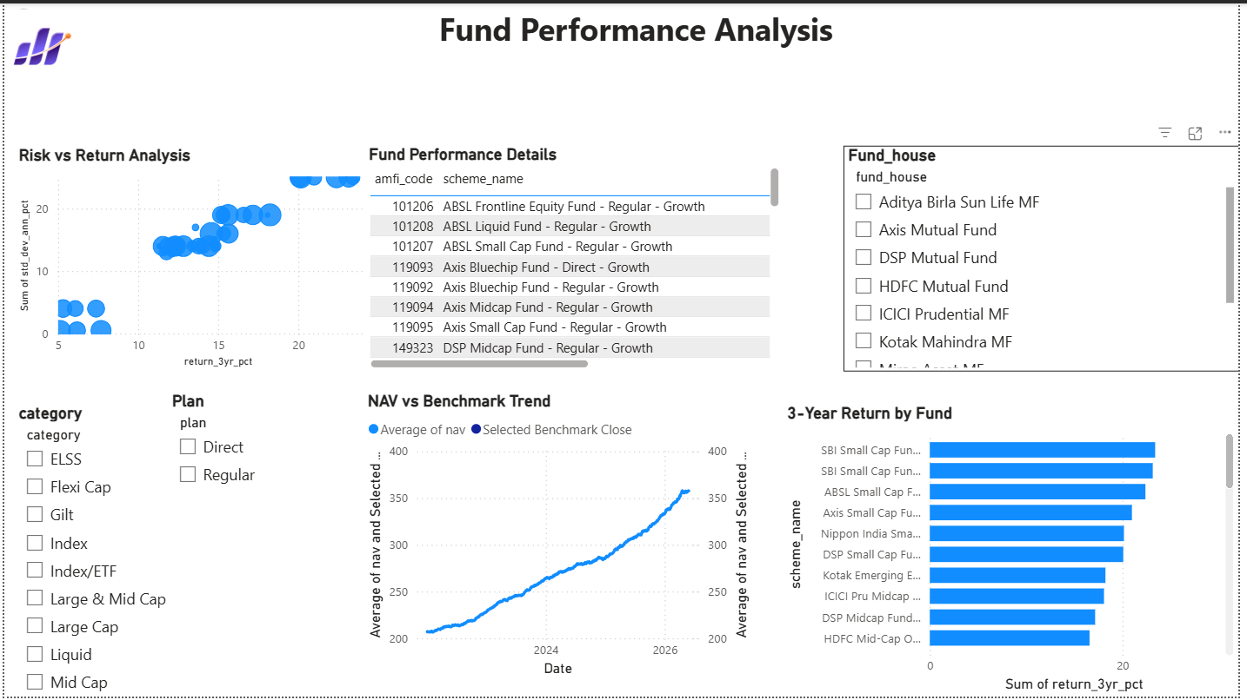
Figure 6. Fund Performance Analysis dashboard
The page also serves as the source for drill-through to the NAV detail page. Using a consistent AMFI code enables the selected scheme to filter the detail page so that the user can inspect scheme metadata, latest NAV, NAV change and historical NAV movement.

11. Power BI Dashboard - Investor Analytics
The Investor Analytics page combines investor segmentation with SIP trends. Required visuals include transaction amount by state, transaction-type split, average SIP amount by age group and monthly transaction volume. The page also contains supporting visuals for SIP inflow, SIP AUM, new SIP accounts and year-over-year SIP growth.
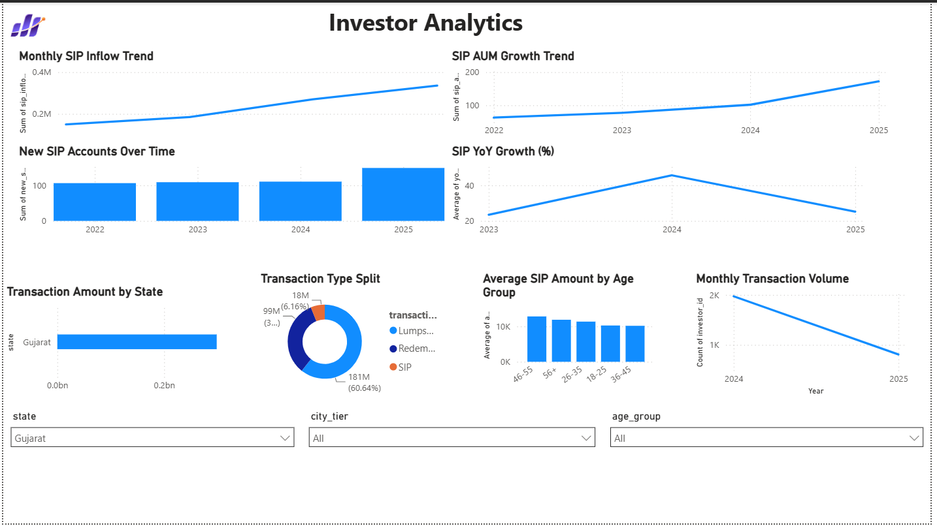
Figure 7. Investor Analytics dashboard
Interactive slicers for state, city tier and age group allow the same page to support geographic and demographic analysis. This layout helps business users move between broad participation trends and specific investor segments without changing reports.

12. Power BI Dashboard - SIP & Market Trends
The SIP & Market Trends page combines systematic investment activity with market context. The dual-axis visual compares SIP inflows with the NIFTY 50 across 2022-2025. Additional visuals show SIP AUM, active SIP accounts, SIP growth, category-wise net inflow and the top five categories by FY25 net inflow.
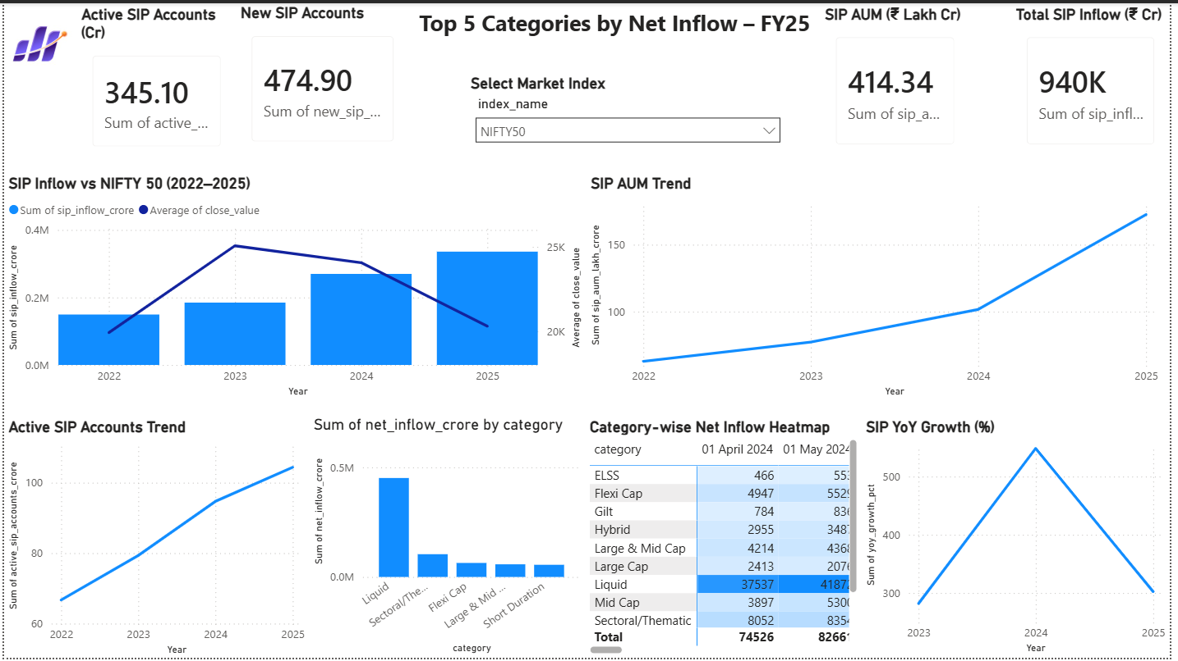
Figure 8. SIP & Market Trends dashboard
The category heatmap helps compare flow intensity across categories and months, while the Top 5 view provides a concise summary for business reporting. The page demonstrates how industry activity and market movement can be interpreted together rather than in isolated charts.

13. Drill-through, Key Findings & Business Interpretation

13.1 NAV Detail Drill-through
A dedicated NAV detail page was created as the drill-through target from the Fund Performance table. The page displays the selected scheme, fund house, category, risk grade, latest NAV, latest NAV date, NAV change and historical NAV trend. This provides a natural path from comparison to detailed inspection.
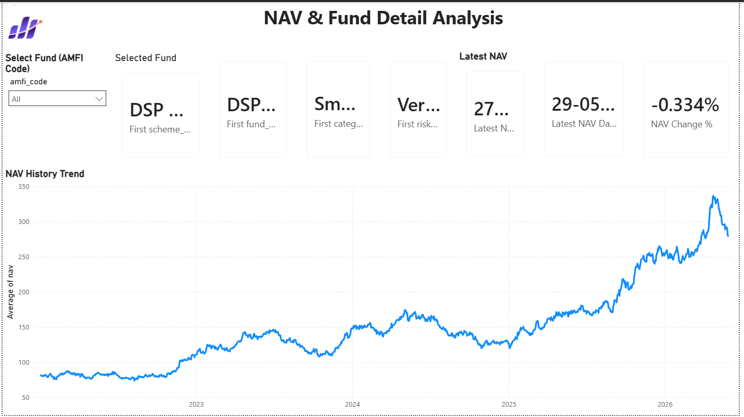
Figure 9. NAV & Fund Detail drill-through page

13.2 Key Findings
- The industry dashboard context reflects strong growth in AUM, SIP activity and folio participation by December 2025.
- Mirae Asset Large Cap - Regular ranked first in the generated multi-metric fund scorecard.
- Small-cap equity schemes show the largest downside-risk magnitudes in the VaR/CVaR results.
- The 2025 cohort has a higher average SIP amount than the 2024 cohort in the synthetic investor dataset.
- SIP continuity analysis can surface investors whose transaction gaps indicate possible disengagement.
- Axis Bluechip Regular has the highest sector HHI among the analysed equity portfolios.
- Rolling risk-adjusted performance changes over time, reinforcing the need for dynamic rather than single-period evaluation.

14. Recommendations, Limitations & Future Enhancements

14.1 Business Recommendations
- Evaluate schemes using a basket of return and risk metrics instead of historical return alone.
- Use VaR and CVaR to complement drawdown and volatility when discussing downside exposure.
- Monitor SIP continuity and proactively engage investors whose transaction gaps become irregular.
- Use cohort and demographic analysis to tailor investor communication rather than relying only on aggregate trends.
- Consider sector concentration alongside fund return, particularly for equity portfolios with high HHI values.
- Extend the recommender with investment horizon, liquidity needs, age, income and goal information before production use.

14.2 Limitations
- Investor transaction data is synthetic and therefore demonstrates analytical methods rather than real customer behaviour.
- Historical performance, VaR and CVaR do not guarantee or fully predict future market outcomes.
- The simple recommender uses risk grade and Sharpe Ratio and does not constitute personal investment advice.
- HHI is calculated from the available portfolio holdings, which may not represent every security in a complete portfolio.
- Power BI results depend on the current data refresh and model configuration.
- Benchmark comparison depends on correct scheme-to-index mapping and data availability.

14.3 Future Enhancements
- Automated weekday NAV ingestion and refresh pipeline
- Streamlit or web application for broader access
- Portfolio optimization using the Efficient Frontier
- Monte Carlo simulation for forward-looking uncertainty bands
- Machine-learning based investor suitability and recommendation
- Automated investor alerts and scheduled analytical reports

15. Conclusion, Deliverables & References

15.1 Conclusion
The Mutual Fund Analytics Capstone successfully implements the full lifecycle of a financial data analytics project. Raw data is ingested and validated, transformed into reusable processed datasets, queried through SQL, explored in Jupyter, evaluated using financial performance and risk metrics, and communicated through an interactive Power BI dashboard.
The advanced analytics layer strengthens the solution beyond descriptive reporting. VaR and CVaR reveal downside risk, rolling Sharpe captures time-varying risk-adjusted performance, cohort and SIP-continuity analysis convert transaction history into behavioural insight, the recommender translates metrics into a simple decision-support workflow, and HHI adds a portfolio concentration perspective.
The project demonstrates practical skills in Python, Pandas, NumPy, SQL, SQLite, financial analytics, Jupyter Notebook, Power BI, DAX, Git and GitHub. It provides a strong foundation for a production-grade mutual fund analytics platform with automated data refresh, richer investor suitability logic and advanced portfolio analytics.

15.2 Final Deliverables
Deliverable | Description | Status
D1 | ETL pipeline & ingestion scripts | Completed
D2 | SQLite schema & SQL analytics | Completed
D3 | EDA notebook | Completed
D4 | Performance analytics & scorecard | Completed
D5 | Interactive Power BI dashboard + PDF/screenshots | Completed
D6 | Advanced analytics notebook + CSVs + recommender | Completed
D7 | Final report & presentation | Finalization stage

15.3 Key Project Files
notebooks/Advanced_Analytics.ipynb | reports/var_cvar_report.csv | reports/rolling_sharpe_chart.png | reports/cohort_analysis.csv | reports/sip_continuity.csv | reports/sector_hhi.csv | scripts/recommender.py | dashboard/bluestock_mf_dashboard.pbix

15.4 References & Data Notes
- Bluestock Fintech - Mutual Fund Analytics Capstone Project Brief (project objectives, tasks, dataset definitions and deliverables).
- AMFI India and MFAPI-referenced project data for mutual fund identifiers, NAV context and industry-level metrics.
- Project GitHub repository: satyaa2429/Mutual-Fund-Analytics (version-controlled scripts, notebooks, reports and dashboard artifacts).
- Investor transaction data is synthetic and used for educational analytics; findings should not be interpreted as real customer behaviour.

