Kotak Mahindra Bank Ltd
KOTAKBANK | Financials | Private Banks

Financial Snapshot
ROE 14.0% |  |  | ROCE 7.1% |  |  | Debt / Equity 4.00x
Revenue CAGR 5Y 13.5% |  |  | PAT CAGR 5Y 20.4% |  |  | Free Cash Flow 6,766 Cr
Latest FY | 2024-03 | P/E |  | 32.90x | P/B |  | 1.15x
EPS | 92.0 | Book Value / Sha |  | re 653.8 | Dividend Payout |  | 2.0%
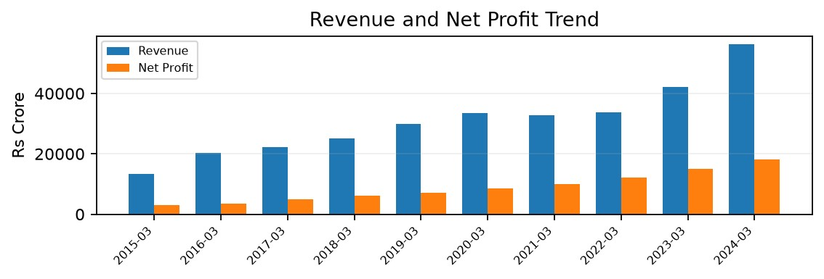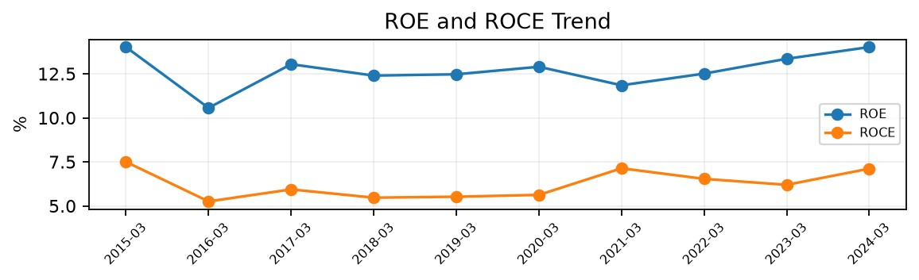
Nifty 100 Financial Intelligence Platform Page 1

Balance Sheet & Cash Flow
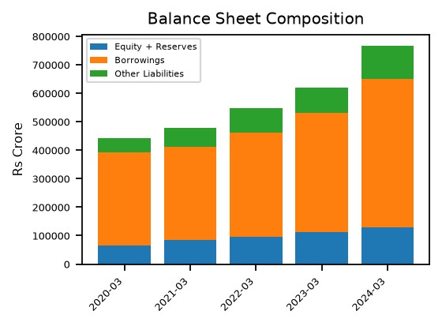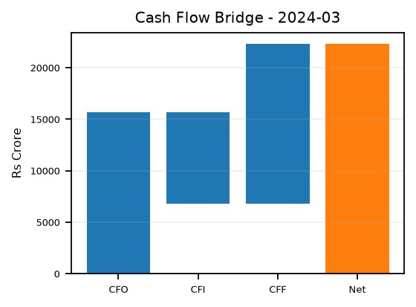

Cash Flow Intelligence
CFO Quality | High Quality Earnings
FCF CAGR 5Y | N/A
CapEx Intensity | 15.9% (Capital Intensive)
FCF Conversion | 14.4% (CapEx Heavy)
Capital Allocation | Mixed
Deleveraging | No
Distress Alert | No

Qualitative Investment Insights
Pros | Cons / Risks
Healthy 5-year PAT CAGR of 20.4%. | Low ROCE of 7.1%.
Healthy 5-year EPS CAGR of 19.3%. | Weak FCF conversion of 14.4%.
 | High CapEx intensity of 15.9%.
Note: This report is generated from the project's structured financial datasets. Rule-based distress, valuation and qualitative signals are analytical indicators and should be interpreted with sector and company context.
Nifty 100 Financial Intelligence Platform Page 2

