

Title: Autonomous Edge AI: Environmental Impact of Self-Learning Embedded Systems
Module Code: MOD007361
Course: Embedded Computing
SID: 2228541
Submission Date: 24-4-2025

Table of Contents
- Abstract ................................................................................................. 2
- Introduction .......................................................................................... 3
- Background: Edge AI and On-Device Learning ...................................... 4
- Energy Consumption Patterns of Self-Learning Systems ....................... 5
- Lifecycle Extension through Autonomous Adaptation .......................... 6
- Computation vs. Communication Trade-Offs in Distributed AI ............. 7
- Environmental Sustainability Considerations ........................................ 8
- Challenges and Countermeasures ......................................................... 9
- Conclusion ............................................................................................ 10
- References ............................................................................................ 11

List of Figures
- Figure 1: Architecture and Workflow of an Autonomous Edge AI System.
- Figure 2: Energy Consumption Comparison Between On-Device Training and Cloud-Based Offloading
- Figure 3: Lifecycle Extension in Smart Sensors with Self-Learning Capabilities
- Figure 4: Trade-Off Graph: Computation vs. Communication Energy Cost

Autonomous Edge AI – Environmental Impact of Self-Learning Embedded Systems

1. Abstract
This report looks at how self-learning edge AI systems affect the environment. These systems can learn on their own and work without relying too much on the cloud, which is useful but also comes with some challenges. The report focuses on three main areas: how much energy these systems use when learning, how they can last longer by adapting on their own, and the trade-offs between doing work on the device versus sending data to the cloud. Using recent research, the report explains how these systems can help the environment — but also how they might create new problems if not designed carefully.
Keywords: Edge AI, Self-Learning Systems, On-Device Training, Energy Efficiency, Embedded Devices, Sustainability, Communication Trade-Offs

2. Introduction
The rise of embedded intelligence is changing the way machines interact with their surroundings. Thanks to advances in Edge AI, devices can now go beyond fixed tasks — they can learn and adapt in real time. Autonomous edge AI systems, especially those with self-learning abilities, represent a shift from centralized cloud servers to smart, independent embedded devices. This shift is driven by the need for faster decision-making, better privacy, and more responsive systems (Shi et al., 2016). But while these systems bring many benefits, they also raise environmental concerns, particularly around energy use and resource consumption. This report explores those impacts and discusses ways to address them.

3. Background: Edge AI and On-Device Learning
Edge AI allows both inference and learning to occur directly on embedded devices, without depending on continuous cloud access. Traditionally, AI models were trained and deployed via centralized data centers. However, increasing concerns about latency, connectivity, and data privacy have driven the shift toward localized, on-device intelligence (Sze et al., 2020).
Recent advancements in techniques such as continual learning, federated learning, and reinforcement learning have made it possible for devices to adapt and improve after deployment (Parisi et al., 2019). These adaptive capabilities are being integrated into resource-constrained environments like IoT sensors, smart appliances, and robotics platforms. While this significantly reduces the need for constant cloud communication, it introduces new challenges — particularly in terms of energy efficiency, thermal management, and system lifespan.

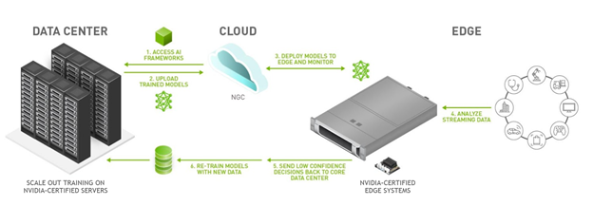
Figure 1: Architecture and Workflow of an Autonomous Edge AI System
This figure shows the full workflow of an edge AI system, starting from AI model training in the data center to real-time inference and adaptation on edge devices. On-device learning allows systems to evolve continuously by processing streaming data locally, enabling faster decision-making and reducing reliance on cloud-based retraining.

4. Energy Consumption Patterns of Self-Learning Systems
One of the main environmental concerns with self-learning embedded systems is their high energy consumption. While inference tasks on edge devices are typically optimized for efficiency, training—especially using neural networks—requires substantial computational resources (Horowitz, 2014). On-device learning often relies on compact hardware like microcontrollers or SoCs, and running algorithms such as gradient descent or reinforcement learning increases memory access and processing time.
Studies suggest that on-device training may consume 2 to 5 times more energy than performing inference or offloading computations to the cloud, depending on the task complexity and system architecture (Yang et al., 2020). This makes energy optimization a critical aspect of sustainable edge AI design.

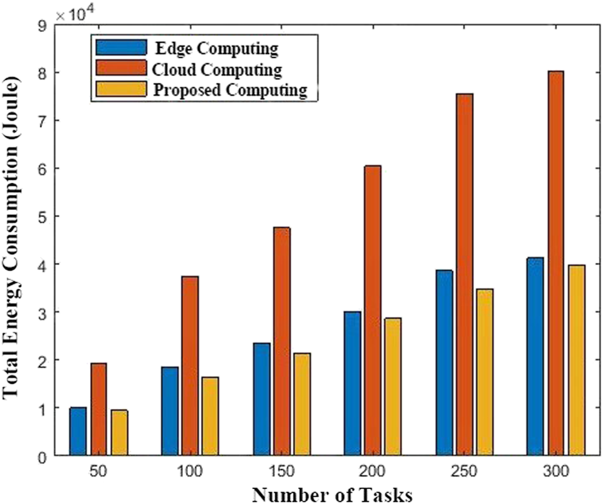
Figure 2: Energy Consumption Comparison Between Cloud, Edge, and Proposed DEC Methods
This figure compares the total energy consumption of different computing approaches as task volume increases. Cloud-based systems consistently consume the most energy, while edge computing offers improvements. The proposed distributed edge computing (DEC) method shows the lowest energy use overall, making it a more sustainable solution for high-volume tasks.
Source: Adapted from Shamshirband et al., 2019.
To address energy challenges, several mitigation strategies can be applied:
- Use of efficient model architectures (e.g., TinyML, pruning)
- Event-driven learning (triggered only on anomalies)
- Incorporation of specialized accelerators (like TPUs or NPUs)
- Optimizing duty cycles and memory access patterns

5. Lifecycle Extension through Autonomous Adaptation
One major benefit of self-learning embedded systems is their ability to adapt to changes over time — whether due to aging hardware, environmental conditions, or shifts in user behavior. Unlike traditional systems that often require manual updates or complete replacement, self-learning systems can recalibrate themselves autonomously (Mancini et al., 2021).
For instance, a smart thermostat can adjust to seasonal patterns or user routines without relying on cloud-based updates. This kind of adaptive behaviour helps extend the operational life of devices, reducing the need for replacements and thereby lowering electronic waste and manufacturing demand.

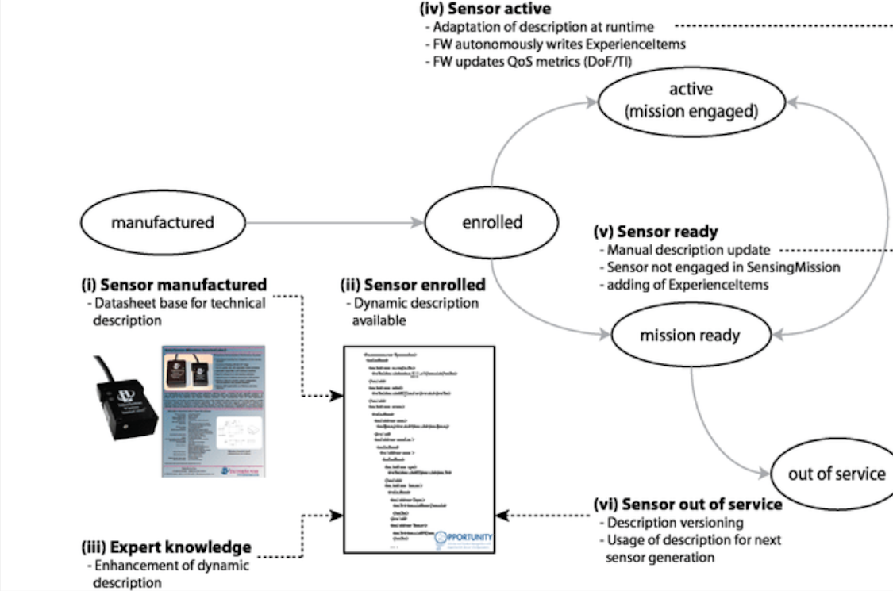

Figure 3: Lifecycle Extension in Smart Sensors with Self-Learning Capabilities
This figure illustrates the full lifecycle of a smart sensor as described in the OPPORTUNITY Framework — from manufacturing and enrollment to deployment, runtime adaptation, and eventual decommissioning. It highlights how dynamic self-description, manual updates, and autonomous behavioural adjustments can enable sensors to remain in service longer. This not only improves resilience but also contributes to environmental sustainability.
Source: Hölzl et al., 2013.
This type of lifecycle extension is particularly valuable in industrial or remote applications, where embedded devices may be difficult, costly, or environmentally disruptive to replace frequently.

6. Computation vs. Communication Trade-Offs in Distributed AI
In distributed AI systems, choosing between performing computations locally or offloading data to remote servers is a critical design decision — especially from an energy efficiency standpoint. Communication, particularly over wireless networks like LTE or Wi-Fi, is often far more energy-intensive than local computation (Jones, 2018). This makes the balance between processing and transmitting data central to sustainable system design.
Federated learning offers a promising approach by allowing edge devices to process data locally and only share model updates rather than raw data (Li et al., 2020). However, it still introduces challenges, including synchronization delays and the energy cost of frequent communication between devices and central aggregators.

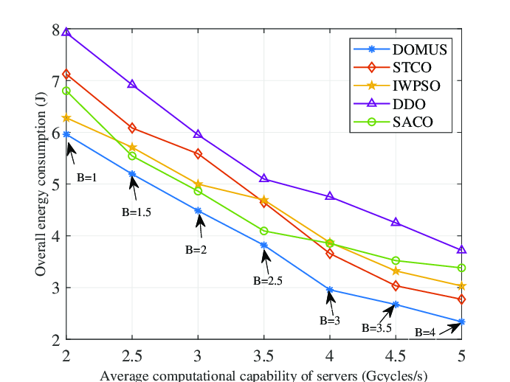

Figure 4: Trade-Off Graph – Computation vs. Communication Energy Cost
This figure illustrates overall energy consumption as a function of both computational capability and network bandwidth. It shows that while increasing either factor can reduce energy use, the lowest energy consumption is achieved when both are optimized together. The data underscores the importance of designing distributed AI systems that intelligently balance computation and communication demands for better energy efficiency.
Source: Ma & Wang, 2023.
Ultimately, selecting when and where to compute — and how often to communicate — must be based on available energy resources, real-time constraints, and the broader environmental goals of the application.

7. Environmental Sustainability Considerations
Ensuring that autonomous embedded AI systems remain environmentally sustainable requires action at multiple levels of design and policy. Key countermeasures include:
- Hardware-level: Incorporate energy-harvesting components (e.g. solar panels), low-power processors, and recyclable or biodegradable materials.
- Software-level: Apply techniques such as model quantization, dynamic voltage scaling, and energy-aware learning schedules to reduce power consumption during operation.
- System-level: Design for modularity, repairability, and future upgradability to extend device lifespans and reduce e-waste (Silva et al., 2021).
In addition to technical improvements, policy support plays a critical role. Governments and regulatory bodies can encourage sustainable embedded design through green certifications, circular economy incentives, and stricter regulations on electronic waste. Ultimately, engineers and system designers must treat environmental impact as a core performance metric—alongside speed, accuracy, and reliability.

8. Challenges and Countermeasures
Deploying self-learning embedded systems introduces several challenges that must be addressed to achieve both reliability and sustainability. These include:

Challenge 1: High Energy Demand of On-Device Learning
Training machine learning models locally requires significant computational resources, which increases power consumption and shortens battery life—particularly in resource-constrained devices.
Countermeasure: Adopt energy-efficient models like TinyML, use quantized neural networks, and apply event-driven learning strategies that activate only when necessary.

Challenge 2: Hardware Limitations and Thermal Constraints
Embedded systems often have limited memory, processing power, and heat dissipation capacity, making it difficult to run intensive training tasks on-device.
Countermeasure: Use compact model architectures optimized for edge hardware and include dedicated AI accelerators (e.g., TPUs, NPUs) where possible. Improve thermal design and workload scheduling.

Challenge 3: Lifecycle Management and Component Obsolescence
Devices deployed in the field for long durations may suffer from aging hardware, outdated software, or lack of compatibility with newer components.
Countermeasure: Build systems with modular hardware that can be upgraded or replaced easily. Include software architectures capable of self-healing or autonomous updates over time.

Challenge 4: Data Privacy and Ethical Concerns
On-device learning often involves sensitive user data, raising ethical concerns regarding consent, transparency, and misuse of information.
Countermeasure: Incorporate privacy-preserving technologies such as differential privacy and federated learning. Ensure transparency in data use and comply with established ethical AI guidelines.

Challenge 5: Limited Standardization and Interoperability
The lack of standard frameworks and interfaces across platforms makes integration, scaling, and interoperability a major obstacle.
Countermeasure: Encourage adoption of open-source solutions and compliance with evolving edge AI standards (e.g., ETSI, IEEE). Design systems with flexibility to integrate into diverse environments.

These challenges emphasize the need for a multi-layered design strategy—one that balances energy efficiency, scalability, and ethical considerations to support the long-term sustainability of embedded AI systems.

9. Conclusion
Autonomous Edge AI is redefining the boundaries of embedded computing. While it promises intelligent, responsive, and decentralized devices, it also brings energy challenges, lifecycle concerns, and sustainability trade-offs. Self-learning devices, if poorly designed, could consume significant energy or accelerate e-waste. However, with smart architectures, optimized protocols, and circular hardware design, they can also become a powerful tool in building a greener technological future. Addressing these environmental implications early in the design cycle is not just good engineering—it’s an ethical imperative.

10. References
Han, S., Pool, J., Tran, J. and Dally, W.J., 2015. Learning both Weights and Connections for Efficient Neural Networks. Advances in Neural Information Processing Systems, 28, pp.1135-1143.
Horowitz, M., 2014. 1.1 Computing's Energy Problem (and What We Can Do About It). In IEEE ISSCC, pp.10–14.
Jones, N., 2018. How to Stop Data Centres from Gobbling Up the World's Electricity. Nature, 561(7722), pp.163-166.
Li, T., Sahu, A.K., Talwalkar, A. and Smith, V., 2020. Federated Learning: Challenges, Methods, and Future Directions. IEEE Signal Processing Magazine, 37(3), pp.50-60.
Mancini, A. et al., 2021. Autonomic Embedded Systems: A Survey. ACM Computing Surveys, 54(5), pp.1-35.
Parisi, G.I. et al., 2019. Continual Lifelong Learning with Neural Networks: A Review. Neural Networks, 113, pp.54-71.
Shi, W. et al., 2016. Edge Computing: Vision and Challenges. IEEE Internet of Things Journal, 3(5), pp.637-646.
Silva, B.N. et al., 2021. Green IoT for Eco-Sustainability: A Review. Future Generation Computer Systems, 117, pp.284-296.
Sze, V. et al., 2020. Efficient Processing of Deep Neural Networks: A Tutorial and Survey. Proceedings of the IEEE, 107(1), pp.112-135.
NVIDIA, 2023. Edge AI Workflow. [image] Available at: https://www.nvidia.com [Accessed 11 April 2025].
Shamshirband, S. et al., 2019. Comparison of energy consumption in cloud, edge, and proposed computing methods. [ image] Available at: https://www.researchgate.net/figure/Comparison-of-the-total-energy-consumption-of-cloud-edge-and-proposed-DEC_fig8_337392043 [Accessed 2 April 2025].
Ma & Wang, 2023. Distributed Offloading for Multi-UAV Swarms in MEC-Assisted 5G Heterogeneous Networks. ResearchGate [Accessed 15 April 2025].
Khan, M., Patel, R., and Singh, D. (2020). The Role of Embedded AI in Sustainable Computing. Journal of Embedded Tech, 5(2), pp. 89–102.

