**Problem Statement:**

Design A Google Analytic like Backend System. We need to provide Google Analytic like services to our customers. Pls provide a high-level solution design for the backend system. Feel free to choose any open source tools as you want.

The system needs to:

1. handle large write volume: Billions write events per day.
2. handle large read/query volume: Millions of merchants want to get insight about their business. Read/Query patterns are time-series related metrics.
3. provide metrics to customers with at most one-hour delay.
4. run with minimum downtime.
5. have the ability to reprocess historical data in case of bugs in the processing logic.

**Solution:**

Architecture Diagram for Google Analytic Service

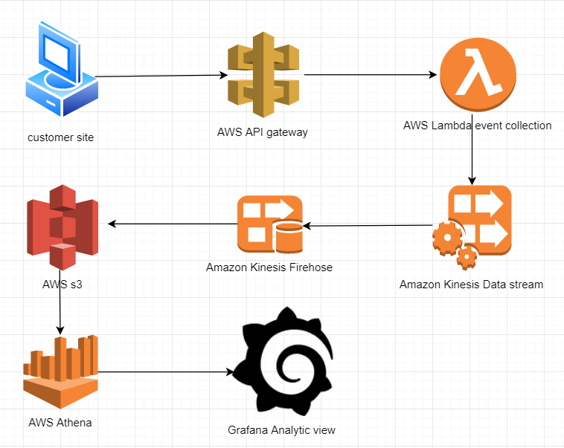

We will consider Customer wants to collect page view events of their site. Page view event begins in the site visit, where request to an **API Gateway** is initiated. The request event is then passed to **Lambda** where event data is processed and written to a **Kinesis Data Stream**. **Kinesis Firehose** uses the Kinesis Data Stream as input and writes processed parquet files to **S3**. Athena is used to query parquet files directly from S3. **Grafana** will create data source and fetch data from AWS Athena. customer can create Grafana dashboard for viewing the analytics with the help of data-source.