Lighting Pattern Simulator
Software Requirements Specification



Submitted By

Satya Bhavsar (B16CS033)
Paridhi Gehlot (B16CS024)
Revision History
Date | Version | Description | People
18 Feb 2018 | 1.0 | First draft | Project Group:  Satya Bhavsar  Paridhi Gehlot
3 March 2018 | 2.0 | Second Draft | Project Group:  Satya Bhavsar  Paridhi Gehlot
24 April 2018 | 3.0 | Third Draft | Project Group:  Satya Bhavsar  Paridhi Gehlot

Table of Contents
1. Introduction 4
1.1 Purpose 4
1.2 Scope 4
1.3 Constraints 4
1.4 Assumptions and Dependencies 4
1.5 Definitions, Acronyms and Abbreviations 4
1.6 References 4

2. Overall Description 5
2.1 Product Functions 5
2.2 User Characteristics 9
3. Specific Requirements 9
3.1 Use case description 9

Software Requirements Specification

Introduction

Purpose: The purpose of the project is to simulate different lighting patterns on different types of buildings.

Scope: The product is aimed to provide a way to demonstrate the lighting patterns to the customers. It is built for lighting corporations so that they can view what the lighting patterns look like on the actual building and increase customer satisfaction. The customers can select from a variety of building types and patterns. The company can view the customer history.

Constraints:

1. The number of building types is limited to 5.

2. For each building a fixed number (i.e. 4) of lighting patterns are available.

Assumptions and Dependencies:

1. The building patterns and the light patterns are assumed to be fixed.

2. There exists only 1 admin.

Definitions, Acronyms and Abbreviations
Term | Definition
* | Represents white light
# | Represents red light
@ | Represents blue light
. | Represents blank space in building, light pattern and design
| ,\ ,/,o | Represents building boundary
Admin | The administration

References
[1] IEEE. IEEE Std 830-1998 IEEE Recommended Practice for Software Requirements
Specifications. IEEE Computer Society, 1998.

Overall Description

Product Functions

Functional Requirements:

1. Administration can view user history.
2. The customer can view and select building type.
3. The customer can view and choose associated lighting pattern.
4. The customer can view final simulation of light pattern on building.

Use Case Diagram:

Use Case: Login

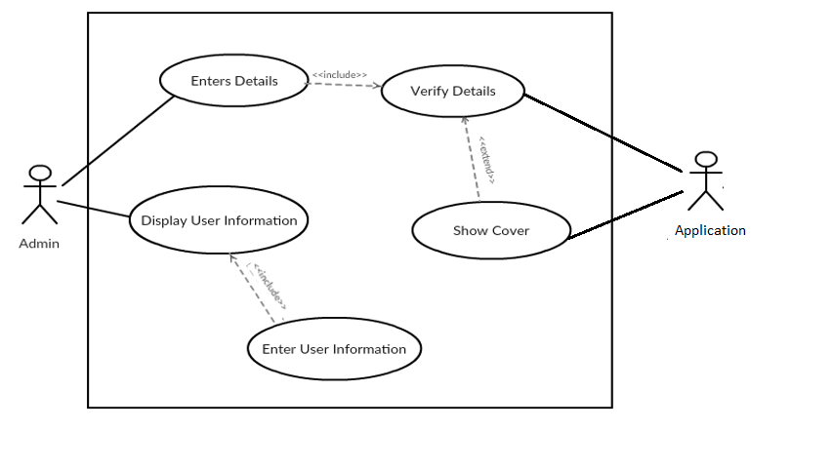

Use Case: Simulate_design

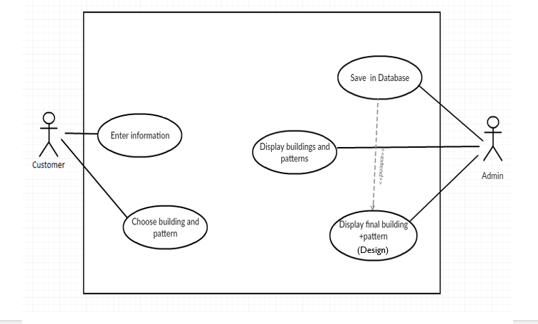

Class Diagram:
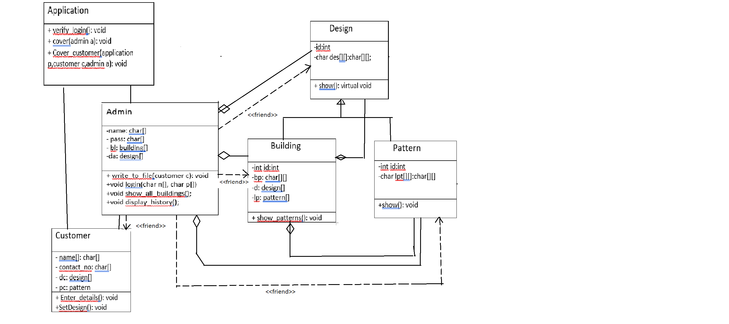

Sequence Diagram:

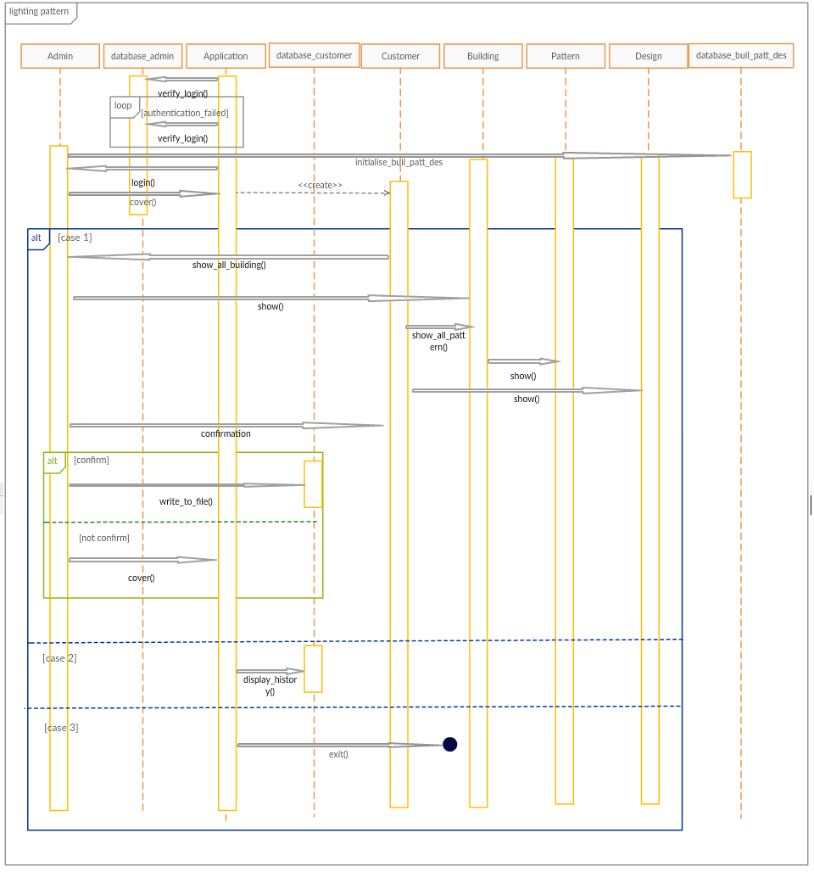

Activity Diagram:

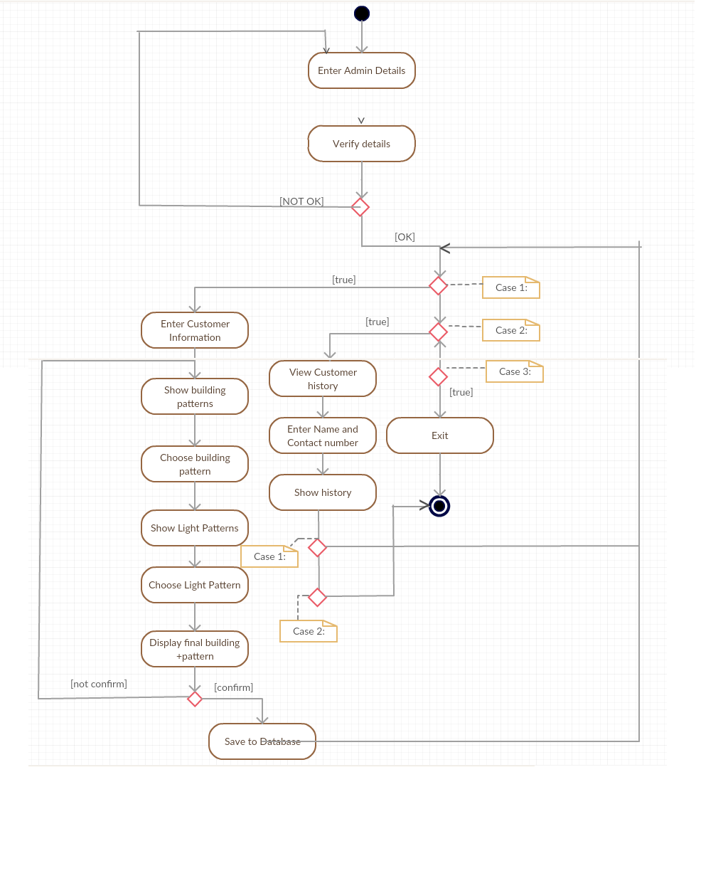

Non-Functional Requirements
1. The system is secure and only initiated after administration login.
2. Once confirmed the user’s selection is saved in database.

User Characteristics:
There are 2 types of users, the administration and the customers. They have different functions. The administration can view customer history. The customer can use the software only after the administration login. Customer can view and choose building types and light patterns associated with it.

Specific Requirements

Use case description

Login

Use Case Name | Login
Trigger | Admin wants to login to start the software.
Precondition | None
Basic Path | 1. Start the program.  2. Enter the username and password.  3. System verifies the details from database.
Alternative Paths | None
Post Condition | Admin is logged in.
Exception Paths | User enters wrong admin details
Others | None

Simulate_design

Use Case Name | Simulate_design
Trigger | Customer wants to simulate lighting patterns on buildings
Precondition | Admin must be logged in
Basic Path | 1. Enter customer information.  2. Select particular building pattern.  3. Select particular lighting pattern.
Alternative Paths | None
Post Condition | Selected light pattern is simulated on simulated building.
Exception Paths | Customer enters invalid option for buildings or light patterns.
Others | None

