# DEMO of project (POSTMAN SOFTWARE, DB BROWSER)

1.a) When adding the data in JSON format, able to get it in database, but the Postman shows an error. Tried to figure out but different type errors coming.

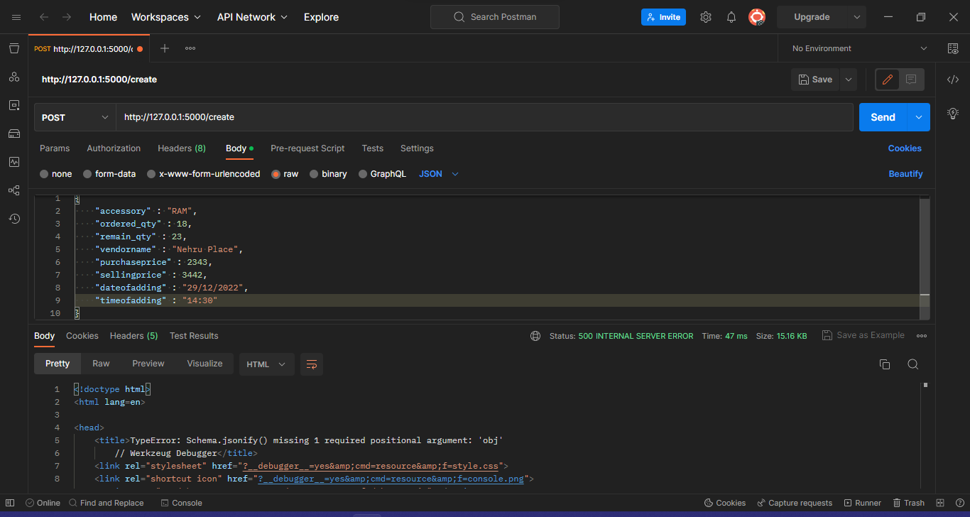

1.b) Successfully saved accessories to database when we are pass db.session.commit()

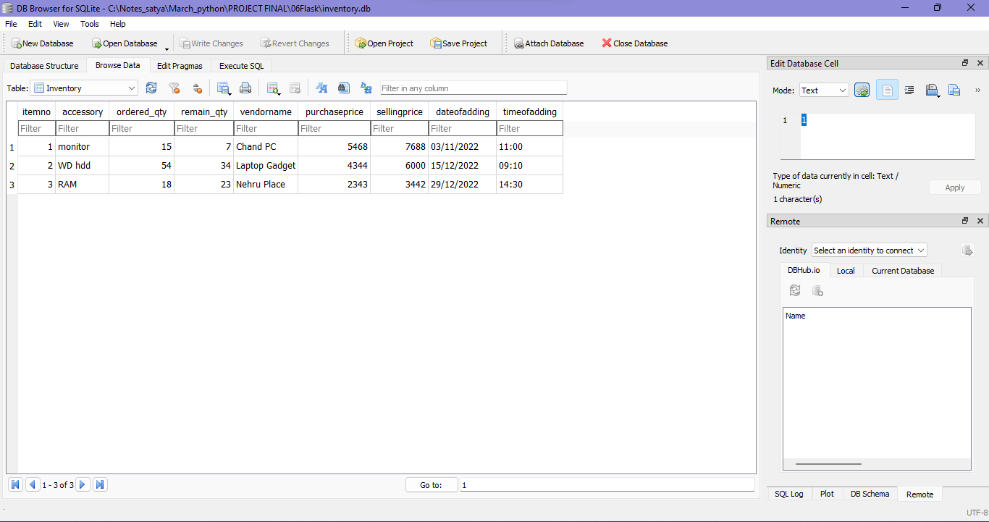

2.a) HTTP methods are working fine in POSTMAN, when we are pass the inputs in JSON format.

I update for (id: 3)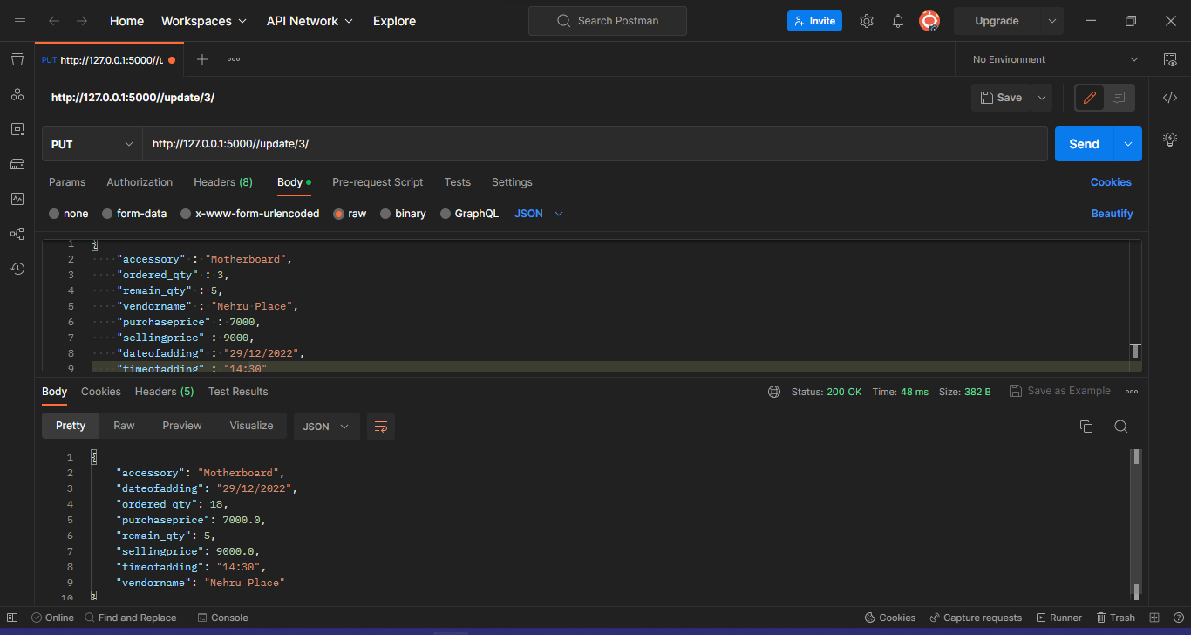

2.b) Update Successfully saved to the database.

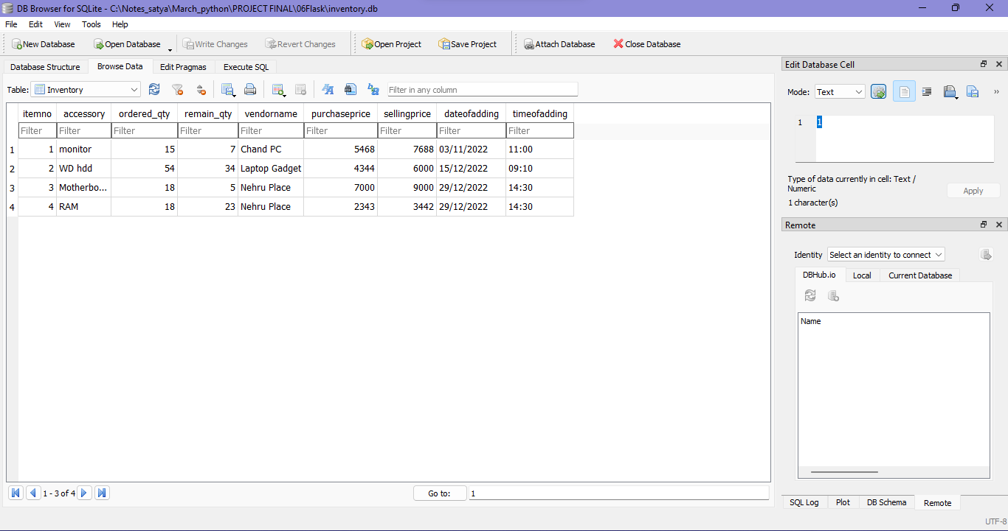

3. Details of accessories in tabular format by using jinja.

