**Prerequisites**:

* Java 1.8
* Gradle

1. Clone from below mentioned repository

Git clone https://github.com/satyadevaddepallya/atm-project.git

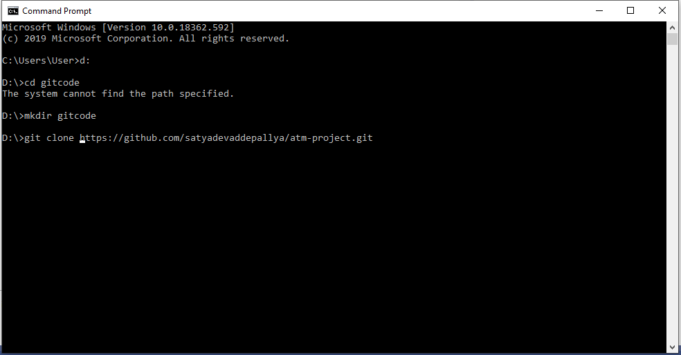

1. Go to Project directory

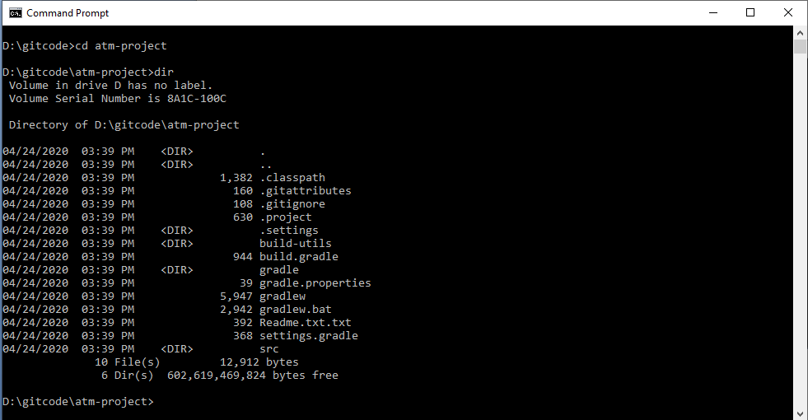

1. Execute gradle command to build fatJar  
   gradle clean build fatJar

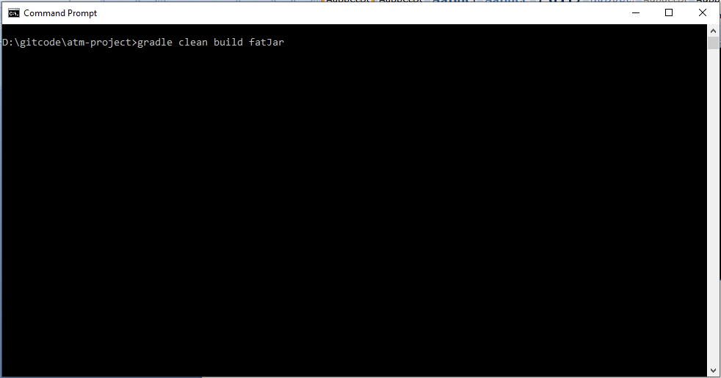

1. Build should be successful (In case of issue please send screen shot to Sangeetha Rao).  
   once build successful you will see jar file inside <<project_directory>> / build/ libs

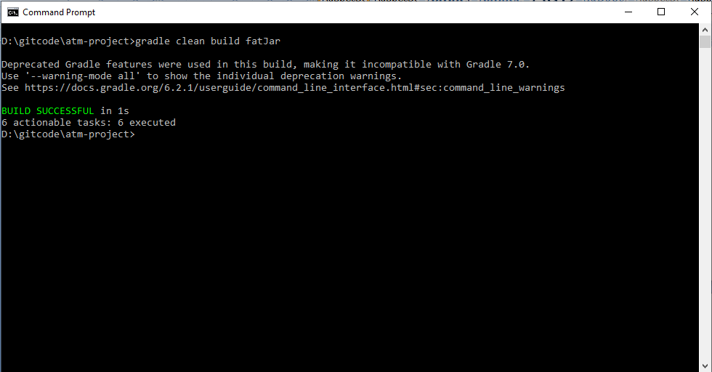

1. Execute Fat Jar with following command:

Java –jar build/libs/atm-project-all-1.0.jar

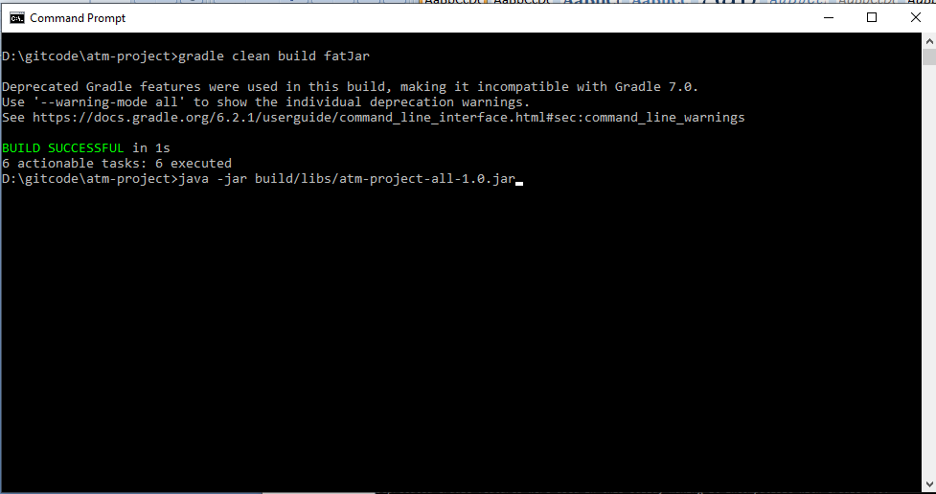

1. You will see application initialized with instructions to follow, followed by transaction type. I chose **D** (Deposit)

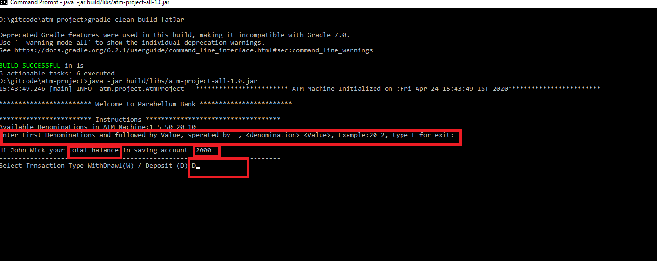

1. Enter denominations as mentioned in below screen shot and Type : **E** for exit

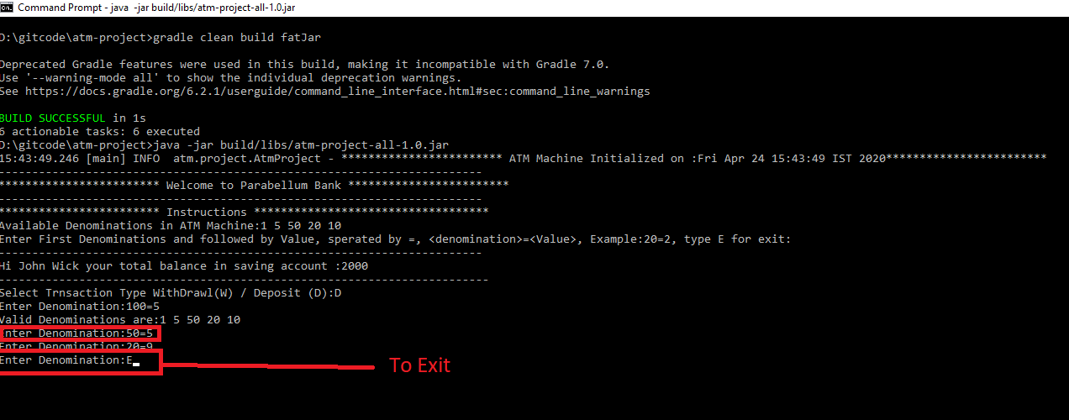

1. Will see final balance with denominations selected as like below screen shot

