Summary findings about HW:

* We are implementing on a VPC a DB in RDS as backend, using EC2 as front end client, and managing and keeping everything private.
* We might use tunneling to EC2 to log into DB.
* Finally shut down to avoid charges

Created DB: Database configuration with VPN, Subnet, Options and Parameters:

The settings in red box.

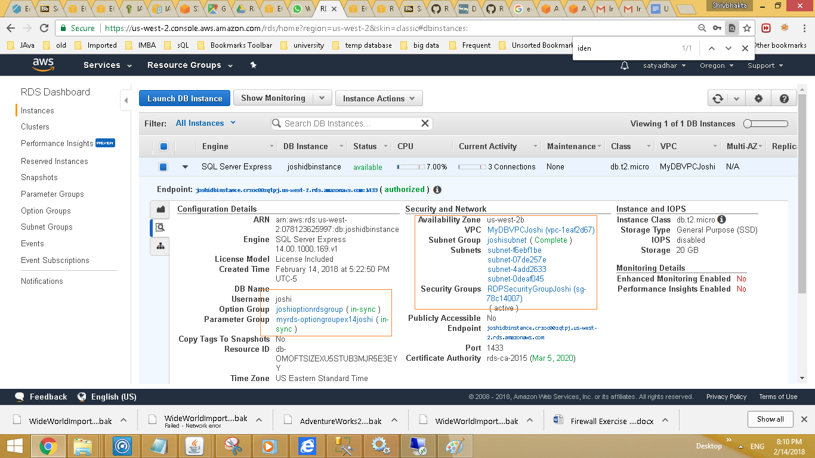

The DB is on RDS which is a standalone system and the DB is not on EC2.

While in HW1 DB2 server was on Windows server - this is diff case.

Different Files uploaded to the bucket Buckets:

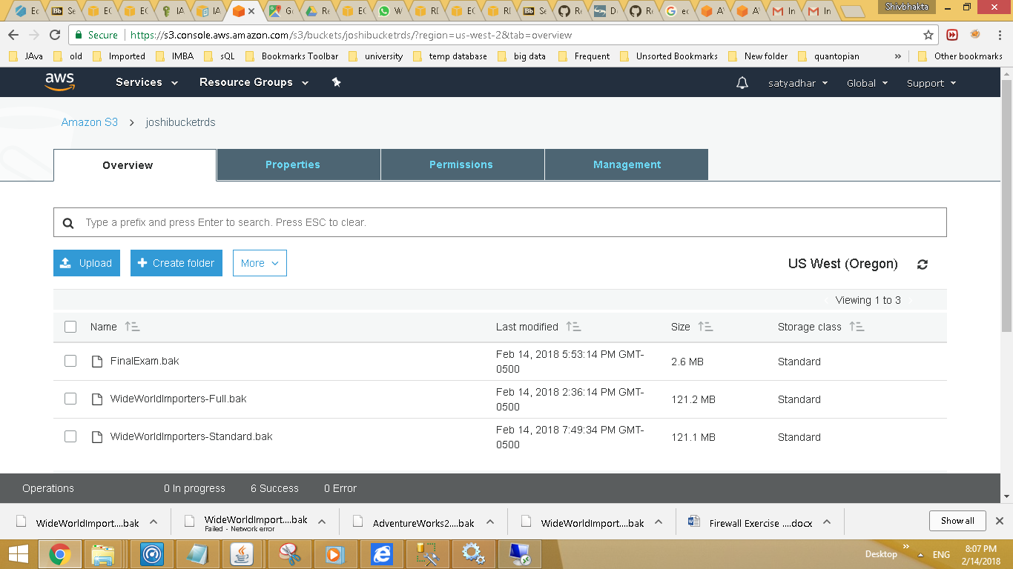

This is an expanding version of S3, the other option is to have 10GB.

In IAM policies we can define who can access or during DBS during the option group wherewe give the backup setting..

Both DB - mine and WorldImporters uploaded:

One DB from Windows and other exam DB of a course at Touro.

E2 instance had no SQL server, so manually downloaded and installed.

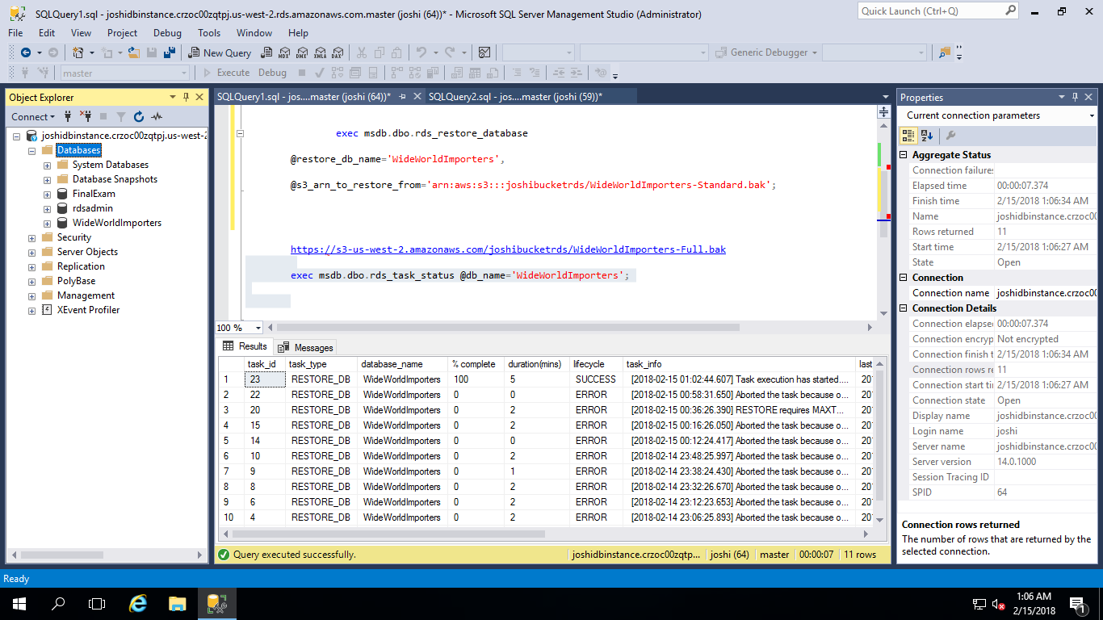

VPN Groups:

Created VPN group as required.

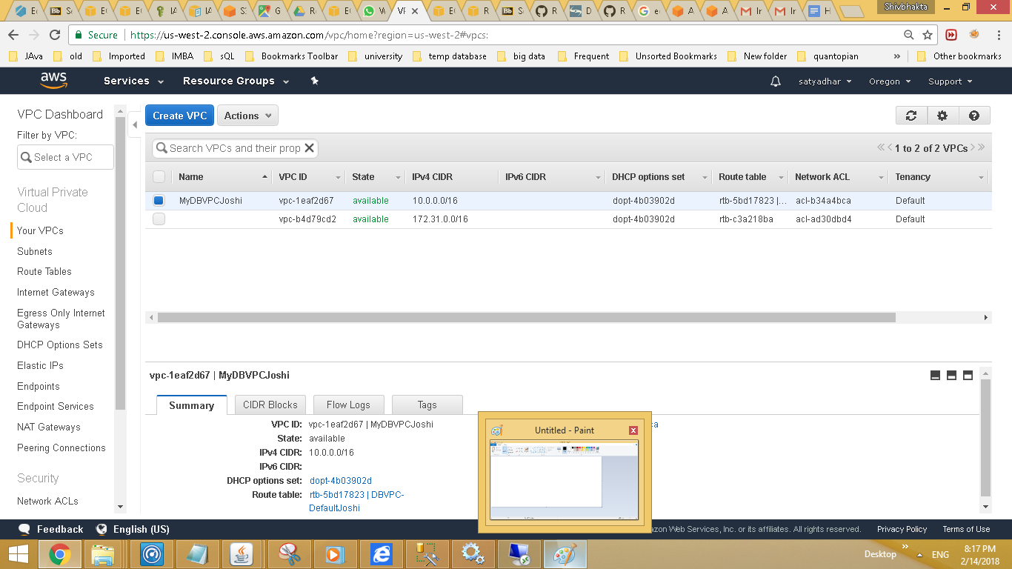

Parameters Group

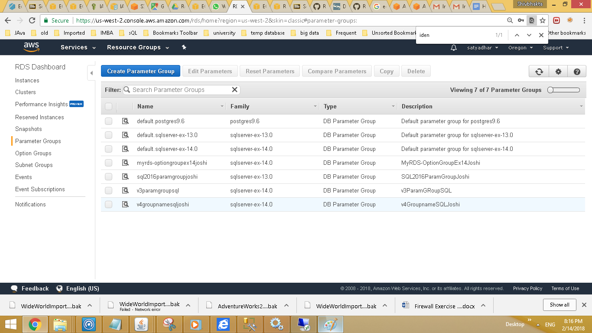

Option Group gives power to us to upload the backup

