**HOSPITAL MANAGEMENT SYSTEM**

**IN**

**COMPUTER SCIENCE AND ENGINEERING**

**(ARTIFICIAL INTELIGENCE & MACHINE LEARNING)**

**By**

**MATTA DURGA NAGA SATYA DINESH (211801360005)**

***Under the esteemed Guidance of***

**Dr.N.V.S Shankar,**

**Associate Professor**



**CENTURION UNIVERSTIY OF TECHNOLOGY AND MANAGEMENT**

**(VIZIANAGARAM)**

**(2022-2023)**

**CENTURION UNIVERSITY OF TECHNOLOGY AND MANAGEMENT**

**VIZIANAGARAM**

**DEPARTMENT OF COMPUTER SCIENCE AND ENGINEERING**



**BONAFIDE CERTIFICATE**

This is to certify that the project work entitled “**HOSPITAL MANAGEMENT SYSTEM PROJECT”** is a fulfillment of project work done by MATTA DURGA NAGA SATYA DINESH (21180360005) , for the award the degree of **BACHELOR OF TECHNOLOGY** in **COMPUTER SCIENCE AND ENGINEERING, CENTURION UNIVERSITY OF TECHNOLOGY** during the academic year 2022-2023.

**INTERNAL GUIDE HEAD OF THE DEPARTMENT**

**Dr.N.V.S Shankar Mr. Lakshmana Rao Rowthu**

**Associate Professor Asst. Professor & HOD**

**Dept. of CSE Dept. of CSE**

**EXTERNAL EXAMINER**

**ACKNOWLEDGEMENT**

It is with at most pleasure and excitement we submit our project partial fulfillment of the requirement for the award of Bachelor of Technology.

The project is a result to the cumulate efforts, support, guidance, encouragement and inspiration from many of those for whom we have to give our truthful honor and express gratitude through bringing out this project at the outset as per our knowledge.

We convey special thanks to our project Guided by **Dr.N.V.S Shankar** who has guided us and encouraged us to enhance our knowledge with present working of this project to bring out enriching the quality of project.

I express my appreciativeness to **Mr. R. LAKSHMAN RAO (Asst. Prof.) and Head of the Department,** who facilitated us to providing the friendly environment which helped to enhance my skills in present project.

I would also like to extend my gratitude to **Dr. K. V. G. KRISHNA MURTHY, Dean-School of Engineering and Technology, Centurion University of Technology and Management** who has helped us to attain all the requirements of the project.

I convey my sincere thanks to **Dr. RAMANA RAO, Ph. D Registrar of Centurion University of Technology and Management** who provided us with an opportunity to take on project work in well-equipped laboratories of Computer Science Department in our college.

At the outset, we thank to **Sri. G.S.N. RAJU**, beloved **Vice Chancellor of Centurion University of Technology and Management** who is the backbone by providing for completion of this project, Thank you sir.

**DECLA****RATION**

We hereby declare that the project entitled **“HOSPITAL MANAGMENT SYSTEM PROJECT”** submitted to the fulfillment of award the Degree of **B.Tech (CSE)** in **CENTURION UNIVERSITY OF TECHNOLOGY AND MANAGEMENT.** This project work in original has not been submitted so far in any part or full for any other university or institute for the award of any Degree or Diploma**.**

**Submitted by,**

**MATTA DURGA NAGA SATYA DINESH (21180136000)**

**ABSTRACT**

*Hospital Management System is an organized computerized system designed and programmed to deal with day-to-day operations and management of hospital activities. The program can look after inpatients, outpatients, records, database treatments, status illness, billings in the pharmacy, and labs. It also maintains hospital information such as ward id, doctors in charge, and department administering. The major problem for the patient nowadays is to get the report after consultation, many hospitals managing reports in their system but it's not available to the patient when he/she is outside. In this project, we are going to provide the extra facility to store the report in the database and make it available from anywhere in the world.*

*The project Hospital Management system includes registration of patients, storing their details into the system, and also computerized billing in the pharmacy, and labs. The software has the facility to give a unique id for every patient and stores the details of every patient and the staff automatically. It includes a search facility to know the current status of each room. Users can search the availability of a doctor and the details of a patient using the id. The Hospital Management System can be entered using a username and password. It is accessible either by an administrator or receptionist. Only they can add data into the database. The data can be retrieved easily. The interface is very user-friendly. The data are well protected for personal use and make the data processing very fast. Hospital Management System is powerful, flexible, and easy to use and is designed and developed to deliver real conceivable benefits to hospitals. Hospital Management System is designed for multispeciality hospitals, to cover a wide range of hospital administration and management processes critical financial accounting, in a seamless flow.*

TEXTS OF CONTENTS

**1.INTRODUCTION**

1.1 PURPOSE

1.2. SCOPE

1.3 REFERENCES

**2 .FUNCTIONAL REQUIREMENTS**

**3. NON-FUNCTIONAL REQUIREMENTS**

3.1 USABILITY REQUIREMENTS

3.2 ERROR HANDLING

3.3 SECURITY REQUIREMENTS

3.4 SOFTWARE REQUIREMENTS

3.5 HARDWARE REQUIREMENTS

**CONTROL FLOW DIAGRAM**

**4.USE CASE ANALYSIS**

4.1 USE CASE ANALYSIS

4.2 CONTROL OF DIAGRAM

**LIST OF FIGURES**

|  |  |  |  |
| --- | --- | --- | --- |
| **S.NO** | **FIG. NO.** | **TITLE** | **PAGE NO** |
| 1. | 4.1 | Flow Chart | 13 |
| 2. | 4.2 | Sequence Diagram | 14 |
| 3. | 5.1 | Login Page | 15 |
| 4. | 5.2 | Adding Patient | 15 |
| 5. | 5.3 | Display Patient | 16 |
| 6. | 5.4 | Exiting the Program | 16 |

**1.INTRODUCTION**

1.1 PURPOSE

**.** Hospital Management System is a system enabling hospitals to manage information and data related to all aspects of healthcare – processes, providers, patients.

**.**Turn ensures that processes are completed swiftly and effectively. When one thinks of the various aspects and departments of a hospital, it becomes apparent that an HMS is critical.

**.**The hospital database management system was introduced in 1960, and has greatly evolved since then – with the ability to integrate with the existing facilities, technologies, software, and systems of a hospital.

**.**Today, patients can begin the process of healthcare in the palm of their hand – the mobile devices and apps – make this possible. This process then moves to the healthcare providers and hospitals.

1.2 SCOPE

Hospital Management System is an organized computerized system designed and programmed to deal with day-to-day operations and management of hospital activities.

The program can look after inpatients, outpatients, records, database treatments, status illness, billings in the pharmacy, and labs.

The hospital management system will soon be able to streamline the administrative process of hospitals. Instead of having paper files, these software programs will use advanced technology to secure and store all patient records in one location.

REFERENCES

.Hospital Management System projected by

. Hospital Management System projected on

**2.FUNCTIONAL REQUIRMENTS**

The Hospital Management System projected by must have the following functional requirements:

1. [Hospital Management System](https://mocdoc.in/util/hospital-management-system) is used to take the data from the patients and then store it for later use. The main goal of the Hospital Management System is to accurately treat as well as decrease overtime pay.
2. Some of the system functions include Registration, Patient checks out, Report generation, and more.
3. The Hospital Management System, which contains various processes, namely Registration, Check out, Report Generation, and Database.
4. Adding Patients: The Hospital Management enables the staff at the front desk to include new patients in the system.
5. ● Assigning an ID to the patients: The HMS enables the staff at the front desk to provide a unique ID for each patient and then add them to the record sheet of the patient.
6. Information of the Patient: The Hospital Management System generates a report on every patient regarding various information like patients name, Phone number, bed number, the doctor's name whom its assigns, ward name, and more.
7. ● Availability of the Bed: The Hospital Management system also helps in generating reports on the availability of the bed regarding information.

**3.NON-FUNCTIONA REQUIREMENTS**

3.1 Usability Requirements

There are a lot of software requirements specifications included in the non-functional requirements of the Hospital Management System, which contains various processes, namely Security, Performance, Maintainability, and Reliability.

3.2 Error Handling

● Back-Up: The system offers efficiency for data backup.

● Errors: The system will track every mistake as well as keep a log of it

3.3Security

● Patient Identification: The system needs the patient to recognize herself or himself using the phone.

● Logon ID: Any users who make use of the system need to hold a Logon ID and password.

3.4 Software Requirements

Programming language C is used to write the whole code and to develop functions.

3.5 Hardware requirement

1. Intel core i5 and above required for a stable experience and fast re trieval of data.

**4.CONTROL OF DIAGRAM OF HOSPITAL MANAGEMENT SYSTEM**

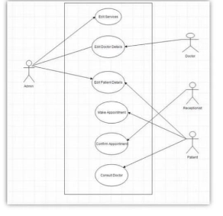

Fig4.1 Flow chart

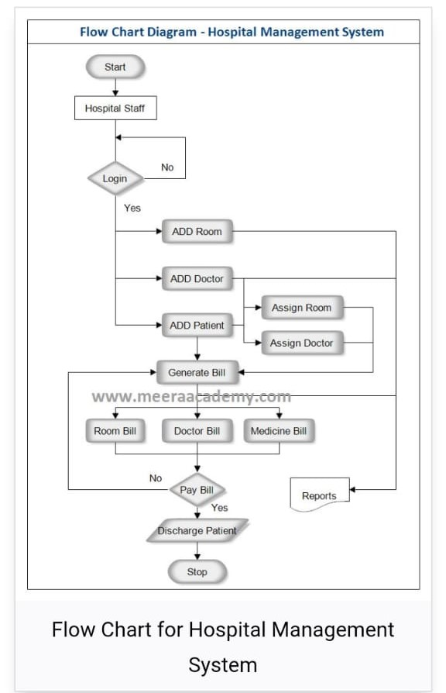

**Fig 4.2** SEQUENCE DIAGRAM

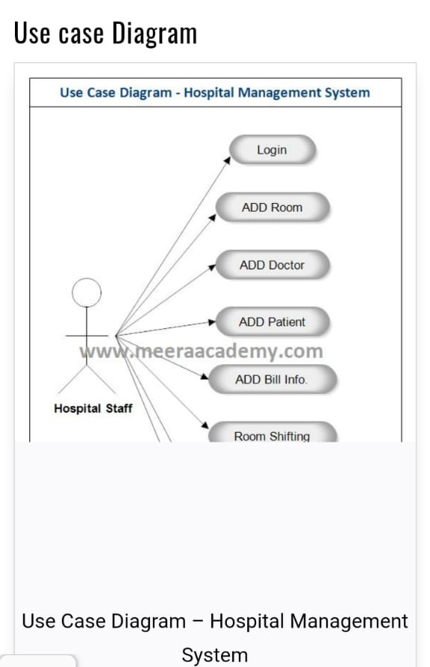

Fig 4.3

**USE CASE ANALYSIS**

|  |  |
| --- | --- |
| Name | Menu Bar |
| Actors | Patients |
| Description | Select options from menu bar (fig 5.1). |

Fig5.1

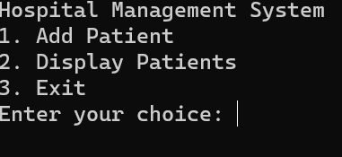

|  |  |
| --- | --- |
| Name | Hospital management |
| Actors | Patients |
| Description | Patients in database (fig 5.2). |

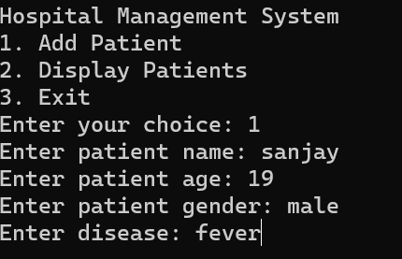

Fig 5.2

|  |  |
| --- | --- |
| Name | Hospital Management |
| Actors | Patients |
| Description | Patients in database (fig 5.2). |

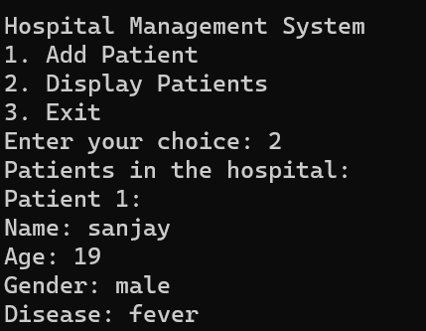

Fig 5.3

**APPENDIX-1**

**CODE**

#include <stdio.h>

#include <stdlib.h>

#include <string.h>

#define MAX_PATIENTS 100

struct Patient {

char name[50];

int age;

char gender[10];

char disease[10];

};

struct Hospital {

struct Patient patients[MAX_PATIENTS];

int count;

};

void addPatient(struct Hospital *hospital) {

if (hospital->count >= MAX_PATIENTS) {

printf("Hospital is full. Cannot add more patients.\n");

return;

}

struct Patient newPatient;

printf("Enter patient name: ");

scanf("%s", newPatient.name);

printf("Enter patient age: ");

scanf("%d", &newPatient.age);

printf("Enter patient gender: ");

scanf("%s", newPatient.gender);

printf("Enter disease: ");

scanf("%s", newPatient.disease);

hospital->patients[hospital->count] = newPatient;

hospital->count++;

printf("Patient added successfully.\n");

}

void displayPatients(struct Hospital *hospital) {

if (hospital->count == 0) {

printf("No patients in the hospital.\n");

return;

}

printf("Patients in the hospital:\n");

for (int i = 0; i < hospital->count; i++) {

printf("Patient %d:\n", i+1);

printf("Name: %s\n", hospital->patients[i].name);

printf("Age: %d\n", hospital->patients[i].age);

printf("Gender: %s\n", hospital->patients[i].gender);

printf("Disease: %s\n", hospital->patients[i].disease);

printf("\n");

}

}

int main() {

struct Hospital hospital;

hospital.count = 0;

int choice;

do {

printf("Hospital Management System\n");

printf("1. Add Patient\n");

printf("2. Display Patients\n");

printf("3. Exit\n");

printf("Enter your choice: ");

scanf("%d", &choice);

switch (choice) {

case 1:

addPatient(&hospital);

break;

case 2:

displayPatients(&hospital);

break;

case 3:

printf("Exiting...\n");

break;

default:

printf("Invalid choice. Try again.\n");

}

printf("\n");

} while (choice != 3);

return 0;

}