Overview: Here we used Langchain/Langgraph frameworks to create a simple AI agents to act as a Fidelity financial advisor to answer user questions about retirement planning and retirement mutual funds.

Requirements:
1. Use Langchain/Langgraph framework to create an IPYNB script to build the graph of an AI agent that will act as a Fidelity financial advisor to answer user questions about retirement planning.
2. Use WebBaseLoader from Langchain to load the following webpage into a document:
▪ https://www.fidelity.com/viewpoints/retirement/how-much-do-i need-to-retire
3. Store the document into Chroma vector store
4. Create a retriever_tool that will be used by the AI Agent to verify that the document is relevant to the question asked by the user before sending it to the chain of the generative AI model to generate an answer to the user question.
5. Create a chain to send the following prompt to LLM to determine if the document(context) that will be used to answer the user’s question is relevant or not:
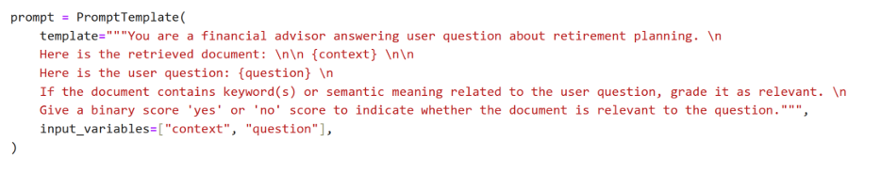
6. Send the following prompt to your graph:
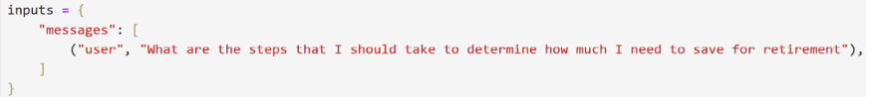
7. Inspect and comment on the output produced by your Ai Agent based on the input prompt you entered above; your output should contain content similar to the following:
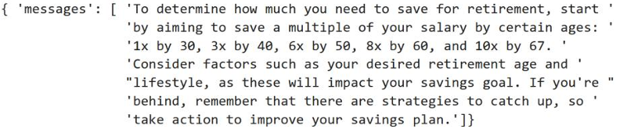
8. Enter another prompt that has “similar” semantic to the prompt entered above. Inspect and comment on the output generated by the AI Agent.
9. Enter a prompt that is not relevant to retirement planning. Inspect and comment on the output generated by the AI Agent.
10. Use PyMuPDF to load the following PDF document for Fidelity Freedom® 2045 Fund (FFFGX): 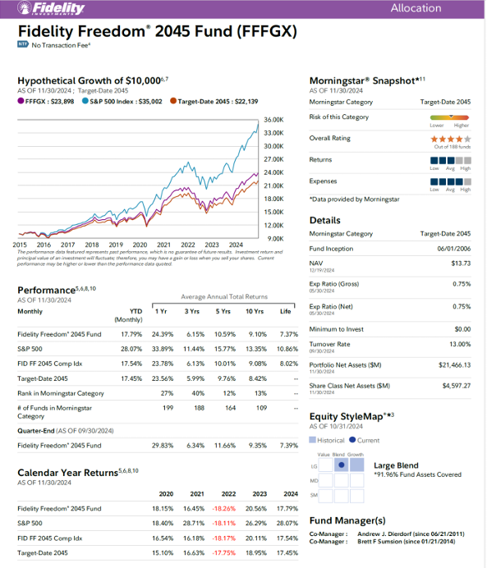
11. Use ChatOpenAI from langchain_openai as the LLM and send a
HumanMessage to answer the following messages, individually, based on
the loaded PDF document:
▪ "What is the name of this fund?"
▪ "Who is the fund manager?"
▪ "What is the calendar year return for 2022 for this fund and S&P
500?"
▪ "What is the Portfolio Net Assets?"
▪ "What is the Morningstar rating for this fund? How many funds used
to rate this fund?"

Using all the above requirements Develop IPYNB scripts to run successfully the following 8 Experiments. You MUST create a NEW script and name it properly for every experiment:
