CHAPTER 1

UNDERSTANDING CONTRACT LAW

A contract is a legally binding (compulsory) agreement between two or more parties that must have certain essential elements to be enforceable. This chapter reviews the six essential elements. For example, registrants must understand the consequences of not having these elements and the fact that such contracts can either be voidable or void

**Contract**

* A contract is broadly defined as a legally binding agreement between two or more persons, competent (Capable, knowledgeable) at law to enter into such agreement, for consideration or value, to do or refrain from doing some lawful and genuinely intended act
* **Contract Form:** The law enforces a binding promise or set of promises made by one person to another or others. **Contracts may exist in many forms; e.g., verbal contracts (word of mouth), contracts made by exchanging letters or contracts drawn up as long, detailed legal documents. All contracts and, therefore, agreements of purchase and sale are affected by contract law**

A document, such as an agreement of purchase and sale, is not technically a contract, but rather evidence of a contract. The contract is the legal relationship created between the parties. If any of the elements essential to the contracting process are absent, it will matter very little how well the document has been prepared. An agreement cannot give evidence of a contract that does not exist at law

* **Certain elements must be present to make the contract enforceable**
* The parties entering into a contract must be legally competent to contract (*capacity of the parties*)
* The contractual arrangement must be lawful (*lawful object of legality or object*)
* Each party must receive something (*consideration*)
* There must be offer and acceptance (*mutual agreement*)
* Both parties must consent to the terms of the contract (*genuine intentio*n)
* The agreement must be certain (*definite and clear*)

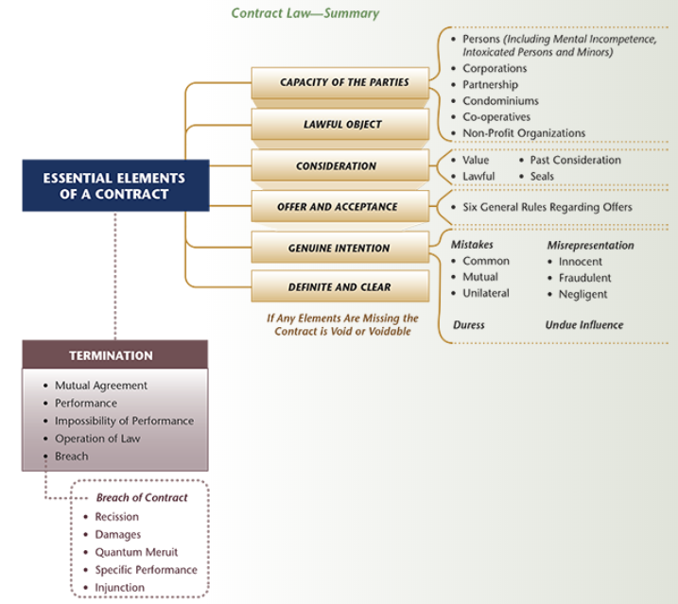

* **If elements missing:**
* Void (never came into existence)
* Voidable (originally valid but capable of being rejected by the offended parties at a later time) or
* Illegal (not enforceable by the courts)
* **Void VS. Voidable:**
* A **void** contract has no force or effect. A contract that is void is said to be a nullity at law. As far as the law is concerned, the agreement does not exist. Neither party can enforce it and neither party has any obligations under it

**Example**: A void contract can occur when the agreement is impossible to perform. For example, Seller Smith and Buyer Jones enter into an agreement of purchase and sale for the acquisition of an isolated cottage owned by Smith. Unknown to either party, Smith's cottage was destroyed by fire during the winter. All of the elements of the contract are in existence, but the structure is not. Both buyer and seller are mistaken as to this essential fact and the contract is impossible to perform and would undoubtedly be judged void

* Conversely, a **voidable** contract is enforceable, valid and binding until rendered void. A contract that is voidable is one where the offended party may make a choice. The person may choose to avoid the contract and treat it as being at an end, or to treat it as subsisting and enforce it against the offending party. A good example of a voidable contract involves minors

**Example**: An example of voidable contract involving undue influence can include a situation where one party, by virtue of special relationship to the other, is in a position of confidence and abuses that position. In cases such as relations between parent and child or solicitor and client, presumption of undue influence may arise that can be rebutted by showing that, in fact, the person susceptible to influence was able to form a decision free of any sort of control

The fact that the person claiming undue influence received independent legal advice or independent valuations of the property are excellent ways of establishing that no undue influence occurred. Where undue influence is shown, the contract is voidable, not void. That is, the person claiming undue influence must go to court to have the contract adjudged void.

**Capacity of the Parties**

* **Persons**: While contractual promises are enforceable against anyone having legal capacity, some persons are deemed by law as either incapable of contracting or having only limited capacity to contract. **In cases involving limited capacity, the contract is usually considered voidable; that is, the contract is valid until the individual goes to court to void it**. As long as the person of limited capacity allows the contract to exist, it may not be voided. Some examples of those with limited capacity to enter a contract include:
* Mentally Incompetent Persons (those having diminished mental capacity);
* Intoxicated Persons (incapable of understanding the nature of a contract by virtue of excessive use of drugs or chemicals);
* Illiterates (unable to read or write); and
* Minors (those under the age of majority)
* **Mental Incompetence:** For purposes of parties to a contract, any person declared to be mentally incompetent is incapable of contracting. Any representation agreement or agreement of purchase and sale entered into by such a person for the purchase, sale, exchange or other disposition of property is voidable. If a person does not declare his/her mental incompetency and the other party knows of this mental incompetency, then the contract may be voidable by the undeclared mentally incompetent person. Expert advice is required on such matters
* **Intoxicated Persons**: Under contract law, two conditions must generally exist in order that a buyer or seller can avoid a contract based on the fact that he or she was intoxicated. First, the individual must have been so inebriated when the contract was signed that he or she did not understand what was taking place. Second, the condition of that party must be known to the other party to the contract. If these two conditions are satisfied, then such a contract would be considered to be voidable
* **Illiterates:** An illiterate is a person who is unable to read or write. In terms of a contract, the question about an illiterate person and whether the contract is binding rests on whether the person knew what was being signed (a rule known as non est factum)
* **Minor:** A minor is a person in Ontario who is under the age of legal competence (age of majority). Simply put, all contracts with minors for the sale or purchase of land are generally voidable, sometimes void and not usually considered valid and binding on the minor
* **Non Est Factum:** Literally translated ***as it is not his deed***, the phrase identifies the legal rule that a person who was induced innocently or fraudulently by another to sign a written document, which is fundamentally different from that which he/she contemplated, is not bound by that document. The document is invalid on the grounds that the mind of the signer did not accompany the signature. He/she never intended to sign and, therefore, in contemplation of the law, the individual never did sign the document to which his/her name is appended.

**Example:**

Buyer Jones signed an agreement to buy a lot on Main Street owned by Smith. He intended to build a new home. At time of inspection and signing of the agreement, Smith was not involved, but rather another person representing Smith

Smith ultimately discovered that the individual representing his interests had done so fraudulently and without proper authority. As a result, Smith argued successfully that the agreement was non est factum and he was not bound in any way by that agreement

* **Corporation:** A corporation usually has the rights, powers and privileges to enter into contracts concerning the purchase and sale of real property, unless specific restrictions are located in the articles of incorporation or the corporation has not enacted empowering provisions in its by-laws. Two important cautions are necessary concerning corporations involved in acquisition or disposition of real estate. First, does the corporation exist and secondly, does it have the right to enter into such contracts?
* **Partnership: A partnership exists when two or more individuals or entities pool their personal and financial resources to carry on a business with the view to profit**. In a partnership, any partner may bind the other partners in a transaction during the ordinary course of business, as all partners are viewed as agents of the business
* **Condominium/Co-Operative:** Condominium corporations and co-operatives are permitted to enter into contracts for the purchase and sale of real property in line with incorporation documents or statutory regulations limiting the scope of such organizations
* **Non-Profit Organization:** Non-profit organizations have the rights, powers and privileges to enter into contracts for the purchase and sale of real property. For example, incorporation documents of a real estate board often specifically mention the right to acquire and dispose of real estate

**Lawful Object**

* Lawful object can be broadly defined as within the bounds of the law. If the object of the contract is illegal by statute or common law, the contract will be void and unenforceable in the courts
* **Examples of illegality or no lawful object would include contracts:**
* Contrary to public policy or good morals
* Injurious or prejudicial to the safety of the state or to the public service
* Tending to pervert justice or abuse the legal process
* in restraint of trade such as price fixing
* in restraint of personal liberty or marriage
* For the commission of a criminal offence or civil wrong, or relating to gambling or wagering (unless authorized by means of provincial statutes)

Often, buyers and sellers believe that a sale made on a Sunday is illegal and void. The Supreme Court of Canada held that the particular section of the *Lord's Day Act*relating to this issue was unconstitutional in view of the Canadian Charter of Rights and Freedoms

**Consideration**

* The element of consideration is what each party receives or is to receive in exchange for promises to act in a certain manner and is something of value that is given by a promisee to a promisor to make the promise binding. The essence of a valid, binding contract is the idea of a bargain between the parties. The bargain is the **consideration** of a contract and may consist of an act in return for an act, a promise in return for a promise or an act in return for a promise. In real estate transactions, consideration usually takes the form of a promise from the seller to sell in return for a sum of money to be received from the buyer. Consideration is best viewed in terms of the following three headings

**Value** - Value is what either party receives of some worth

**Lawful** - The consideration under the contract must be lawful

**Past Consideration** – Example: Old consideration is no consideration. For example, the buyer enters into an agreement to purchase a cottage for $85,000. Subsequent to that agreement, the seller mentions that he will include the boat. No documentation is prepared and no consideration is given. At closing, the boat has been removed by the seller. As consideration does not exist and past consideration ($85,000) did not include the boat, the buyer does not have an enforceable contract concerning the boat

* **Using a Seal:** A contract can be made binding without consideration if a seal is used. Where a promise is made under seal, no consideration is required since the law presumes the act of sealing replaces consideration. Therefore, in the case of an agreement involving real estate, if legal seals are affixed at the time of signing, no consideration is required. This is only valid if the parties are clearly aware of the legal effect that a seal has on the contract

Generally, the courts will now accept anything from red wafers to preprinted or hand written seals as long as it is clear the parties signing knew, or were directed to the fact, that they were signing under seal

While, in many instances, the corporate seal is unnecessary for signing documents, any document signed on behalf of a company under its corporate seal and indicating the authority of the person signing by inserting that person's position above the signature would be good business practice. If a corporate seal is not used, the following words should be used:

**I have the authority to bind the corporation.**

The act of placing a mark or symbol on a document is evidence and assurance of the intent to carry out promises contained therein. A sealed document provides added confirmation of intent of the parties to perform a contract. Under old conveyancing law, an official seal was often used as a substitute for consideration. Where a promise is made under seal, no consideration is required since the law presumes that the solemn act of sealing replaces consideration.

**Offer and Acceptance (Mutual Agreement)**

A contract is formed when the offer (made by the offeror) is accepted by the other party (the offeree)

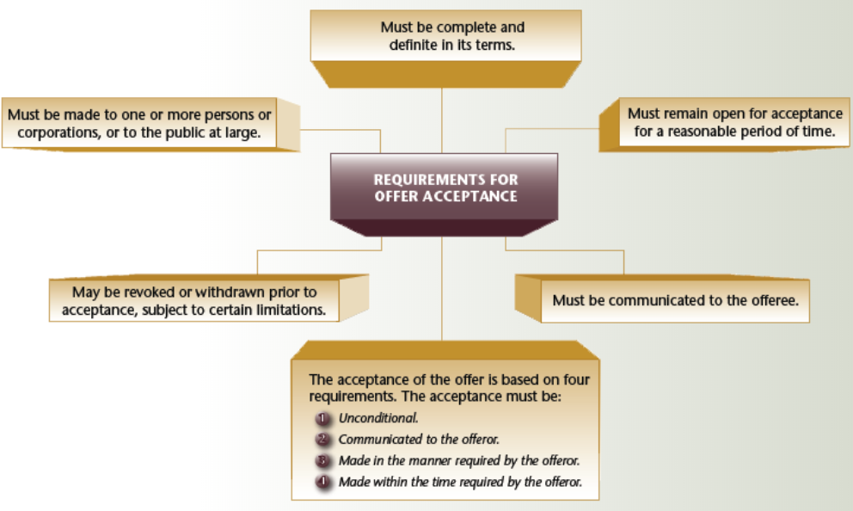

Where the communication of acceptance is permitted by mail, telegram or fax, such acceptance is deemed to be completed upon the letter having been mailed, the telegram sent or the fax transmitted. The contract is binding even if the letter, telegram or fax is not received. Further, if an offer is made in the form of a promise upon the performance of a future act, the process of carrying out that act can constitute acceptance

**Genuine Intention**

* The agreement must have genuine intention and give more than the outward appearance of a contract. In other words, one of the parties may have been induced to enter into the agreement by improper means and the document does not express what was intended. Inducements by improper means are caused by four different circumstances

**Mistake**: The law does not simply declare a contract void simply because one or other of the parties makes a mistake. Only certain types of mistakes give rise to a remedy. Mistakes can be grouped under the following three common headings – **Common Mistake, Mutual Mistake and Unilateral Mistake**

* **Misrepresentation:** A representation may be defined as a statement or assertion made by one party to the other, before or at the time of contracting, regarding some existing fact matter or circumstance affecting the contract or its object. Simply put, misrepresentation is a false statement of fact. Misrepresentations are viewed as innocent, fraudulent or negligent

Types of Misrepresentation:

**Innocent**: An innocent misrepresentation is a statement by one party of a material fact that is **untrue, but is honestly believed to be true**

**Fraudulent:** Where such fraud exists, the party deceived may resist enforcement of the contract and that party has the right to recover damages for deceit

**Negligent:** If there is a special relationship between the parties and a misrepresentation is made negligently, then the person who is misled will have an action for damages. This could occur in situations where the buyer has relied on a real estate salesperson, who is agent for the seller

* **Negligent Misrepresentation and Tort (offense) Liability:**