Chapter 14

Mortgage Lending Practices

**Residential Underwriting**

* Mortgage underwriting is a process (mortgage qualification) undertaken by a lender to evaluate the credit worthiness of the applicant and assess the property being offered as security for the mortgage. Underwriting involves applying specific lender credit policies leading to the acceptance or rejection of the application
* Residential mortgages follow a standardized processing procedure involving seven steps from initial contact with the lender to final closing of the mortgage

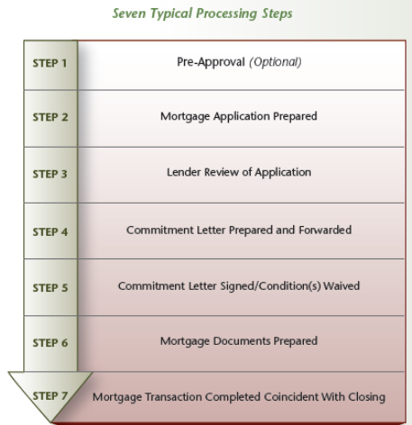

* **Mortgage Stress Test:** Beginning in 2018, all Canadians must undergo a mortgage stress test regardless of whether the downpayment is more or less than 20%. The stress test applies to obtaining or refinancing a mortgage from a federally-regulated lender (i.e., the large banks). This test does not apply if renewing a mortgage with the same lender, but obviously restricts the borrower who wants to shop the mortgage market. The stress test does not apply to provincially-regulated lenders such as credit unions and private investment corporations

This test was devised to address certain risky lending practices in a time of rising household debt. It has a direct impact on how large a mortgage can be secured and, consequently, what value of home can be purchased. The rules are straightforward. Uninsured home buyers (down payments of 20% or more) must qualify using the Bank of Canada’s five-year benchmark rate (this rate varies; it was 5.34% at time of printing) OR the rate offered by your lender plus 2%, whichever is the greater. For those seeking an insured mortgage (buyers having a downpayment of less than 20%), the qualifying rate is the five-year benchmark rate or the rate offered by your lender (without adding the 2%)

**The Borrower**

* Once an offer is accepted regarding a property and financing is required, the application is forwarded to the lender for review (assuming that no pre-approval was granted). The lender scrutinizes applications based on the 5 C's of credit, applies GDS and TDS ratios and completes a credit report through a credit bureau

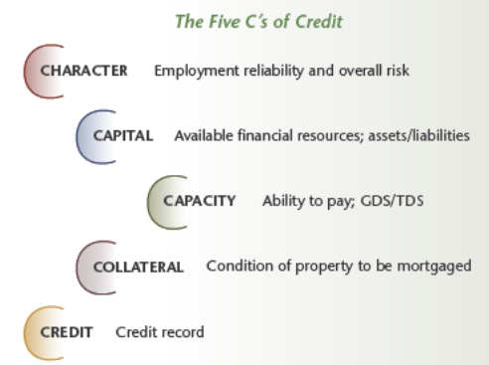

**The Property**

* **Lender Holdback**: A lender holdback refers to funds not advanced by the lender until specific requirements and/or conditions are met by the borrower. A lender typically requires a holdback of funds involving resale properties until certain work is completed or repairs are made to a property being considered for mortgage financing. This could apply when electrical service must be brought up to standard, the furnace replaced, siding installed, or structural changes made

**Mortgage Processing**

* **Mortgage Commitment**: The lender, once the underwriting process is complete, prepares a mortgage commitment setting out terms and conditions for acceptance by the borrower
* **Underwriting and Other Costs**: Most lenders assess a fee for underwriting expense when arranging a mortgage:
* A conventional mortgage typically involves an application fee plus the cost of an appraisal. Mortgage default insurance fees are normally not applicable, but can be imposed based on lender requirements
* High ratio mortgages through CMHC or private insurance providers (e.g., Genworth Financial Capital and Canada Guarantee Mortgage Insurance Company) are subject to an application fee and an insurance premium, with graduated upward rates as the loan-to-value ratio rises. Mortgage insurance fees are subject to provincial sales tax, which must be paid on closing
* High ratio mortgages under the National Housing Act, administered by CMHC, are similarly graduated and subject to an application fee and insurance premium. Mortgage default insurance premiums can be paid up front or added to the mortgage amount
* **Mortgage Brokers Fees:** Mortgage brokers can receive fees for services provided to the borrower and/or the lender. Borrower fees are typically associated with commercial mortgages or residential mortgages requiring additional services by the broker. For most residential mortgages, the lender pays the fee

Brokers and lenders use basis points when calculating fees; i.e., 100 basis points equals one percent. For example, if a mortgage broker is paid 75 basis points on a $200,000 mortgage, he or she would receive $1,500 ($200,000 x .0075). Mortgage brokers are required to make disclosures regarding fees in accordance with the Mortgage Brokerages, Lenders and Administrators Act, 2006

* **Legal Fees:** Lawyers typically charge a fee for preparing and registering the mortgage. Often, the fee for the transfer of title and arranging the mortgage are combined. Additional legal costs include specific fees/disbursements relating to the title search, arranging title insurance, conducting a title search (including an access fee to Teranet) and mortgage registration fees

**Mortgage Products:**

Most mortgage products flow from four basic payment arrangements: interest only, interest accruing, interest plus specified principal and blended (amortized). The final option can be either a fixed or variable rate

* **Interest Only**: The borrower does not repay any principal, but remits interest payments at regular, specified intervals. The principal amount is due at the end of the mortgage term. Interest only mortgages are sometimes used in short-term seller take backs or interim financing to avoid complex interest calculations. A promissory note is typically based on an interest only arrangement
* **Interest Accruing:** The lender receives no payment of interest or principal during the mortgage term. Interest due and payable is accrued. Consequently, the lender's risk actually grows during the term. Interest accruing mortgages are rarely found in today's marketplace and, if used at all, would undoubtedly be for a very short time period. Interest accruing arrangements are often found in student loan programs
* **Interest Plus Specified Principal**: This plan, sometimes referred to as a straight principal reduction plan, requires the borrower to repay a fixed principal amount at specified times during the term. At regular intervals, the borrower is also asked to pay interest on the outstanding balance. For example, a loan of $60,000 might require quarterly principal payments of $2,000 together with interest on the unpaid balance for each quarter
* **Blended (Amortized):** This plan provides for equal payments made at regular specified intervals during the mortgage term. Each payment is a blend of principal and interest based on the amortized schedule for the mortgage. Blended mortgages can be either fixed or variable. The fixed mortgage has a set interest rate for the blended mortgage during the mortgage term. The variable rate mortgage has an interest rate that varies based on the lender's prime rate or some other identified index. As rates rise or fall, payments or the amortization period are adjusted accordingly. The blended plan dominates the residential market
* **Fixed vs. Variable:**
* The standard blended mortgage is generally referred to as a fixed mortgage; i.e., a blended principal/interest payment is fixed throughout the term. Longer-term fixed mortgages are popular when rates are expected to trend upwards. Short term fixed may offer attractive rates, but renewal timing can be problematic in volatile mortgage markets; e.g., a six-month mortgage which renews just as interest rates spike
* Variable rate mortgages fluctuate with the applicable bank prime rate. Corresponding adjustments are made to payments or amortization. Typically, payment adjustments are made quarterly, half-yearly or yearly…but many variations exist
* **Open vs. Closed**
* A fully-closed mortgage does not permit principal repayment before maturity (other than regularly scheduled payments). However, market circumstances can alter the lender's perspective. For example, a mortgage written at 4% is a poor investment if current rates are hovering at 8%. The lender, in allowing prepayment, could free up funds for potentially higher returns
* Conversely, an open mortgage may not actually be fully open. The lender may require a penalty or, at minimum, notice. Creative mortgage products now contain both open and closed provisions. In other words, only part of the principal may be open without notice or penalty; e.g., a one-time 10% principal reduction (remember, 90% remains closed) or the mortgage may be periodically open subject to notice but no penalty; e.g., an option for 10% principal reduction on each anniversary date
* A closed mortgage may become open and an open mortgage may be partially closed

**Negotiations**

Seven creative approaches are presented that can assist new registrants when working with buyers and sellers, should difficulties arise in the financing process

* **Increase Amortization**: Lenders may consider a longer amortization given strong borrower covenant, thereby reducing mortgage payments and, in turn, permitting lower income qualification levels for GDS/TDS purposes
* **Refinance/Debt Consolidation:** Consolidating short-term debts into a longer-term amortized loan can reduce monthly financial commitments and free up borrower credit for qualifying purposes
* **Use Leverage:** Effective use of borrowed funds can result in wealth building, assuming rising real estate values. As a cautionary note, registrants are reminded that while positive leverage is desirable, negative leverage can have serious adverse consequences during market downturns
* **Include a Guarantor:** A person may co-sign as a guarantor, thereby reducing risk from the lender's perspective and resulting in the applicant's approval. The guarantor is providing a separate personal covenant over and above a named party in a contract regarding some obligation, such as a mortgage, personal loan or lease
* **Improve the Borrower's Qualifying Profile:** Many borrowers overlook funds that can increase down payment, while improving their overall covenant. Don't forget about often overlooked sources: cash value life insurance, negotiable stocks/bonds, gifts, future bonuses (confirmed by employer), income tax refunds and pledging of future dividends
* **Use the Right Lender:** The buyer has limited resources, a few financial problems in the past and doesn't fit the ideal borrower profile. Get expert mortgage advice and seek lenders specializing in nonconfirming (sub prime) loans. Underwriting fees and mortgage rates will probably be higher, but the borrower can secure credit and start building equity (and a better future credit rating)
* **Shop for the Total Package, Not Just Rates:** Don't let clients immediately leap at the lowest rate. Other costs (e.g., underwriting fees, appraisal costs, application/processing charges, discharge penalties) add up quickly. Further, attractive introductory rates for variable mortgages may be prelude to higher lock-in rates. The client should carefully compare and seek out the best, tailor-made package

**Commercial Underwriting:**

* **Mortgage Documentation Package**: The overall structure of a typical documentation package is illustrated, but scope and format vary significantly in the marketplace
* Summary Statement of Objectives
* Site Description (general description, site data and relevant statistics)
* Improvements (detailed description of existing or planned improvements)
* Financial Profile (personal and/or corporate)
* Mortgage Financing Request (amount, terms and special requirements)
* Support Documentation (fully completed mortgage application, credit references and financial information)
* **Small Business Financing**: Small business financing is typically offered through a separate department or distinct division within a commercial banking division. Given the wide range of businesses (e.g., garages, retail shops, restaurants and repair facilities) lenders rarely use a standardized approach as information required will vary
* **Canada Small Business Financing (CSBF) Program**: In addition to in-house mortgage, lenders may avail themselves of the Canada Small Business Financing (CSBF) Program. This federal financing program was created to assist entrepreneurs by way of loans, including capital leases, when establishing and improving small businesses. The federal government guarantees 85% of lenders' losses due to default. The CSBF program is not available for farming, charitable or religious enterprises. CSBF loans have proven particularly effective with startup businesses requiring significant leasehold improvements; e.g., restaurant equipment and computer hardware/software

**Alternative Sources:**

* **Private Investors:** Private investors may offer greater scope given more relaxed lending criteria, safety margins or other approval considerations. In addition, application forms, underwriting requirements and the mortgage approval process may be simplified. On the converse, buyers need to be aware of limited legislation imposed on such investors. Ensure that the buyer's lawyer is involved in all aspects of the mortgage transaction

Reliable sources of private money often include: seller take back mortgages, local developers/investors and lawyers acting for clients (e.g., private investors, trusts and estates). Specialized investors frequently advertise availability of funds in appropriate trade magazines or local/regional/national newspapers

* **Seller Take Back**: The seller take back mortgage is a popular negotiating tool in both residential and commercial markets, particularly when financing proves difficult through conventional lenders and/or seller participation provides a better overall package in negotiations. The buyer may be attracted to this type of financing as it can avoid certain costs, paper work and regulations of conventional lenders. The seller may be drawn to the STB if his/her property remains unsold. Further, a mortgage might be a worthwhile investment for the seller
* **STBs may be seriously considered in the following situations:**
* **Seller Motivation**: The seller is anxious to sell and has no real concerns about taking back a mortgage to hasten the sale of his/her property
* **Underwriting Fundamentals**: The market is strong, the equity position of the buyer is adequate (i.e., downpayment) and the buyer can qualify to make the required mortgage payments
* **Limited Appeal**: The property has limited buyer appeal due to age, condition or location and financing would improve overall marketing impact
* **Increased Competition**: The number of competing houses is increasing and a competitive advantage from a financing perspective is required to increase salability
* **Sale Potential**: Buyers for the mortgage are available should the seller wish to sell the STB
* **Sale/Leaseback:** A sale/leaseback involves the sale of a property by an owner with the lease back of the property to that original owner. The sale/leaseback arrangement can prove beneficial to both the seller and buyer of property. The seller liquidates his/her equity in the land and building to use for other purposes, while retaining the location under a long-term lease arrangement. The buyer, as an investor, is assured of a long-term cash flow and the seller may have an option to repurchase the property following the lease

**Commercial Lending Practices:**

* **Loan-to-Value Ratio:** Most lenders use a conservative loan-to-value ratio (also referenced as the loan ratio) as their first line of risk defense. Additional security or collateral is usually sought in instances when the loan-to-value ratio meets or slightly exceeds a predetermined comfort level for the lender. Loan-to-value ratios vary by lender and type of property. Institutional lenders are restricted by law to a maximum 80% of the appraised lending value or sale price (whichever is less) unless the mortgage is insured through a mortgage insurance program

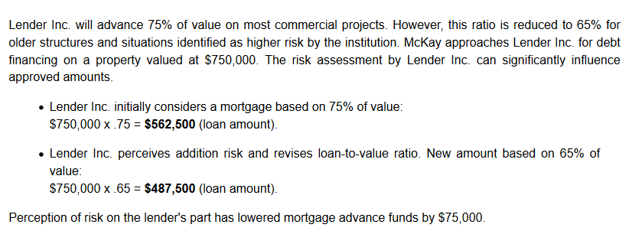

* **Debt Coverage Ratio:** This ratio, comparing net operating income to total debt service, is also referred to as the debt service coverage ratio. The debt coverage ratio is frequently used by loan and mortgage underwriters to establish whether a business or rental property is capable of handling a specific debt payment level

The debt coverage ratio is calculated by dividing net operating income (NOI) by total debt service (principal and interest payments). The ratio should be in a positive range (i.e., above 1) in order for income to properly address total debt service. Lenders often require a debt coverage ratio of 1.2 or higher when considering loan applications for rental property and other commercial ventures. In other words, for $1.00 of debt, a net operating income of $1.20 is available to service that debt

**Lender DCR Met:**

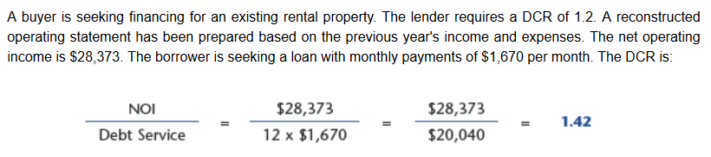

**Lender DCR Not Met:**

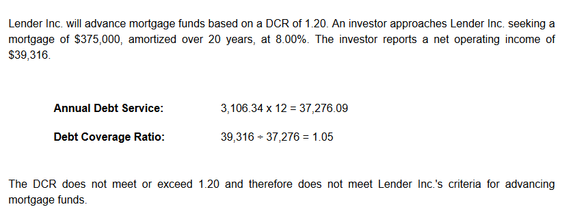

* **Safety Margin:** Some lenders apply a safety margin when lending based on net operating income. In effect, the margin accomplishes the same net result as the debt coverage ratio in that the mortgage amount is directly linked to net operating income
* **Risk and Capitalization Rate:** Lenders may elect to reduce risk and augment investment security by increasing the capitalization rate. A cap rate increase lowers value for lending purposes
* **Operating Statement Adjustments:** Lenders may require certain adjustments to reconstructed worksheets based on a review of the owner's operating statements and past experience with similar structures. For example, market data may suggest vacancy and credit losses other than stated on the reconstructed operating statement. Also, the lender may wish to include a reserve for replacement of specific items not included in the statement

**Specialized Products**

* Certain unique products are used in commercial lending given specialized needs when arranging financing for new projects and existing properties. Thirteen products are highlighted in alphabetical order for illustration purposes, some of which also apply to residential financing
* Bridge Loan
* Development Loan
* Gap Loan
* Interim Financing
* Letter of Commitment
* Letter of Credit
* Letter of Guarantee
* Letter of Intent
* Line of Credit
* Standby Loan
* Wraparounds (WRAPs)
* Blanket Mortgage
* Participation Financing

**Notables:**

* Mortgage underwriting is a process undertaken by a lender to evaluate the credit worthiness of an applicant and assess the property being offered as security
* Pre-approvals are typically subject to conditions. Always read with extreme care
* Required borrower documentation can vary by lender. Typical minimum documentation includes employment and income verification
* Two credit bureaus operate in Ontario: Equifax Canada and TransUnion
* Adverse property conditions can impact the approval of a mortgage and a lender may require a holdback until specific requirements and/or conditions are met
* The mortgage commitment sets out terms and conditions of a proposed mortgage for acceptance by the borrower
* Underwriting and related costs can vary based on whether a conventional or high ratio mortgage is being arranged
* The current mortgage market offers a wide variety of fixed, variable, open and closed mortgages. Read the fine print carefully relating to all privileges, stipulations and conditions
* Commercial underwriting can vary somewhat depending on whether a large commercial mortgage or small business financing is being arranged
* As a general guideline: the larger the commercial mortgage, the greater the emphasis that is placed on business and property with less focused on the personal covenant
* Commercial mortgage documentation packages can be complex; the range of materials varies by property type and size
* Alternative lending sources offer greater scope to commercial registrants seeking creative financing solutions
* Commercial lending practices are designed to provide reasonable lender security combined with investor opportunity to enhance yield

**Mini-Review:**

* Credit reports typically provide a credit score that can range from 600 to 1000 >> **False** [The range is between 300 and 900]
* Lenders may require a Notice of Assessment issued by the Canada Revenue Agency to verify income of prospective borrowers >> **True** [Other acceptable documents could include T4s or T4As, income tax return and/or employer letter/pay stubs]
* A mortgage commitment typically sets out terms and conditions for acceptance by the borrower that is valid for a specified time period >> **True**
* If a high ratio mortgage is obtained for $227,500 and the mortgage default premium is 2.75% of the mortgage, the amount due for this insurance would be $625.63 >> **False** [Decimal point placed incorrectly. The insurance premium would be $6,256.25]
* With a variable rate mortgage, the payment may be adjusted on a periodic basis to reflect changes in interest rates >> **True**
* Opening of several credit accounts within a short period of time can adversely impact a credit score >> **True**
* A guarantor on a mortgage agrees to perform and carry out covenants outlined in the mortgage document >> **True**
* The Canada Small Business Financing Program is a provincial program designed to assist entrepreneurs by way of loans >> **False** [Federal Program]
* A seller take back can be an effective alternate source of mortgage funds when a property has limited appeal and the number of competing properties is increasing >> **True**
* An increase in the capitalization rate by a lender has the net effect of increasing a property’s value for lending purposes >> **False** [An increasing capitalization rate effectively lowers the value being established for lending purposes]
* A bridge loan is an interim form of financing used for commercial properties, but not for residential properties >> **False**
* A gap loan could involve a lender providing funds to assist a developer who is facing construction delays and, consequently, is unable to receive construction advances to address immediate costs >> **True**
* A line of credit is normally granted by a lender based on past performance of the borrower client and that borrower's strength of covenant (personal or corporate) >> **True**

**Active Learning Exercise:**

1. Purchase Price: $343,250 DOWN PAYMENT: $53,250. What is Loan to Value?

**LTV = [($343,250-$53,250)/ $343,250] x 100 = 84%**

1. **Exercise 2 Mortgage Balance and Recalculation**: Mr. and Mrs. Hutchings are arranging a mortgage for $184,500 at 6.75% calculated semiannually, not in advance, amortized over 25 years and due in five years

* Calculate the monthly payment that must be paid by the owners:

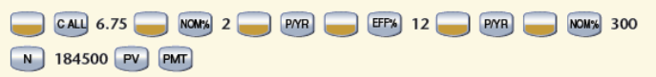

**The correct answer is: $1,263.92**

* Calculate the outstanding balance at the end of the 5-year term



The correct answer is: $167,440.70

* How much would the monthly payment have to be increased if a $190,000 mortgage was arranged with the same terms?



The correct answer is: $37.67

1. Buyer Thompson is concerned about interest paid on financing provided by three lenders. Which of the following has the least amount of interest paid over the full amortization period?
   1. Alternative C: A $230,000 mortgage, at 5.65% amortized over 25 years
   2. Alternative A: A $225,000 mortgage, at 6.5% amortized over 20 years
   3. Alternative B: A $225,000 mortgage, at 5.75% amortized over 25 years

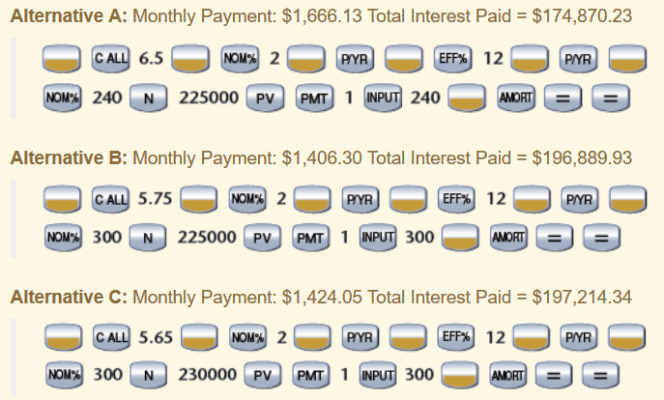

**The correct answer is**: Alternative A: A $225,000 mortgage, at 6.5% amortized over 20 years

1. **Principal and Interest**

Robert and Cynthia Baird are contemplating the purchase of a $255,000 home with a $35,000 down payment, an interest rate of 5.75% (compounded semi-annually, not in advance) and a 25-year mortgage amortization. They will be paying a high ratio insurance fee in cash on closing. Calculate the following:

* + The bi-weekly mortgage payment

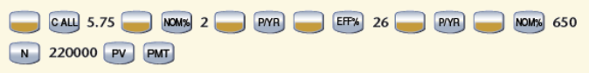

**The correct answer is: $633.83**

* + The amount of interest and principal paid in the first payment of this mortgage

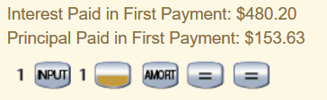

**The correct answer is: Interest: $480.20 & Principal: $153.63**

1. **Exercise 5 Unknown Principal Amount**

A property owner states today that his mortgage is fully amortized in eight years, has a 6.0% rate and has blended monthly payments of $1,544.00 monthly. What is the outstanding balance today?

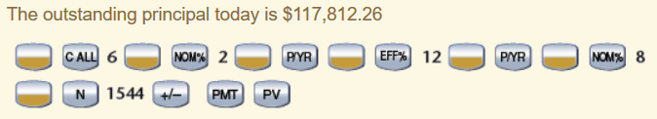

**The correct answer is: $117,812.26**

1. **Exercise 6 The Reconstructed Operating Statement**

Investor McKay is developing a reconstructed worksheet in readiness for Lender Inc. and has asked for your assistance.

**6.1**

Complete the worksheet and estimate of value based on the following assumptions: Other income represents 5% of potential rental income; the vacancy factor is 4% and the cap rate is 9.25 with a loan-to-value ratio of .75. Based on the estimated value, calculate the loan that could be arranged based on McKay’s reconstructed worksheet

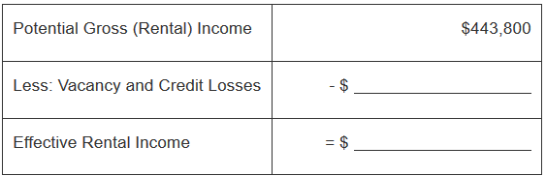

**The correct answer is: 17,752 and 426,048**

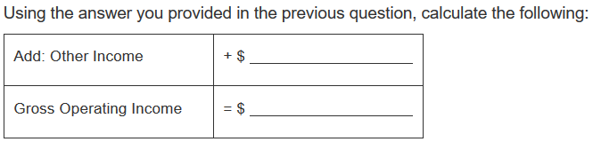

**The correct answer is: 22,190 and 448,238**

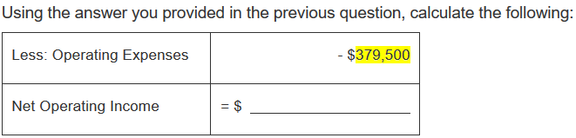

**The correct answer is: 68,738**

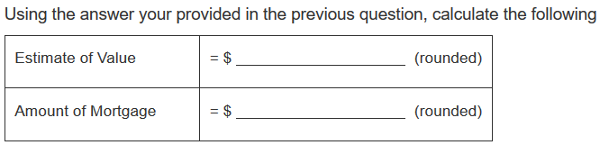

**Estimate of Value** ($68,738 ÷ .0925) = **$743,114** (rounded)

**Amount of Mortgage** ($743,114 x .75) = **$557,336** (rounded)

The correct answer is: 743,114 557,336

**6.2**

Lender Inc. is considering the mortgage documentation package, but will apply various rules and assumptions in reviewing the application. The vacancy factor must be 5%, a minimum cap rate of 9.50 is required and given the age of the structure, the loan-to-value ratio is .70

Based on this information, and assuming other income is 5% of potential rental income, determine the maximum mortgage that Lender Inc. will approve

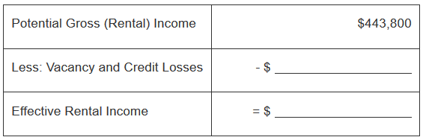

**The correct answer is: 22,190 and 421,610**

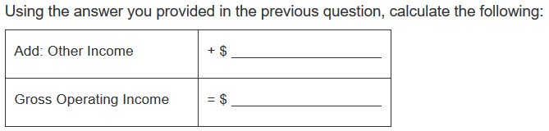

**The correct answer is: 22,190 and 443,800**

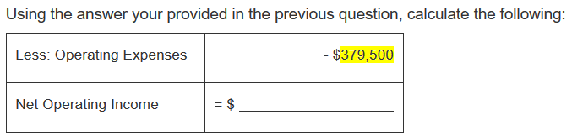

**The correct answer is: 64,300**

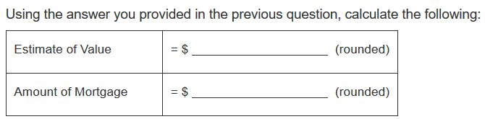

**Estimate of Value** ($64,300 ÷ .0950) = **$676,842** (rounded)

**Amount of Mortgage** ($676,842 x .70) = **$473,789** (rounded)

The correct answer is: 676,842 473,789

1. **Debt Coverage Ratio**

National Lending Inc. recently arrived in Southgate and is attempting to gain a foothold in the commercial marketplace. The debt coverage ratio is used primarily when assessing risk. Savard submits a reconstructed worksheet showing a NOI of $37,393. National Lending Inc. requires a minimum cap rate of 9.5, a DCR of 1.20 and a loan-to-value ratio of 75%.

* What is the maximum loan permitted based on the cap rate and loan-to-value ratio?

Show all calculations

Estimated Value Based on 9.5 Cap Rate: $37,393 ÷ .095 = $393,611 (rounded)

Maximum Loan: $393,611 x .75 = $295,208 (rounded)

* If National Lending Inc. is prepared to mortgage the property at 8.25%, amortized over 20 years, does this mortgage fall within the DCR guidelines of 1.20? Show all calculations

Monthly Mortgage Payment: $2,489.80 (using HP 10BII)

Annual Debt Service: 2,489.80 x 12 = $29,878 (rounded)

Debt Coverage Ratio: 37,393 ÷ 29,878 = 1.25

The mortgage falls within the DCR guidelines established by National Lending Inc

1. **Risk and Cap Rates**

Investor McKay is shopping the market for the most suitable mortgage financing for his multi-residential building that produces a net operating income of $37,500. Following are lending criteria from three lenders. Market research indicates that the capitalization rate for such property is 9.55. Which of the following lenders will advance the largest mortgage?

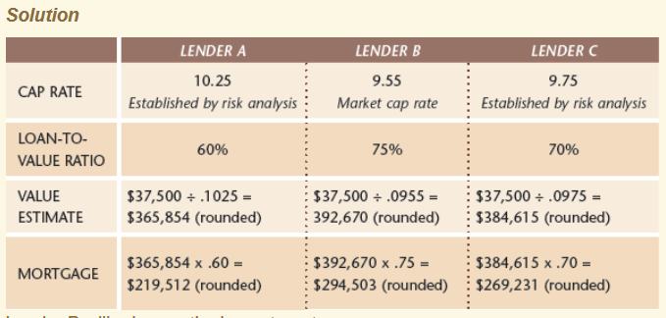

Lender B will advance the largest mortgage

**The correct answer is: Lender B**