Chapter 15

Trading and Agency Relationships

* REBBA 2002 consists of the statute and six regulations, three of which have direct bearing on real estate trading including day-to-day listing/selling activities and brokerage administration. The remaining three focus on regulation-making powers associated with the Ministry of Small Business and Government Services (the Ministry) and the Real Estate Council of Ontario (the Administrative Authority), and Code of Ethics issues involved in the transition from the old to the new Act

1. REBBA : Real Estate and Business Brokers Act, 2002
2. GEN : General, Ontario Regulation, 567/05
3. OTH : Education Requirements, Insurance, Records and Other Matters, Ontario

Regulation, 579/05

1. CODE : Code of Ethics, Ontario Regulation, 580/05

* Terminologies:

|  |  |
| --- | --- |
| **Legislative Term** | **Commonly used Market Place Term** |
| Representation | Agency |
| Representation Agreement | Listing (Seller Agency) Agreement  Buyer Agency Agreement |
| Agreement | Agreement of Purchase and Sale |
| Multiple Representation | Dual Agency |
| Convey Offer | Present Offer |
| Acquisition/Divestiture by Registrant | Purchase/Sale by registrant |

* Trading Exemptions: the most notable of which are detailed below.

1. **Auctioneer** [a person who conducts auctions by accepting bids and declaring goods sold]If the trade is made during and as part of the auctioneer's business
2. **Full-Time Salaried Employee of a Party to a Trade** If the employee involved in the trade is acting for and on behalf of his or her employer in respect of land situated in Ontario; e.g., a full-time employee of a builder
3. **Solicitor** [lawyer, advocate]A solicitor of the Superior Court of Justice who is providing legal services if the trade in real estate is itself a legal service or is incidental to and directly arising out of the legal services
4. **Residential Tenancies** A person who trades in real estate solely for arranging leases to which the *Residential Tenancies Act* applies

* Trading and Representation: A real estate brokerage, when involved with trading as set out in REBBA 2002, is legally viewed as an agent under common law. Brokers and salespersons, as individual registrants, are representatives of the agent and act on the agent's behalf. Common law represents principles, customs and procedures recognized over many years by the courts
* Agency Relationships:

1. Agency is a relationship between two parties in which one party (the agent) accepts responsibility for representing the other party (the principal) in dealing with a third party
2. A principal (client) is an individual who authorizes an agent to act on his/her behalf in an agency relationship

* Indemnification [compensation, Recompense]: The principal is obligated to compensate or indemnify the agent for liabilities incurred while carrying out responsibilities under the relationship. If the agent is not acting within the authority given (actual or implied authority), or is acting unlawfully, the principal would not be responsible. In real estate, the duty to reimburse for expenses under the general responsibility of indemnification does not normally apply. For example, expenses involving property promotion are waived in return for anticipated commission pursuant to a representation agreement. However, indemnification does apply in specific fields relating to real estate brokerage; i.e., property management
* Remuneration: Under common law, an agent is entitled to payment for services rendered as agreed between the agent and the principal. Remuneration provisions are typically set out by way of a seller representation agreement or buyer representation agreement
* Brokerage: sole proprietorship, partnership or corporation
* An agency relationship can be created in several ways including by agreement, by ratification, by estoppel or by operation of law. Typically, the most common method associated with real estate brokerages is agency based on a written agreement between the client and the brokerage (e.g., seller representation agreement or buyer representation agreement)

1. A definite understanding which may be an express agreement (written or verbal). Alternatively, the agreement can be implied given circumstances and the relationship of the parties
2. Common law does not require a written agreement nor a form, but such is strongly encouraged
3. To receive commission, the brokerage must prove that a contract existed. The best solution: a written, signed agreement. Provincial legislation may require written agreements to enforce commission arrangements

* Ratification: An agent's authority can be granted retroactively. Ratification applies if the agent has acted either without authority or more than granted authority. In such instances, the principal subsequently agrees to be bound by such unauthorized acts. The remaining two methods are uncommon, but legally possible in real estate agency relationships
* Limits on Brokerage Authority: Contract, Delegation, Purchase Price and Expense
* **General Obligations:** Obligations owed by an agent to a principal as set out in common law. Other obligations are grouped under fiduciary and regulator. Eight general obligations apply to real estate brokerages when representing a **client.** Two of these obligations (*Exercise Care & Skill and Ensure Honesty*) apply to **customers**

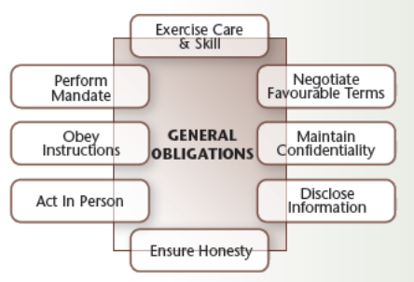

* **Fiduciary Obligations:** A fiduciary [ధనసంబందమైన, involving trust, especially about the relationship between a trustee and a beneficiary] must maintain utmost loyalty and protect the interests of the principal (client), avoid conflicts of interest, disclose conflicts, not make secret profits and not misuse confidential information. Fiduciary relationships arise in many different situations including a lawyer working on behalf of a client, a trustee on behalf of an estate and a real estate brokerage on behalf of a seller or buyer

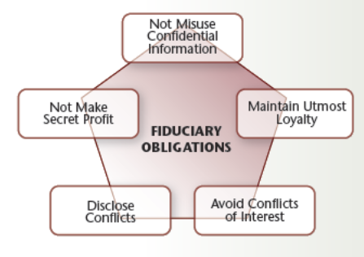

* Premises Underlying a Fiduciary Relationship: Trust & Confidence, Best Interests and Loyalty
* **Implied Representation**: Caution is always advised as a fiduciary relationship can arise when brokerages and/or their representatives have, in some way, implied that a relationship exists (due either to some action or inaction, particularly regarding confidential information), are working gratuitously for clients or are engaged in joint ventures with clients
* **Regulatory Obligations**: Obligations imposed by regulatory authorities which are owed by the agent to the principal over and above those imposed by common law and fiduciary obligations

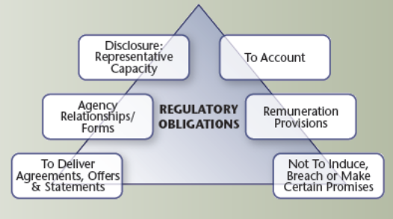

* + **To Account:** This obligation focuses on the agent's regulatory responsibility to account for and safeguard money, documents and property entrusted to that agent
  + **Remuneration** **Provisions**: Common law merely requires that brokerages establish the existence of an agreement and confirmation that the applicable event occurred relating to the payment of commission or other remuneration. Common law places no restraint on how the commission is calculated. However, regulatory frameworks impose limitations, particularly regarding how remuneration is established (i.e., calculated) and rights to recover commission, including the requirement to be registered/licensed in that jurisdiction
  + Sec. 36(1) of REBBA 2002 states that the commission or other remuneration shall be an agreed-upon flat fee or percentage of the sale price/rental price, or a combination of both
  + **Not to Induce (encourage, tempt), Breach (opening, break) or Make Certain Promises:** Provincial jurisdictions generally prohibit brokerages from inducing a party to break a contract for entering into another agreement. This requirement is set out in Sec. 33(1) of the Act. Further, brokerages and their authorized representatives cannot make certain promises (e.g., to resell the property) unless these are put in writing, signed by the brokerage and delivered to the party to whom the promise is made. REBBA 2002 addresses these requirements in the General Regulation (GEN), Sec. 25
  + **To deliver agreements, offers and statements**: Most Canadian jurisdictions include regulatory requirements concerning delivery of agreements, offers and other related statements. In Ontario, REBBA 2002 requires the prompt delivery of written agreements in connection with a trade in real estate. This provision found in the Code of Ethics (Sec. 12, 28 and 29) includes buyer and seller representation agreements, service agreements, agreements of purchase and sale, and deposits, as well as notices, amendments and other documents relating thereto
  + **Agency relationships/forms**: Traditionally, jurisdictions have not regulated agency relationships, nor addressed content of representation agreements. However, such initiatives are now underway in various provinces. In Ontario, REBBA 2002 has certain requirements regarding such agreements. For example, the Code of Ethics requires that a date must be specified as to when the agreement takes effect and the date on which it expires
  + **Disclosure of representative Capacity**: Timely disclosure of representative capacity and guidelines regarding what triggers this type of disclosure have become focal regulatory issues. The Real Estate and Business Brokers Act, 2002 requires that a brokerage and its representatives must provide certain information as early as is practically possible and before entering an agreement in respect of a trade in real estate

**Duty of Care:** Brokerages and their representatives owe both clients and customers a duty of care, but the extent of that duty differs considerably. With clients, the duty applies to everything that is done or ought to be done for a client. With customers, the duty is limited to the giving of information, responding to questions and doing anything that the salesperson has agreed to do for the customer



* **Principals Duties to Agent:** Three obligations are owed by the principal when entering an agency relationship**: indemnification, remuneration** and **obligations** set out in the representation agreement. The principal does not owe any fiduciary or regulatory obligations to the agent

**General Obligations:**

* **Indemnify**: As a rule of agency, the principal must compensate an agent for loss or damage incurred in carrying out lawful acts. Indemnity also extends to reimbursement for expenses incurred. However, by the terms of most real estate representation agreements the right to reimbursement does not generally apply when, for example, real estate brokerages receive a commission (unless specifically stated in the agreement)

**Ex**: A buyer sued both the seller and the seller’s real estate brokerage since five expensive appliances that were stated to be included in the purchase price on the Agreement of Purchase and Sale were removed from the property by the seller on completion of the transaction. The court held that the seller must indemnify the brokerage and assume the full liability for the loss suffered by the buyer

**Remunerate:** The principal is obligated to remunerate the agent (typically by way of commission) if the agent is duly authorized by provincial legislation to trade in real estate and that the terms of a representation agreement are performed

**Obligations in the agreement:** The principal must also perform other obligations as agreed and set out in the representation agreement. The following illustration details typical remuneration-related provisions involving a seller representation agreement

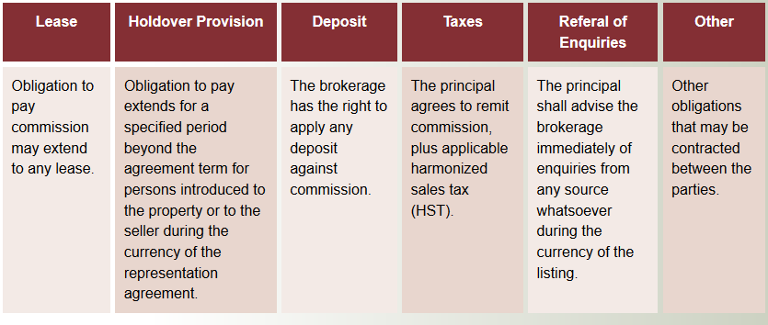

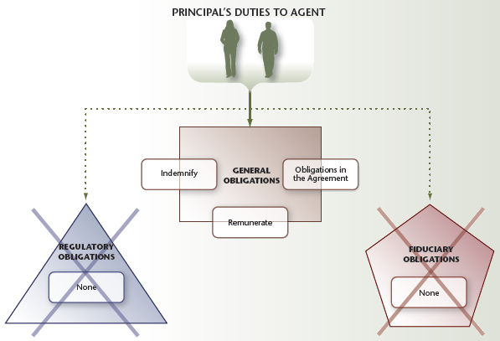

* **Agency Termination:** An agency relationship can be terminated by acts of the parties or operation of law. Such termination does not disturb legal rights and obligations associated with the relationship, unless otherwise agreed to by the parties

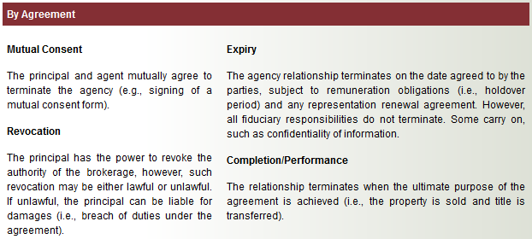

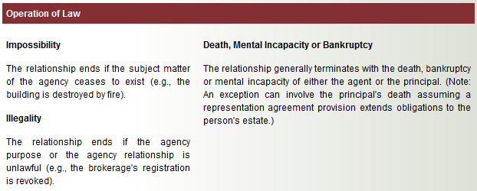

**Continuance of Rights/Obligations:** Termination by either principal or agent does not affect the rights of either party nor any associated obligations owed by one to the other, unless the parties agree otherwise. Termination of the brokerage as agent does not generally impact the relationship between the client and a third party (e.g., a buyer). However, subsequent negotiations between the brokerage and the third party could affect the client's legal position in relation to that third party. Two examples are if result in legal action. The outcome of any such action depends on circumstances concerning the situation

* **Example:** A seller listed his property with a brokerage for a 90-day period. During the initial two weeks, the brokerage showed the property to four buyers. One buyer expressed interest and wanted to re-inspect the home, however, the seller refused stating that he had decided not to sell the property. The seller also would not sign a mutual release, but effectively terminated the agency relationship by ceasing all communication with the brokerage. Several weeks later, the brokerage discovered that the seller sold the property privately to the interested buyer previously introduced and took legal action for commission based on rights set out in the seller representation agreement
* **Example:** Salesperson A, on behalf of the brokerage, entered into a 90-day listing with the seller for a commercial property. A buyer client was introduced to the property by Salesperson B, another salesperson employed by the brokerage. The sale closed one month following expiration of the representation agreement. After closing, the new owner discovered that the property could not be used for car repairs, despite assurances to the contrary by Salesperson B. The seller had provided a list of relevant usage limitations to Salesperson A, but this information was apparently not conveyed to the buyer. The new owner took legal action against the brokerage for breach of duties under the buyer representation agreement

**Notables:**

* REBBA 2002 consists of the statute and six regulations, three of which have a direct bearing on real estate trading
* A real estate brokerage, when involved in trading, is legally viewed as an agent under common law, but must also adhere to regulatory requirements regarding representation
* An agency relationship between agent and principal can be express (written or oral) or implied. Written agreements are essential from a registrant's perspective
* Agency is created by four methods; the most relevant to real estate is by agreement
* Agency terms can be confusing given differing perspectives of the courts, legislators, real estate brokers and consumers
* Agency applies to all types of agents wherever common law exists. However, the practice and extent of agency authority varies by profession
* For real estate agency purposes, the terms brokerage and agent have become legally synonymous
* Agent authority is best described in terms of actual and implied authorities
* Obligations of an agent (i.e., brokerage) and its representatives are grouped under three categories: general, fiduciary and regulatory
* Fiduciaries must always act in the client's best interests and never permit their own interests or that of a third party to override this duty
* Real estate brokerages owe clients and customers a duty of care, but the extent of such duties varies depending on whether a client or customer relationship exists
* The standard of care is not one of perfection, but rather of reasonableness; that is, how prudent members of the real estate industry would conduct themselves under the circumstances

**Mini-Review:**

* A seller representation agreement is often referred to in the marketplace as a listing agreement **>> True**
* Agency describes a relationship in which one party (the agent) accepts responsibility for representing another (a third party) **>> False [**The agent accepts responsibility for representing a principal, not a third party]
* The term agent refers to a salesperson registered pursuant to REBBA 2002 **>> False** [The term 'agent' refers to a brokerage registered pursuant to REBBA 2002]
* An agency relationship created by agreement can either be express or implied **>> True**
* An agent's authority can be granted retroactively **>> True** [Ratification (approval, section) is one of four methods by which agency can be created]
* While agency relationships are commonplace, situations can arise in which a buyer or seller is provided only selected services as a customer **>> True**
* The terms agency and representation are generally analogous for purposes of discussing agency relationships as they impact real estate brokerage **>> True**
* Real estate brokerage's actual agency authorities are typically set out in writing in a representation agreement **>> True** [Actual authorities (set out in writing) should be clearly differentiated from implied authorities, which are assumed]
* A real estate brokerage's agency authority is subject to only three limitations **>> False** [Four limitations are identified including contract, delegation, purchase price and expense]
* Real estate agency relationships are generally assumed to give rise to fiduciary obligations **>> True**
* A fiduciary relationship, which is enforceable by the courts, can only be created by written agreement **>> False** [An agency relationship is determined by the facts and need not be in writing. However, registrants are strongly encouraged to have all agency relationships established by express (written) agreement]
* A major element in determining if a fiduciary relationship has been established is whether the client has agreed to pay remuneration >> False [A fiduciary relationship can be established when agents are working gratuitously for clients]
* Real estate brokerages are not permitted to accept commissions from anyone other than the principal in a transaction, unless full disclosure is made to that client **>> True** [the obligation to not make a secret profit]
* A salesperson who claims to have special expertise will be judged in court according to that higher standard **>> False**
* A salesperson employed by a brokerage owes a customer both honesty and confidentiality when fulfilling his/her duty of care **>> False** [A salesperson owes honesty and reasonable care/skill to customers. Confidentiality is an obligation owed to clients]
* An agency relationship can only be terminated by operation of law **>> False** [An agency relationship can be terminated by an act of the parties or by operation of law]

**Active Learning Exercise:**

* Matching

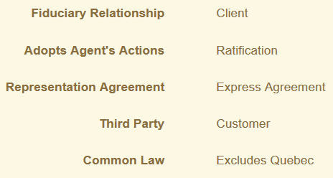

* Actual authorities are typically set out by way of a **express** agreement
* A brokerage selecting various advertising and promotion methods relating to a seller representation agreement is usually operating under an **implied** authority
* Certain regulatory obligations are established under REBBA 2002, as distinct from common law
* Two elements essential in a fiduciary relationship are trust and confidence
* A general obligation that requires a brokerage to possess the necessary abilities to perform agency duties is best described by the phrase **care and skill**
* A brokerage that avoids conflicts of interest is adhering to agent obligations commonly grouped under the category of **fiduciary obligations**
* Identify which of the following circumstances are examples of duty of care in the marketplace:
* The salesperson informs the buyer customer that many buyers seek out the services of a home inspector
* The salesperson takes accurate room measurements and includes these on the seller representation agreement
* The customer asks about arranging a new mortgage and the salesperson provides the buyer with a list of lenders that typically lend on that type of property
* The salesperson, when asked by the buyer about legal matters involving the house purchase, advises the client to seek appropriate expert advice
* Which of the following terms best describes duties performed by a real estate brokerage in seller representation? **Special Agency**
* Which of the following best describes the key difference between clients and customers? >> **The term client relates to an agency relationship, while customer refers to a non-agency relationship**
* A seller permits a salesperson employed by a brokerage to show his property, agrees that the brokerage will represent his interests and discusses remuneration to be paid. However, the seller does not sign the seller representation agreement provided to him. The property is subsequently sold to a buyer by that brokerage. This situation is best described as: **Creating agency by oral agreement**
* A salesperson, when listing a property, elects to focus most of her advertising efforts on the Internet rather than print media, given the particular features of the home. The seller is not aware of this specific advertising decision. This action is best described as: **An implied authority**
* A buyer’s representative is unaware of potential water problems within a particular neighbourhood, but accidentally overhears the seller customer discussing his problems with water quality and adequate supply. The listing brokerage has made no mention of this matter. The prospective buyer client is keenly interested in the property. After leaving the property, the salesperson informs the buyer regarding what was overheard. This scenario is best described by which of the following general obligations? > **Disclosure**
* A salesperson is instructed by the seller client not to divulge mould problems associated with the listed property. The salesperson agrees once the seller assures him that the problem has gone away. Further, evidence of any problem is not readily visible from a cursory inspection. The buyer, as a customer, discovers the problem subsequent to completion of the sale and takes legal action. Regardless of the outcome, which of the following general or fiduciary obligations will be most closely scrutinized by the Courts? > **Obedience**
* A buyer client is pursuing legal recourse, because the salesperson failed to inform her that the basement apartment in the purchased home was not legal. The salesperson, in his defense, argues that he only recently obtained his salesperson’s registration and can’t be expected to know about such matters. Which of the following statements best describes the merits of the salesperson’s argument? >> **The argument has little legal merit, as a duty of care is owed regardless of experience level**