Chapter 16

Representations

* **Single Representation:** Brokerage represents buyer or seller with the other party (i.e., the seller or buyer respectively) being a third party (customer)
* **Multiple Representation:** Brokerage represents more than one party, typically the buyer and the seller

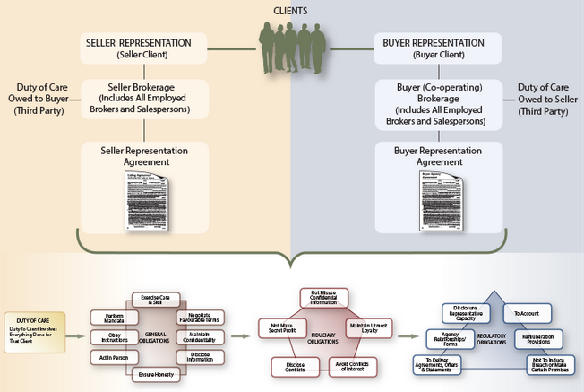

**Single Representation**

* Single representation is a relationship between a seller or buyer and an agent wherein the agent is considered in law to represent only the principal
* In **seller representation**, the brokerage represents the seller as a client. The seller brokerage and all salespeople employed by that brokerage promote the listed property, seek out qualified buyers and use their professional negotiation skills to advance the seller's interests. General and fiduciary duties are owed to the seller/client, along with a limited duty of care to the customer
* In **buyer representation**, the brokerage represents the buyer as a client. The buyer brokerage (often referred to as the co-operating brokerage) and all salespersons employed by that brokerage must promote the buyer's interests, locate a suitable property and use their professional negotiation skills to advance the buyer's interests. General and fiduciary obligations are owed to the buyer/client, along with a limited duty of care to the customer, who in this instance would be the seller

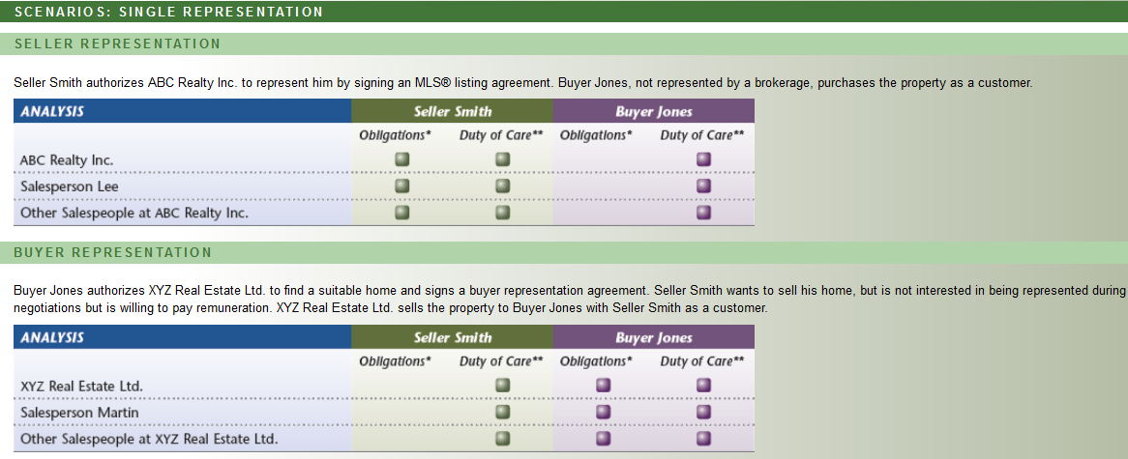

* **Commission**: In Canadian jurisdictions, the seller typically pays commission or other remuneration to the seller's brokerage who, in turn, disburses the agreed portion to the buyer's (co-operating) brokerage. The buyer must be informed of this arrangement and of the amount of the remuneration to be received by the buyer's brokerage from the seller's brokerage. Alternatively, the buyer's brokerage can be paid directly by the buyer in which case such amount does not form part of the sale proceeds

As an important qualification, a buyer's brokerage could be paid by the seller or could potentially seek remuneration from both. The real estate brokerage, as with all agents in a fiduciary relationship, must disclose such arrangements to the client (or clients) and receive their fully informed consent. This obligation also extends to receipt of money from third parties, such as referral fees paid by persons involved in the transaction (e.g., mortgage brokers, lenders and lawyers) or those providing incidental services (e.g., moving companies and interior decorators).

* **REBBA 2002 Compliance**:
* Information before agreement
* Minimum Content
* Copies of agreements
* Agreement in writing

**Multiple Representation**

* Multiple representation is a relationship in which a brokerage represents two or more parties at the same time in the same transaction, most commonly buyer and seller. The underlying legal assumption is that all representatives in a brokerage share each other's confidences; i.e., knowledge of confidential matters is imputed to all other representatives. Consequently, multiple representation can arise in various circumstances. Most commonly, this situation arises when the same broker or salesperson in a brokerage represents both buyer and seller or two different salespeople within that brokerage (located in the same office or different branch offices) represent the buyer and the seller respectively
* Multiple representation is not prohibited by law but, given that an inherent conflict of interest exists between the interests of the seller and the buyer, this practice must be strictly regulated
* An effective way to avoid multiple representation is to represent one party, while giving the other party customer status, thereby avoiding the legal pitfalls associated with multiple representation. This approach is particularly effective in situations involving the same broker or salesperson. As a final note, if multiple representation is practiced and a dispute develops and remains unresolved, the brokerage and its representatives cannot continue to act for both parties

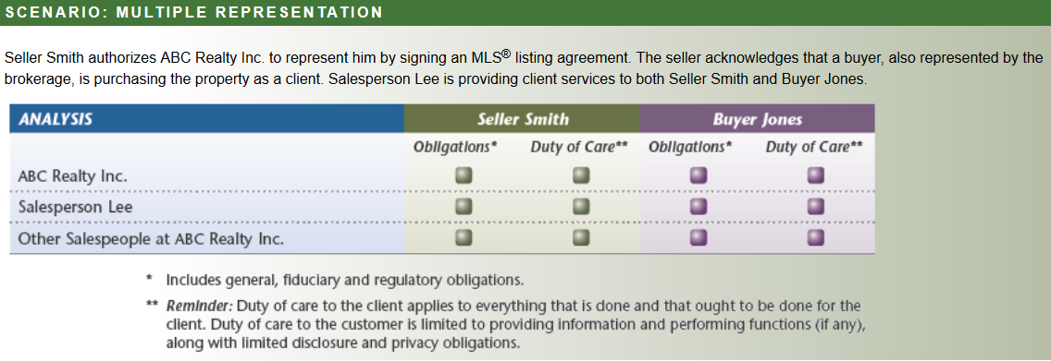

* **REBBA 2002 Compliance**:
* Informed, written contest
* Disclosure before multiple representation
* **Implied Multiple Representation**: A real danger with multiple representation lies not so much in representing more than one party, which can be largely addressed through proper disclosure procedures, but rather with implied (indirect) relationships. Salespeople can inadvertently give the impression through words and actions that a client relationship does exist. No formal document need exist for unintended multiple representation

**Competing [Opposing] Buyers/Sellers**

* Multiple representation normally focuses on situations in which buyers and sellers are involved in the same trade. However, other conflicts of interest can arise in which the brokerage is representing individuals with competing interests, but not within the same trade; e.g., a brokerage may have two or more buyer clients who are competing for the same property, but not involved in the same trade. Both multiple representations involving the same trade and other conflicts not involving the same trade can be broadly grouped under the heading of concurrent representation
* **Competing Buyers**: Assume that a brokerage has two or more buyers as clients who are concurrently competing for the same property. Given the fiduciary relationship with both, the brokerage and its representatives cannot allow a conflict of interest to exist without the informed consent of the clients. While not a typical multiple representation situation, the buyers are in direct competition. Clearly, the brokerage and its representatives from a common law perspective must:
* Disclose the nature of the conflict and seek the informed consents of both buyer clients
* Discuss how the brokerage intends to proceed under the circumstances with both buyer clients
* Outline implications for the buyer clients when giving consent to this conflict of interest
* **Statutory [Legal] Disclosure**: The issue of competing buyers has caused considerable discussion over the years. Such activities have not traditionally fallen under the definition of multiple representation (as the buyers are not involved in the same trade, but rather different trades involving the same property). The Registrar has stated that, for purposes of REBBA 2002, competing buyers are viewed statutorily as falling under multiple representation and regulatory disclosure requirements apply.

As a qualifier regarding the timing of such disclosure, registrants might not be initially aware of competing buyers given that different registrants within the brokerage could be working with separate buyers looking at the same property. However, disclosure requirements must be fulfilled when such a circumstance becomes known during negotiations

* **Competing Sellers:** Unlike competing buyers where conflicting interests are evident, the circumstance of representing two or more sellers does not typically invoke such conflict, because the brokerage can loyally serve the interests of each seller as remuneration is due upon effecting a sale and, consequently, the interests of the brokerage and those of the sellers generally align. Regardless, representation agreements now typically include reference to such conflicts of interest and seek the buyer's or seller's consent, as the following examples illustrate. At time of printing, no statutory directive has been issued regarding competing sellers
* **Sequential Representation:** Sequential representation involves a situation in which a brokerage is potentially placed in a multiple representation in a subsequent transaction owing to a client relationship established by a previous agreement. For example, a salesperson acts for the seller client by listing and selling his property. Subsequently, the same salesperson working with the seller, who is now looking to buy, locates a property listed with his or her employing brokerage

**Disclosure of Interest**

* Registrants must also disclose any existing or contemplated interest that they have in real estate which they are either divesting or acquiring. The registrant must deliver a notice to all other parties to the agreement and receive acknowledgement in writing of receipt of this notice from those parties. The notice must contain a statement concerning the registrant's status (i.e., brokerage, broker or salesperson), full disclosure of known facts that affect or will affect value and of any subsequent negotiations (if an acquisition is involved)

**Sub-agency**

* An agency relationship in which a brokerage representing a seller or buyer seeks the assistance of another brokerage in transacting the affairs of that principal (with express or implied consent of the principal)
* Sub-agency involves the authorization by one brokerage to another brokerage to assist in advancing the interests of the principal, with the express consent of that principal. The sub-agent owes all the same general, fiduciary and regulatory obligations to the principal, as does the agent
* Sub-Agency: Is it Still Viable?

Sub-agency once dominated residential markets, due largely to the MLS® system with all co-operating brokerages acting as sub-agents of the seller brokerage. While this approach has faded as the industry has searched for ways to avoid dual agency, does it still have a role in the marketplace? The answer: a qualified ‘yes,' as certain circumstances may warrant this approach. Assume, for example, that a large commercial client is seeking specific locales across a province for an expanding franchise. The client might retain a primary brokerage as the agent who, in turn, would seek the assistance of sub-agents in locating suitable properties for presentation to the client

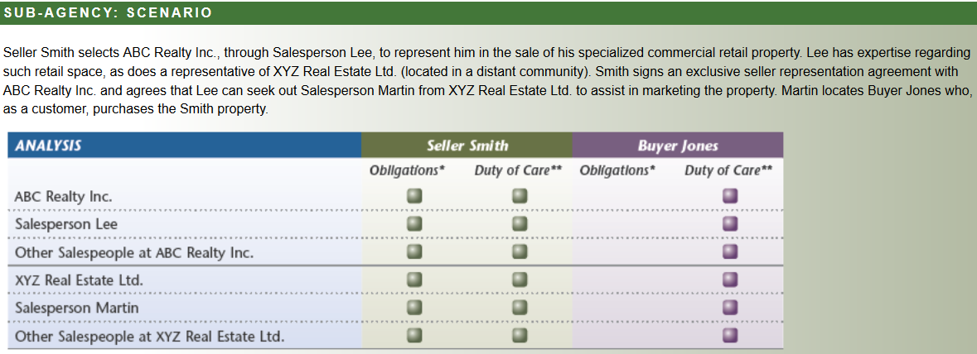

* **Servicing the Customer**: An agreement in which the brokerage provides services to the customer, as distinct from a representation agreement with a client

Chapter 16 focuses on representation, but service agreements involving customer status are gaining prominence, as registrants seek ways to offer non-representation services to consumers. Such agreements can also be effective in avoiding multiple representation and associated conflicts of interest; i.e., treating one party as the client by way of a representation agreement and the other as the customer with written confirmation by way of a service agreement. Such agreements are proving effective in minimizing confusion leading to implied representation while, at the same time, more clearly delineating responsibilities owed to customers, as distinct from those owed to clients

**Notables:**

* Single representation involves an agent representing either buyer or seller with the other party being a third party (i.e., a customer)
* The Code of Ethics sets out specific requirements regarding protecting and promoting the client's interests, as well as duties to others involved in the transaction
* The Agency Task Force has developed a list of obligations imposed by common law regarding single representation
* The Code of Ethics sets out specific requirements regarding information provided before agreements, contents of such agreements and prompt delivery of signed agreements
* Multiple representation has certain inherent risks given issues concerning competing interests and imputed knowledge
* Brokerages and their representatives must fully comply with REBBA 2002 disclosure and related requirements
* Other conflicts of interest must be fully disclosed, as with multiple representation, and registrants must ensure that informed consent is obtained
* Representation agreements now typically contain reference to conflicts involving competing buyers and sellers and the need to seek the client's informed consent
* Registrants must meet strict disclosure requirements when acquiring or disposing of real estate
* Sub-agency once dominated residential markets, but now has faded in popularity. However, this variation can be effective in selected circumstances
* Service agreements can be effective both in avoiding multiple representation and offering alternatives to representation

**Mini-Review:**

* Agency relationships can be grouped under two main categories: single representation and multiple representation **>> True**
* In single representation, the brokerage and its representatives owe the client both general and fiduciary obligations **>> True** [While the term 'representation' is not defined in REBBA 2002, it is generally viewed as analogous to agency and, therefore, duties would include both general and fiduciary obligations (as well as regulatory obligations set out in the Act and Regulations).]
* Typically, the brokerage representing the seller assumes that the co-operating brokerage is NOT representing the buyer, but instead is treating that buyer as a customer **>> False** [The brokerage representing the seller typically assumes that the co-operating brokerage is representing the buyer]
* According to REBBA 2002, a brokerage and its representatives must be fair and honest to the buyer as a customer, but duties do not extend to offering conscientious service **>> False** [Section 5 of the Code of Ethics requires that the brokerage and its representatives provide conscientious and competent service to both clients and customers]
* In single buyer representation, one of the common law obligations to the client is to disclose, in a timely manner, all relevant facts known to the brokerage and its representatives about the property or transaction **>> True**
* When offering single representation, a brokerage and its representatives must represent the interests of the client, but do not owe a duty of care to that client **>> False** [Duty of care is owed to both clients and customers. The duty applies to everything done for a client, but is more limited in the case of customers]]
* One of the challenges for brokerages involved with multiple representation is to handle conflicting instructions from two principals **>> True**
* A salesperson representing a client, who suggests in confidence to the customer that he or she could work in his or her best interests at the same time, faces the legal perils of implied representation **>> True** [Implied multiple representation can have serious legal consequences]
* If two salespeople within a brokerage are representing competing buyers, they must follow disclosure procedures as set out for all multiple representation situations **>> True**
* If ABC Realty Inc. represents the seller and XYZ Real Estate Ltd. is appointed as a sub-agent, then XYZ Real Estate Ltd. owes the same general, fiduciary and regulatory obligations to the seller as does ABC Realty Inc **>> True** [The sub-agent owes the same duties to the client as the agent]

**Active Learning Exercise:**

* Provisions in REBBA 2002 (General Regulation and the Code of Ethics) regarding multiple representation: **Require that clients provide consent in writing to multiple representation**
* Which of the following is most correct in the case of single representation? **Regulatory obligations can apply to both customers and clients**
* Salesperson Lee, on behalf of ABC Realty Inc., lists the seller’s property and then locates a suitable new home for his client. The new home is listed by another salesperson in the same brokerage. If Lee represents the seller (now a buyer) in purchasing this listed property, he is facing a situation legally referred to as: **Sequential Representation**
* Which of the following is NOT a true statement regarding multiple representation? **Imputed knowledge, from a legal perspective, refers to the fact that all registrants within a brokerage share each other’s confidences**
* A salesperson, on behalf of the brokerage, agrees to represent the seller when listing his home and then also agrees to represent a buyer in the purchase of that home. The most appropriate term describing this circumstance is: **Multiple Representation**
* The salesperson, as a representative of a brokerage, has been working first with the seller as a client and then with a buyer client under a multiple representation relationship for more than a week, attempting to put a deal together. The problem revolves around the offered price and the closing date. To move things along, the salesperson casually mentions to the buyer that the seller is getting anxious and will probably accept a lower price, if the seller’s closing date is met. The seller has not given the salesperson authority to make that statement. Which of the following best describes this situation? > **Even a minor advantage given to one client over the other can dramatically tip the negotiating scale.**
* Which of the following statements is correct? > **A service agreement can be effective in avoiding multiple representation when a salesperson in a brokerage is working with a seller client and is approached by a buyer to purchase the seller’s property**
* Identify which of the following circumstances are examples of multiple representation
* Two salespersons in the same brokerage representing different clients in the same transaction
* Two salespersons from different branches of the same brokerage representing different clients in the same transaction
* A salesperson from a brokerage representing a seller client and an appraiser from the same brokerage providing an evaluation of the seller client’s home to a buyer who wishes to purchase the seller’s home
* **Exercise 3 Obligations to Seller and Buyer**

ABC Realty Inc. has listed a unique, six-outlet bistro operation called Bistro Best. Salesperson Lee of ABC Realty Inc. obtains the seller's consent to involve another brokerage as a sub-agent to market the enterprise. Salesperson Martin, employed by XYZ Real Estate Ltd. (the sub-agent) interests ACME Holdings Inc. as a customer in looking at the property and has an appropriate agreement signed with ACME. Based on this scenario, from the multiple-choice questions below, select which obligations (general, fiduciary and regulatory), as well as duty of care, apply to the respective brokerages

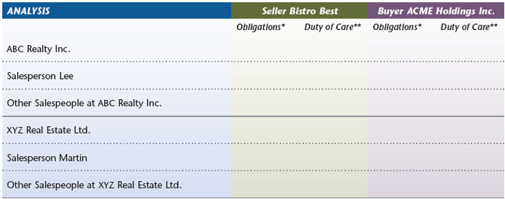

***\**** Includes general, fiduciary and regulatory obligations.

***\*\* Reminder:*** Duty of care to the client applies to everything that is done and that ought to be done for the client. Duty of care to the customer is limited to providing information and performing functions (if any), along with limited disclosure and privacy obligations

1. ABC Realty Inc.

* Seller Bistro Best - Obligations*
* Seller Bistro Best - Duty of Care**
* Buyer ACME Holdings Inc. - Duty of Care**

1. Salesperson Lee

* Seller Bistro Best - Obligations*
* Seller Bistro Best - Duty of Care**
* Buyer ACME Holdings Inc. - Duty of Care**

1. Other Salespeople at ABC Realty Inc.

* Seller Bistro Best - Obligations*
* Seller Bistro Best - Duty of Care**
* Buyer ACME Holdings Inc. - Duty of Care**

1. XYZ Real Estate Ltd

* Seller Bistro Best - Obligations*
* Seller Bistro Best - Duty of Care**
* Buyer ACME Holdings Inc. - Duty of Care**

1. Salesperson Martin

* Seller Bistro Best - Obligations*
* Seller Bistro Best - Duty of Care**
* Buyer ACME Holdings Inc. - Duty of Care**

1. Other Salespeople at XYZ Real Estate Ltd

* Seller Bistro Best - Obligations*
* Seller Bistro Best - Duty of Care**
* Buyer ACME Holdings Inc. - Duty of Care**