**Wednesday 5/1/2019 to Saturday 5/4/2019**

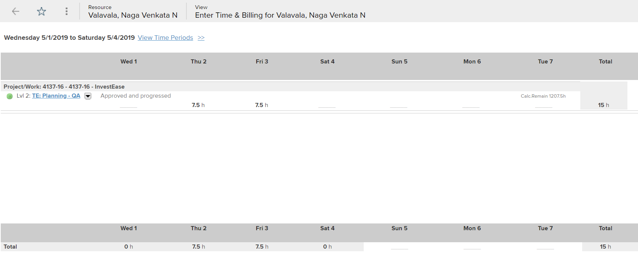

**Sunday 5/5/2019 to Saturday 5/11/2019**

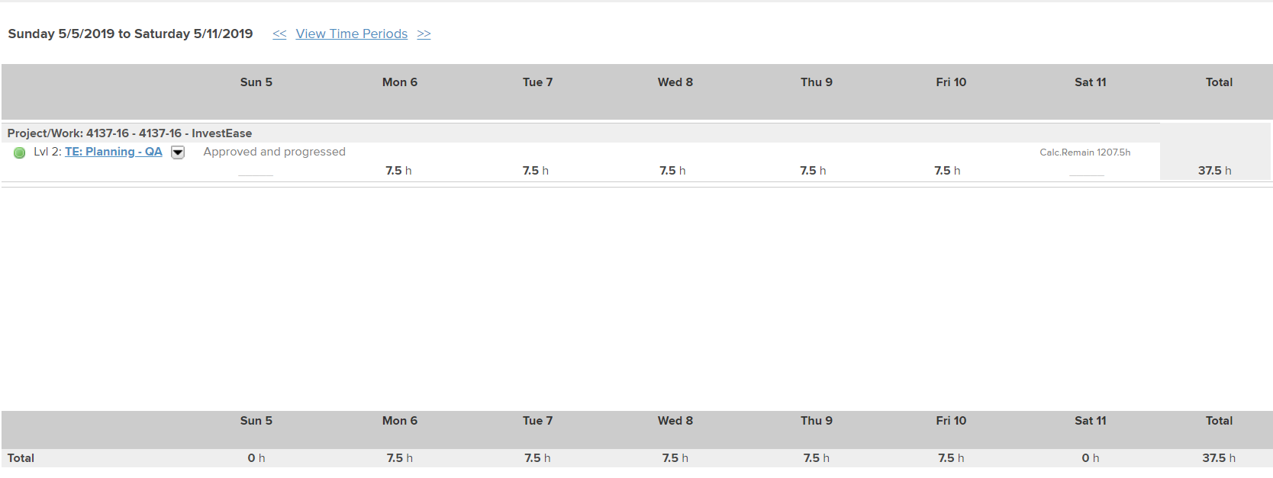

**Sunday 5/12/2019 to Saturday 5/18/2019:**

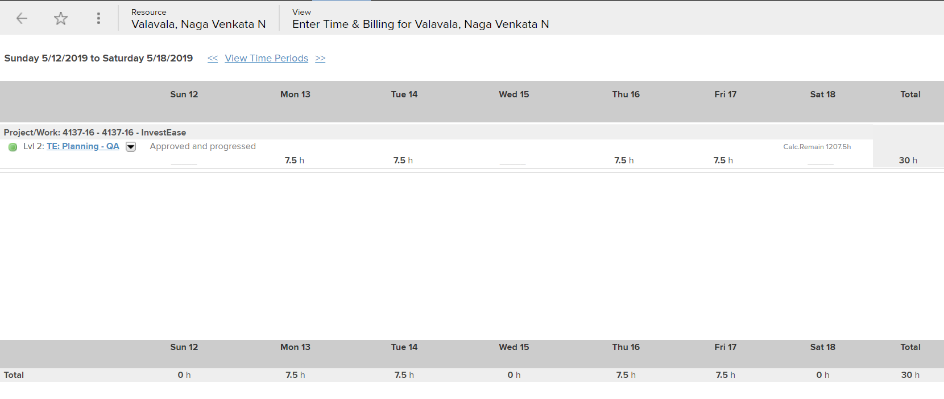

**Sunday 5/19/2019 to Saturday 5/25/2019**

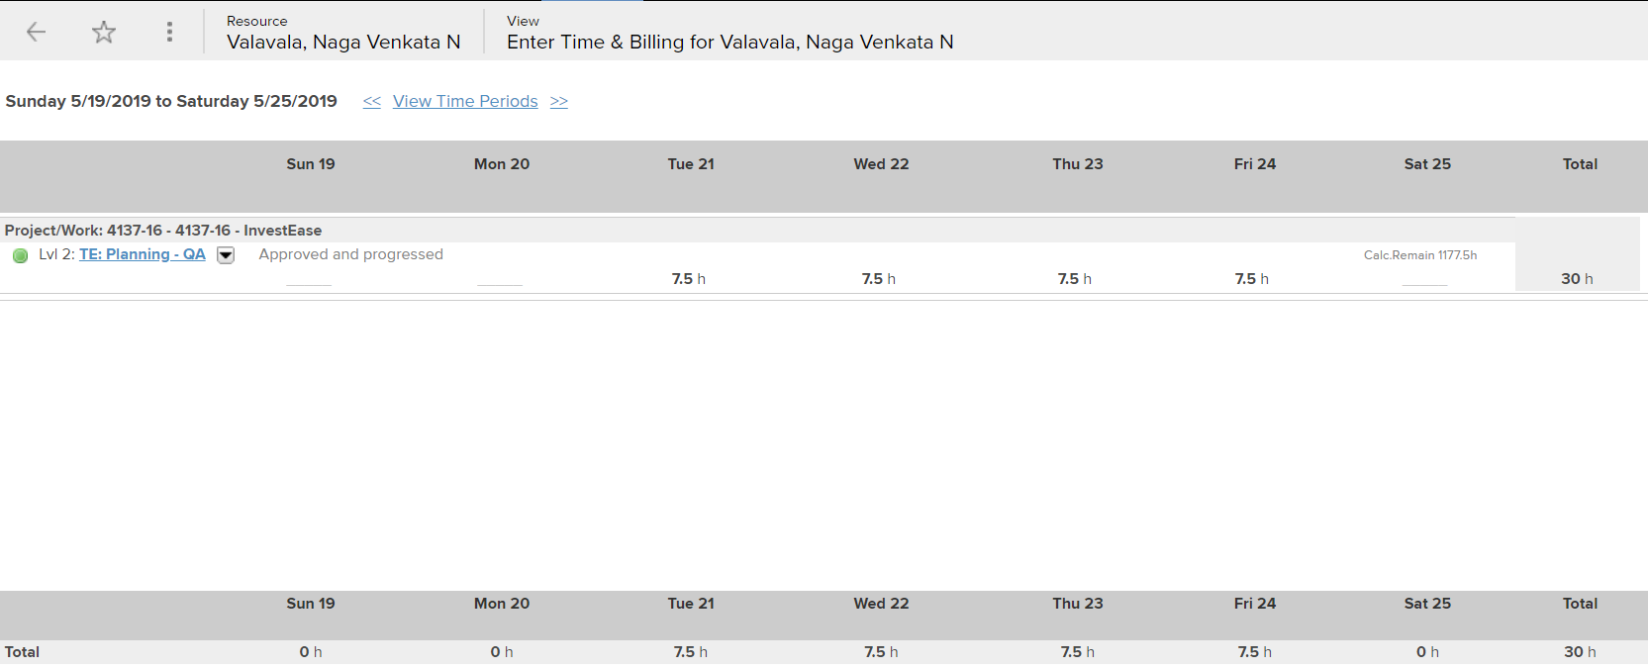

**Sunday 5/26/2019 to Friday 5/31/2019**

