**A Novel Min-Max Fuzzy Logic to Guarantee Reliable Data Delivery through Optimal Route in Cluster based Delay Tolerable IoT network**

In this project ,we create a network topology .it consists n- nodes , n- Aggregator nodes based on no of divisions and 1-sink .Divide the network into n-equal size cells and we deploy Aggregators at the center point of the cell.Next perform the cluster process by using Improved Particle Swarm Optimization based K-means (IPSO-K means). After that Select the optimal forwarder node in the cell by using Minimum - Maximum Fuzzy Logic (Min-Max FL) .The sensed data from each sensor is forwarded to aggregator through optimal forwarder node. At aggregators the aggregated packets are categorized into emergency and non-emergency packets based on flag value. The Non-emergency packets are compressed by In-networking Dual Compression (IN-DC) technique. Then aggregator waits for mobile sink arrival, after that it transmits the compressed data to mobile sink. If an emergency packet is identified by aggregator then that packet is transmitted to sink node immediately through optimal route. The optimal path for data transmission is selected by Knowledge based Firefly optimization Algorithm (KFFA) .We plot the results graph for Delay vs no.of.nodes,Delay vs buffer size,Packet Delivery Ratio vs no.of.nodes,Packet Delivery Ratio vs buffer size and Overhead vs no.of.nodes.

Open the terminal

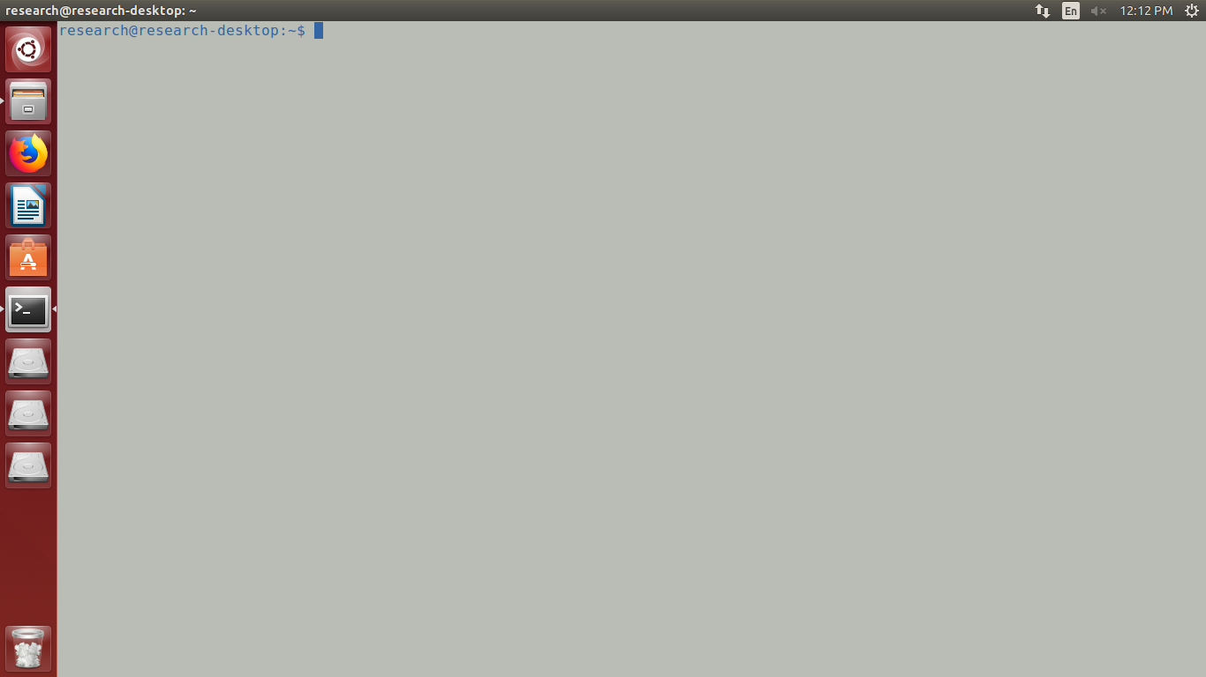

change the location

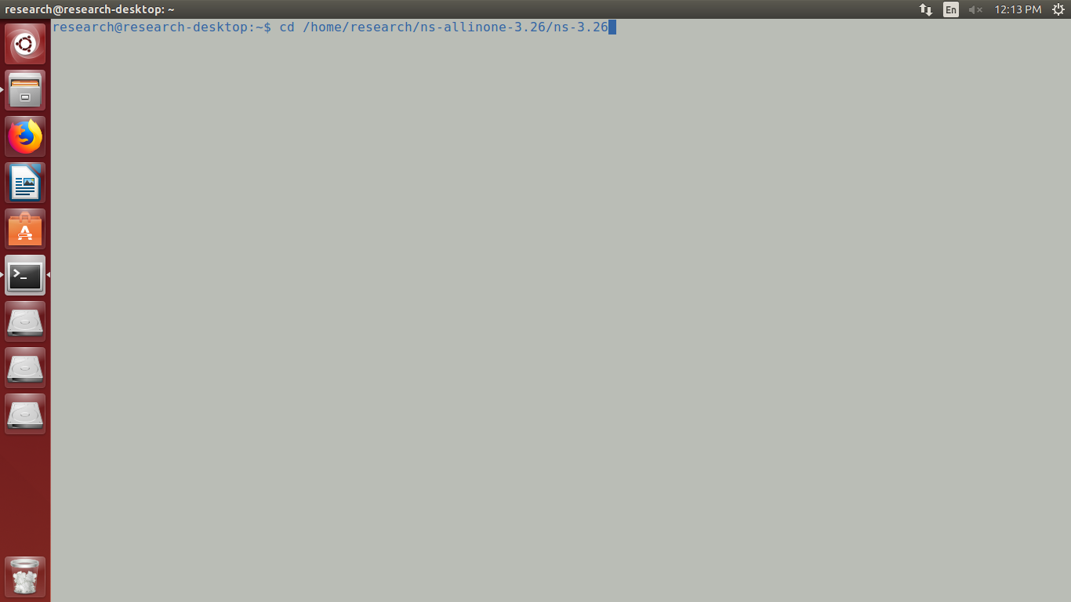

execute the command ' sudo ./waf --run Guarantee_Reliable_Data_Delivery --vis '

enter the no.of nodes [devices]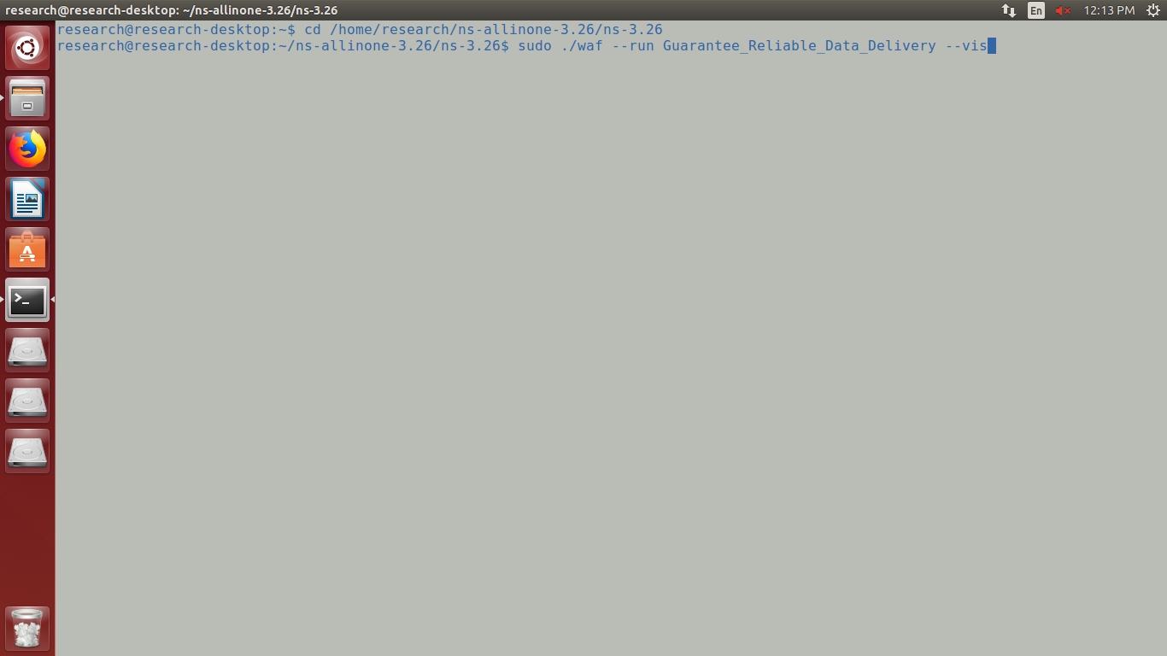

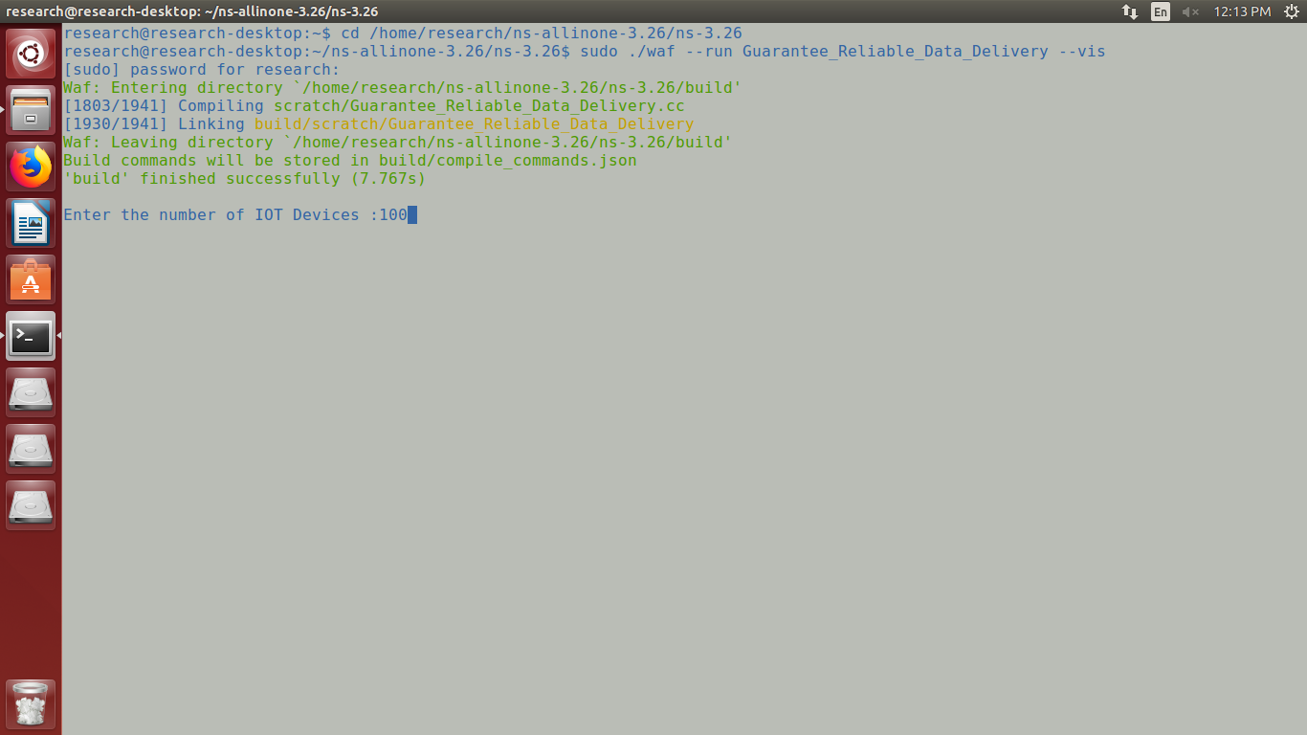

enter the no.of.divisions [eg:- if you enter 3 then 3*3=9 divisions]

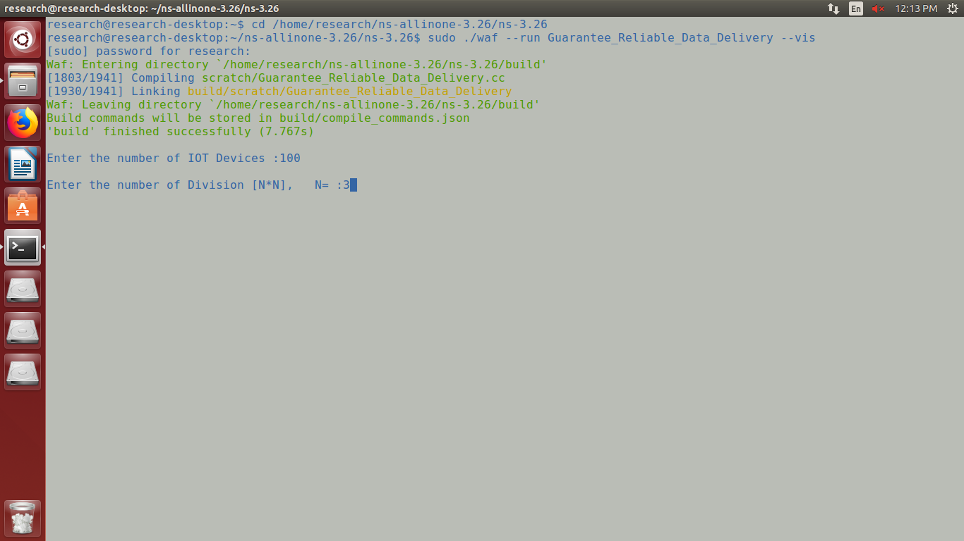

we create a network topology .it consists n- nodes , n- Aggregator nodes based on no of divisions and 1-sink .

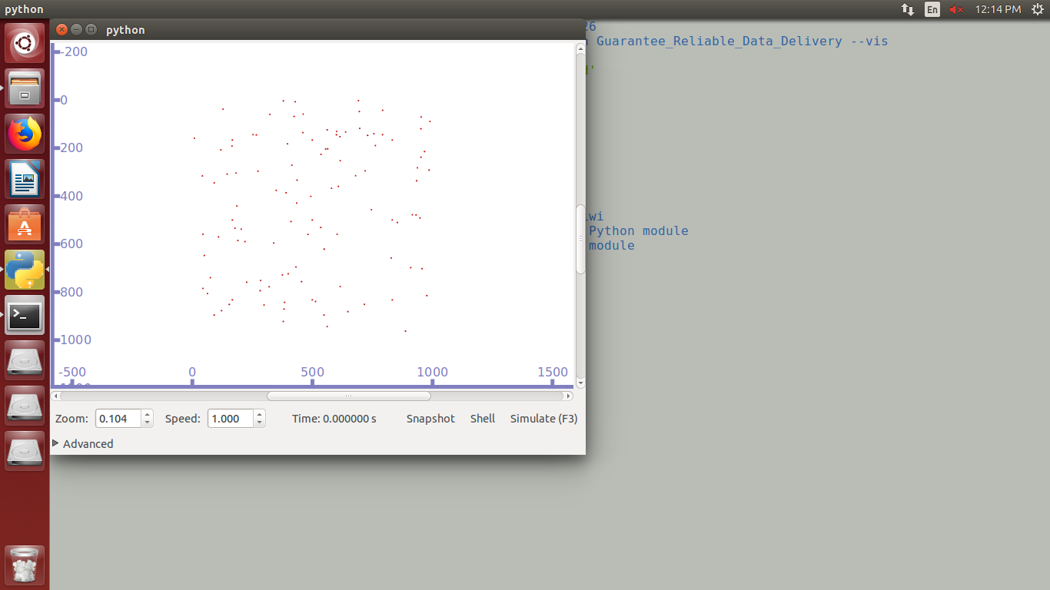

Divide the network into n-equal size cells and we deploy Aggregators at the center point of the cell.

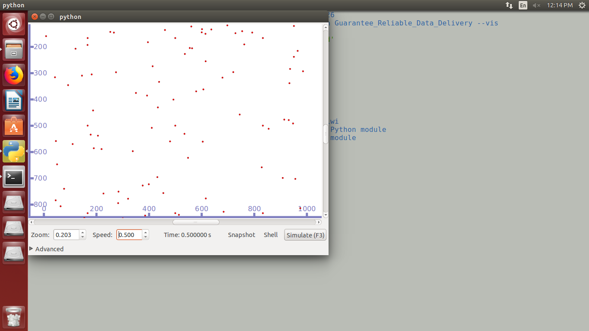

Perform the cluster process by using Improved Particle Swarm Optimization based K-means (IPSO-K means).

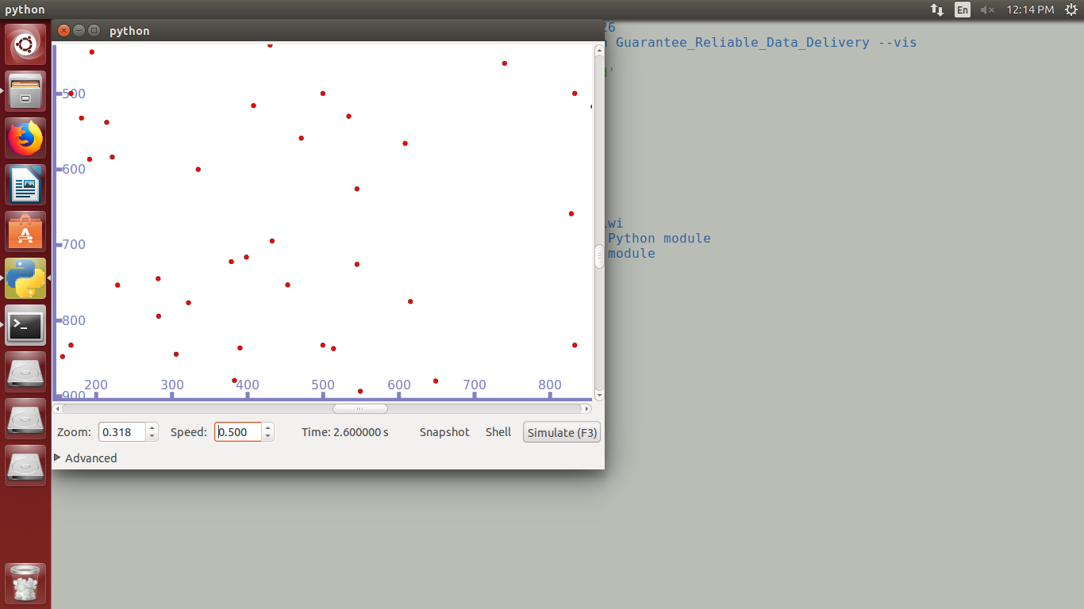

Select the optimal forwarder node in the cell by using Minimum - Maximum Fuzzy Logic (Min-Max FL) .

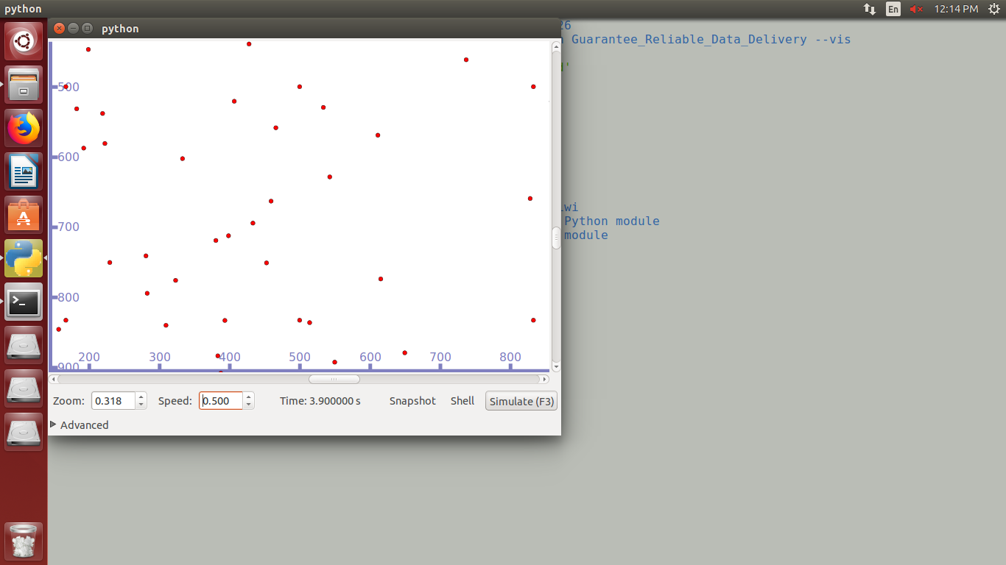

The sensed data from each sensor is forwarded to aggregator through optimal forwarder node. At aggregators the aggregated packets are categorized into emergency and non-emergency packets based on flag value.The Non-emergency packets are compressed by In-networking Dual Compression (IN-DC) technique. Then aggregator waits for mobile sink arrival, after that it transmits the compressed data to mobile sink.

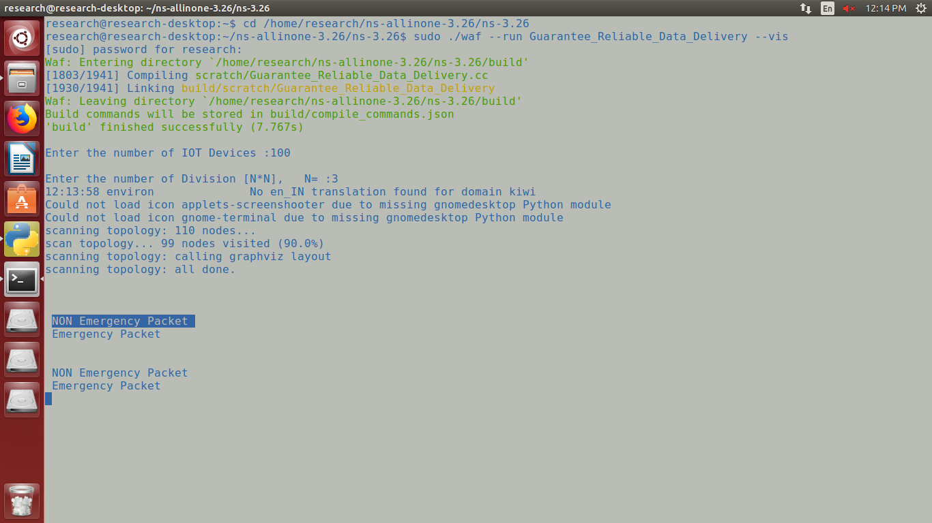

If an emergency packet is identified by aggregator then that packet is transmitted to sink node immediately through optimal route. The optimal path for data transmission is selected by Knowledge based Firefly optimization Algorithm (KFFA) .

Change the location for get the animator result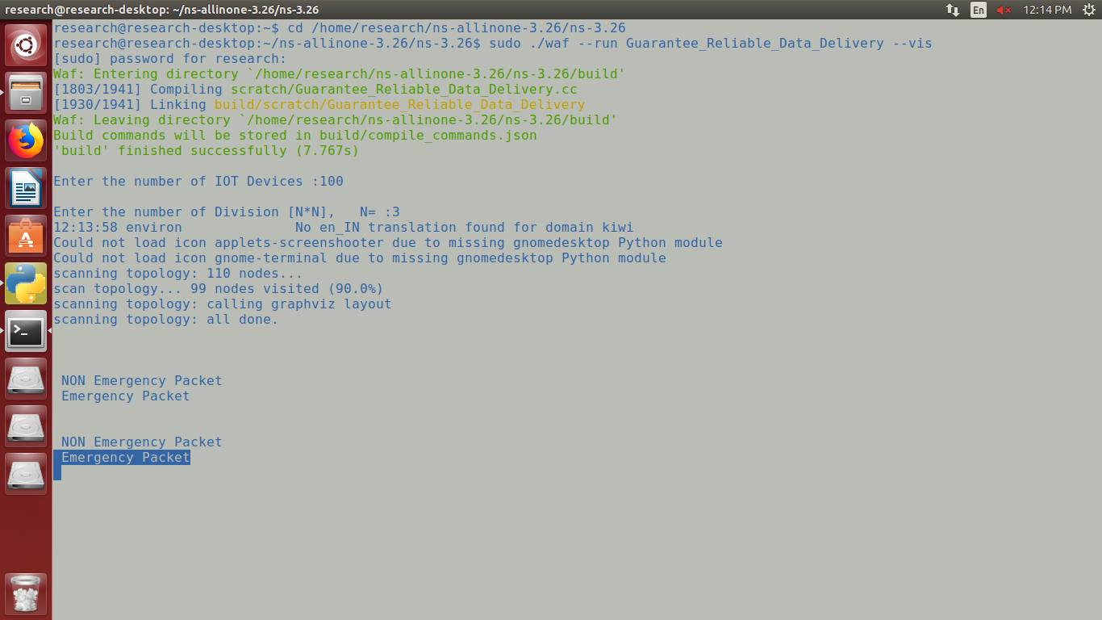

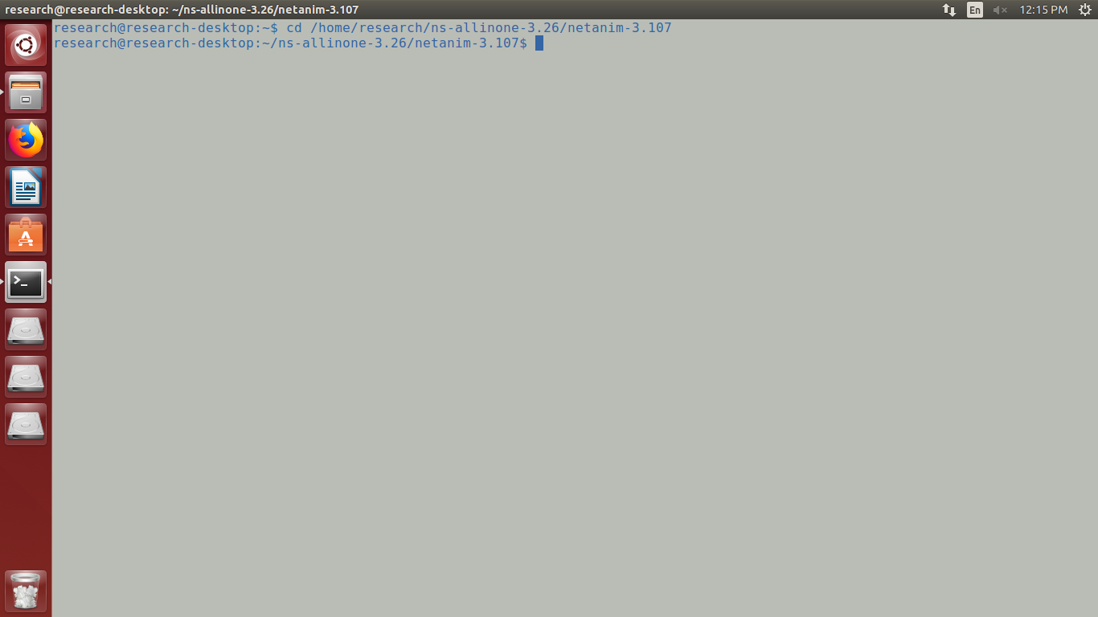

execute the command ' ./NetAnim '

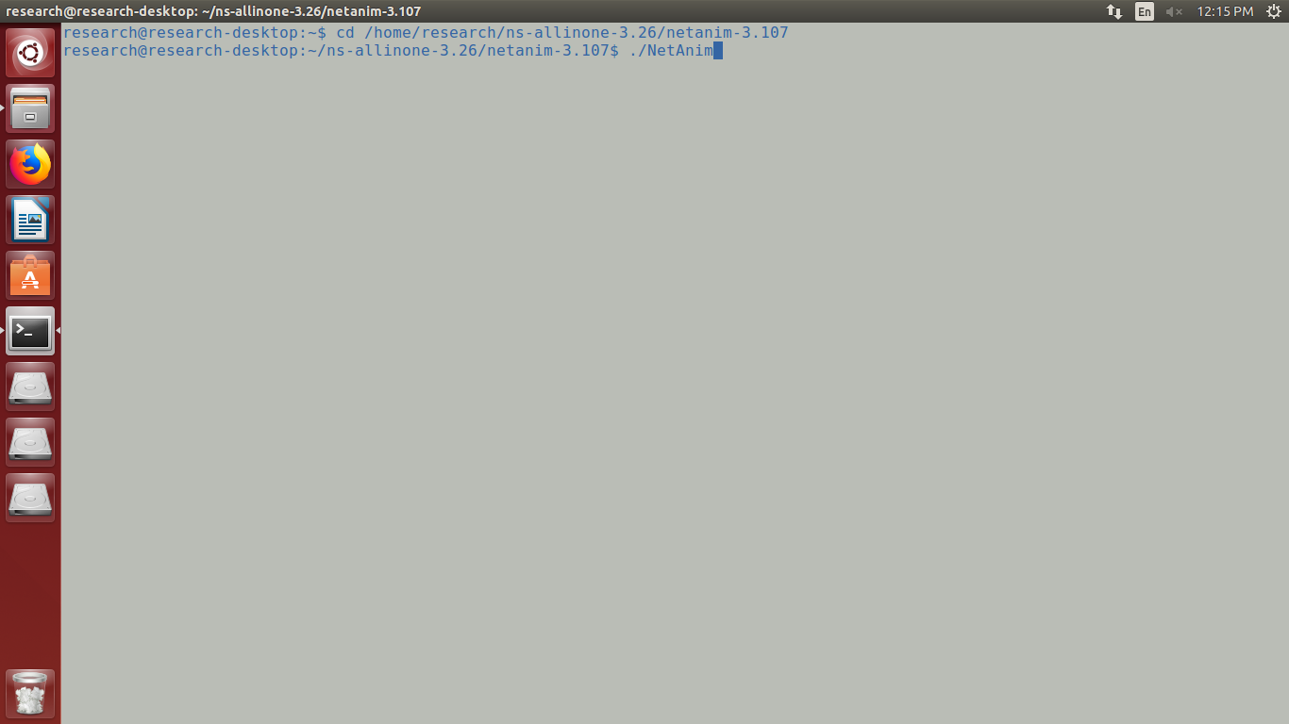

select the xml file

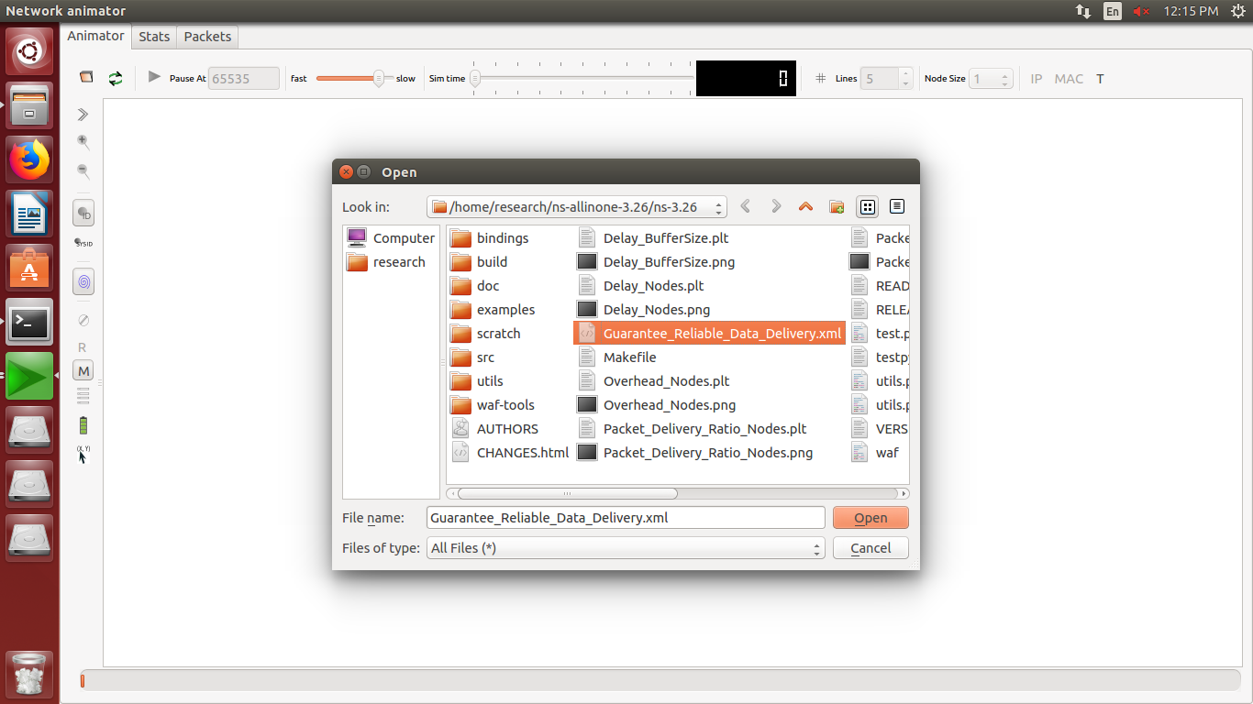

get the simulation

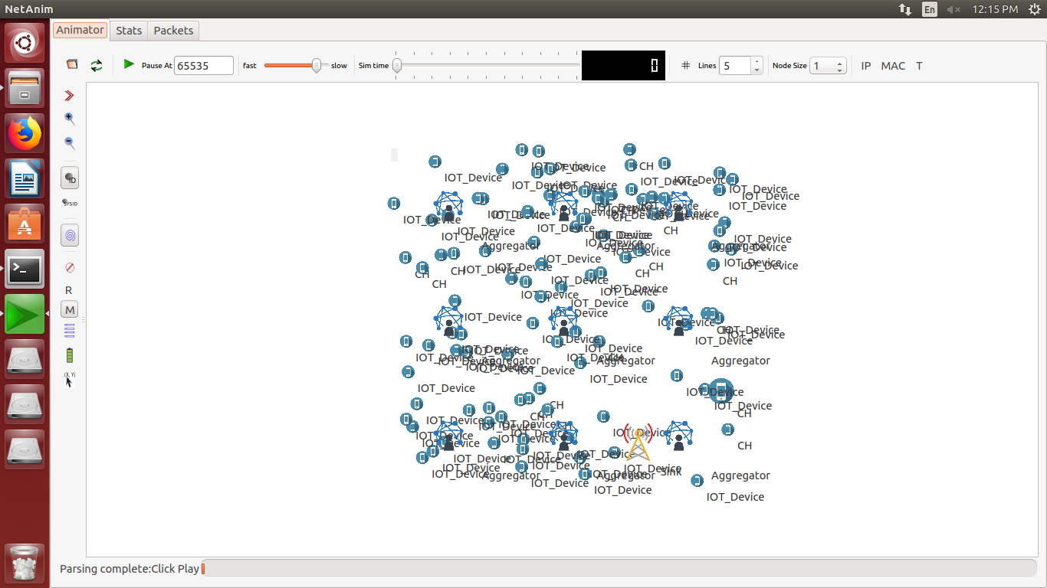

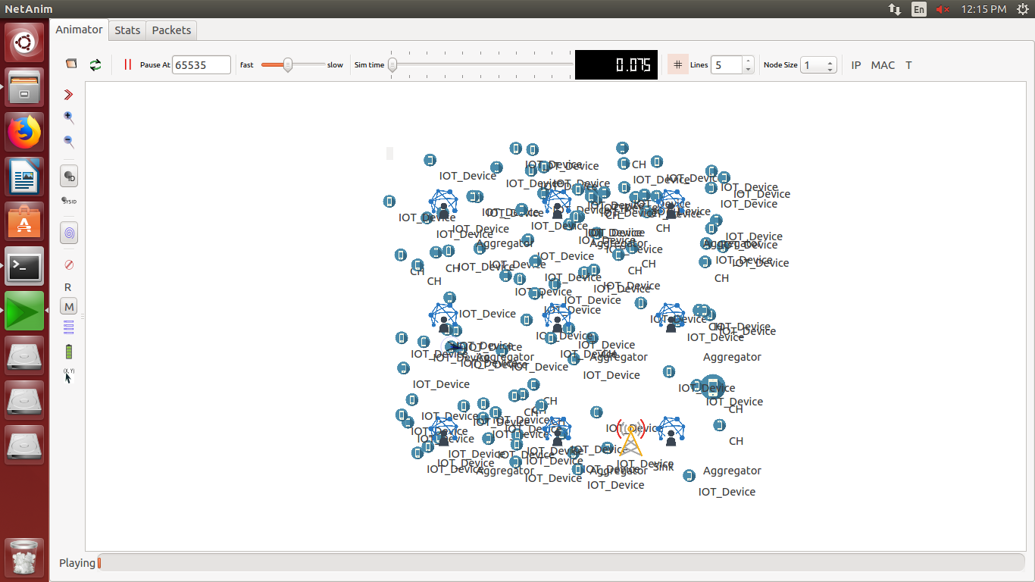

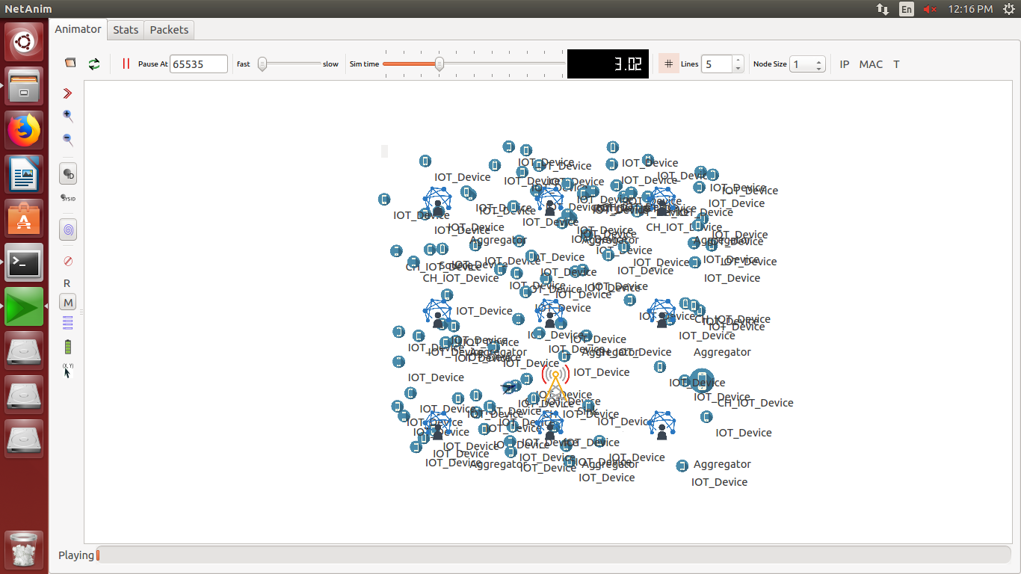

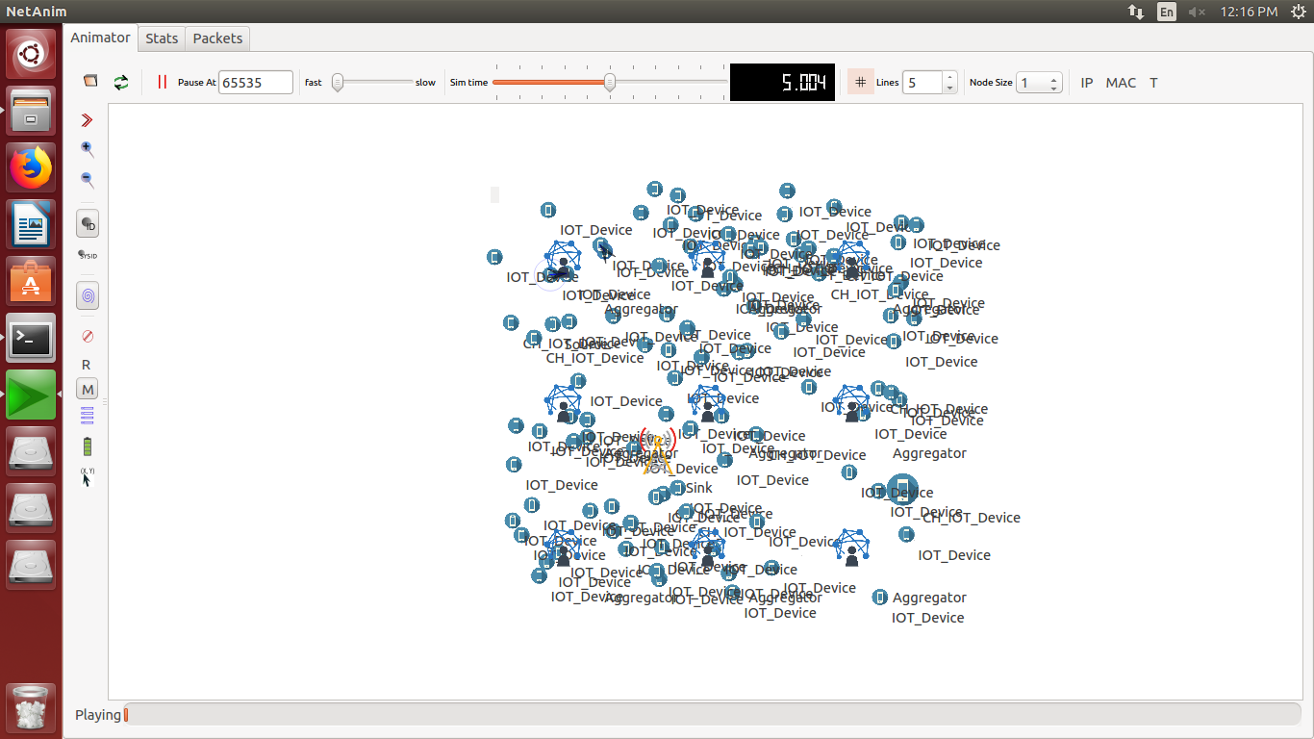

plot the results graph for Delay vs buffer size

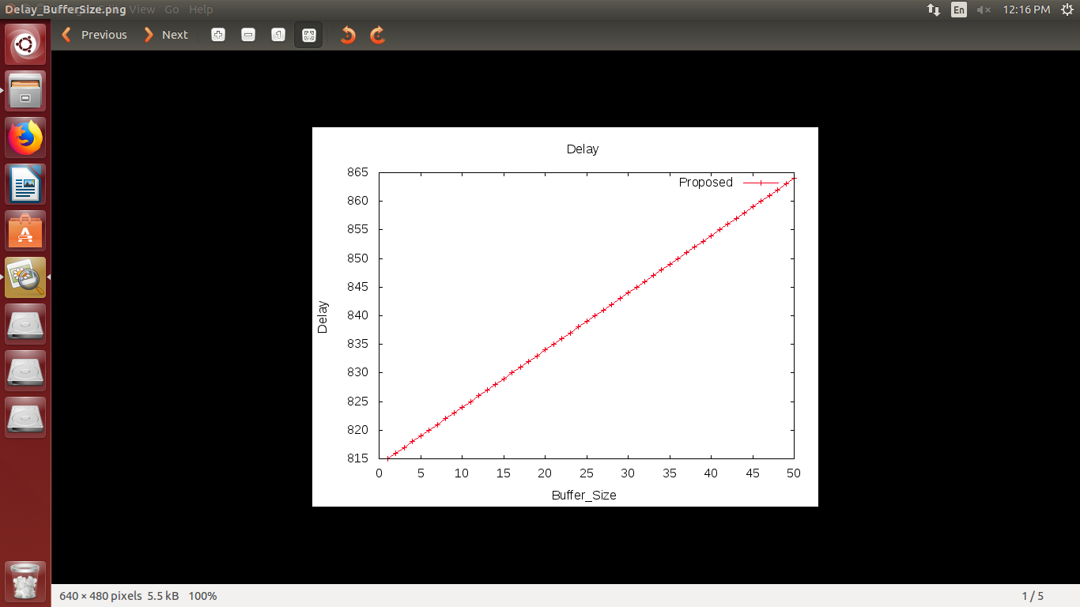

plot the results graph for Delay vs no.of.nodes

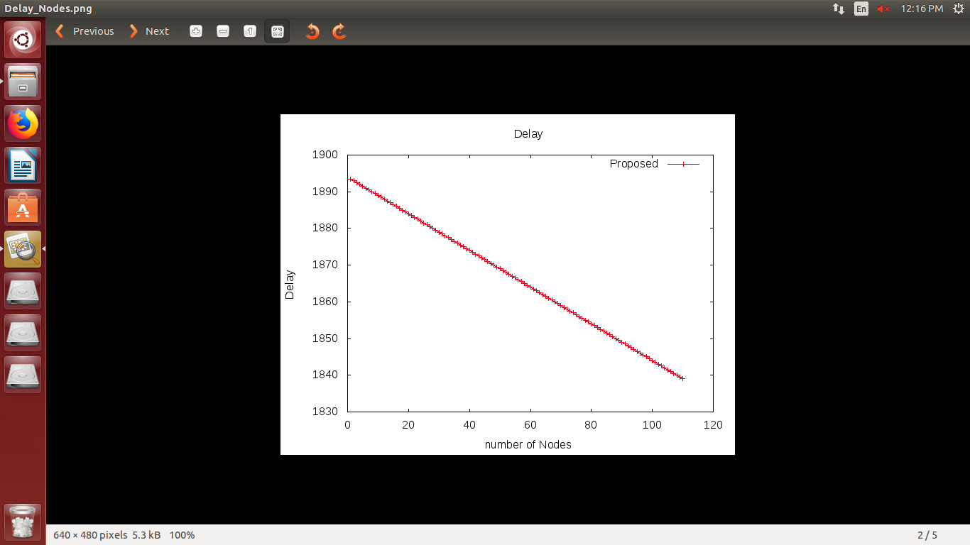

plot the results graph for Overhead vs no.of.nodes

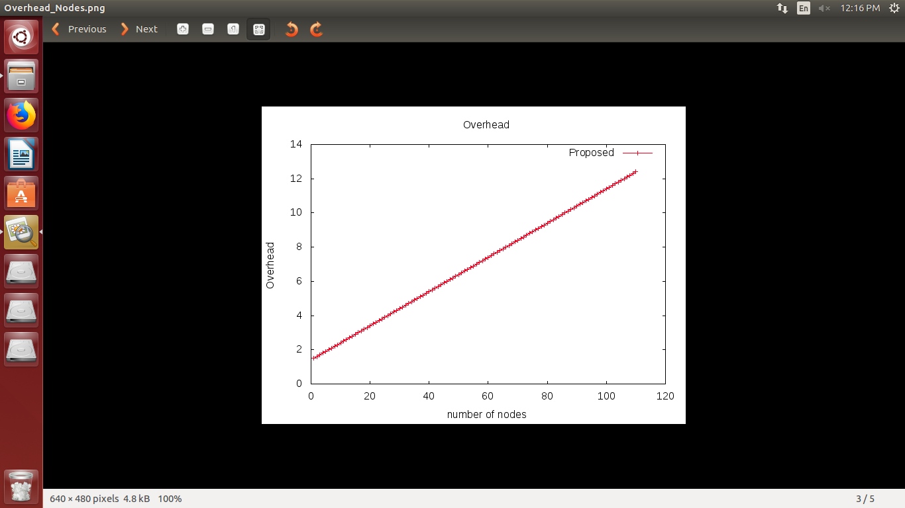

plot the results graph for Packet Delivery Ratio vs buffer size

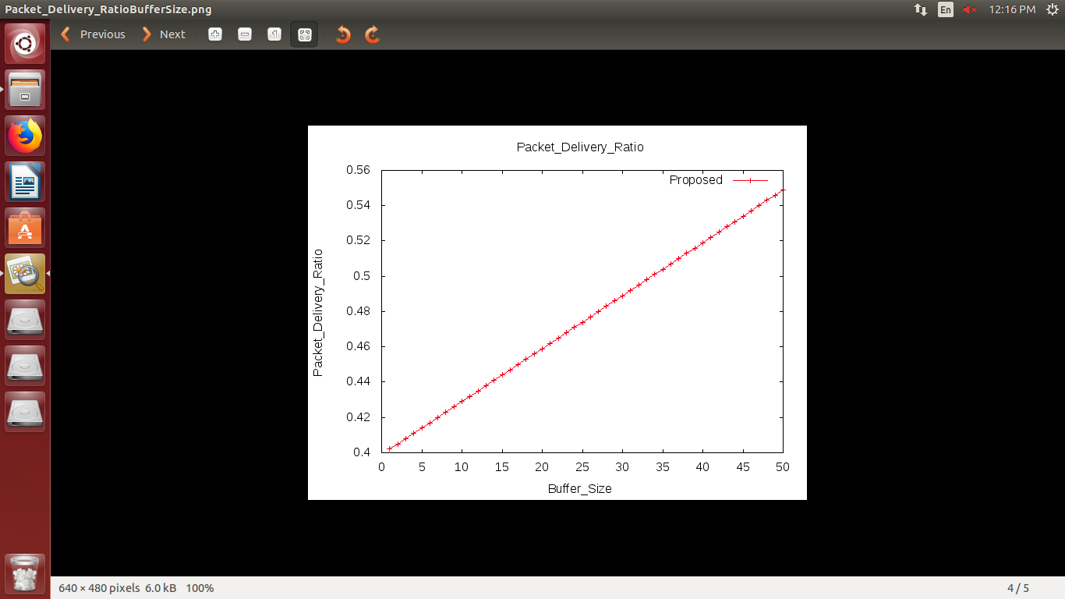

plot the results graph for Packet Delivery Ratio vs no.of.nodes

