FINAL REPORT

Coursera IBM Data Science Certification

Capstone Project - The Battle of Neighbourhoods

**SATYAJEET DAS**

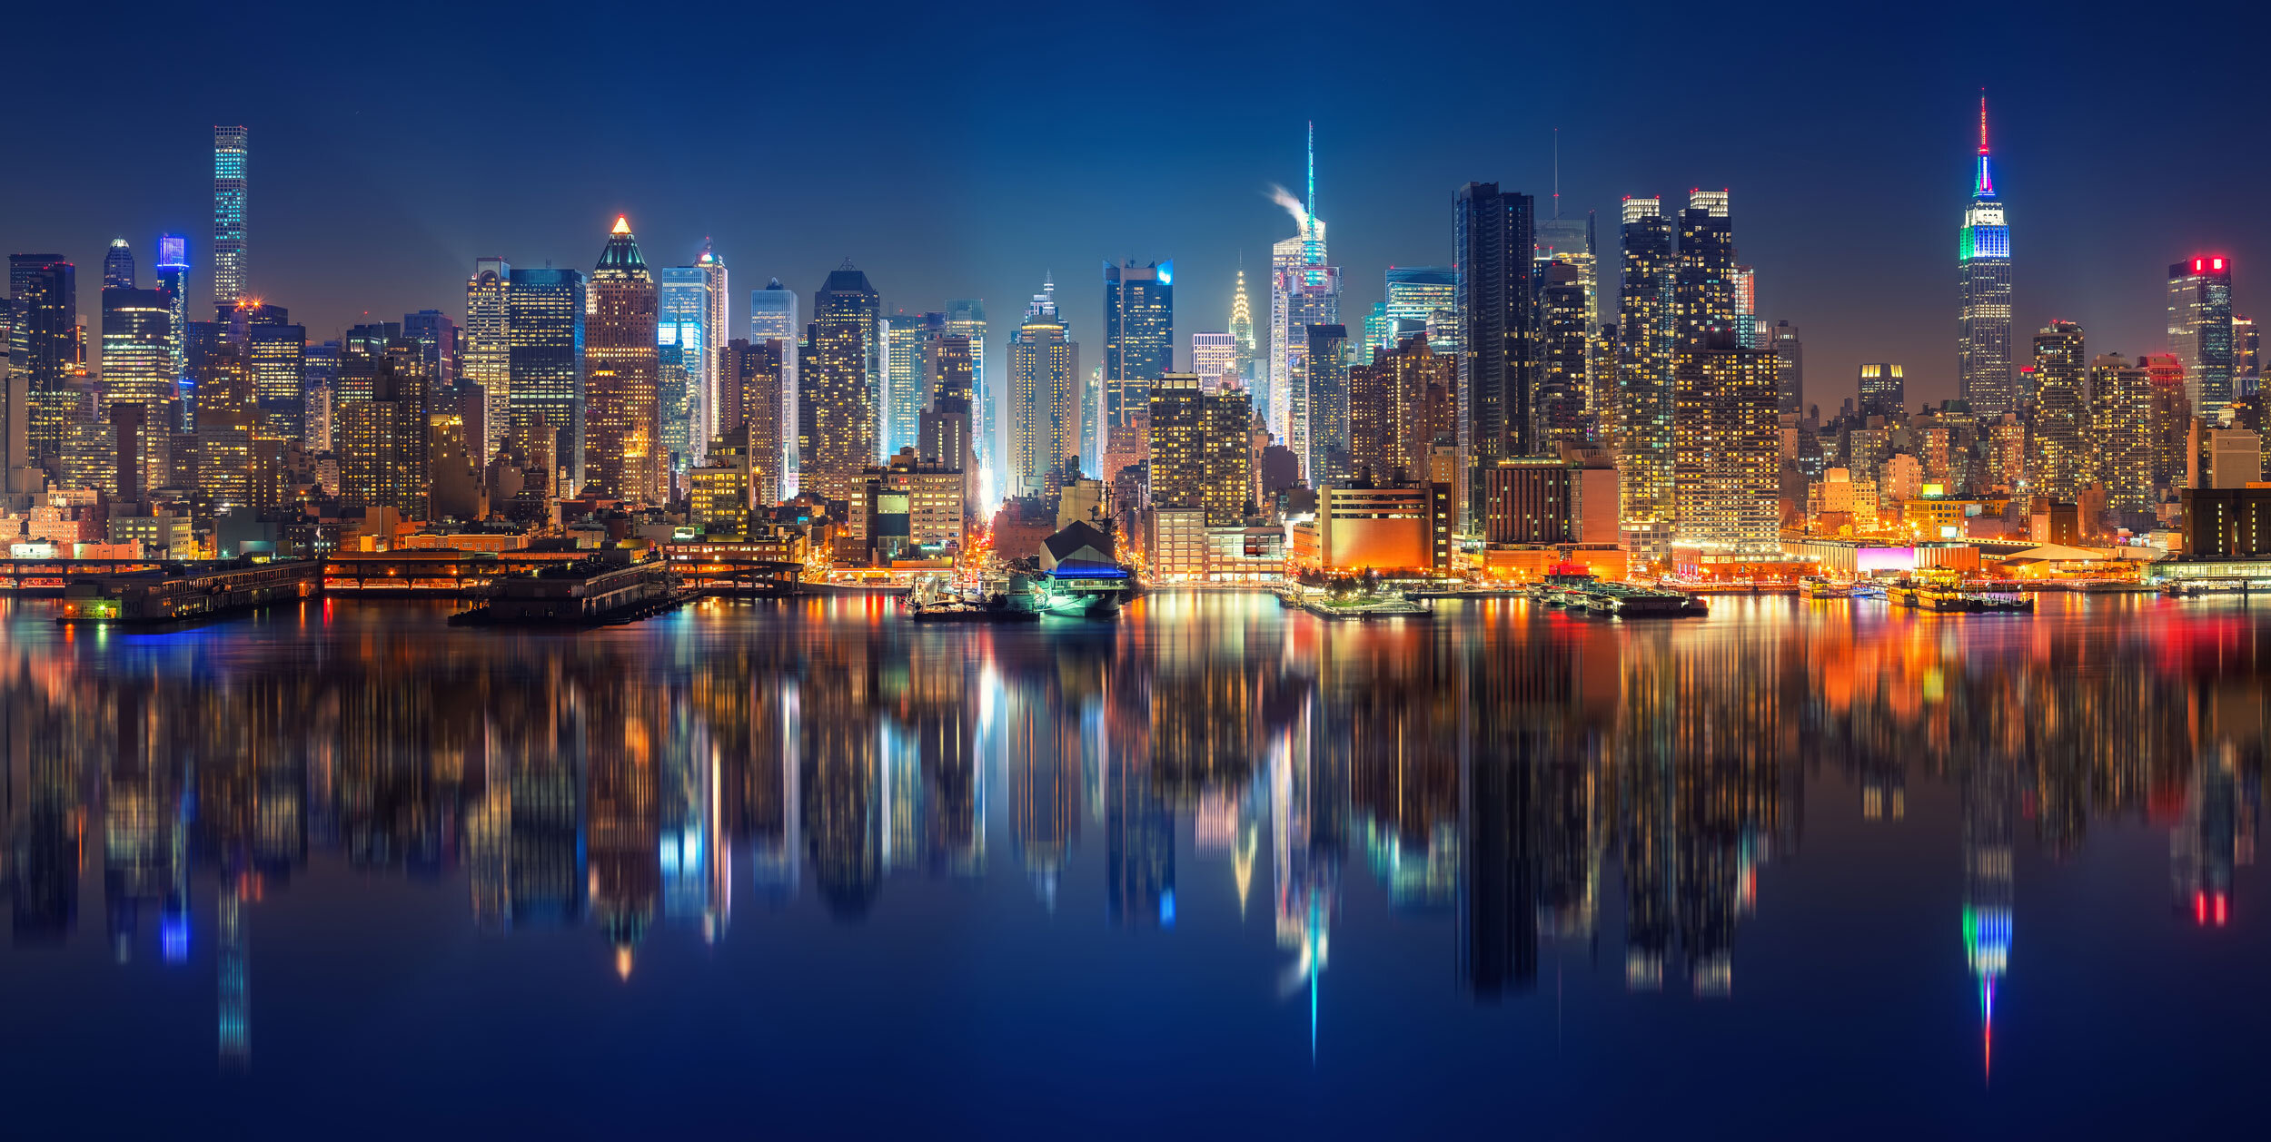

**Introduction:**

**Problem Background:**

New York City, often called simply New York and abbreviated as NYC, is the [most populous city](https://en.wikipedia.org/wiki/List_of_United_States_cities_by_population) in the [United States](https://en.wikipedia.org/wiki/United_States). With an estimated 2019 population of 8,336,817 distributed over about 302.6 square miles (784 km2), New York is also the [most densely populated](https://en.wikipedia.org/wiki/List_of_United_States_cities_by_population_density) major city in the United States.[[6]](https://en.wikipedia.org/wiki/New_York_City#cite_note-2019estimate-6) Located at the southern tip of the [U.S. state](https://en.wikipedia.org/wiki/U.S._state) of [New York](https://en.wikipedia.org/wiki/New_York_(state)), the city is the center of the [New York metropolitan area](https://en.wikipedia.org/wiki/New_York_metropolitan_area), the largest [metropolitan area](https://en.wikipedia.org/wiki/Metropolitan_area) in the world by [urban landmass](https://en.wikipedia.org/wiki/Urban_area).[[10]](https://en.wikipedia.org/wiki/New_York_City#cite_note-10) With almost 20 million people in its [metropolitan statistical area](https://en.wikipedia.org/wiki/List_of_metropolitan_statistical_areas) and approximately 23 million in its [combined statistical area](https://en.wikipedia.org/wiki/List_of_Combined_Statistical_Areas), it is one of the world's most populous [megacities](https://en.wikipedia.org/wiki/Megacity). New York City has been described as the [cultural](https://en.wikipedia.org/wiki/Culture_of_New_York_City), financial, and media capital of the world, significantly influencing commerce,[[11]](https://en.wikipedia.org/wiki/New_York_City#cite_note-WorldEconomicAndFinancialSuperCenter-11) entertainment, research, technology, education, politics, tourism, art, fashion, and sports.

New York City is America’s classic immigrant city; it was the major historic gateway for the country’s eastern and southern European arrivals a century ago and is a major receiving center today. Its immigrant history, the composition and extraordinary diversity of its current immigrant streams, and its institutions have combined to make it an immigrant city like no other in the United States. New York’s contemporary immigrant population stands out for its extraordinary diversity. What is remarkable is the large number from so many different countries. In 2000, the top three groups—Dominicans, Chinese, and Jamaicans—were just under 30 percent of all the foreign-born. No other country accounted for more than five percent, and there were substantial numbers of many West Indian, Latin American, Asian, and European nationalities. The incredible ethnic diversity of New York’s immigrants is matched by the heterogeneity of their skills. The mixture of nationalities has ensured a mix of class and occupational origins. In 2000, nearly a quarter of foreign-born New Yorkers age 25 and older had a college degree; at the other end of the spectrum, 35 percent had not completed high school.

New York City, let aside it being the most diverse city of USA, it’s also a major point of entry for immigrants; the term "melting pot" was coined to describe densely populated immigrant neighbourhoods on the Lower East Side. As many as 800 languages are spoken in New York, making it the most linguistically diverse city in the world.

With its diverse culture, comes social, economic as well as cuisine diversity.

**Problem Description:**

* With advent globalisation people from varied background tend settle across diverse destinations of the world. We are considering the case New York City, the most diverse community of the world. Being the economic hub, it attracts people from varied background. A city with such a diversity needs to be explored in detail, this will be done in first part.
* For the second part, we will analyse three type of restaurants (Italian, Chinese and Indian) across NYC. The ability to eat and the enjoyment of eating are important aspects of good quality of life. In other words, “being able to eat what I want, when I want” makes us feel good. Hence restaurants are a major factor while selecting neighbourhood. Apart from that, the major events of life, personal and professional, are celebrated in restaurants. Acquaintances become friends around a table in the safe and controlled environment of a restaurant. Individuals become lovers across a restaurant table, sometimes. The aforementioned facts are some of the major inspiration towards analysing restaurants.

## For third part, we will be analysing the ease of commute across NYC in a simple way. We are assuming the person will use public transport.

## We will analyse the number of **Bus Stops** and **Metro Stations** in the neighbourhood of NYC. The case of cabs is excluded as their service can be acquired in even remote location. But the fact that they are about three to four times costlier as compared to metros and buses, leads us to believe that a normal person will prefer a metro or bus compared to taxi. It’s an inherent tendency of human to save money. And for daily commute buses and metros far too economical compared to their counterpart taxis. Who likes a spendthrift, right!! Nobody will be willing to pay more if other economical and convinient methods are available.

**This project will be divided into three parts:**

1. We will the exploring New York City
2. Exploring Restaurants around New York City (Italian, Chinese and Indian)
3. Exploring the ease of commute across New York City (Metros and Buses)

**Target audience for this project:**

* People looking for neighborhood to rent an apartment
* People looking for neighborhood based on cuisine
* People looking to open a restaurant
* People looking to explore the various venues that NYC provides

**To find the answers to the following questions:**

* Which neighbourhoods can be considered similar in NYC, show them in NYC map?
* Various types of venues in NYC?
* Number of Italian restaurants in NYC?
* what is best location in New York City for Italian Cuisine?
* Number of Chinese restaurants in NYC?
* what is best location in New York City for Chinese Cuisine?
* Number of Indian restaurants in NYC?
* what is best location in New York City for Indian Cuisine?
* what is best location in New York City considering Buses as the mode of transport?
* what is best location in New York City considering Metros as the mode of transport?

**Data Section:**

For this project uses following data:

* New York City data that contains list Boroughs, Neighbourhoods along with their latitude and longitude.
* Data source : <https://cocl.us/new_york_dataset>
* Description: we will use this data set to explore various neighbourhoods of New York City
* Venues in each neighbourhood of New York City.
* Data source : Foursquare API
* Description: By using this API we will get all the venues in each neighbourhood. We can filter these venues to get Italian, Indian and Chinese restaurants as well as various transportation system the city offers (Metros and Buses).
* GeoSpace data
* Data source : <https://data.cityofnewyork.us/City-Government/Borough-Boundaries/tqmj-j8zm>
* Description: By using this geo space data we will plot the NYC map with its neighbourhood, NYC map with neighbourhood grouped into clusters.