Demonstration: EE 302 Group 3

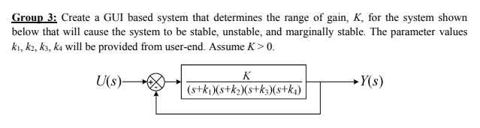

Example 1:

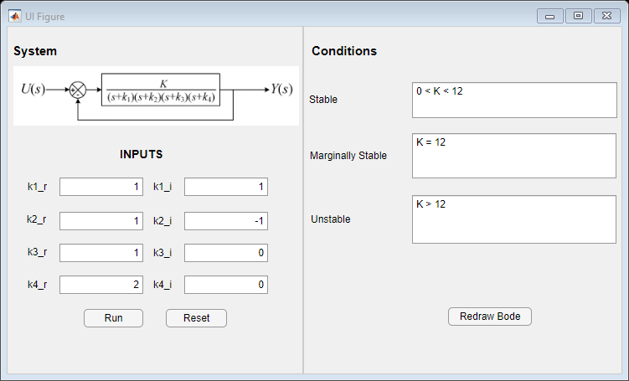

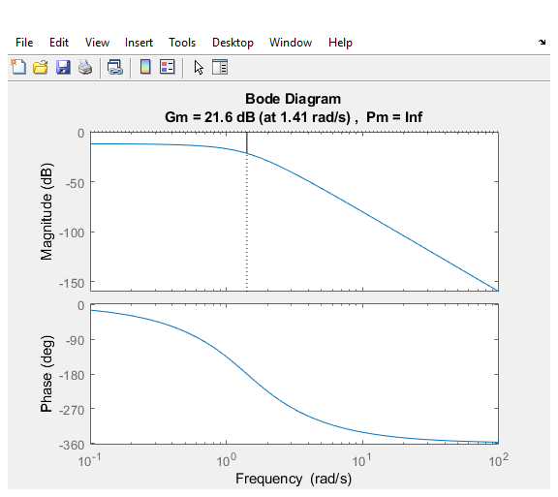

Example 2:

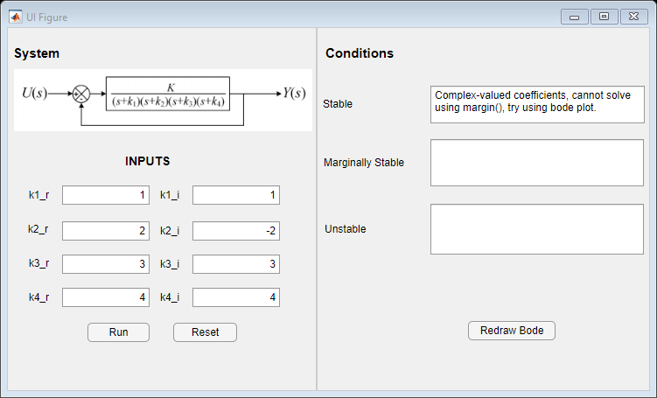

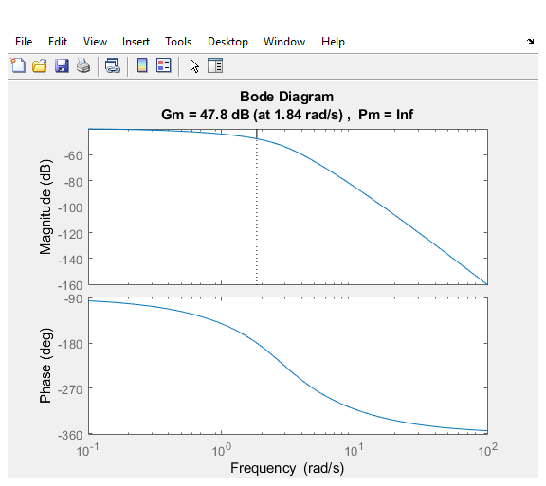

MATLAB limitation of using margin() function. Although we still get a plot from where we can see for K less than 47.8 dB (K = 245.47 in magnitude) system shall remain stable. Marginally stable at 245.47 and Unstable after that.

Example 3:

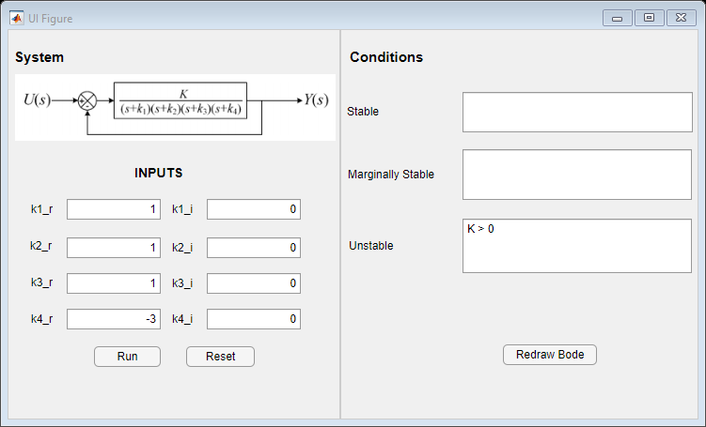

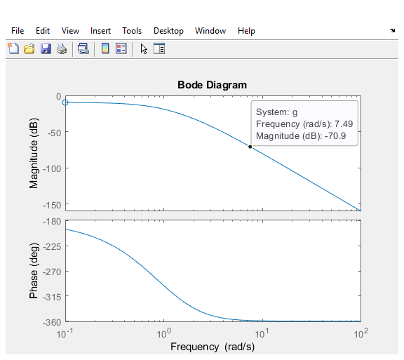

Clearly Phase margin is always negative. System is not stable for any applied gain.