User Manual for Android 2D Game

Question)How to install .apk file in your android mobile phone?

Answer:-App files (known as "APK" files) are useful if you want to install an app that isn't listed on the Google Play Store, but you'll have to enable installations from other sources on your Android before you can download and install an APK.Click on the link below

<https://www.wikihow.tech/Install-APK-Files-on-Android>

1. In Android version of the game

The player will be moving at some pace automatically.

* Tap on left side of the screen to change the colour of the square
* Tap on right side of the screen to jump

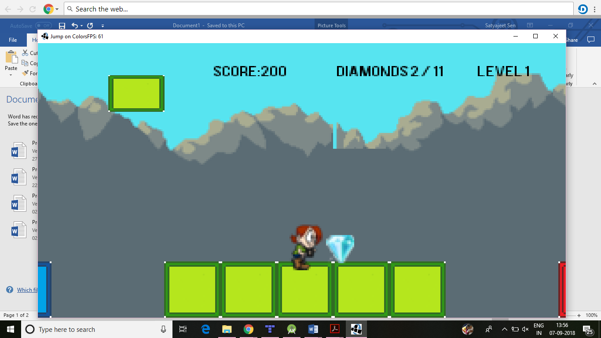

Game Play screen

1. In Desktop version of the game

Que)How to install or run game from JAR File?

Ans)Double-click the JAR File

* Press spacebar to jump from one platform to another
* Press Enter to change the colour of the square from blue to red to green

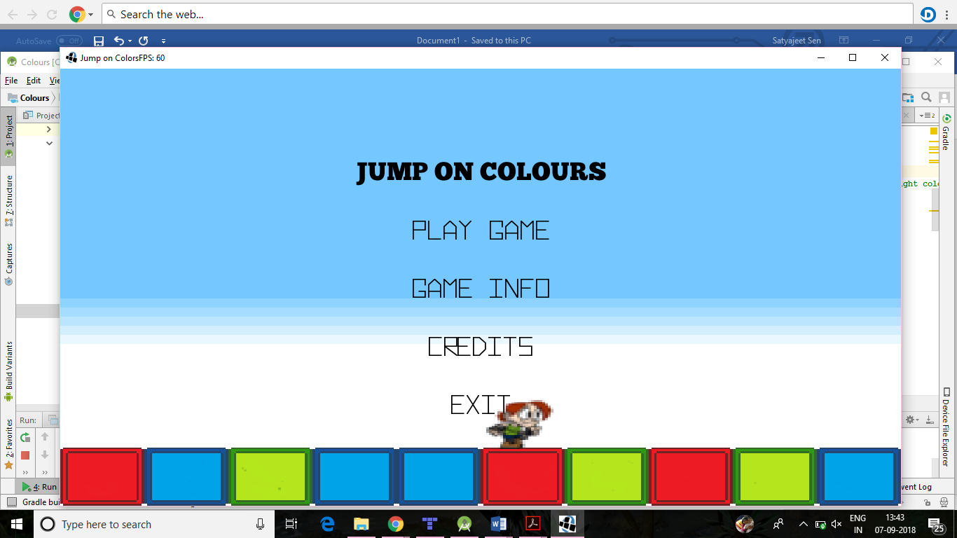

Menu screen

1)To Play the game, left click on the play button on the screen

2)To see information of the game about how to play the game in android, left click on the Game Info button on the screen.

3)To see the creditor of the game, left click on credits

4)To exit the game, left click on the exit button

To navigate to the main menu from game over screen click on the main menu

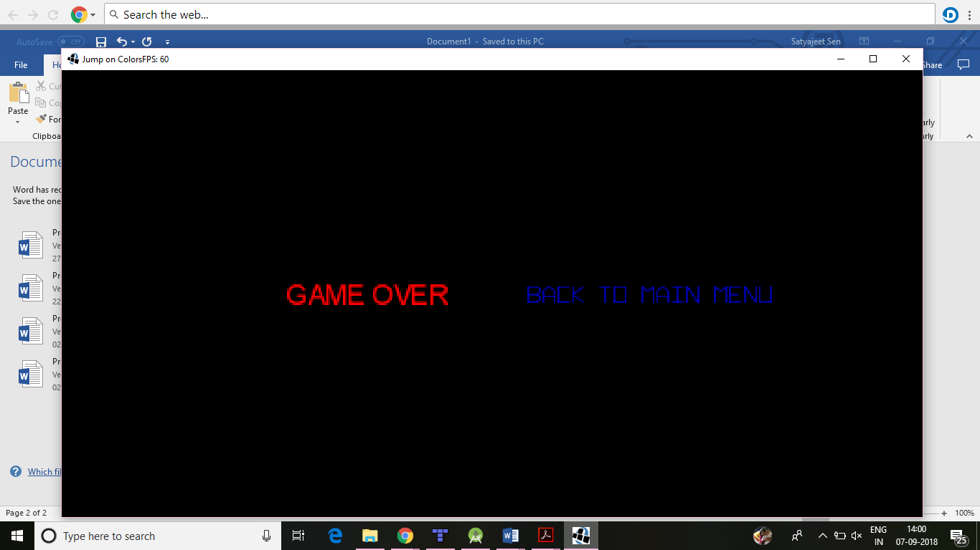

To navigate from the credits page to the main menu click anywhere on the screen.

To navigate from game-info page to the main menu click on back to the main menu