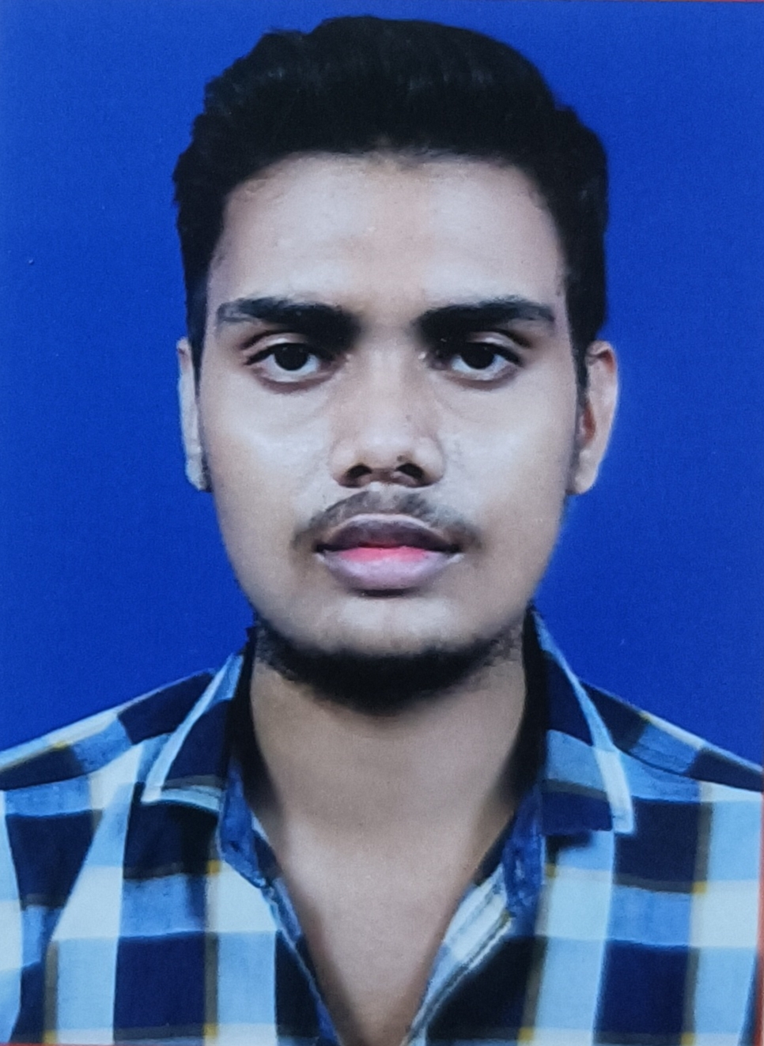
RESUME

SATYAJIT SAMANTARAY
S/o- Dusmanta kumar samantaray
At/Po-Goberdhanpur,Ps-Kujang
Dist-Jagatsinghpur, Pin-754160, Odisha
Mob-8144714191
Email ID – satyajitsamantaray555@gmail.com

OBJECTIVE :
Intend to build my career at an esteemed organization which would tell my knowledge, help to achieve my goals and to move ahead in this competitive world while being resourceful, innovative and flexible.

EDUCATIONAL QUALIFICATION :
- Passed +2 Science from Aurobindo institute of science and technology, Cuttack in the year 2023
- Passed H.S.C from Kalarabank high school, Cuttack in the year 2021
- P.G.D.CA, C LANGUAGE, JAVA From crack computer care, Cuttack

COMPUTER SKILLS :
- Well versed with MS Word, Excel, Power Point, Outlook and Windows 2007 , ,
PERSONAL TRAITS :

- Self motivated with a positive attitude.
- The ability to work in a team.
- Adaptable to the changes in my surroundings.
- I take initiative to improving the things and convince others to join me.
- Interested in exploiting my theoretical knowledge as practical.

PERSONAL DETAILS :
Name : Satyajit Samantaray
Father’s Name : Dusmanta Samantaray
Date of Birth : 26.04.2005
Marital Status : Unmarried
Languages Known : Oriya, Hindi & English,
Nationality : Indian
Religion : Hindu
Gender : Male

DECLARATION :
I consider myself fit and efficient for all type of situations and conditions. I am also confident of my ability to work in a team as I have proved it in my school, college and work field.

I hereby declare that the information furnished above is true to the best of my knowledge.

Place: Jagatsinghpur
Date:
Satyajit Samantaray

