SATYAJIT DAS

16IT8020

import numpy as np

if __name__ == "__main__":

print("Enter the number of sources: ")

sources = int(input().strip())

print("Enter the number of destinations: ")

destins = int(input().strip())

cost = np.zeros((sources, destins))

print("Enter the cost matrix: ")

for i in range(sources):

for j in range(destins):

cost[i][j] = int(input().strip())

supply = []

demand = []

tot_supply = 0

tot_demand = 0

print("Enter the supply capacaties: ")

for i in range(sources):

supply.append(int(input().strip()))

tot_supply = tot_supply + supply[i]

print("Enter the demands: ")

for j in range(destins):

demand.append(int(input().strip()))

tot_demand = tot_demand + demand[j]

if tot_demand != tot_supply:

print("The model is not balanced!")

exit()

i = 0

j = 0

allocations = np.zeros((sources, destins))

tot_cost = 0

while(i < sources and j < destins):

allocate = min(supply[i], demand[j])

allocations[i][j] = allocate

supply[i] = supply[i] - allocate

demand[j] = demand[j] - allocate

tot_cost = tot_cost + allocate*cost[i][j]

if supply[i] == 0:

i = i + 1

elif demand[j] == 0:

j = j + 1

print("Allocations made: ")

print(allocations)

print("Total cost of allocations: ", tot_cost)

SATYAJIT DAS

16IT8020

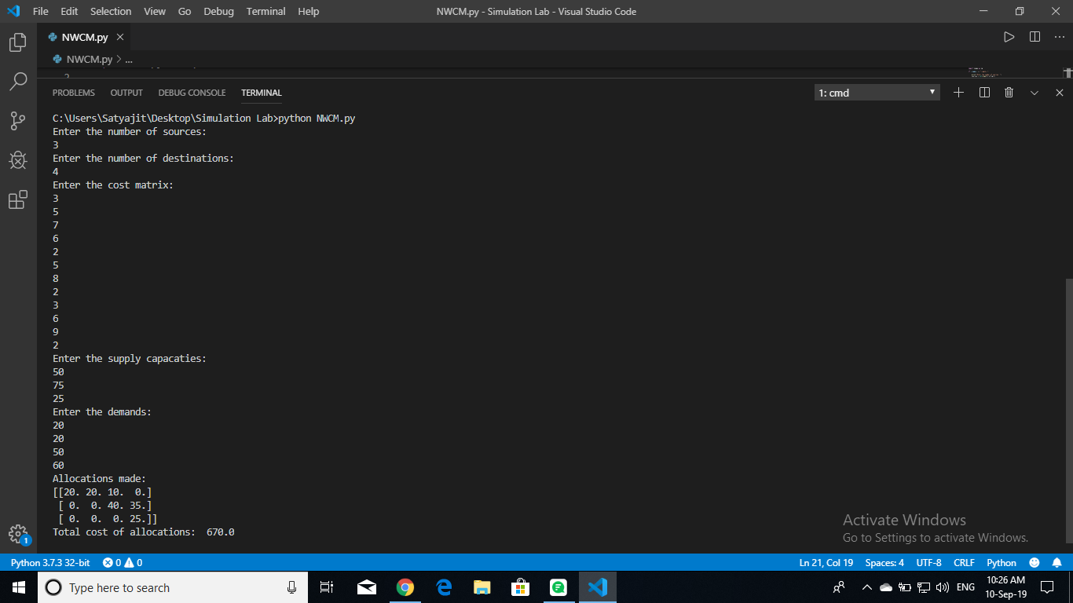

SATYAJIT DAS

16IT8020

import numpy as np

def find_min(allocations, cost, supply, demand):

A_i = -1

A_j = -1

min_cost = 100000

allocate = 0

for i in range(len(supply)):

for j in range(len(demand)):

if demand[j] == 0 or supply[i] == 0 or allocations[i][j] != 0:

continue

if cost[i][j] < min_cost:

min_cost = cost[i][j]

A_i = i

A_j = j

allocate = min(supply[i], demand[j])

elif cost[i][j] == min_cost and allocate < min(supply[i], demand[j]):

allocate = min(supply[i], demand[j])

A_i = i

A_j = j

return [A_i, A_j]

if __name__ == "__main__":

print("Enter the number of sources: ")

sources = int(input().strip())

print("Enter the number of destinations: ")

destins = int(input().strip())

cost = np.zeros((sources, destins))

print("Enter the cost matrix: ")

for i in range(sources):

for j in range(destins):

cost[i][j] = int(input().strip())

supply = []

demand = []

tot_supply = 0

tot_demand = 0

print("Enter the supply capacaties: ")

for i in range(sources):

supply.append(int(input().strip()))

tot_supply = tot_supply + supply[i]

print("Enter the demands: ")

for j in range(destins):

demand.append(int(input().strip()))

tot_demand = tot_demand + demand[j]

if tot_demand != tot_supply:

print("The model is not balanced!")

exit()

allocations = np.zeros((sources, destins))

tot_cost = 0

while tot_demand > 0 and tot_supply > 0:

idx = find_min(allocations, cost, supply, demand)

allocations[idx[0]][idx[1]] = min(supply[idx[0]], demand[idx[1]])

tot_cost = tot_cost + allocations[idx[0]][idx[1]]*cost[idx[0]][idx[1]]

supply[idx[0]] = supply[idx[0]] - allocations[idx[0]][idx[1]]

demand[idx[1]] = demand[idx[1]] - allocations[idx[0]][idx[1]]

tot_demand = tot_demand - allocations[idx[0]][idx[1]]

tot_supply = tot_supply - allocations[idx[0]][idx[1]]

print("Allocations: ")

print(allocations)

print("Total cost of allocation: ", tot_cost)

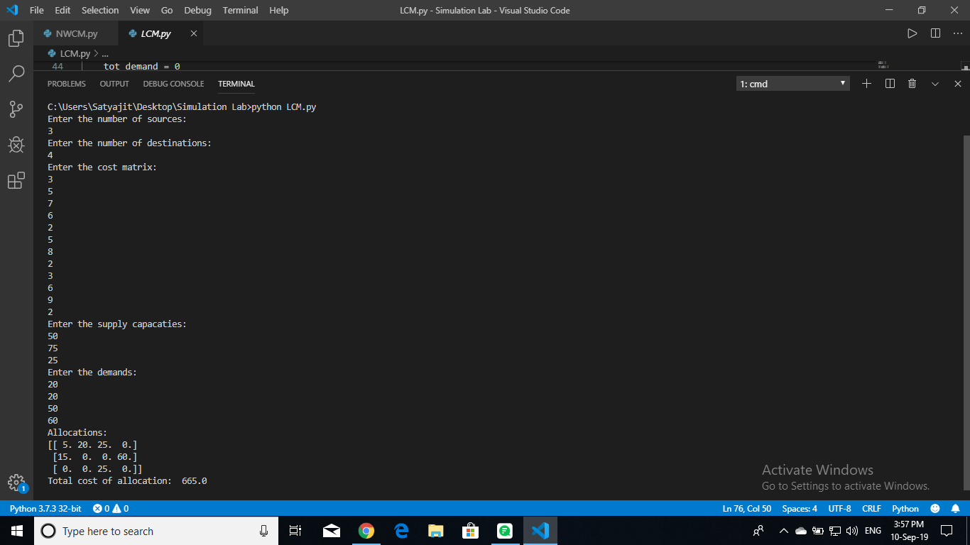

SATYAJIT DAS

16IT8020

SATYAJIT DAS

16IT8020

import numpy as np

def min_row(mat, row, n, penality_col):

    idx = -1

    val = 100000

    for i in range(n):

        if mat[row][i] < val and penality_col[i] != -1:

            val = mat[row][i]

            idx = i

    return idx

def min_2_row(mat, row, n, min_idx, penality_col):

    idx = -1

    val = 100000

    for i in range(n):

        if mat[row][i] <= val and i != min_idx and penality_col[i] != -1:

            val = mat[row][i]

            idx = i

    return idx

def min_col(mat, col, m, penality_row):

    idx = -1

    val = 100000

    for i in range(m):

        if mat[i][col] < val and penality_row[i] != -1:

            val = mat[i][col]

            idx = i

    return idx

def min_2_col(mat, col, m, min_idx, penality_row):

    idx = -1

    val = 100000

    for i in range(m):

        if mat[i][col] <= val and i != min_idx and penality_row[i] != -1:

            val = mat[i][col]

            idx = i

    return idx

def max_p(penality):

    idx = 0

    val = penality[0]

    for i in range(1, len(penality)):

        if val < penality[i]:

            idx = i

            val = penality[i]

    return idx

def tot_cost(alloc, cost, m, n):

    t_cost = 0

    for i in range(m):

        for j in range(n):

            t_cost += alloc[i][j] * cost[i][j]

    return t_cost

if __name__ == "__main__":

    print("Enter no. of sources and destinations: ")

    m, n = input().strip().split(' ')

    m = int(m)

    n = int(n)

    mat = np.zeros((m,n))

    alloc = np.zeros((m,n))

    print("Enter cost matrix: ")

    for i in range(m):

        for j in range(n):

            mat[i][j] = int(input())

    demand = []

    t_sum = 0

    print("Enter the demand: ")

    for i in range(n):

        demand.append(int(input()))

        t_sum += demand[i]

    supply = []

    print("Enter the supply: ")

    for i in range(m):

        supply.append(int(input()))

        t_sum -= supply[i]

    if t_sum != 0:

        print("Unbalanced problem")

        exit()

    penality_row = [0 for _ in range(m)]

    penality_col = [0 for _ in range(n)]

    loop = m + n - 1

    while(loop):

        # row

        for i in range(m):

            if penality_row[i] == -1:

                continue

            min_idx = min_row(mat, i, n, penality_col)

            min_2_idx = min_2_row(mat, i, n, min_idx, penality_col)

            if min_2_idx == -1:

                penality_row[i] =  mat[i][min_idx]

            else:

                penality_row[i] = mat[i][min_2_idx] - mat[i][min_idx]

        # column

        for j in range(n):

            if penality_col[j] == -1:

                continue

            min_idx = min_col(mat, j, m, penality_row)

            min_2_idx = min_2_col(mat, j, m, min_idx, penality_row)

            if min_2_idx == -1:

                penality_col[j] = mat[min_idx][j]

            else:

                penality_col[j] = mat[min_2_idx][j] - mat[min_idx][j]

        r_p = max_p(penality_row)

        c_p = max_p(penality_col)

        if(penality_row[r_p] >= penality_col[c_p]):

            r_min = min_row(mat, r_p, n, penality_col)

            alloc[r_p][r_min] = min(supply[r_p], demand[r_min])

            supply[r_p] -= alloc[r_p][r_min]

            demand[r_min] -= alloc[r_p][r_min]

            if supply[r_p] == 0:

                penality_row[r_p] = -1

            elif demand[r_min] == 0:

                penality_col[r_min] = -1

        else:

            c_min = min_col(mat, c_p, m, penality_row)

            alloc[c_min][c_p] = min(supply[c_min], demand[c_p])

            supply[c_min] -= alloc[c_min][c_p]

            demand[c_p] -= alloc[c_min][c_p]

            if supply[c_min] == 0:

                penality_row[c_min] = -1

            elif demand[c_p] == 0:

                penality_col[c_p] = -1

        loop -= 1

    print("Allocation made: ")

    print(alloc)

    print("Min. cost: ", tot_cost(alloc, mat, m, n))

SATYAJIT DAS

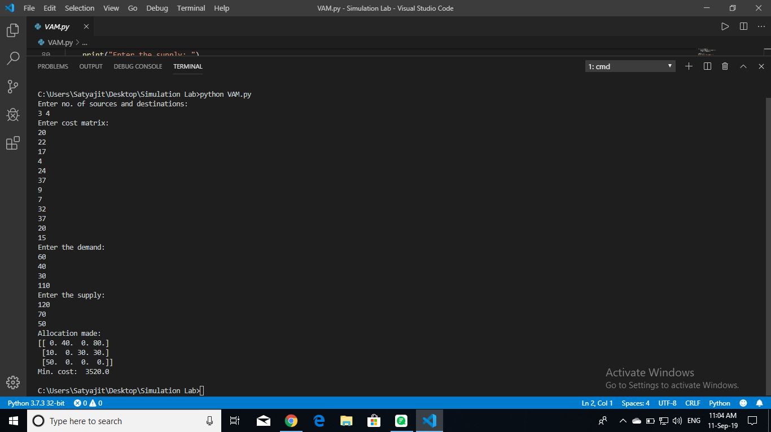16IT8020

SATYAJIT DAS

16IT8020

import numpy as np

from math import isnan

def get_an_occupied_cell(allocs, i, j):

    try:

        if (allocs[i][j + 1] != 0):

            return i, j+1

    except IndexError:

        pass

    try:

        if (allocs[i+1][j] != 0):

            return i+1, j

    except IndexError:

        pass

    try:

        if (allocs[i-1][j] != 0):

            return i-1, j

    except IndexError:

        pass

    try:

        if (allocs[i][j-1] != 0):

            return i, j-1

    except IndexError:

        pass

    return -1, -1

def create_cycle(allocs, neg_i, neg_j):

    cycle_coordinates = []

    i, j = get_an_occupied_cell(allocs, neg_i, neg_j)

    print("@", i, j)

    while i != neg_i or j != neg_j:

        if i == -1 or j == -1:

            raise Exception("Couldn't find another cell")

        cycle_coordinates.append((i, j))

        i, j = get_an_occupied_cell(allocs, i, j)

    print("%", cycle_coordinates)

    return cycle_coordinates

def get_min_in_cycle(allocs, cycle_coordinates):

    min = 0

    for i in cycle_coordinates:

        if min > allocs[i[0]][i[1]]:

            min = allocs[i[0]][i[1]]

    return min

def modify_cycle(allocs, cycle_coordinates):

    t = 1

    min = get_min_in_cycle(allocs, cycle_coordinates)

    for x, y in cycle_coordinates:

        allocs[x][y] = min + int(t * allocs[x][y])

        if t == 1:

            t = -1

        else:

            t = 1

def get_all_allocated_coordinates(allocs):

    coordinates = []

    for i in range(len(allocs)):

        for j in range(len(allocs[0])):

            if allocs[i][j] > 0:

                coordinates.append((i, j))

    return coordinates

def isAnyNan(l):

    for i in l:

        if isnan(i):

            return True

    return False

def get_uv(costs, allocs):

    u = []

    v = []

    for _ in costs:

        u.append(float('nan'))

    for _ in costs[0]:

        v.append(float('nan'))

    u[0] = 0

    coordinates = get_all_allocated_coordinates(allocs)

    stopLoopCount = 0

    while isAnyNan(u) or isAnyNan(v):

        stopLoopCount += 1

        for x, y in coordinates:

            if not isnan(u[x]) and isnan(v[y]):

                v[y] = costs[x][y] - u[x]

            elif isnan(u[x]) and not isnan(v[y]):

                u[x] = costs[x][y] - v[y]

        if stopLoopCount % 100 == 0:

            ans = input("Loop ran for {0} times. Do you want to continue? [y] ".format(stopLoopCount))

            if ans != 'y':

                break

    return u, v

def isValid(costs, allocs, u, v):

    min_val = 1000000000000000

    min_x = -1

    min_y = -1

    #print(u, v)

    for i in range(len(costs)):

        for j in range(len(costs[0])):

            if allocs[i][j] == 0:

                x = costs[i][j] - u[i] - v[j]

                #print('#', x, i, j)

                if x < min_val:

                    min_val = x

                    min_x, min_y = i, j

    if (min_val < 0):

        return min_x, min_y

    else:

        return -1, -1

if __name__ == '__main__':

    costs = []

    allocs = []

    rows_count = int(input("Enter rows: "))

    print("Enter the cost matrix: ")

    for i in range(rows_count):

        costs.append(list(map(int, input().strip().split(' '))))

    print("Enter the allocation matrix: ")

    for i in range(rows_count):

        allocs.append(list(map(int, input().strip().split(' '))))

    u, v = get_uv(costs, allocs)

    x, y = isValid(costs, allocs, u, v)

    while x != -1 and y != -1:

        cycle_coordinates = create_cycle(allocs, x, y)

        modify_cycle(allocs, cycle_coordinates)

        print("  ##  ")

        print(u, v)

        print(x, y)

        print(cycle_coordinates)

        print(allocs)

        print("  ##  ")

        ans = input("Continue? [y]")

        if ans != 'y':

            break

        u, v = get_uv(costs, allocs)

        x, y = isValid(costs, allocs, u, v)

    print("\nOptimal solution: ")

    print(np.array(allocs))

print("Min. cost: ", tot_cost(allocs, costs, rows_count, len(costs[0])))

SATYAJIT DAS

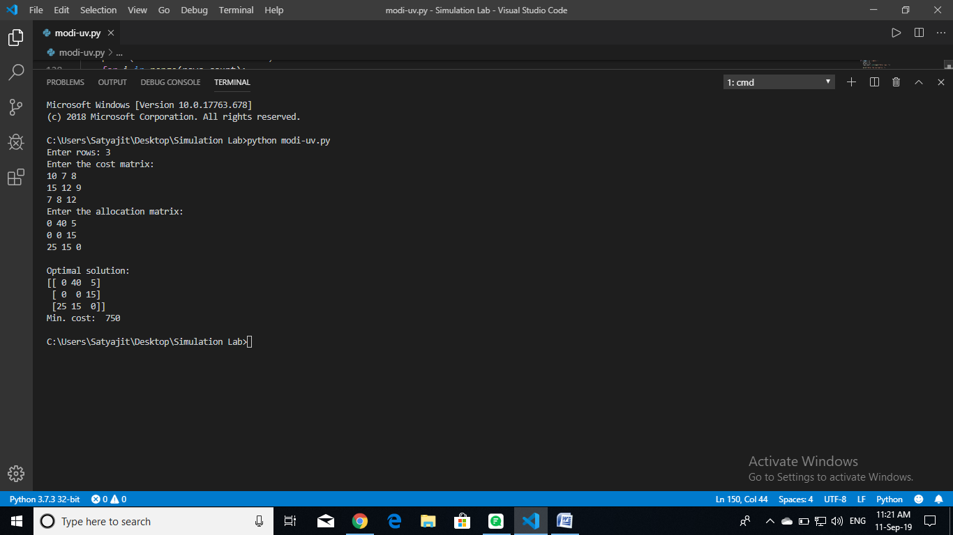16IT8020