

|  |  |
| --- | --- |
| **ASSIGNMENT** | |
| **Course Code** | BSC101A |
| **Course Name** | Engineering Mathematics – 1 |
| **Programme** | B.Tech |
| **Department** | Mathematics |
| **Faculty** |  |

#### 

|  |  |
| --- | --- |
| **Name of the Student** | Satyajit Ghana |
| **Reg. No** | 17ETCS002159 |
| **Semester/Year** | 1st - 2017 |
| **Course Leader/s** |  |

|  |  |  |  |  |  |  |  |  |
| --- | --- | --- | --- | --- | --- | --- | --- | --- |
| **Declaration Sheet** | | | | | | | | |
| Student Name |  | | | | | | | |
| Reg. No |  | | | | | | | |
| Programme |  | | | | | Semester/Year |  | |
| Course Code |  | | | | | | | |
| Course Title |  | | | | | | | |
| Course Date |  | | to | |  | | | |
| Course Leader |  | | | | | | | |
| **Declaration**  The assignment submitted herewith is a result of my own investigations and that I have conformed to the guidelines against plagiarism as laid out in the Student Handbook. All sections of the text and results, which have been obtained from other sources, are fully referenced. I understand that cheating and plagiarism constitute a breach of University regulations and will be dealt with accordingly. | | | | | | | | |
| Signature of the Student | |  | | | | | Date |  |
| Submission date stamp  (by Examination & Assessment Section) | |  | | | | | | |
| Signature of the Course Leader and date | | | | Signature of the Reviewer and date | | | | |
|  | | | |  | | | | |

# **Contents**

____________________________________________________________________________

**Declaration Sheet** ii

**Contents** iii

**List of Tables** v

**List of Figures** vi

**List of Symbols** vii

**Question No. 1** 8

A.1 Description of the concept of Riemann sum using the three methods: left rectangles, right rectangles and mid-point rectangles with an example: 8

A.2 Description of the geometrical meaning of Riemann sums with sketch of the left rectangles, right rectangles and mid-point rectangles using an example: 9

A.3 MATLAB function to compute the Riemann sum using left rectangles, right rectangles and mid-point rectangles. 11

A.4 Comparison of the results of the above three methods and conclusion. 11

**Question No. 2** 12

B1.1 Compute velocity and acceleration at $t= π2$ and $= 3π2$: 12

B1.2 Plot the graph of displacement curve: 13

B1.3 Show that the particle comes to rest at least once before attaining uniform velocity 14

B1.4 Conclude and comment on the results 15

**Question No. 3** 16

B2.1 Obtain the Maclaurin series for the kinetic energy as a function of the velocity: 16

B2.2 Show that when v is very small compared to c, the expression for K agrees with the classical Newtonian physics by $K=12m0v2$: 18

B2.3 Comment on the results and conclude. 18

**Question No. 4** 19

B3.1 Choose any algorithm to search the index of a given element in vector X and explain: 19

B3.2 Write a MATLAB function to implement the above chosen algorithm. The function should accept the array and an element as input and should output the index of that element in the given array: 20

B3.3 Use MATLAB built-in function ‘find’ to search the index of the required element. Compare and comment on the results: 20

**Question No. 5** 21

B4.1 Obtain Equations for the temperature at the four intersection points: 21

B4.2 Solve the resultant system to find the temperature at each intersection point in the grid: 21

B4.3 Write a MATLAB script to check for the consistency of the system and obtain the solution. 22

B4.4 Comment on the results obtained and conclude 24

# **List of Tables**

**____________________________________________________________________________**

|  |  |  |
| --- | --- | --- |
| **Table No.** | **Title of the table** | **Pg.No.** |
| Table 1.1 | Title of the table | 12 |
| Table 1.2 | Title of the table | 14 |
| Table 2.1 | Title of the table | 18 |
|  |  |  |

< The table numbers have to be based on the chapter number>

# **List of Figures**

____________________________________________________________________________

|  |  |  |
| --- | --- | --- |
| **Figure No.** | **Title of the figure** | **Pg.No.** |
| Figure 1.1 | Title of the figure | 13 |
| Figure 1.2 | Title of the figure | 15 |
| Figure 2.1 | Title of the figure | 19 |
|  |  |  |

< The Figure numbers have to be based on the chapter number>

# **List of Symbols**

____________________________________________________________________________

|  |  |  |
| --- | --- | --- |
| **Symbol** | **Description** | **Units** |
| A | Current | Amp |
| g | Acceleration due to gravity - 9.81 | m/s2 |
| V | Voltage | Volts |
| w | Width | mm |
|  |  |  |

< Arrange in alphabetical order>

# **Question No. 1**

**Solution to Question No. 1 Part A:**

## A.1 Description of the concept of Riemann sum using the three methods: left rectangles, right rectangles and mid-point rectangles with an example:

The Riemann Sum can be interpreted as one of a method that helps to approximate the area under a given curve $f(x)$, Riemann achieves this by diving the area under the function into shapes like rectangles, trapezoids, parabolas, etc. and then finding the sum of these shapes.

$f(x)$

$Area under the curve = \sum_{i=1}^{n}{f\left(x_{i}\right)∆x_{i}}$

$∆x$

Given a function $f\left(x\right),$ for which the area under the curve of $f\left(x\right)$ is to be calculated under the interval

$a≤x≤b$

We define $∆x$ such that $∆x=\frac{b-a}{n}$, hence the interval $[a,b]$ is essentially is divided into $n$ parts, now as the value of $n$ increases or $\lim_{n→ ∞}{∆x}→0$ the Riemann sum obtained is more close the original integral, i.e.

$$\int_{a}^{b}{f\left(x^{*}\right)dx}= \lim_{∆x→0}{\sum_{i=0}^{n}{f\left(x_{i}\right)∆x}= ∆x(f\left(x_{0}\right)+f\left(x_{1}\right) + . . . . . +f(x_{n}))}$$

The integral sign $∫$ refers to sum like notation just like the summation sign $Σ$,the only difference is that integration is the sum over an infinite number of terms which is evident as our $∆x$ approaches 0 we will have infinite number of terms for which summation is to be calculated or simply integrated.

The collections of points ${\{x}_{0}, x_{1}, x_{2}, x_{3}. . . .x_{n}\}$ is known as the partition of $[a,b]$

1. Left rectangles
$$Approximation of\int_{a}^{b}{f\left(x\right)dx}= \sum_{i=0}^{n-1}{f\left(x_{i}\right)∆x}= ∆x(f\left(x_{0}\right)+f\left(x_{1}\right) + . . . . . +f(x_{n-1}))$$

2. Right rectangles
$$Approximation of\int_{a}^{b}{f\left(x\right)dx}= \sum_{i=1}^{n}{f\left(x_{i}\right)∆x}= ∆x(f\left(x_{1}\right)+f\left(x_{2}\right) + . . . . . +f(x_{n}))$$

3. Mid-Point rectangles

$$Approximation of\int_{a}^{b}{f\left(x\right)dx}= \sum_{i=1}^{n}{f\left(\overline{x_{i}}\right)∆x}= ∆x(f\left(\overline{x_{1}}\right)+f\left(\overline{x_{2}}\right) + . . . . . +f(\overline{x_{n}}))$$

Where $\overline{x_{i}}$ represents the midpoint of the interval i.e. $\frac{{(x}_{i}+x_{i-1})}{2}$

## A.2 Description of the geometrical meaning of Riemann sums with sketch of the left rectangles, right rectangles and mid-point rectangles using an example:

Riemann Sums, in a geometric way can be interpreted as breaking up the given function $f(x)$ into the same shape, either rectangles or trapezoids, then finding the sum of these shapes, the resultant will be the area under the curve $f(x)$, an observation can be made that this is an approximation and not the exact value, but as the number of shape slices of the function increase the sum of slices approaches more and more close to the exact value of the area under the curve.

Let’s consider the function $f\left(x\right)= \sqrt{x}$ in the interval $0≤x≤5$ for which we would like to compute the Riemann sum, taking $n=5$, $∆x=\frac{5-0}{5}=1$

1. Left rectangles

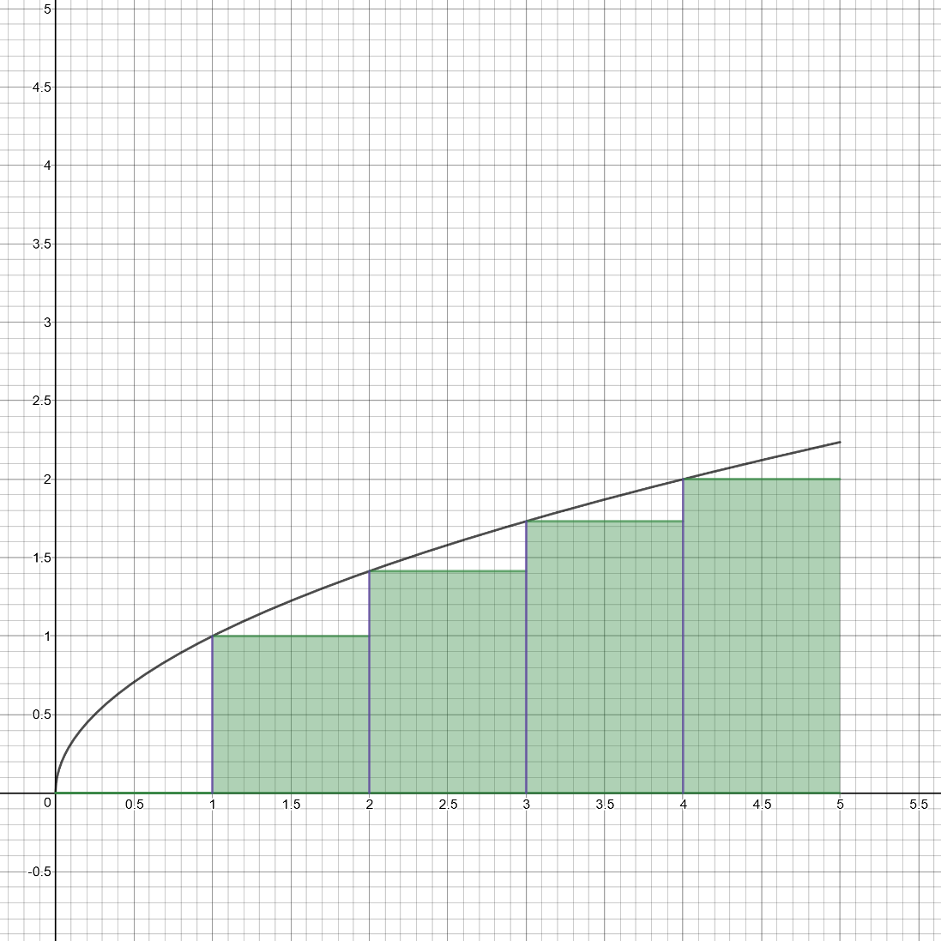

Figure A.1 left rectangles Riemann sum

$$f\left(0\right)×1= \sqrt{0}=0.000000000$$

$$f\left(1\right)×1= \sqrt{1}=1.000000000$$

$$f\left(2\right)×1= \sqrt{2}=1.414213562$$

$$f\left(3\right)×1= \sqrt{3}=1.732050808$$

$$f\left(4\right)×1= \sqrt{4}=2.000000000$$

$$\sum_{i=0}^{n-1}{f(x_{i})∆x}=6.146264370$$

1. 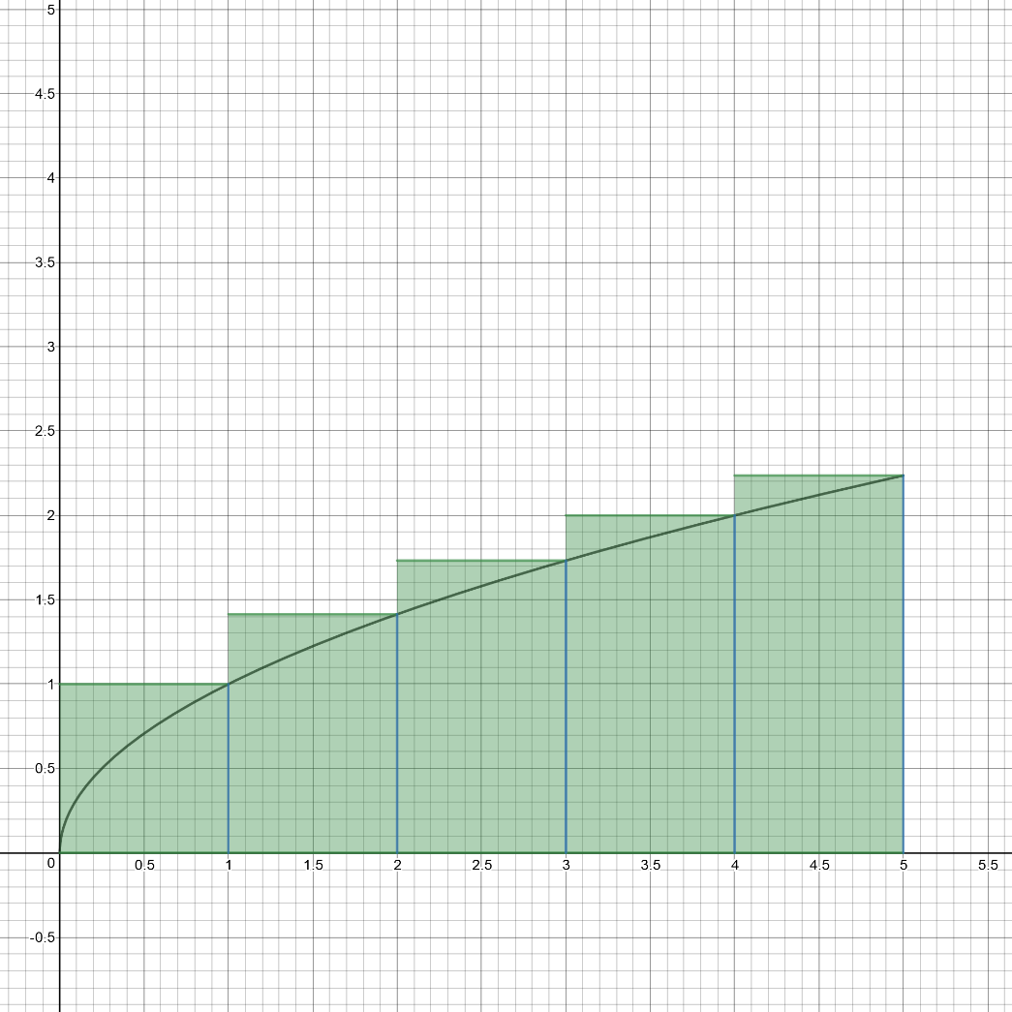Right rectangles

Figure A.2 right rectangles Riemann sum

$$f\left(1\right)×1= \sqrt{1}=1.000000000$$

$$f\left(2\right)×1= \sqrt{2}=1.414213562$$

$$f\left(3\right)×1= \sqrt{3}=1.732050808$$

$$f\left(4\right)×1= \sqrt{4}=2.000000000$$

$$f\left(5\right)×1= \sqrt{5}=2.236067977$$

$$\sum_{i=1}^{n}{f(x_{i})∆x}=8.382332347$$

1. 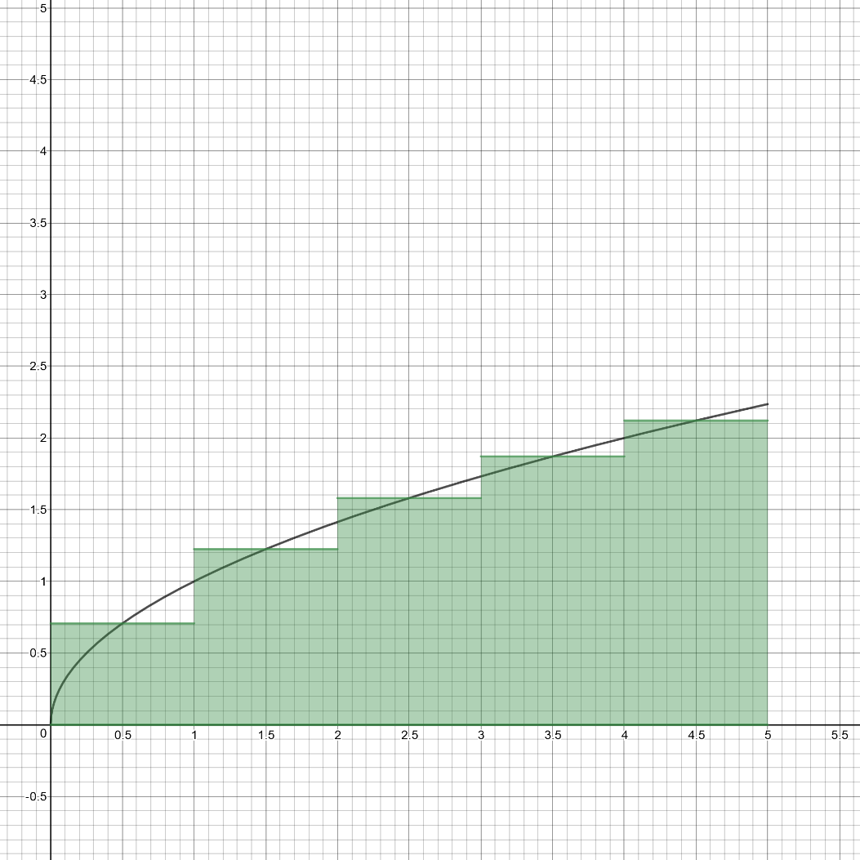Mid-Point rectangles

$$f\left(0.5\right)×1= \sqrt{0.5}=0.707106781$$

$$f\left(1.5\right)×1= \sqrt{1.5}=1.224744871$$

$$f\left(2.5\right)×1= \sqrt{2.5}=1.581138830$$

$$f\left(3.5\right)×1= \sqrt{3.5}=1.870828693$$

$$f\left(4.5\right)×1= \sqrt{4.5}=2.121320344$$

$$\sum_{i=1}^{n}{f(\overline{x_{i}})∆x}=7.505139520$$

Figure A.3 middle-point rectangles Riemann sum

## A.3 MATLAB function to compute the Riemann sum using left rectangles, right rectangles and mid-point rectangles.



## A.4 Comparison of the results of the above three methods and conclusion.

All the three methods approximately compute the area under the curve of $f(x)$, from the observations made in A.2 , left rectangle Riemann Sums is underestimating if $f$ is a monotonically increasing and overestimating if $f$ is a monotonically decreasing function.

The right rectangle Riemann Sums is overestimating for if $f$ is monotonically increasing and underestimating if $f$ is monotonically decreasing.

The middle rectangle Riemann Sums is more closer to the actual area under the curve.

Another observation to make is that as the number of partitions increase all the three type of sumations, namely left rectangle Riemann Sum, right rectangle Riemann Sum and middle rectangle Riemann sums converge to the actual area under the curve $f(x)$.

# **Question No. 2**

**Solution to Question No. 1 Part B:**

## B1.1 Compute velocity and acceleration at $t= \frac{π}{2}$ and $= \frac{3π}{2}$:

Given the Displacement as a function of time, the equation of velocity can be computed by finding the derivative of $s(t)$, using the fact that velocity is change is displacement over time, i.e. $v\left(t\right)= \frac{d s(t)}{dt}$.

Hence

$$v\left(t\right)= \frac{1}{2}\frac{d\left(t^{2}+5tsin t\right)}{dt}$$

$$v(t)= \frac{1}{2} (2t+5\sin{t}+5tcos t)$$

$$v\left(t\right) |_{t=\frac{π}{2}}= \frac{1}{2} (2×\frac{π}{2} + 5×\sin{\frac{π}{2}}+5×\frac{π}{2}×\cos{\frac{π}{2}})$$

$$v\left(t\right) |_{t=\frac{π}{2}}=\frac{5+ π}{2}$$

$$velocity remains constant after t=π and is equal to v(π)$$

$$v\left(t\right) |_{t=\frac{3π}{2}}= v\left(t\right) |_{t=π}$$

$$v\left(t\right) |_{t=π}= \frac{1}{2} (2×π + 5×\sin{π}+5×π×\cos{π})$$

$$v\left(t\right) |_{t=\frac{3π}{2}}=-\frac{3π}{2}$$

Now that the velocity is calculated as a function of time, finding the acceleration is easy, just find the derivative of the velocity, as change in velocity with respect to time is acceleration.

$$a\left(t\right)= \frac{d\left(v(t)\right)}{dt}$$

$$a\left(t\right)= \frac{d\left(\frac{1}{2}(2t+5\sin{t}+5t\cos{t)}\right)}{dt}$$

$$a\left(t\right)= \frac{1}{2}(2+10\cos{t-5t\sin{t})}$$

$$a\left(t\right) |_{t=\frac{π}{2}}= \frac{1}{2}(2+10×\cos{\frac{π}{2}-5×\frac{π}{2}×sin{\frac{π}{2}})}$$

$$a\left(t\right) |_{t=\frac{π}{2}}=1-\frac{5π}{4}$$

$$The velocity of the particle after t=π is constant,$$

$$hence the acceleration being derivative of velocity, and derivative of$$

$$a constant is zero, acceleration will be zero after t=π$$

$$a\left(t\right) |_{t=π}=0$$

## B1.2 Plot the graph of displacement curve:

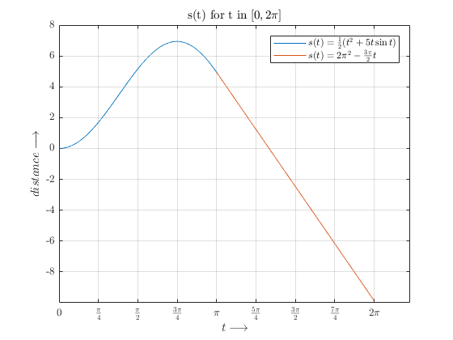

Figure B1.1 Displacement vs Time curve for the particle

MATLAB Code for the figure



## B1.3 Show that the particle comes to rest at least once before attaining uniform velocity

Given that

$$s\left(t\right)={\frac{1}{2}(t}^{2}+5t\sin{t)}$$

When the slope of this curve goes to zero or becomes parallel to x-axis the particle comes to rest, i.e. the particle will come to rest when the velocity becomes zero.

For the function $s(t)$ where $t ϵ [1.51632,3.14159]$

1. $s(t)$ is continuous as it’s a combination of polynomial and the ever continuous sine curve, and also this is evident from *Figure B1.1*
2. $s^{'}\left(t\right)=\frac{1}{2}\left(2t+5sint+5tcost\right)$, as $s^{'}\left(t\right)$ is continuous in the interval $t ϵ \left(1.51632,3.15159\right),$ $s\left(t\right)$ is derivable in the range $(1.51632,3.14159)$
3. $s\left(1.51632\right)= 4.9348$; $s\left(3.14159\right)=4.9348$; $s\left(b\right)=s(a)$

As $s\left(t\right)$ for $t ϵ [1.51632,π]$ satisfies all the three conditions for Rolle’s Theorem we can conclude that there will be at least one $c ϵ (1.51632,π)$ for which $s^{'}\left(c\right)=0$.

The velocity function being:

$$v\left(t\right)=\frac{1}{2}(2t+5\sin{t}+5t\cos{t})$$

The particle will come to rest when the velocity becomes zero.

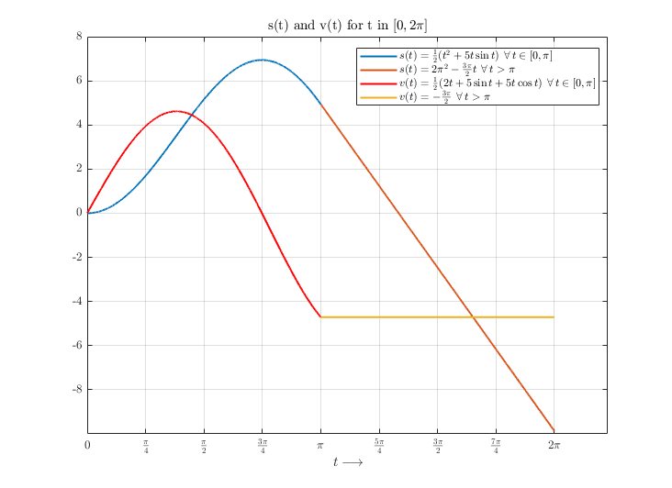

Figure B1.2 Displacement and Velocity vs Time Curve for the Particle0

The particle comes to rest when $s^{'}\left(t\right)=v\left(t\right)=0$ which is true when $t= ± 2.35003646166806$ as $ϵ (0,π)$, hence for $t=2.35003646166806 second$ the particle comes to rest.

## B1.4 Conclude and comment on the results

Velocity is a derivative of displacement w.r.t. time and acceleration is derivative of velocity w.r.t time, Hence when the velocity becomes constant at $= π$, acceleration becomes zero.

# **Question No. 3**

**Solution to Question No. 2 Part B:**

## B2.1 Obtain the Maclaurin series for the kinetic energy as a function of the velocity:

Maclaurin series for a function $f(x)$ is:

$$f\left(x\right)=f\left(0\right)+f^{'}\left(0\right)x+ \frac{f^{''}\left(0\right)x^{2}}{2!}+\frac{f^{'''}\left(0\right)x^{3}}{3!}+ . . . +\frac{f^{\left(n\right)}\left(0\right)x^{n}}{n!}= \sum_{n=0}^{∞}{\frac{f^{(n)}\left(0\right)x^{n}}{n!}}$$

$$given m=m_{0}{\left(1-\frac{v^{2}}{c^{2}}\right)}^{-\frac{1}{2}} and K=mc^{2}-m_{0}c^{2}$$

$$Where m is the relativistic mass of the object and m_{0} is the rest mass of the object.$$

$$v is the velocity of the object relative to the observer, and c is speed of light.$$

$$and hence we have K=m_{0}c^{2}{\left(1-\frac{v^{2}}{c^{2}}\right)}^{-\frac{1}{2}}-m_{0}c^{2}$$

$$K=m_{0}c^{2}\left[{\left(1-\frac{v^{2}}{c^{2}}\right)}^{-\frac{1}{2}}-1\right]$$

$$Let f\left(x\right)={\left(1-x\right)}^{-\frac{1}{2}}-1$$

$$Now we can compute the Maclaurin Series for f$$

$$f\left(0\right)={\left(1-x\right)}^{-\frac{1}{2}}-1=1-1=0$$

$$f^{'}\left(0\right)= \frac{1}{2}{\left(1-x\right)}^{-\frac{3}{2}}= \frac{1}{2}$$

$$f^{''}\left(0\right)=\frac{1}{2}∙\frac{3}{2}{\left(1-x\right)}^{-\frac{5}{2}}=\frac{3}{4}$$

$$f^{'''}\left(0\right)=\frac{1}{2}∙\frac{3}{2}∙\frac{5}{2}{\left(1-x\right)}^{-\frac{7}{2}}= \frac{15}{8}$$

$$f^{n}\left(0\right)= \frac{1∙3 ∙5∙7∙. . . ∙\left(2n-1\right)}{2^{n}}{\left(1-x\right)}^{-\frac{2n+1}{2}}$$

$$Hence the Maclaurin Series for f is$$

$$f\left(x\right)=\frac{1}{2}x+\frac{3}{8}x^{2}+\frac{5}{16}x^{3}+\frac{35}{128}x^{4}+\frac{63}{256}x^{5}+\frac{231}{1024}x^{6}+O(x^{7})$$

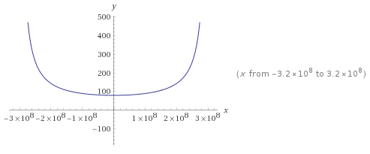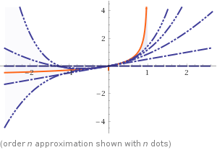

Figure B2.2 graphical plot for f(x)

Figure B2.1 n order approximation for f(x)

$$Now we can use this to analyze Kinetic Energy$$

$$K=mc^{2}-m_{0}c^{2}=m_{0}c^{2}×f\left(\frac{v^{2}}{c^{2}}\right)$$

$$K=m_{0}c^{2}\left[ \frac{1}{2}\frac{v^{2}}{c^{2}}+\frac{3}{8}{\left(\frac{v^{2}}{c^{2}}\right)}^{2}+ \frac{5}{16}{\left(\frac{v^{2}}{c^{2}}\right)}^{3}+ . . . \right]$$

$$K={\frac{1}{2}m}_{0}v^{2}+ m_{0}\left[ \frac{3}{8}{\left(\frac{v^{2}}{c^{2}}\right)}^{2}+ \frac{5}{16}{\left(\frac{v^{2}}{c^{2}}\right)}^{3}+ . . . \right]$$

## B2.2 Show that when v is very small compared to c, the expression for K agrees with the classical Newtonian physics by $K=\frac{1}{2}m_{0}v^{2}$:

Previously we formulated our Relativistic Kinetic Energy to be

$$K={\frac{1}{2}m}_{0}v^{2}+ m_{0}\left[ \frac{3}{8}{\left(\frac{v^{2}}{c^{2}}\right)}^{2}+ \frac{5}{16}{\left(\frac{v^{2}}{c^{2}}\right)}^{3}+ . . . \right]$$

In this if we assume that there is no particle that can go faster than light, and that the velocities that we deal with in Newtonian Physics have fairly low velocity compared to speed of light, which is said to be the ultimate speed that a particle could ever reach, then $<c$, which implies that $\frac{v^{2}}{c^{2}}< 1$ which is not too small to ignore though ${\left(\frac{v^{2}}{c^{2}}\right)}^{n}≪1$ and its exponents tend to be a very small quantity and diminish hence can be ignored.

Hence now our Kinetic Energy which is true according to Newtonian Physics is

$$K={\frac{1}{2}m}_{0}v^{2}$$

## B2.3 Comment on the results and conclude.

Classical Newtonian Kinetic Energy can be obtained from the Relativistic Kinetic energy when $v$ is considered to be very small compared to $c$.

# **Question No. 4**

**Solution to Question No. 3 part B:**

## B3.1 Choose any algorithm to search the index of a given element in vector X and explain:

To Search from an unsorted array there is only one way which would be linear as there is no order in it. The time complexity here is $O(n)$ which is linearly increasing. Hence the algorithm being:

1. Start
2. Take the Vector X and Element to search as input
3. Take an element from Vector X and compare with Element to search
4. If element is found then store the index in Vector indexes
5. Repeat Step 3 and 4 until the last element of Vector X
6. Display Vector Indexes
7. Stop

## B3.2 Write a MATLAB function to implement the above chosen algorithm. The function should accept the array and an element as input and should output the index of that element in the given array:



## B3.3 Use MATLAB built-in function ‘find’ to search the index of the required element. Compare and comment on the results:

The built-in $find()$ function has more scalability compared to the user defined function in *B3.2* ,

$I=find(X,K)$ returns at most first $K$ indices for which the $X$ is satisfied, here $X$ can also be a relational statement.

Comparing the runtimes of the two, along with another algorithm binary search which sorts the given vector using $sort()$ function and then binary searched for the element. A 50,000,000 element vector was taken with random integers, and a random element was searched in this vector using the in-built $find$ function and the user-defined search function, the run time being :

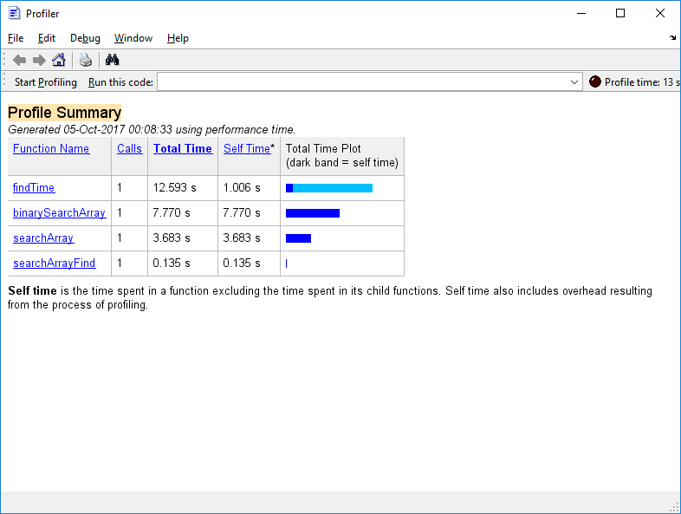

Figure B3.1 Run Time comparison for build-in find function and user defined search function

There is a large difference between the run time of *searchArray* and *searchArrayFind*, $find()$ function is way more quicker in searching for the element and provides more options to search for.

# **Question No. 5**

**Solution to Question No. 4 Part B:**

## B4.1 Obtain Equations for the temperature at the four intersection points:

$$Temperature at x_{1}=\frac{200+200+x_{3}+x_{2}}{4}$$

$$Temperature at x_{2}=\frac{200+100+x_{4}+x_{1}}{4}$$

$$Temperature at x_{3}=\frac{200+x_{1}+x_{4}+100}{4}$$

$$Temperature at x_{4}=\frac{x_{2}+100+100+x_{3}}{4}$$

The equations hence formed are :

$$4x_{1} -x_{2} -x_{3} =400$$

$$-x_{1}+4x_{2}-x_{4}=300$$

$$-x_{1}+4x_{3}-x_{4}=300$$

$$-x_{2}-x_{3}+4x_{4}=200$$

This can be written in an Matrix form as :

$$\left(\begin{matrix}4 & -1 & -1 & 0 \\ -1 & 4 & 0 & -1 \\ -1 & 0 & 4 & -1 \\ 0 & -1 & -1 & 4\end{matrix}\right)\left(\begin{matrix}x_{1} \\ x_{2} \\ x_{3} \\ x_{4}\end{matrix}\right)= \left(\begin{matrix}400 \\ 300 \\ 300 \\ 200\end{matrix}\right)$$

## B4.2 Solve the resultant system to find the temperature at each intersection point in the grid:

Students are expected to provide the solution to the question considering the points mentioned in the marking scheme of the assignment question

$$The Augumented matrix is :$$

$$\left(\begin{matrix}4 & -1 & -1 & 0 & 400 \\ -1 & 4 & 0 & -1 & 300 \\ -1 & 0 & 4 & -1 & 300 \\ 0 & -1 & -1 & 4 & 200\end{matrix}\right)$$

$$R_{2}→4R_{2}+R_{1}$$

$$R_{3}→4R_{3}+R_{1}$$

$$\left(\begin{matrix}4 & -1 & -1 & 0 & 400 \\ 0 & 15 & -1 & -4 & 1600 \\ 0 & -1 & 15 & -4 & 1600 \\ 0 & -1 & -1 & 4 & 200\end{matrix}\right)$$

$$R_{3}→15R_{3}+R_{2}$$

$$R_{4}→15R_{4}+R_{2}$$

$$\left(\begin{matrix}4 & -1 & -1 & 0 & 400 \\ 0 & 15 & -1 & -4 & 1600 \\ 0 & 0 & 224 & -64 & 25600 \\ 0 & 0 & -16 & 56 & 4600\end{matrix}\right)$$

$$R_{3}→\frac{R_{3}}{32};R_{4}→\frac{R_{4}}{8}$$

$$\left(\begin{matrix}4 & -1 & -1 & 0 & 400 \\ 0 & 15 & -1 & -4 & 1600 \\ 0 & 0 & 7 & -2 & 800 \\ 0 & 0 & -2 & 7 & 575\end{matrix}\right)$$

$$R_{4}→7R_{4}+2R_{3}$$

$$\left(\begin{matrix}4 & -1 & -1 & 0 & 400 \\ 0 & 15 & -1 & -4 & 1600 \\ 0 & 0 & 7 & -2 & 800 \\ 0 & 0 & 0 & 45 & 5625\end{matrix}\right)$$

$$rank of augumented matrix=rank of matrix, hence we have an unique solution$$

$$Now we have$$

$${45x}_{4}=5625$$

$$7x_{3}-2x_{4}=800$$

$$15x_{2}-x_{3}-4x_{4}=1600$$

$$4x_{1}-x_{2}-x_{3}=400$$

$$The Solution being :$$

$$x_{1}=175$$

$$x_{2}=150$$

$$x_{3}=150$$

$$x_{4}=125$$

## B4.3 Write a MATLAB script to check for the consistency of the system and obtain the solution.





## B4.4 Comment on the results obtained and conclude

The given problem turns out to be a 4 variable equation with $x_{1},x_{2},x_{3},x_{4}$ whose values are to be computed, to find the value of these 4 equations are setup which is then solved to get the values of respective variables. The system is consistent and has a Unique Solution which was verified with the results obtained using the formed MATLAB function.

**Bibliography**

________________________________________________________________________________

1. James Stewart, 2015, *Calculus – Early Transcendentals*, Cengage Learning, pp 379-386