

|  |  |
| --- | --- |
| **ASSIGNMENT** | |
| **Course Code** | ESC107A |
| **Course Name** | Elements of Electrical Engineering |
| **Programme** | B.Tech |
| **Department** | Electrical Engineering |
| **Faculty** |  |

#### 

|  |  |
| --- | --- |
| **Name of the Student** |  |
| **Reg. No** |  |
| **Semester/Year** |  |
| **Course Leader/s** |  |

|  |  |  |  |  |  |  |  |  |
| --- | --- | --- | --- | --- | --- | --- | --- | --- |
| **Declaration Sheet** | | | | | | | | |
| Student Name |  | | | | | | | |
| Reg. No |  | | | | | | | |
| Programme |  | | | | | Semester/Year |  | |
| Course Code |  | | | | | | | |
| Course Title |  | | | | | | | |
| Course Date |  | | to | |  | | | |
| Course Leader |  | | | | | | | |
| **Declaration**  The assignment submitted herewith is a result of my own investigations and that I have conformed to the guidelines against plagiarism as laid out in the Student Handbook. All sections of the text and results, which have been obtained from other sources, are fully referenced. I understand that cheating and plagiarism constitute a breach of University regulations and will be dealt with accordingly. | | | | | | | | |
| Signature of the Student | |  | | | | | Date |  |
| Submission date stamp  (by Examination & Assessment Section) | |  | | | | | | |
| Signature of the Course Leader and date | | | | Signature of the Reviewer and date | | | | |
|  | | | |  | | | | |

# **Contents**

____________________________________________________________________________

**Declaration Sheet** ii

**Contents** iii

**List of Tables** iv

**List of Figures** v

**List of Symbols** vi

**Question No. 1** 7

A1.1 Discussion of Norton’s and Superposition theorems with an example: 7

A1.2 Illustration and conditions of Thevenin’s and superposition theorems: 7

A1.3 Suitability of Norton’s/ superposition theorem for power calculation 7

A1.4 Conclusion 7

**Question No. 2** 8

B1.1 Value of the effective resistance between terminals A and B: 8

B1.2 Value of ‘Rx’ for transfer of maximum power: 9

B1.3 Value of the maximum power transferred 10

B1.4 Conclusion 10

**Question No. 2 part B** 12

Given X = 59V and Y = 2X = 118V 12

B2.1 Calculate the value of the resistance using colour code: 12

B.2 Draw the network configuration for the given circuits shown in figure 2 and figure 3: 12

B2.3 Voltage drop across each resistor 13

B2.4 Current flowing through each resistor: 13

B2.5. Conclusion: 13

B3.1 Total connected load in kW: 14

B3.2 Maximum current drawn from the supply: 14

B3.3 Daily consumption of energy: 14

B3.4 Electricity bill for the month of September 14

**Question No. 4 part B** 15

B4.1 Simulation and graph: 15

B4.2 Mathematical equation: 15

B4.3 Conduction of experiment 15

B4.4 Comment 15

# **List of Tables**

**____________________________________________________________________________**

|  |  |  |
| --- | --- | --- |
| **Table No.** | **Title of the table** | **Pg.No.** |
| Table B1.1 | Given circuit for B1 | 12 |
| Table 1.2 | Title of the table | 14 |
| Table 2.1 | Title of the table | 18 |
|  |  |  |

# **List of Figures**

____________________________________________________________________________

|  |  |  |
| --- | --- | --- |
| **Figure No.** | **Title of the figure** | **Pg.No.** |
| Figure 1.1 | Title of the figure | 13 |
| Figure 1.2 | Title of the figure | 15 |
| Figure 2.1 | Title of the figure | 19 |
|  |  |  |

# **List of Symbols**

____________________________________________________________________________

|  |  |  |
| --- | --- | --- |
| **Symbol** | **Description** | **Units** |
| A | Current | Amp |
| g | Acceleration due to gravity - 9.81 | m/s2 |
| V | Voltage | Volts |
| w | Width | mm |
|  |  |  |

< Arrange in alphabetical order>

# **Question No. 1**

**Solution to Question No. 1 Part A:**

## A1.1 Discussion of Norton’s and Superposition theorems with an example:

Overview to the question (students are expected to give a brief introduction to the context on which the question is set, applications, limitations, new developments happening and students own views on the question and the paragraph should not exceed 200 words and references should be cited and it should be authored by the students means to say students should not be borrowing sentences as they are from any referred literature)

## A1.2 Illustration and conditions of Thevenin’s and superposition theorems:

Students are expected to provide the solution to the question considering the points mentioned in the marking scheme of the assignment question

## A1.3 Suitability of Norton’s/ superposition theorem for power calculation

Students are expected to discuss the solutions obtained in section 1.2 and present their views/suggestions/recommendations (not to exceed 150 words)

## A1.4 Conclusion

Students are expected to draw conclusions based on the discussions and suggestions (not to exceed 100 words)

# **Question No. 2**

**Solution to Question No. 1 Part B:**

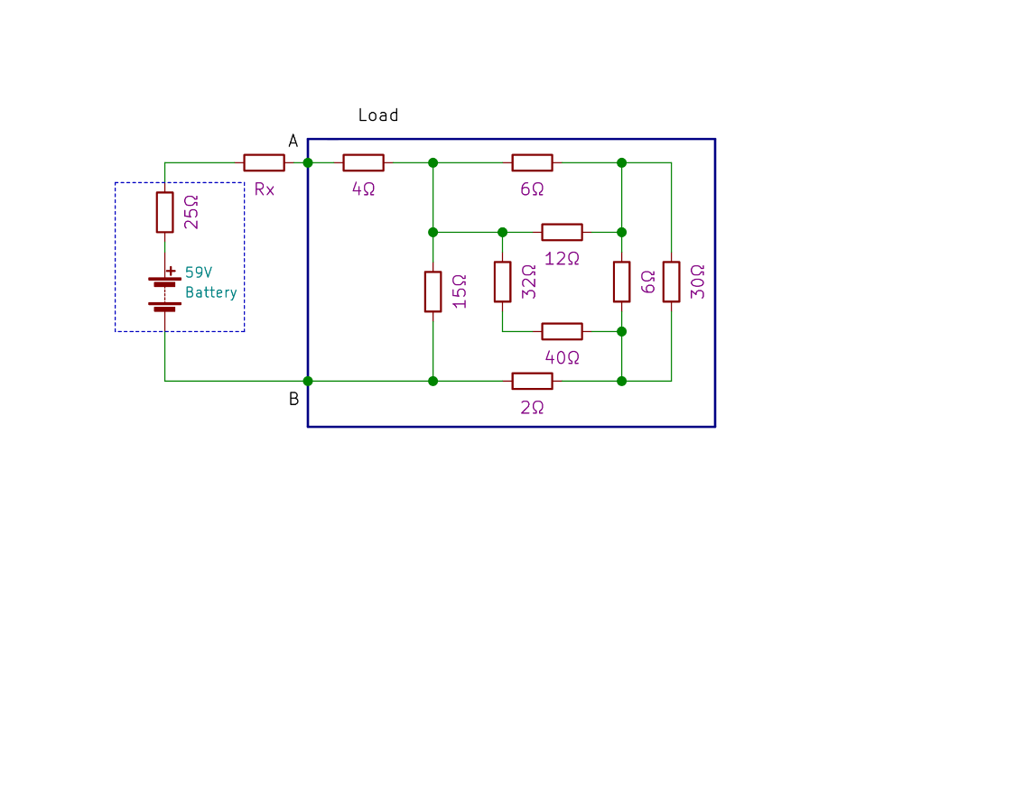

Figure B1.1 Given Circuit for B1

## B1.1 Value of the effective resistance between terminals A and B:

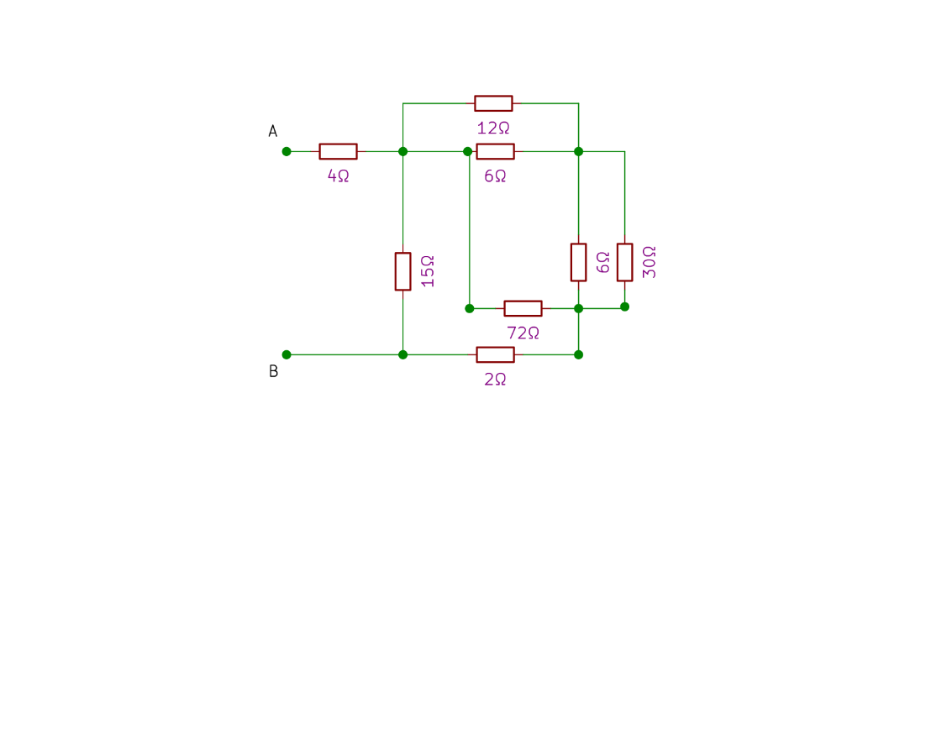The 32Ω resistor and 40 Ω resistor are in series, hence they can simply be algebraically added to give 72 Ω.

Figure B1.2 Solution step 1

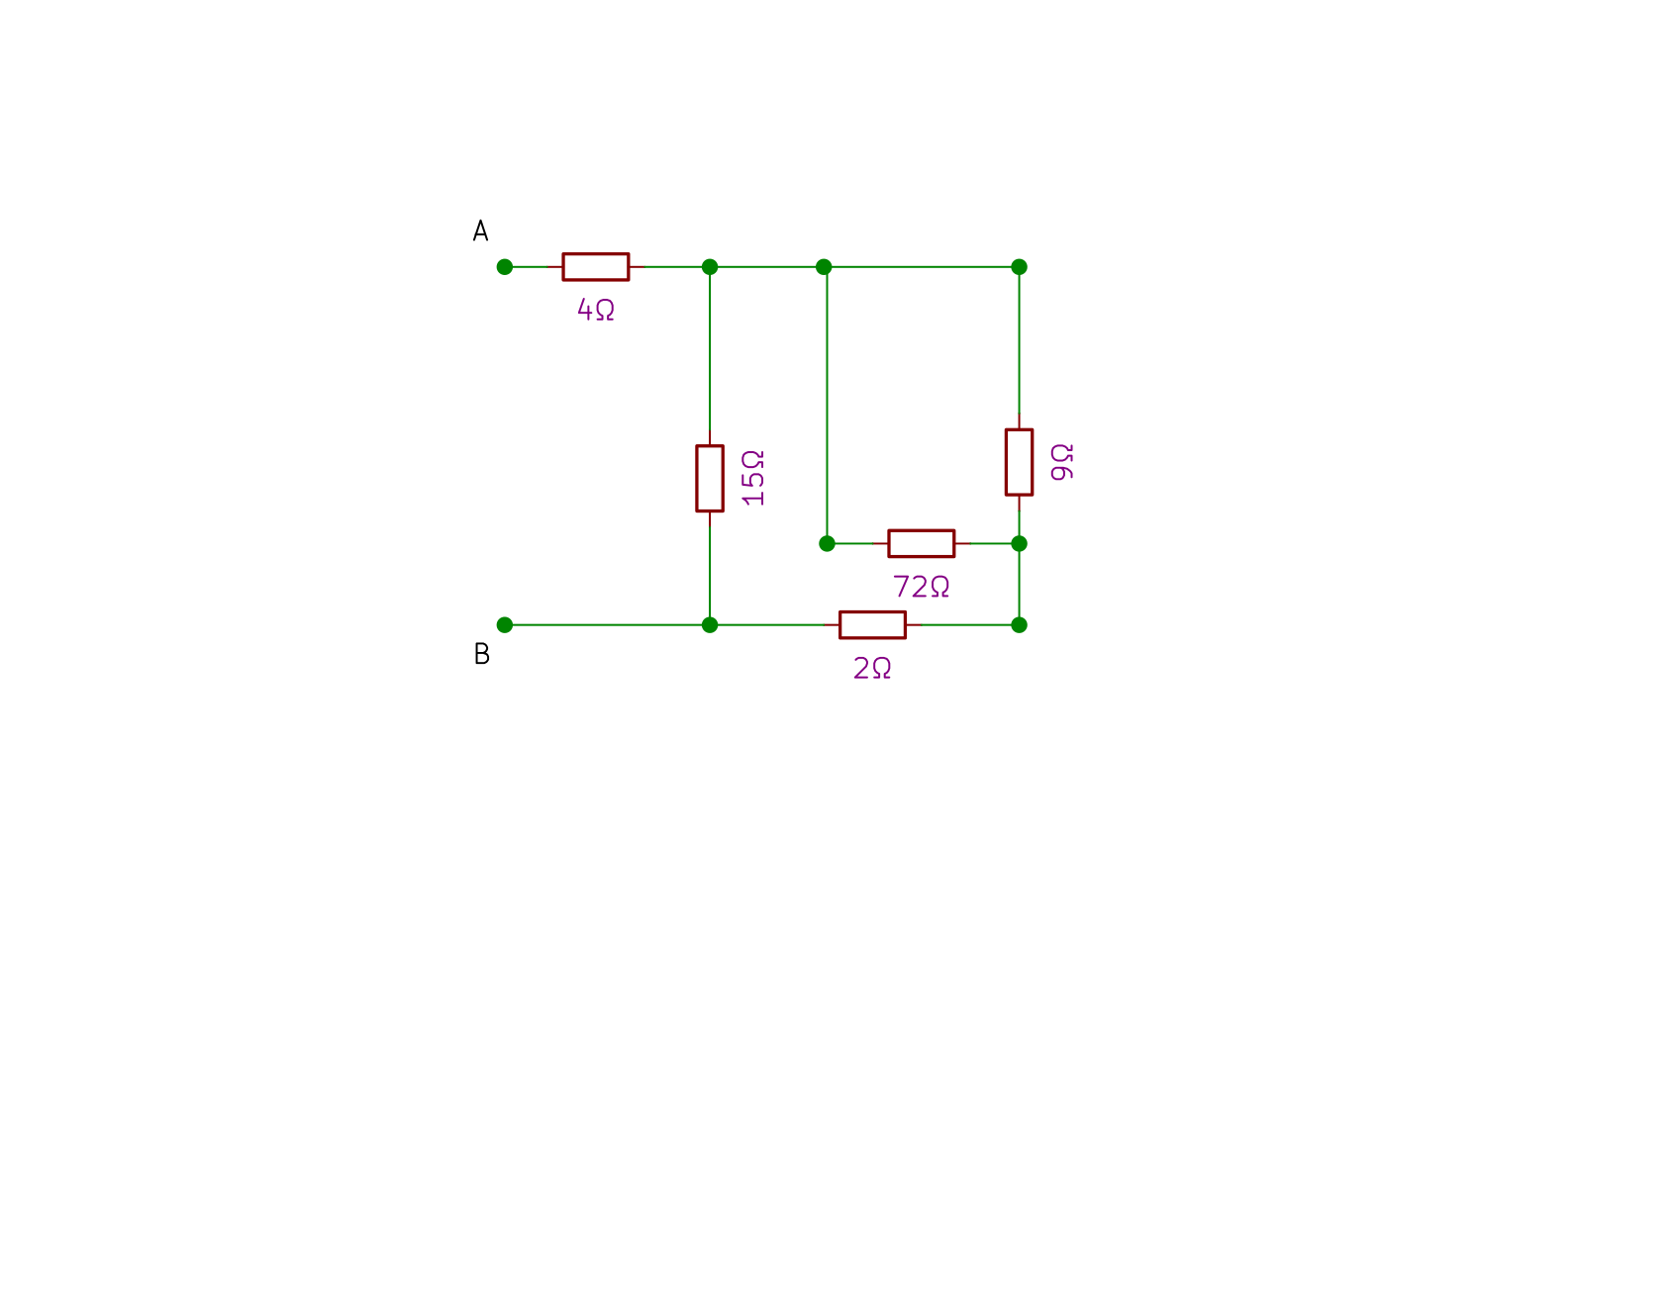

Figure B1.3 Solution step 2

The 12 Ω and 6 Ω resistor are in parallel, which result in a value of 4 Ω,

6 Ω resistor on the right and 30 Ω resistor are in parallel too, they result in a value of 5 Ω,

The resultants of the above are in series and hence forming a resistance of 9 Ω

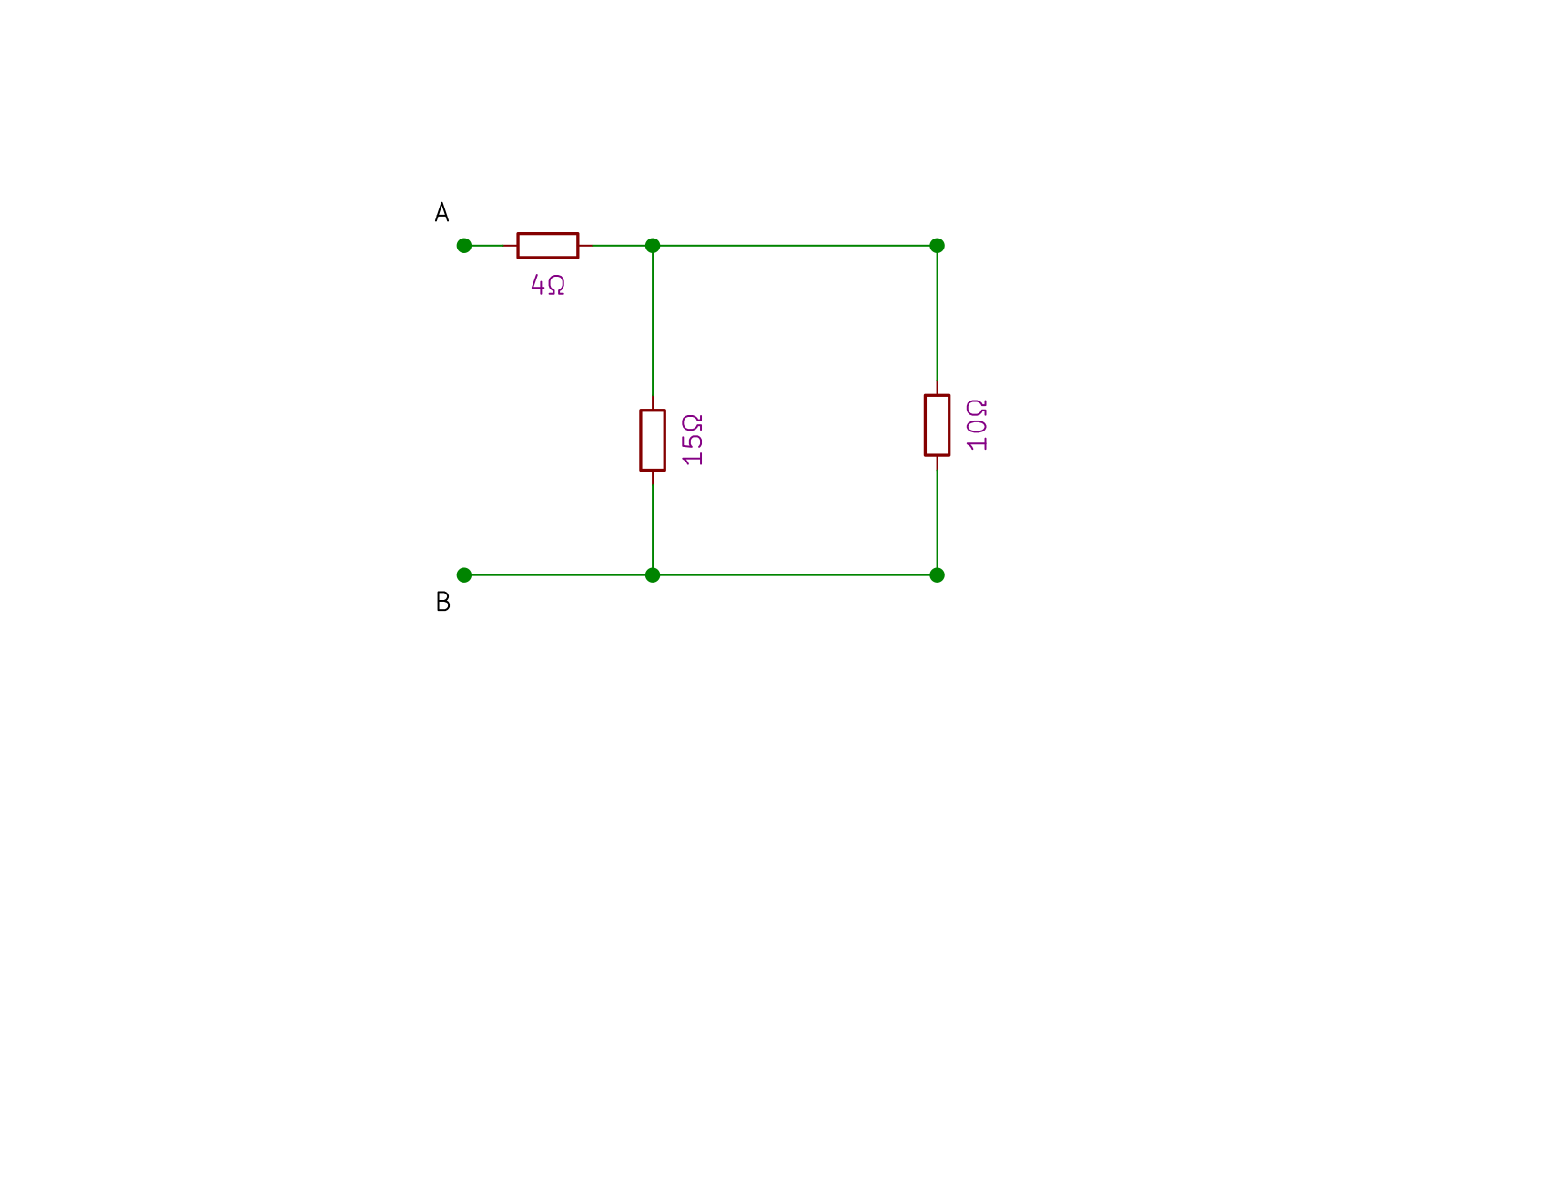The 72 Ω resistor and the 9 Ω resistor now are in parallel resulting in an equivalent resistance of 8 Ω, which is in series with the 2 Ω resistor forming 10 Ω

Figure B1.4 Solution step 3

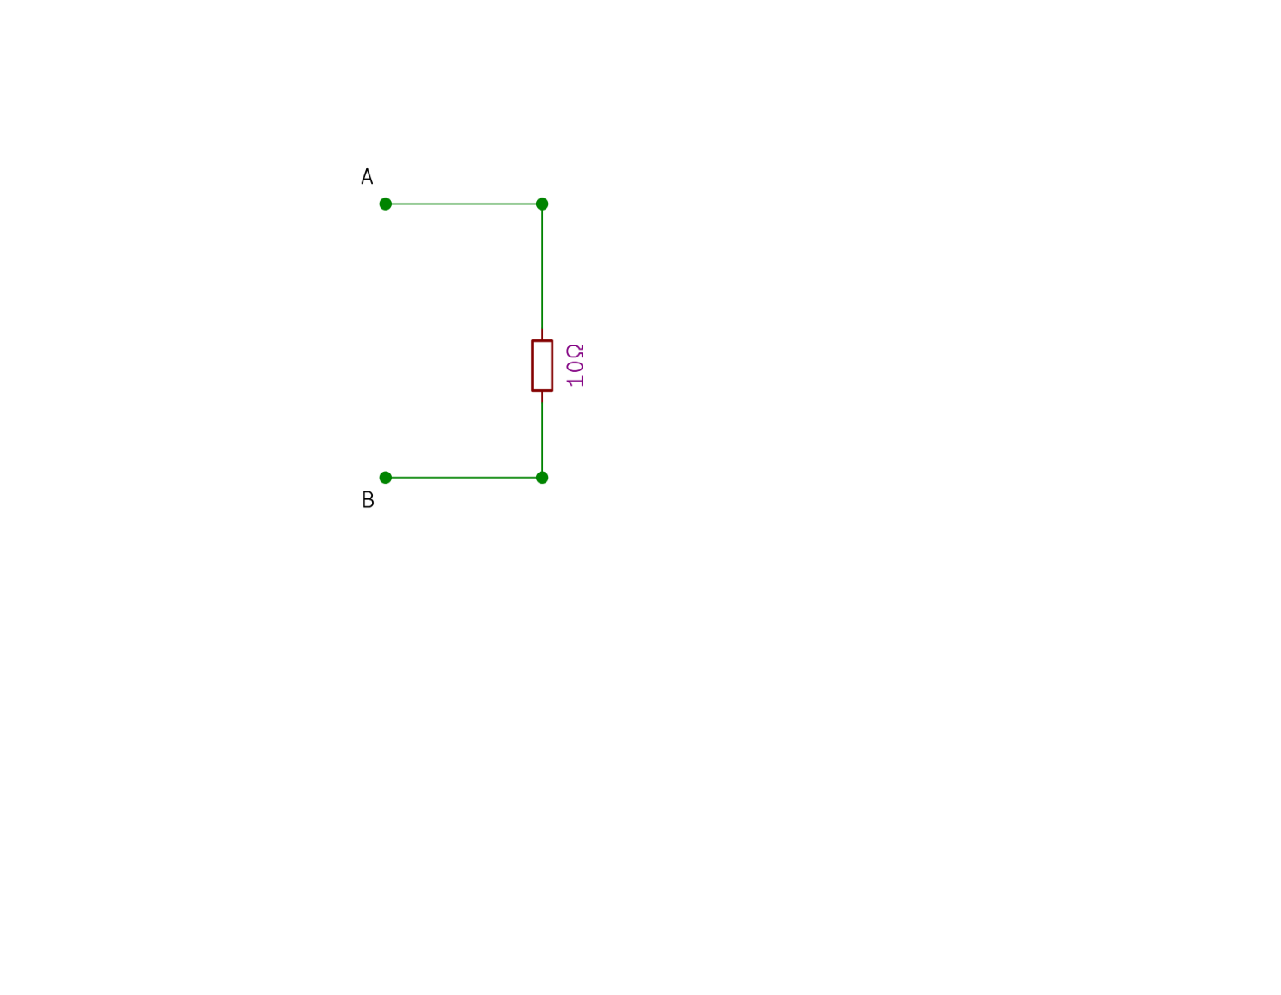

Figure B1.5 Solution step 4

The left now 10 Ω resistor is parallel to 15 Ω forming a

resitance of 6 Ω, which then is series with the 4 Ω

resistor, now we obtain 10 Ω which is the total

equivalent resistance of the given load circuit.

## B1.2 Value of ‘Rx’ for transfer of maximum power:

From the maximum power transfer theorem, the maximum power is transferred to the load when the Source Reistance or the the Thevenin’s Resistance is equal to the Load Resitance,

Here we have the source resistance as $25+Rx$, this should be equal to $R_{L}$ for maximum power transfer, hence,

$$25+R_{x}=10$$

$$R_{x}= -15 Ω$$

Negative Resistances do not exist in Real world, the negative value here means there should be less internal resistance to get the maximum power transferred at the load. Thus the Source Resistance now is $25Ω-15Ω=10 Ω$, now this stratifies $R_{s}=R_{L}$.

## B1.3 Value of the maximum power transferred

From maximum power transfer theorem,

$$P_{max}=\frac{V^{2}}{4R}$$

$$P_{max}=\frac{V^{2}}{R}=\frac{{59}^{2}}{4×10}=87.0250 W$$

## B1.4 Conclusion

# **Question No. 2 part B**

**Solution to Question No. 2 Part B:**

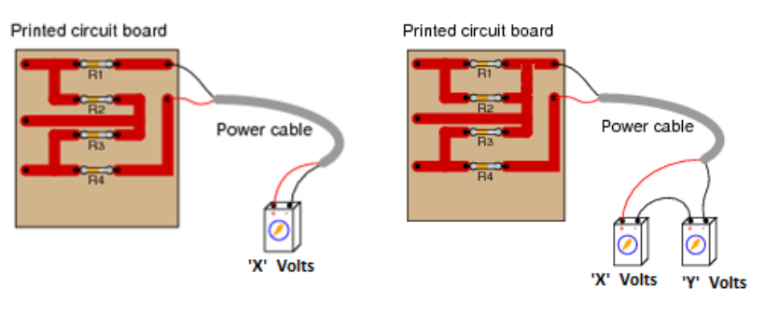

Figure B2.1 given circuit 1 Figure B2.2 given circuit 2

## Given X = 59V and Y = 2X = 118V

## B2.1 Calculate the value of the resistance using colour code:

R1 = Brown, Green, Red, Gold = $15×{10}^{2} ±5\%=1.50 kΩ$

R2 = Yellow, Violet, Orange, Silver = $47×{10}^{3} ±10\%=47.00 kΩ$

R3 = Red, Green, Red, Gold = $25×{10}^{2} ±5\%=2.50 kΩ$

R4 = White, Black, Red, Silver = $90×{10}^{2} ±10\%=9.00 kΩ$

## B.2 Draw the network configuration for the given circuits shown in figure 2 and figure 3:

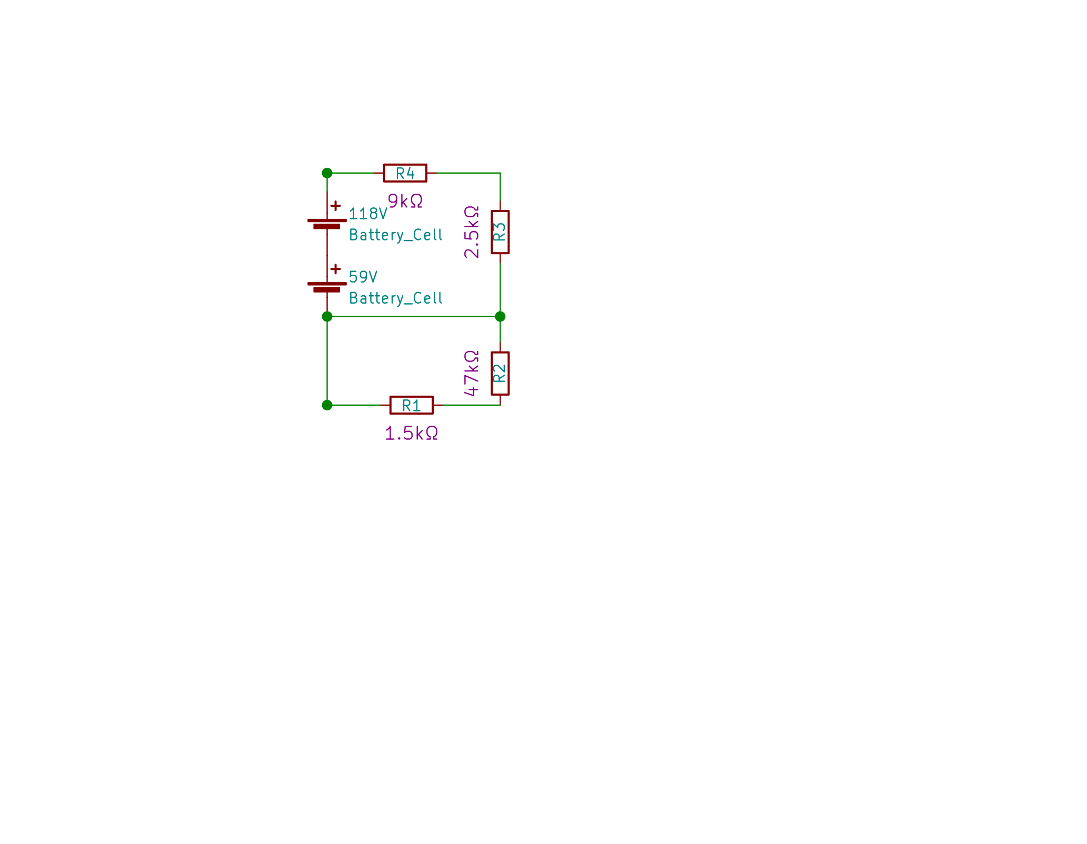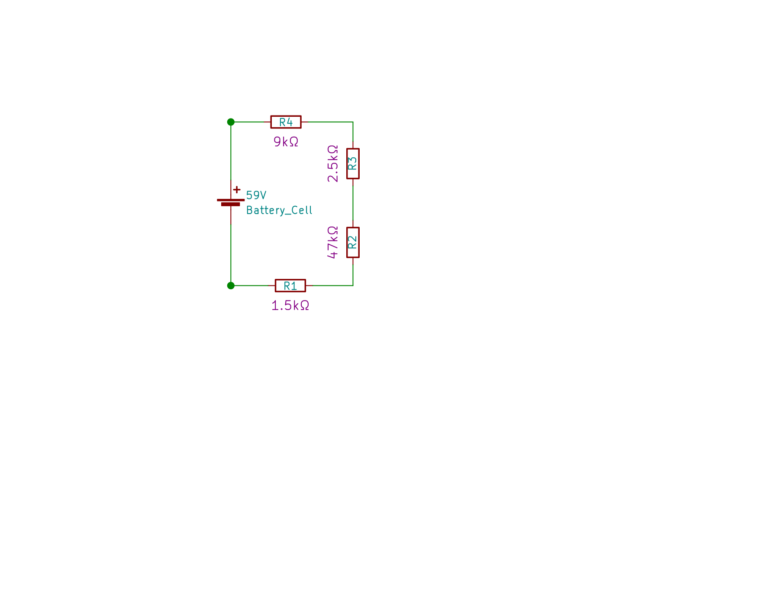

Figure B2.4 Circuit Schematic for figure B2.2

Figure B2.3 Circuit Schematic for figure B2.1

## B2.3 Voltage drop across each resistor

In figure 4 we can clearly see that the R1, R2, R3 and R4 are in series, hence the equivalent resistance is

$R1+R2+R3+R4=1.5kΩ+47kΩ+2.5kΩ+9kΩ=60kΩ$

The current through each of the resistor is same which is $i=\frac{V}{Req}= \frac{59}{60000}= 0.9833 mA$

Potential drop at each resistor can be calculated by $V=iR$

|  |  |
| --- | --- |
| **Resistor ($Ω$)** | **Potential/Voltage Drop (V)** |
| R1 – 1.5 k $Ω$ | 1.4749 V |
| R2 – 47.0 k $Ω$ | 46.2166 V |
| R3 – 2.5 k $Ω$ | 2.4583 V |
| R4 – 9.0 k $Ω$ | 8.8499 V |

Table B2.1 Potential Drop at resistors in Figure B2.1

Sum of the Voltage drop should be equal to the Voltage Source as per Kirchoff’s Voltage Law, hence the sum is 58.9997 V ~ 59 V.

In figure 5 R2 and R1 are shorted, i.e. the potential will be same, hence there will be no current flowing through them. Now R3 and R4 are in series so, $R3+R4=2.5kΩ+9kΩ=11.5kΩ$

The current through each resistor except R1 and R2 will be same which is $i=\frac{V}{Req}= \frac{177}{11500}= 15.3913 mA$

|  |  |
| --- | --- |
| **Resistor ($Ω$)** | **Potential/Voltage Drop (V)** |
| R1 – 1.5 k $Ω$ | 0 V |
| R2 – 47.0 k $Ω$ | 0 V |
| R3 – 2.5 k $Ω$ | 38.4782 V |
| R4 – 9.0 k $Ω$ | 138.5217 V |

Table B2.2 Potential Drop at resistors in Figure B2.2

Sum of the Voltage drop should be equal to the Voltage Source as per Kirchoff’s Voltage Law, hence the sum is 176.9999 V ~ 177 V.

## B2.4 Current flowing through each resistor:

In figure 2 all the Resistors are in series which is more intuitive in figure 3, Hence the current through all the resistors will be same and equals to 0.9833 mA.

In figure 3 R1 and R2 are shorted together which means that they share the same potential, hence no current shall pass through them i.e. 0 A, while R3 and R4 are connected in series and the same current shall flow through them which is 15.3913 mA.

## B2.5. Conclusion:

Circuit Schematics are a good way to represent circuits.

**Question No. 3 part B**

**Solution to Question No. 3 Part B:**

## B3.1 Total connected load in kW:

The total load will be the sum of loads, which is

$$15×16 W+4×75 W+750 W+100 W+380 W=1770 W=1.77 kW$$

## B3.2 Maximum current drawn from the supply:

The Voltage at the facility is 230 VRMS, which translates to 325.2691 VMAX ,

The maximum power at an instant is 1.77 kW , now $P=V×I$

$$I=\frac{P}{V}$$

$$I=\frac{1700}{230}=7.3913 A_{RMS}=10.4528 A_{MAX}$$

## B3.3 Daily consumption of energy:

Lamps : $0.24 kW ×5 hour=1.2 kWh$

Fans : $0.30 kW ×10 hour=3.0 kWh$

Heater : $0.75 kW ×1 hour=0.75 kWh$

TV : $0.10 kW ×6 hour=0.60 kWh$

Water Pump : $0.38 kW ×2 hour=0.76 kWh$

Hence a total of $6.31 kWh per day$

## B3.4 Electricity bill for the month of September

September having 30 days the total consumption will be

$$6.31 kWh per day ×30 days=189.3 kWh$$

Considering the charges according to BESCOM Domestic Consumer Tarrif for 2017 to be

$$0-30kWh , ₹3.25 per kWh$$

$$31-100 kWh, ₹4.70 per kWh$$

$$101-200 kWh, ₹6.25 per kWh$$

Calculations :

$$30 kWh ×₹3.25 per kWh=₹97.50$$

$$70 kWh × ₹4.70 per kWh= ₹329.00$$

$$89.3 kWh × ₹6.25 per kWh= ₹558.125$$

And adding the extra ₹20 for the meter

This gives a total of **₹1004.625**

# **Question No. 4 part B**

**Solution to Question No. 4 part B:**

## B4.1 Simulation and graph:

|  |  |
| --- | --- |
| VDC (Volts) | IDC (Amps) |
| 0 |  |
| 1 |  |
| 2 |  |
| 3 |  |
| 4 |  |
| 5 |  |
| 6 |  |
| 7 |  |
| 8 |  |
| 9 |  |
| 10 |  |

## B4.2 Mathematical equation:

Students are expected to provide the solution to the question considering the points mentioned in the marking scheme of the assignment question

## B4.3 Conduction of experiment

Students are expected to discuss the solutions obtained in section 1.2 and present their views/suggestions/recommendations (not to exceed 150 words)

## B4.4 Comment

Students are expected to draw conclusions based on the discussions and suggestions (not to exceed 100 words)

**Bibliography**

________________________________________________________________________________

1. Kinicki and Williams Irwin. (2008) *Management*, McGraw Hill.
2. Decenzo David and Robbin Stephen A. (1996) *Personnel and Human Reasons Management*, Prentice Hall of India.
3. J.A.F. Stoner, Freeman R. E and Daniel R Gilbert. (2004) *Management*, 6th Edition, Pearson Education.
4. Fraidoon Mazda. (2000) *Engineering Management*, Addison Wesley.

All referencing, bibliography needs to be done as described in the following article:

<http://www.msruas.ac.in/pdf_files/VCBlogs/Academic%20Good%20Practices.pdf>

***Guidelines for writing the report***

Font and Font size of the text: Calibri, 11

Line Spacing: 1.5, Justified

All mathematical equations be edited using Microsoft Equation Editor

All figures, tables, equations taken from reference material be cited

1. **Inserting a table**

Title of the table should be at the top of the table and be left justified with ref to table

**Table 1.1 Properties of Air at Low Pressure [Ref.]**

|  |  |  |  |  |
| --- | --- | --- | --- | --- |
| **T (K)** | **h (J/kg)** | **p (atm)** | **u (J/kg)** | **φ (J/kg K)** |
|  |  |  |  |  |
|  |  |  |  |  |
|  |  |  |  |  |
|  |  |  |  |  |
|  |  |  |  |  |

[Note: the table should be centered w.r.t the page width. Use suitable SI units]

**Referring to a table in the text:**

The data is tabulated as shown in Table 1.1.

[Note: Please do not write as *“As shown below”* or *“As shown above”*]

1. **Inserting a figure, a photo or screen shot**

The figure should be sufficiently large and legible. It should be centered w.r.t the page width.

Figure

Figure 2.1 Machining Process [Ref.]

Title of the Figure should be at the bottom of the figure and be left justified. The reference must be quoted.

**Referring to a figure in the text:**

The machine is shown in Figure 7.1

[Note: Please do not write as *“As shown below”* or *“As shown above”*]

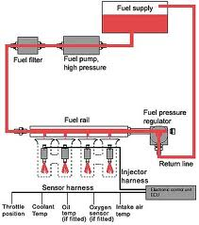

Figure 7.1 The Wonder Machine [2]

**[5]….. reference number; this should be quoted in the References.**

1. **Quoting the references in the text**

According to Kestin[5], “ the science of thermodynamics is a branch of physics. It describes natural processes in which changes in temperature play an important part. Such as the …………………………..”

1. **The Appendix if any should be the last section in the report.**