

|  |  |
| --- | --- |
| **ASSIGNMENT** | |
| **Course Code** | BSC102B |
| **Course Name** | Engineering Physics |
| **Programme** | B.Tech |
| **Department** | CSE |
| **Faculty** | FET |

#### 

|  |  |
| --- | --- |
| **Name of the Student** | Satyajit Ghana |
| **Reg. No** | 17ETCS002159 |
| **Semester/Year** | 02/2018 |
| **Course Leader/s** | Dr. Suguna M, Dr. Sidling M. |

|  |  |  |  |  |  |  |  |  |
| --- | --- | --- | --- | --- | --- | --- | --- | --- |
| **Declaration Sheet** | | | | | | | | |
| Student Name |  | | | | | | | |
| Reg. No |  | | | | | | | |
| Programme |  | | | | | Semester/Year |  | |
| Course Code |  | | | | | | | |
| Course Title |  | | | | | | | |
| Course Date |  | | to | |  | | | |
| Course Leader |  | | | | | | | |
| **Declaration**  The assignment submitted herewith is a result of my own investigations and that I have conformed to the guidelines against plagiarism as laid out in the Student Handbook. All sections of the text and results, which have been obtained from other sources, are fully referenced. I understand that cheating and plagiarism constitute a breach of University regulations and will be dealt with accordingly. | | | | | | | | |
| Signature of the Student | |  | | | | | Date |  |
| Submission date stamp  (by Examination & Assessment Section) | |  | | | | | | |
| Signature of the Course Leader and date | | | | Signature of the Reviewer and date | | | | |
|  | | | |  | | | | |

# **Contents**

____________________________________________________________________________

**Declaration Sheet** ii

**Contents** iii

**List of Figures** iv

**List of Symbols** **Error! Bookmark not defined.**

**Question No. 1** 5

A1.1 LASER Lithotripsy: 5

A1.2 LASER Angioplasty: 6

**Question No. 2** 9

B.1.1 Calculation of deceleration: 9

B.1.2 Calculation of time: 9

**Question No. 3** 11

B.2.1 Calculation of MI along the axis of the rod: 11

B.2.2 Calculation of CM and MI perpendicular to the axis of the rod: 11

**Question No. 4** 13

B.3.1 Estimate of distance: 13

B.3.2 Calculation of coefficient of static friction: 14

B.3.3 Free body diagrams: 14

**Question No. 5** 16

B.4.1 Calculation of the ratio of population of N2/N1: 16

B.4.2 Estimation of temperature: 16

B.4.3 Computation of life time: 17

# **List of Figures**

____________________________________________________________________________

|  |  |  |
| --- | --- | --- |
| **Figure No.** | **Title of the figure** | **Pg.No.** |
| Figure A1.1 | Kidney Stones Lithotripsy | 5 |
| Figure A1.2 | Coronary Arteries Laser Angioplasty | 6 |
| Figure B2.1 | The Two Sphere System | 12 |
| Figure B3.1 | FBD for B3.1 | 14 |
| Figure B3.2 | FBD for B3.2 | 15 |
|  |  |  |

# **Question No. 1**

**Solution to Question No. 1 part A:**

## A1.1 LASER Lithotripsy:

Principle and Procedure:

LASER Lithotripsy is based on pulsatile light delivered through small, flexible quartz fibre to the stone through the working channel of flexible ureteroscopes. Lasers such as Dye Lasers and $Nd:YAG$ lasers are preferably used for lithotripsy of urinary calculi inside the ureter. It has been postulated that laser energy creates local plasma at the surface of calculus, with rapid expansion and collapse for the plasma “bubble” producing shock waves capable of physical disruption of the stone. **(Watson GM, 1987)**

Typically, pulse energies of $50-200m$ J and pulse durations between $10 ns$ and $1 μs$ are applied. The diameter of the optical fiber varies between $200 μm$ and $600 μm$. With these parameters, optical breakdown is achieved close to the target. The photodisruptive interaction finally leads to the fragmentation of urinary calculi.

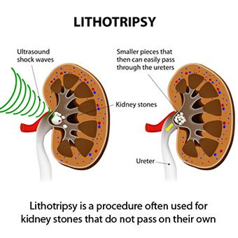

Figure A1.1 Kidney Stones Lithotripsy

Compared to extracorporeal shock wave lithotripsy, holmium laser lithotripsy has been shown to reduce the chance of steinstrasse. This is a complication of extracorporeal shock lithotripsy in which fragments of the stones block the ureter.

Merits and Advantages:

The procedure has been shown to be effective for a patient with multiple stones.

Holmium laser lithotripsy requires general anesthesia. For this reason, there is a hospital stay and higher costs compared to extracorporeal shock wave lithotripsy.

Limitations and Complications:

Some complications of holmium laser lithotripsy includes Pain, Blood in urine, trouble urinating, fever, injury to the ureters. **(Feng C, Wu, Jiang H, Ding Q & Gao P, 2013)**

Other complications such as Bleeding around kidney, Pieces of stone that blocks flow of urine from kidney(this can cause severe pain or damage to kidneys), Pieces of stone being left inside the body (more treatments may be required), Problems in kidney function after procedure.

## A1.2 LASER Angioplasty:

Principle and Procedure:

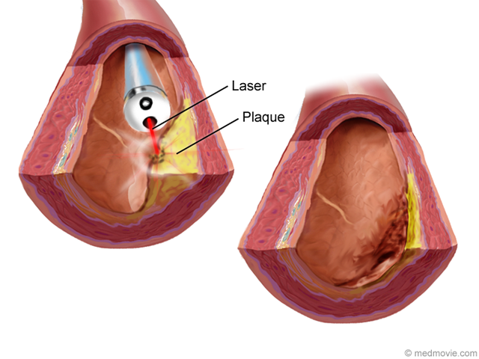Laser Angioplasty (also known as excimer laser coronary angioplasty) is a technique that can be used to open coronary arteries blocked by plaque. A catheter with a laser at its tip is inserted into an artery. Then it’s advanced through the artery to the blockage. When the laser is in position, it emits pulsating beams of light that vaporize the plaque.

Figure A1.2 Coronary Arteries Laser Angioplasty

The laser directs a cool beam toward the blockage through a catheter in the coronary artery. The laser beam vaporizes the plaque causing the blockage, changing it to gases and water.

This procedure aims to remove the fatty deposits that can’t be dealt with using standard techniques. A flexible tube (a catheter), connected to a laser, is inserted into an artery in the leg (the femoral artery). It is moved upwards to the site of the blockage under X-ray guidance and the laser is then used to bur n through the deposits. This procedure is usually done with other techniques to help remove the deposits and/or keep the blood vessel open. It is often used together with balloon angioplasty and followed by angiography (a technique to view blood vessels using X-ray) to record the results.

Advantages and Merits :

The potential advantages of laser angioplasty address the limitations of PTCA. In contrast to balloon angioplasty where the plaque material is compressed or displaced, laser angioplasty ablates the plaque material. This bulk removal of plaque material could improve acute procedural success rates, decrease complication rates, treat "untreatable" lesions, and decrease restenosis rates. Because laser energy can vaporize atherosclerotic plaque, there may be no requirement for a preexisting channel, and therefore laser angioplasty may have a high success rate for the treatment of coronary occlusions. In its best embodiment, laser angioplasty offers the potential for passing a fiberoptic catheter through the entire length of the coronary circulation to vaporize all atherosclerotic plaque along the arterial wall. This applicability for the treatment of diffuse atherosclerotic disease would offer treatment opportunities currently unavailable with conventional bypass surgery or angioplasty. **(Lawrence I. Deckelbaum MD, 1994).**

Limitations and Complications :

Percutaneous coronary intervention, using balloons, stents, and/or atherectomy can achieve effective relief of coronary arterial obstruction in 90% to 95% of patients. In a very small percentage of individuals, percutaneous coronary intervention cannot be performed because of technical difficulties. These difficulties usually involve the inability to pass the guide wire or the balloon catheter across the narrowed artery segments. The most serious complication of percutaneous coronary intervention results when there is an abrupt closure of the dilated coronary artery within the first few hours after the procedure. Abrupt coronary artery closure occurs in 5% of patients after simple balloon angioplasty, and is responsible for most of the serious complications related to percutaneous coronary intervention. Abrupt closure is due to a combination of tearing (dissection) of the inner lining of the artery, blood clotting (thrombosis) at the balloon site, and constriction (spasm) or elastic recoil of the artery at the balloon site.

In the study of 9222 patients there was no difference in the rate of heart attack between patients who had the laser treatment and those who had balloon angioplasty at 30 days after treatment. A study of 3012 patients looked at patients previously treated with a stent and who then had restenosis followed by further treatment. The rate of serious adverse cardiac events was 35% for laser angioplasty, 29% for balloon angioplasty and 31% for stent-in-stent treatment.

# **Question No. 2**

**Solution to Question No. 1 part B:**

Given:

Number of Revolution $N=59+10=69 rev$

Initial Velocity $u$ = $120\frac{km}{hr}=\frac{100}{3}m/s$

Final Velocity $v=45\frac{km}{hr}=\frac{25}{2} m/s$

Radius of the wheel $r=0.3 m$

## B.1.1 Calculation of deceleration:

From the Angular Equation of Motion,

$$ω^{2}-ω_{0}^{2}=2αθ$$

And we know,

$v=r×ω ;ω=\frac{v}{r}$; $θ=2πN$

$$\frac{v^{2}-u^{2}}{r^{2}}= 4απN$$

Hence,

$$α=\frac{v^{2}-u^{2}}{4πNr^{2}}$$

Substituting the values

$$α=\frac{{\left(\frac{25}{2}\right)}^{2}-{\left(\frac{100}{3}\right)}^{2}}{4×π×69×{0.3}^{2}}$$

$$α= -12.23597953 rad/s^{2}$$

Hence the Wheel is decelerating with an angular acceleration of approximately $12.236 rad/s^{2}$

## B.1.2 Calculation of time:

The time required for the wheel to stop with this deceleration is to be calculated,

From equations of motion,

$$ω=ω_{0}+αt$$

The final angular velocity of the wheel will be zero since the wheel has come to a stop,

$$t=\frac{-ω_{0}}{α}$$

And, $ω=\frac{v}{r}$

$$t=\frac{-u}{r×α}$$

Now substituting the values,

$$t=\frac{-\frac{100}{3}}{0.3×-12.23597953 }$$

$$t=9.080687885 s$$

So, it will take approximately $9.08 s$ for the wheel to come to complete rest with that deceleration.

# **Question No. 3**

**Solution to Question No. 2 part B:**

## B.2.1 Calculation of MI along the axis of the rod:

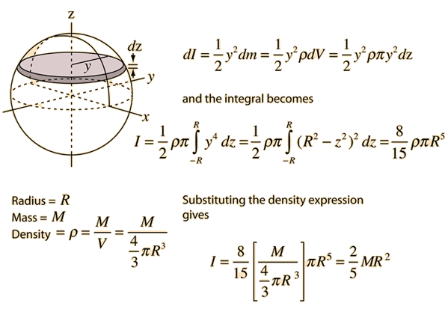

The Moment of Inertia of a Solid Sphere is $\frac{2}{5}MR^{2}$

Given the mass of the Sphere is $M= 10+59 g=69×{10}^{-3} kg$,

and the Radius of the Sphere is $R=1 cm=1×{10}^{-2} m$

Since there are two such Spheres,

$$2×MI of Solid Sphere=2×\frac{2}{5}MR^{2}=2×\frac{2}{5}×69×{10}^{-3}×{\left(1×{10}^{-2}\right)}^{2}$$

$$= 5.52×{10}^{-6} kg m^{2}$$

## B.2.2 Calculation of CM and MI perpendicular to the axis of the rod:

$$X_{CM}=\sum{\frac{m_{i}x_{i}}{m_{i}}}$$

Given the distance between the Spheres is $20 cm$, and both the spheres are of equal masses, $m kg$.

$$X_{CM}=\frac{m_{1}x_{1}+m_{2}x_{2}}{m_{1}+m_{2}}$$

$$X_{CM}=\frac{m(x_{1}+x_{2})}{2m}=\frac{x_{1}+x_{2}}{2}=\frac{0+20}{2}=10 cm$$

Hence the Centre of Mass of this two sphere system is $10 cm$ towards the other sphere, from either of the sphere, along the axis.

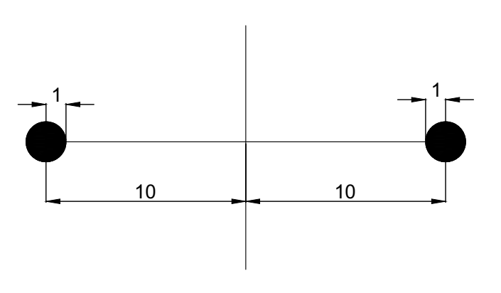

Figure B2.1 The Two Sphere System

The moment of Inertia about and axis perpendicular and passing through the Center of Mass can we calculated using the Parallel Axis Theorem applied to both the Spheres,

We take the moment of Inertia for one sphere about an axis parallel to the axis passing through the Center of Mass, since both the Sphere have the same Moment of Inertias and are at equal distances from the Centre,

$$I_{CM}=2×\left(\frac{2}{5}MR^{2}+MD^{2}\right)$$

Where $D$ is the distance of the Centre of Mass of sphere from the Center of Mass of the two Spheres, $R$ is the radius of the sphere and $M$ is the mass of the sphere.

$$I_{CM}=2×\left[\frac{2}{5}×69×{10}^{-2}×{\left(1×{10}^{-2}\right)}^{2}+69×{10}^{-2}×{\left(10×{10}^{-2}\right)}^{2}\right]$$

$$I_{CM}=1.38552×{10}^{-3} kg m^{2}$$

# **Question No. 4**

**Solution to Question No. 3 part B:**

Given Data:

Mass of the Block = $150+X×10=150+3×10=180 g=0.18 kg$

Initial Speed of the Block = $7+N×0.05=9.95 m/s$

Coefficient of Kinetic Friction between the ramp and the block = $0.2+X×0.01=0.2+3×0.01=0.23$

Angle of Inclination = $25 °$

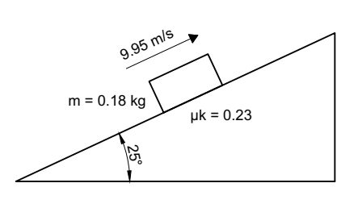

## B.3.1 Estimate of distance:

From the Free Body Diagram and using Newton’s second Law, using $g=9.80665 m/s^{2}$

$$μmg\cos{θ}-mg\sin{θ}= ma$$

$$a=-g(\sin{θ}-μ\cos{θ})$$

$$a=-9.80665×\left(\sin{25°}-0.23×\cos{25°}\right)$$

$$a=-2.100265427 m/s^{2}$$

Using Equations of Linear Motion,

$$v^{2}-u^{2}=2as$$

The Final Velocity will be zero, so

$$s= \frac{-u^{2}}{2a}=\frac{-{10.75}^{2}}{2×-2.100265427}=27.51140368 m$$

## B.3.2 Calculation of coefficient of static friction:

For the Block to be under Equilibrium due to Static Friction alone the net Acceleration of the Block should be Zero,’

$$μmg\cos{θ}=ms\sin{θ}$$

$$μ=\tan{θ}$$

$$μ=\tan{25°}$$

$$μ=0.4663076582$$

Coefficient of Static Friction is equal to the Angle of Repose, which becomes $25°$ if the block has to be stationary.

## B.3.3 Free body diagrams:

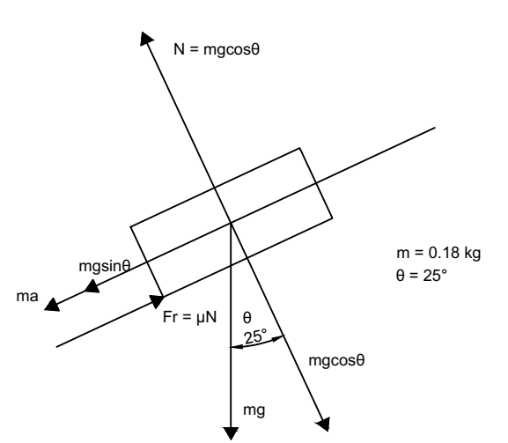

Figure B3.1 FBD for B3.1

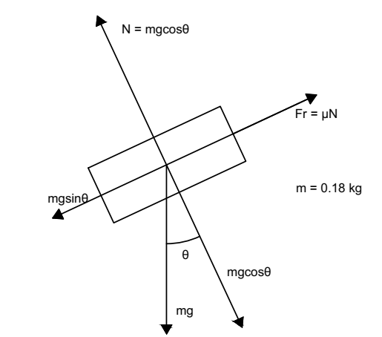

Figure B3.2 FBD for B3.2

# **Question No. 5**

**Solution to Question No. 4 part B:**

Given :

Temperature $T=300+X+0.1N=300+3+5.9=308.9 K$

$$E_{2}=2 eV=2×1.6×{10}^{-19}=3.2×{10}^{-19} J$$

$$E_{1}=0 eV=0 J$$

$$E_{3}=2.5 eV= 2.5×1.6×{10}^{-19}=4×{10}^{-19}J$$

$$\frac{N_{3}}{N_{1}}=0.01+0.01×X=0.04$$

$$B_{21}=1.5×{10}^{20}$$

$$B_{31}=0.7×{10}^{20}$$

## B.4.1 Calculation of the ratio of population of N2/N1:

Given $T=300+3+0.1×59=308.9 K$

Using the Boltzmann Equation,

$$\frac{N_{2}}{N_{1}}= e^{-\frac{\left(E_{2}-E_{1}\right)}{kT}}$$

$$\frac{N_{2}}{N_{1}}=e^{\frac{-3.2×{10}^{-19}}{1.38×{10}^{-23}×308.9}}$$

$$\frac{N_{2}}{N_{1}}=e^{-75.0676782}$$

$$\frac{N_{2}}{N_{1}}=2.503350076×{10}^{-33}$$

## B.4.2 Estimation of temperature:

Given $\frac{N_{3}}{N_{1}}=0.01+0.01×3= 0.04$

Using the Boltzmann Equation again, but now for the Energy levels $E_{3}$ and $E_{1}$.

$$\frac{N_{3}}{N_{1}}=e^{-\frac{E_{3}-E_{1}}{kT}}$$

$$0.04=e^{-\frac{4×{10}^{-19}}{1.38×{10}^{-23}×T}}$$

Taking $\log{}$ both sides,

$$\ln{0.04}= -\frac{4×{10}^{-19}}{1.38×{10}^{-23}×T}$$

$$T=-\frac{4×{10}^{-19}}{1.38×{10}^{-23}×\ln{0.04}}$$

$$T=9004.854124 K$$

## B.4.3 Computation of life time:

From Planks’ Equations, the relationship between Energy and Wavelength of light is,

$$E=\frac{hc}{λ}=hν$$

Where $h$ is the planks constant, $λ$ is the wavelength of the photon and $ν$ is the frequency of the photon.

Also,

$$ν=\frac{ΔE}{h}$$

The Population at an Energy level decreases exponentially with time

$$\frac{dN_{2}}{N_{2}}=-A_{21}dt$$

$$\frac{N_{2}\left(τ\right)}{N_{2}\left(0\right)}=\frac{1}{e}=e^{-A_{21}τ}$$

Hence the Life Time $τ$ of the excited state is given by,

$$life time=\frac{1}{A_{21}}$$

Where $A_{21}$ is the coefficient of spontaneous emission,

Also,

$$\frac{A_{21}}{B_{21}}=\frac{8πhν^{3}}{c^{3}}$$

$$A_{21}=B_{21}×\frac{8πhν^{3}}{c^{3}}$$

$$\frac{1}{A_{21}}=\frac{c^{3}}{B_{21}×8πhν^{3}}$$

$$\frac{1}{A_{21}}=\frac{c^{3}×h^{3}}{B_{21}×8πhΔE^{3}}$$

$$\frac{1}{A_{21}}=\frac{c^{3}×h^{2}}{B_{21}×8π{×\left(E_{2}-E_{1}\right)}^{3}}$$

Now substituting the values,

$$\frac{1}{A_{21}}=\frac{{\left(3×{10}^{8}\right)}^{3}×{\left(6.6×{10}^{-34}\right)}^{2}}{1.5×{10}^{20}×8π×{\left(3.2×{10}^{-19}\right)}^{3}}$$

$$τ=\frac{1}{A_{21}}=9.5207×{10}^{-8}s$$

Similarly for transition from 3 to 1

$$\frac{1}{A_{31}}=\frac{c^{3}×h^{2}}{B_{31}×8π{×\left(E_{3}-E_{1}\right)}^{3}}$$

Now substituting the values,

$$\frac{1}{A_{31}}=\frac{{\left(3×{10}^{8}\right)}^{3}×{\left(6.6×{10}^{-34}\right)}^{2}}{0.7×{10}^{20}×8π×{\left(4×{10}^{-19}\right)}^{3}}$$

$$τ=\frac{1}{A_{21}}=1.04456×{10}^{-7}s$$

**Bibliography**

________________________________________________________________________________

1. Watson GM, Murray S, Dretler SP et al. The pulse-dye laser for fragmenting urinary Calculi. J Urol 1987, pg 138:195-198.
2. Feng, C., Wu, Z., Jiang, H., Ding, Q., & Gao, P. (2013). Ureteroscopic Holmium:YAG laser lithotripsy is effective for ureteral steinstrasse post-SWL. Minimally Invasive Therapy & Allied Technologies, 22(5), 279-282.
3. Lawrence I. Deckelbaum MD, Coronary laser angioplasty (1994)
4. eMedicine.com. "Percutaneous Transluminal Coronary Angioplasty". <http://emedicine.medscape.com/article/161446-overview> Accessed 09-Mar-2018